PERF-TEST-AGENT v2.0
Agentic Performance Testing Pipeline
Technical Deep Dive — All Phases

CTx CQE Performance Engineering & Cybersecurity
AT&T
March 2026
CONFIDENTIAL — INTERNAL USE ONLY

Table of Contents

1. Architecture Overview
PERF-TEST-AGENT is an end-to-end LLM-powered agentic pipeline that automates the performance testing lifecycle for AT&T’s CTx CQE telecom systems. The framework uses LangChain ReAct (Reasoning + Acting) agents orchestrated through a 7-phase pipeline, each backed by Azure OpenAI GPT-4o/GPT-4o-mini, with Human-in-the-Loop (HITL) approval gates between every phase.

1.1 System Architecture
The system is composed of four layers: Presentation (FastAPI + React + WebSocket + CLI), Orchestration (PipelineOrchestrator + 7 BaseAgent subclasses + LangChain AgentExecutor), Integration (13 external system clients wrapped as LangChain tools), and Data/Config (Snowflake with 15 tables + 4 views, manifest-driven YAML references, Pydantic v2 models).
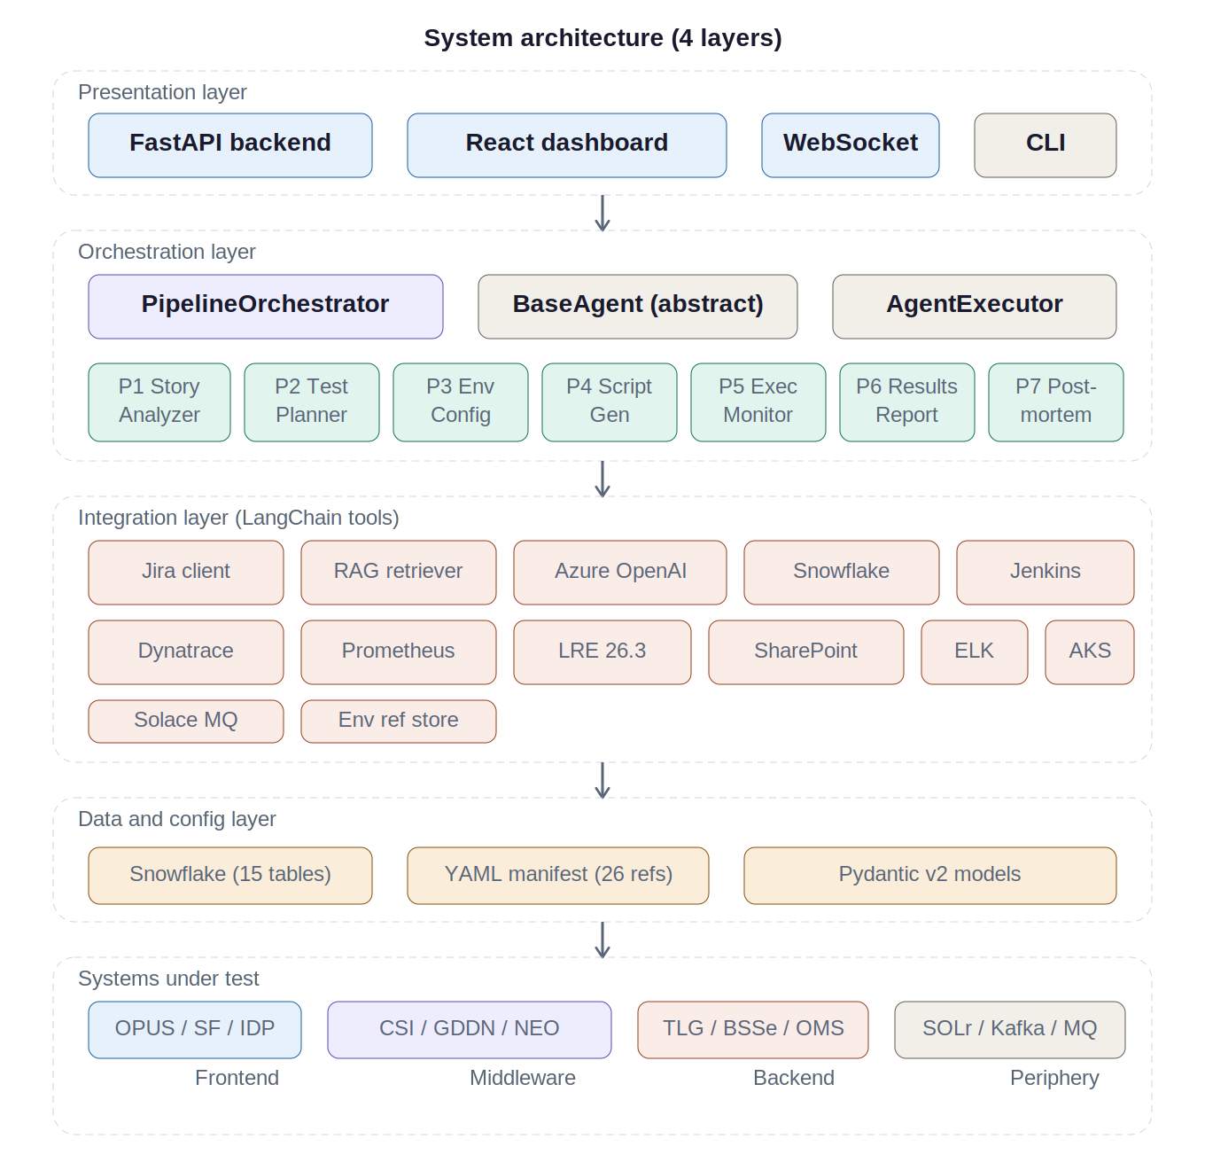

1.2 Pipeline Flow
The pipeline executes seven phases in strict sequence. The PipelineOrchestrator manages phase ordering via PHASE_ORDER, state persistence between phases, and HITL gate callbacks. The central PipelineState (Pydantic model) accumulates data as each phase writes its outputs, flowing the complete context forward.
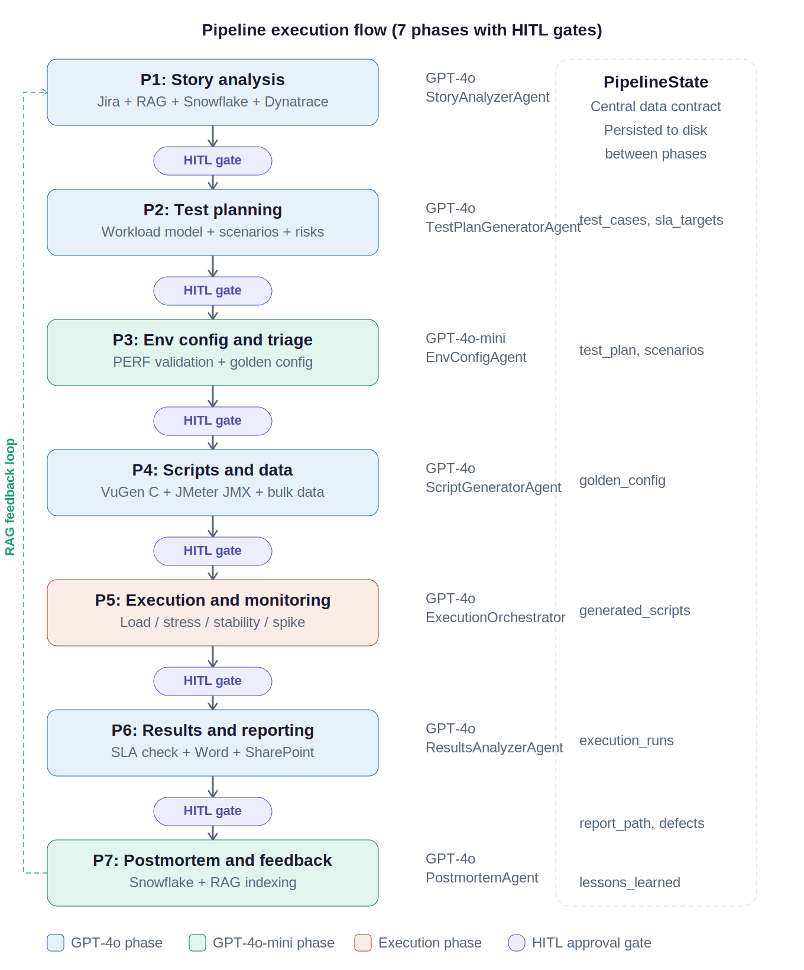

1.3 LLM Task Routing
The Settings module routes LLM calls based on task complexity. GPT-4o handles complex reasoning and code generation (8,192 tokens); GPT-4o-mini handles extraction, classification, and formatting (1,024–4,096 tokens). Temperature is fixed at 0.1 across all tasks.
Task Type | Model | Max Tokens | Used In
COMPLEX_REASONING | GPT-4o | 8192 | Phases 1, 2, 5, 6, 7
CODE_GENERATION | GPT-4o | 8192 | Phase 4
EXTRACTION | GPT-4o-mini | 4096 | Phase 3
CLASSIFICATION | GPT-4o-mini | 1024 | Routing, triage

1.4 BaseAgent Infrastructure
All seven phase agents inherit from BaseAgent (src/agents/base_agent.py). The lifecycle is: lazy LLM initialization with task-appropriate model, tool registration via get_tools(), ReAct agent creation via LangChain create_react_agent() with a PromptTemplate, AgentExecutor with max 15 iterations and retry logic (3 attempts, exponential backoff 2s–30s), JSON output parsing against a Pydantic model, reasoning trace extraction from intermediate_steps, and artifact persistence to the run directory.
The HITL workflow supports three levels of prompt customization per phase, all scoped to the current run: prompt override (replaces the system prompt), pre-execution context (appended to agent input), and post-execution notes (captured during approval).

2. Phase 1: Story Analysis
Agent: StoryAnalyzerAgent (src/agents/story_analyzer.py)
LLM: COMPLEX_REASONING — GPT-4o, 8,192 tokens
Output: StoryAnalysisOutput (src/models/test_case.py)

Phase 1 is the entry point of the pipeline — where raw Jira stories get transformed into structured, actionable performance test cases. It uses the most reasoning-intensive LLM configuration because the agent must synthesize context from multiple sources and make judgment calls about risk, harness selection, and SLA targets.

2.1 ReAct Loop and Tool Calls
The agent enters a LangChain AgentExecutor loop (max 15 iterations) with tools for Jira, RAG, Snowflake, and Dynatrace. While the agent reasons about tool call order at each step, the system prompt strongly guides this sequence:
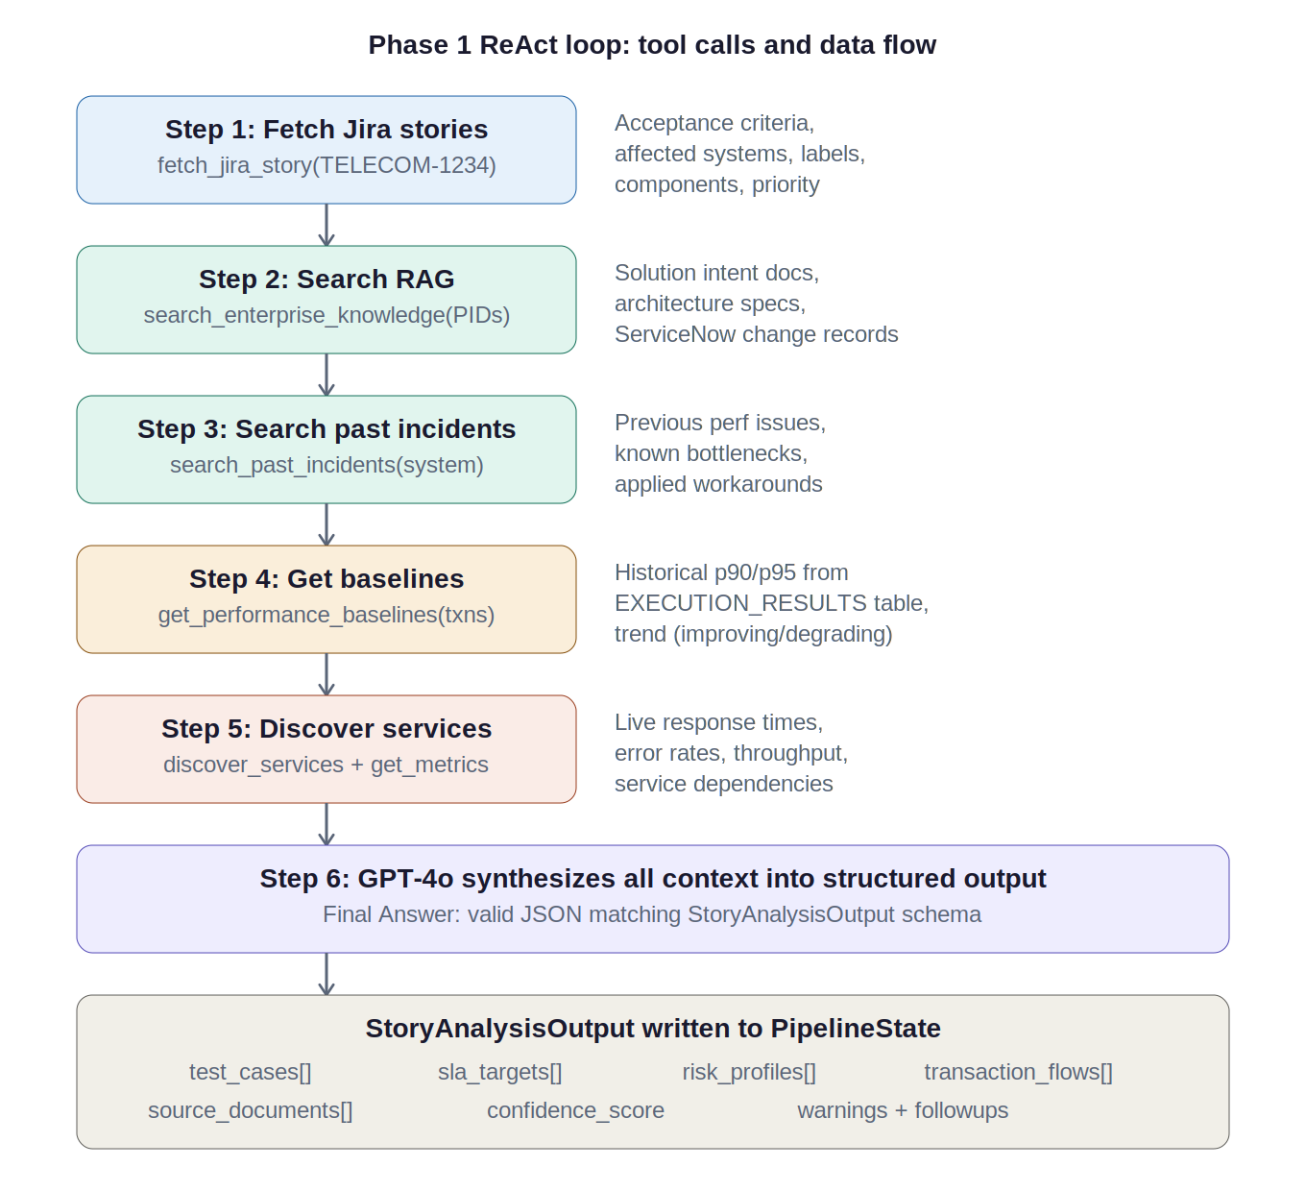

- Step 1 — Fetch Jira Stories: Calls JiraClient.get_story() via REST API at /rest/api/2/issue/{key} with expand=renderedFields. Extracts summary, description, acceptance criteria (custom field), priority, labels, components, and story points.
- Step 2 — Search RAG: Calls RAGRetriever.search() against Azure AI Search with semantic ranking. Combines story summary with context IDs (PIDs/E1 IDs). Searches pre-indexed Microsoft Graph content — SharePoint wikis, PowerBI reports, ServiceNow records. Results truncated to 4,000 chars each.
- Step 3 — Search Past Incidents: Calls RAGRetriever.search_past_incidents() filtered to source eq ‘servicenow’. Finds previous performance degradation events, known connection pool issues, GC pause problems.
- Step 4 — Get Baselines: Calls SnowflakeClient.get_transaction_baselines() which runs a windowed query against EXECUTION_RESULTS. Computes rolling averages from the last 10 runs per transaction with trend detection (improving/stable/degrading based on 10% threshold).
- Step 5 — Discover Services: Calls DynatraceClient.get_services() to map live service topology, then get_service_metrics() for response time distributions, throughput, and error rates over the last 24 hours.
- Step 6 — LLM Synthesis: GPT-4o synthesizes all gathered context into TestCase objects, each containing transaction flows, SLA targets, risk levels, recommended harness, data requirements, and correlation hints.

2.2 Output Structure
Each TestCase carries an id (format TC-{story_key}-{sequence}), the full transaction flow as an ordered list of system calls (e.g., OPUS → CSI → TLG → BSSe), SLA targets with p90/p95/error thresholds, a risk level with rationale, the recommended harness, data requirements, and correlation hints for script generation.

2.3 Harness Selection Logic
Hard-coded in the system prompt: OPUS (Web HTTP/HTML) always routes to LoadRunner Enterprise VuGen; REST/JSON APIs route to JMeter; SOAP/XML routes to JMeter SOAP sampler; Solace MQ (GDDN) routes to JMeter with Solace JMS plugin using PERSISTENT delivery mode.

2.4 Default SLA Targets
When stories don’t specify SLA targets, the agent falls back to defaults:
Transaction Type | p90 (ms) | p95 (ms) | p99 | Max Err %
Interactive UI (OPUS) | 3000 | 5000 | — | 1.0%
REST API call | 1000 | 1500 | — | 0.5%
SOAP API call | 1500 | 2500 | — | 0.5%
Async MQ flow | 5000 | 8000 | — | 2.0%
Authentication | 500 | 800 | — | 0.1%

State Written: test_cases, sla_targets, risk_profiles, transaction_flows, source_documents

3. Phase 2: Test Planning
Agent: TestPlanGeneratorAgent (src/agents/test_plan_generator.py)
LLM: COMPLEX_REASONING — GPT-4o, 8,192 tokens
Output: TestPlan (src/models/test_plan.py)

Phase 2 takes the structured test cases from Phase 1 and builds them into a comprehensive, executable test plan. This is where abstract “what to test” becomes concrete “how to test it.” The agent gets the same Jira, RAG, Snowflake, and Dynatrace tools as Phase 1, plus a unique read_app_config tool that reads per-application .md configuration files from templates/app_configs/.

3.1 TestPlan Output Structure
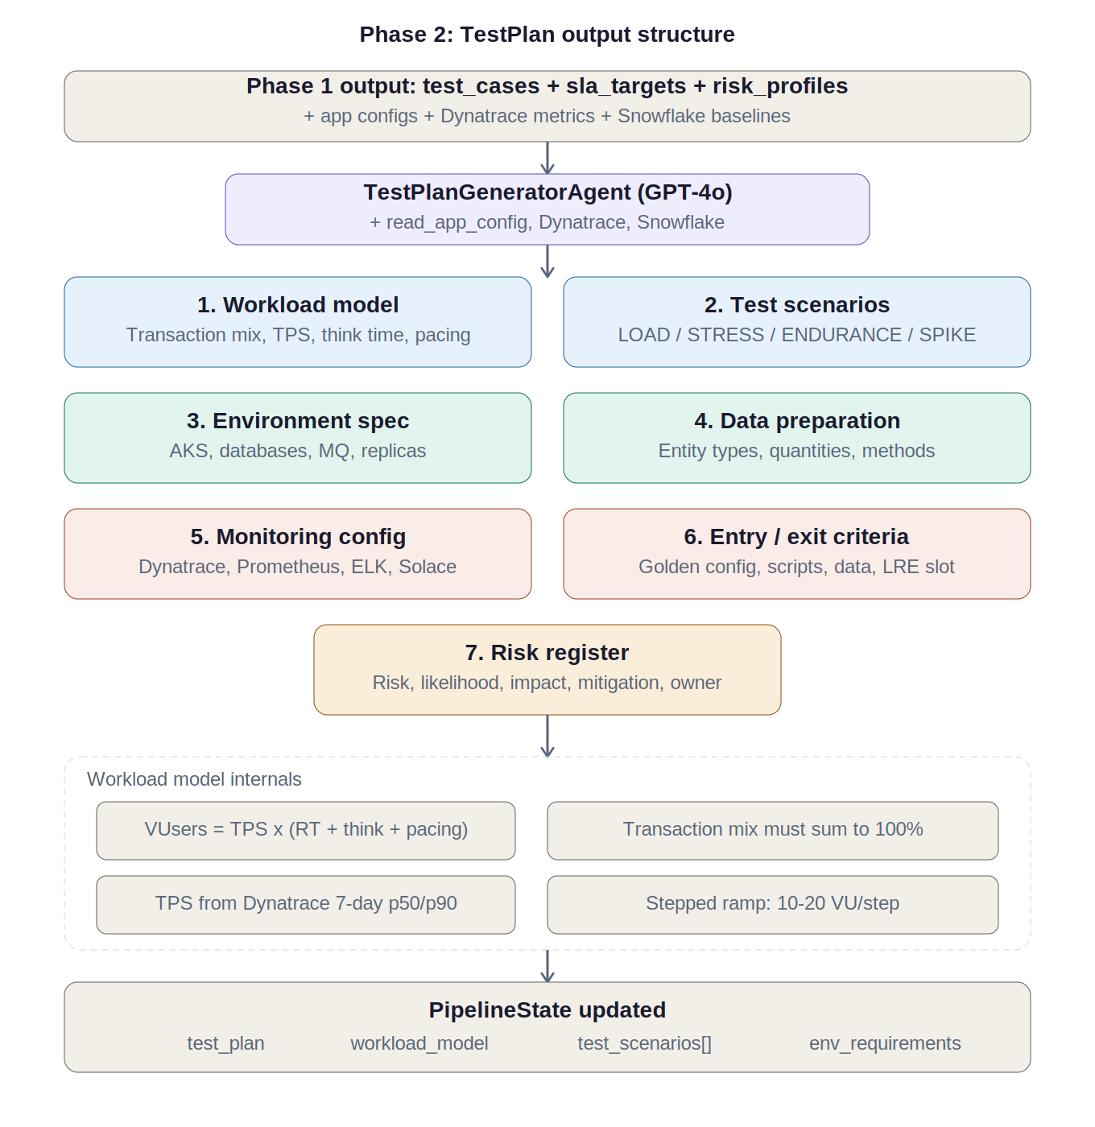

The system prompt requires seven sections:
- 1. Workload Model: Transaction mix (must sum to 100% — enforced by Pydantic validator), TPS targets from Dynatrace 7-day p50/p90, think times, pacing. Formula: VUsers = TPS × (avg_response_time + think_time + pacing). Stepped ramp at 10–20 users/step to protect Solace MQ and Cassandra.
- 2. Test Scenarios: LOAD (30 min steady state, always required), STRESS (ramp to breakpoint, always required), ENDURANCE (1–4 hr sustained, if async/MQ flows), SPIKE (3x burst for AKS auto-scaling).
- 3. Environment Spec: Systems required, AKS namespaces, expected replica counts, database connections, MQ requirements. Becomes direct input for Phase 3.
- 4. Data Preparation: Entity types, quantities, creation methods (sql_insert, api_provisioning, data_tool, manual), source systems, dependencies.
- 5. Monitoring Config: Dynatrace management zone and tags, Prometheus target metrics and queries, ELK index patterns, Solace queue depth queries.
- 6. Entry/Exit Criteria: Entry requires golden config, validated scripts, provisioned data, operational monitoring. Exit requires all SLAs evaluated, peak/break identified, stability passed.
- 7. Risk Register: Each risk with description, likelihood, impact, mitigation, and owner. TLG connection pool sizing is mandatory.

State Written: test_plan, workload_model, test_scenarios, environment_requirements, bulk_data_requirements

4. Phase 3: Environment Configuration and Triage
Agent: EnvConfigAgent (src/agents/env_config_checker.py)
LLM: EXTRACTION — GPT-4o-mini, 4,096 tokens (the only phase using the cheaper model)
Output: ConfigValidationReport (src/models/env_config.py)

Phase 3 is the safety gate. It exists because the single most expensive mistake in performance testing is running against the wrong environment. In AT&T’s telecom stack, the difference between a PERF endpoint and a QC endpoint is often just three characters in a hostname.

4.1 Environment Reference System
Environment references are per-application YAML configuration files managed via a central manifest (config/environment_references/manifest.yaml). The repository ships with 26 manifest entries covering 22 unique applications. Each YAML file contains ConfigField entries with expected_perf_value, inspection_tool enum, and known_qc_values.
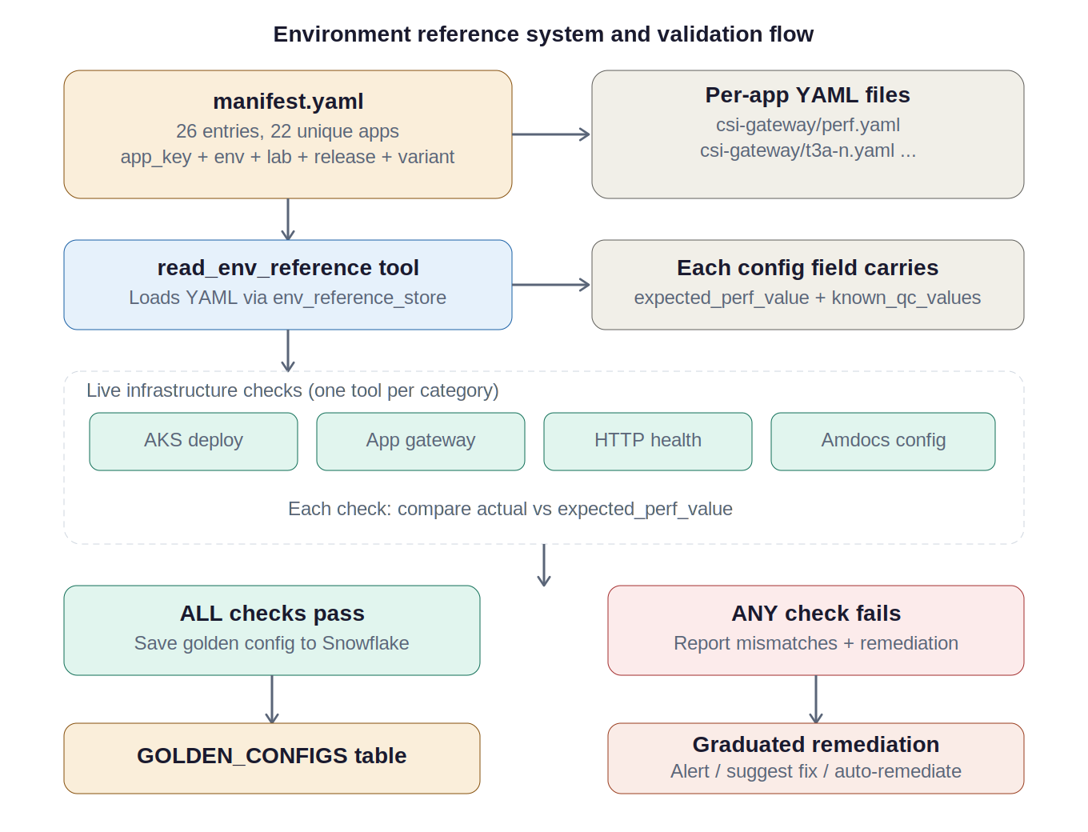

4.2 The Critical QC Detection Rule
CRITICAL RULE: ALL configurations MUST point to PERF, NOT QC. Any reference to qc2, qc3, QC3QM, qc-vpn, or qc-scan in any URL, hostname, VPN, or connection string is flagged as a CRITICAL mismatch. A single QC pointer means the test is INVALID.

4.3 Validation Flow
- Read environment reference YAMLs from the manifest-driven store.
- For each application: validate AKS deployments (env vars, replicas, ConfigMaps), Azure App Gateway backend pools, Amdocs backend endpoints, Solace MQ VPN/queue config, database connections, and endpoint health.
- Compare each actual value against the expected PERF value from the reference YAML.
- If ALL checks pass: save golden config baseline to Snowflake GOLDEN_CONFIGS table.
- If ANY checks fail: report mismatches with graduated remediation (ALERT_ONLY, SUGGEST_FIX, or AUTO_REMEDIATE with HITL approval).

4.4 Daily Drift Checks
After golden config is established, daily drift checks are scheduled via Jenkins cron (06:00 UTC). Any drift triggers a pipeline halt notification and Jira ticket. All checks are tracked in Snowflake CONFIG_CHECK_HISTORY with is_drift_check=true, feeding the V_CONFIG_DRIFT_HISTORY view.

State Written: env_config_results, golden_config, config_mismatches, env_validation_passed

5. Phase 4: Script and Data Creation
Agent: ScriptGeneratorAgent (src/agents/script_generator.py)
LLM: CODE_GENERATION — GPT-4o, 8,192 tokens
Output: ScriptDataOutput (src/models/script_gen.py)

Phase 4 transitions from planning to building. It produces actual executable artifacts — VuGen C scripts for LoadRunner, JMeter JMX test plans, and provisioned test data.

5.1 VuGen C Script Generation
The generate_vugen_script tool creates a directory under ./runs/scripts/vugen/{transaction_name}/ with four files: Action.c, globals.h, vuser_init.c, and vuser_end.c. The _build_vugen_action() helper generates the C code with web_reg_save_param correlation (registered BEFORE the request returning the dynamic value), lr_start/end_transaction wrapping, web_url() calls per endpoint, HTTP status code error handling, and lr_think_time(3).

5.2 JMeter JMX Generation
The generate_jmeter_script tool writes a single .jmx file. The _build_jmeter_jmx() helper generates valid XML with HTTPSamplerProxy elements (URL decomposed via urlparse into domain/port/path/protocol), ThreadGroup with JMeter property functions for runtime configurability (${__P(users,10)}, ${__P(rampup,60)}, ${__P(duration,300)}), HeaderManager, and ConstantTimer for think time. ThreadGroup.scheduler is set to true for duration-based scheduling.

5.3 Script Validation
The validate_script tool checks scripts by harness. For JMeter: verifies jmeterTestPlan root element, ThreadGroup, and at least one sampler (HTTPSamplerProxy or JMSSampler). For LoadRunner: verifies Action() function, lr_start_transaction, and lr_end_transaction in Action.c.

5.4 Data Provisioning
Four strategies per system type: SQL Insert (Oracle/Cassandra), API Provisioning (TLG/Salesforce/IDP with retry logic and rate limiting at 100/batch), Amdocs Data Tools (BSSe/OMS), and Manual (LDAP/SOLr with verification queries).

5.5 Design Choice: LLM Reasons, Templates Build
The LLM’s job is to decide which tool to call with what parameters based on the test plan. The actual code generation happens in validated helper functions (_build_vugen_action, _build_jmeter_jmx). This avoids reliability problems of having GPT-4o write raw C or XML from scratch.

State Written: generated_scripts, bulk_data_status, script_validation_results

6. Phase 5: Execution and Monitoring
Agent: ExecutionOrchestratorAgent (src/agents/execution_orchestrator.py)
LLM: COMPLEX_REASONING — GPT-4o, 8,192 tokens
Output: ExecutionOutput (src/models/execution.py)

Phase 5 is where the pipeline stops planning and starts doing. It’s the longest-running phase by far — a typical execution covers load, stress, endurance, and spike tests spanning hours of real clock time — and it’s the only phase that interacts with live test infrastructure in real time. It has the largest tool set of any phase: 10 tools across 4 factory functions.

6.1 Execution Sequence (Strict Order)
- Step 1 — Pre-flight Config Check: Verify golden config has not drifted since Phase 3. If drift detected, HALT immediately.
- Step 2 — LOAD Test: 30 min steady state at expected peak. Stepped ramp (10–20 VUsers/step). Monitor every 60s via Dynatrace, Prometheus, ELK. Pass: all p90 met, error < 1%.
- Step 3 — STRESS/Breakpoint: Ramp beyond peak. Record Peak Point (highest stable TPS where p90 meets SLA AND error < 1% AND CPU < 85%, memory < 85%, JVM heap < 80%) and Breakpoint (error > 5% or timeout > 10% or HTTP 503 dominates). Gap = headroom margin.
- Step 4 — ENDURANCE/Stability: Sustain Peak Point TPS for 1–4 hours. Monitor for memory leaks (15-min rolling averages), MQ depth buildup, p90 drift > 10%, GC pause increase, connection pool exhaustion, Cassandra read latency degradation.
- Step 5 — SPIKE (if AKS in scope): Burst to 3x peak over 5 min, hold 5 min, ramp down 5 min. Verify pod scale-out within 2 min and SLA recovery within 5 min.

6.2 Real-Time Monitoring
During all steps, three monitoring sources are polled every 60 seconds:
- Dynatrace: Service response time (p50/p90/p95), error rate, throughput, active Problems.
- Prometheus: CPU (container_cpu_usage_seconds_total), memory (container_memory_working_set_bytes), JVM heap, GC pause duration, MQ queue depth (solace_queue_messages_queued), pod count, HTTP request rate.
- ELK: Error log patterns (OutOfMemoryError, SocketTimeoutException, Connection refused, Circuit breaker, 503, FATAL).

6.3 Anomaly Routing Table
Anomalies are classified by severity and routed to the responsible team:
Anomaly | Severity | Route To
Error rate spike >5% | CRITICAL | Application Development
HTTP 503 / Connection Refused | CRITICAL | Network Ops + CSTEM
Response time >2x SLA | ERROR | Application Development
JVM heap >80% | ERROR | Platform Engineering
DB connection pool exhaustion | ERROR | DBA Team
MQ queue depth >1000 | WARNING | Middleware Team
GC pause >500ms | WARNING | Application Development
Cassandra read latency >50ms | WARNING | DBA Team

CRITICAL and ERROR anomalies trigger automatic Jira defect creation with full context: anomaly description, timestamp, affected system, metrics snapshot, and suggested root cause.

State Written: execution_runs, peak_point_results, breakpoint_results, stability_results, anomalies

7. Phase 6: Results Analysis and Reporting
Agent: ResultsAnalyzerAgent (src/agents/results_analyzer.py)
LLM: COMPLEX_REASONING — GPT-4o, 8,192 tokens
Output: AnalysisReport (src/models/analysis.py)

Phase 6 is where execution data becomes a decision. It takes raw metrics, anomalies, and benchmark results from Phase 5 and produces a verdict — GO, NO-GO, or CONDITIONAL — backed by SLA compliance analysis, baseline comparisons, and a formal Word report published to SharePoint.

7.1 Five-Part Analysis Framework
- 1. SLA Compliance: Per-transaction comparison of p90/p95 response time and error rate against targets. Calculates deviation percentage and margin from SLA limit.
- 2. Baseline Comparison: Current p90 vs rolling averages from Snowflake V_TRANSACTION_BASELINES. Trend: IMPROVING (>5% better), STABLE (within 5%), DEGRADING (>5% worse). Regressions >10% are flagged.
- 3. Peak/Breakpoint Analysis: Headroom margin = (Breakpoint TPS - Peak TPS) / Peak TPS × 100%. Below 20% = capacity risk. Identifies bottleneck component.
- 4. Stability Analysis: p90 drift (first-15-min vs last-15-min), memory trend, queue depth trend, GC pause frequency.
- 5. Anomaly Summary: All anomalies sorted by severity, mapped to Jira defects.

7.2 Verdict Decision
- GO: All SLAs met, no BLOCKER/CRITICAL defects, adequate headroom (>20%).
- CONDITIONAL: All SLAs met but MAJOR defects require remediation before release.
- NO-GO: BLOCKER defect, multiple CRITICAL failures, or insufficient headroom (<10%).

7.3 Four Deliverables
- Word Report: 10-section .docx with executive summary, SLA compliance table, peak/breakpoint analysis, stability results, anomaly timeline, defect summary, baseline comparison, and recommendations.
- SharePoint: Published to CTxCQE Reports library via Microsoft Graph.
- Snowflake: Per-transaction execution results saved to EXECUTION_RESULTS. These become the baseline corpus for future runs — the first half of the feedback loop.
- Jira Defects: New defects for violations not already caught by Phase 5.

State Written: report_path, sharepoint_url, jira_defect_keys

8. Phase 7: Postmortem and Feedback Loop
Agent: PostmortemAgent (src/agents/results_analyzer.py, re-exported from postmortem_agent.py)
LLM: COMPLEX_REASONING — GPT-4o, 8,192 tokens
Output: PostmortemOutput (src/models/analysis.py)

Phase 7 closes the loop. It’s the only phase whose primary purpose isn’t producing something for the current test cycle — it’s producing something for every future test cycle. The structured issues go to Snowflake for trend analysis; the unstructured lessons go to the RAG knowledge base where Phase 1 and Phase 2 agents retrieve them automatically.

8.1 Five-Step Postmortem Framework
- 1. Issue Cataloging: Reviews all phase results. Each issue records: phase (1–7), category (environment, data, tooling, process, communication, technical), title, impact, resolution, time lost (hours), and resolved status.
- 2. Time Analysis: Sums time lost per category. Computes efficiency ratio: (total_duration - time_lost) / total_duration. Target: >80% efficiency.
- 3. Lessons Learned: Structured LessonLearned objects with: actionable title, context (when it applies), lesson (causal chain), recommendation (prevention), applicable_systems, applicable_phases, and tags for RAG retrieval.
- 4. Pattern Detection: Searches RAG for similar lessons from previous cycles. Checks whether the same systems are consistently problematic and whether time lost per category has improved or worsened.
- 5. Recommendations: Top 3 process improvements, infrastructure changes, monitoring gaps, and automation opportunities.

8.2 Dual Archival Mechanism
Snowflake (Structured): POSTMORTEM_ENTRIES table (one row per issue, clustered by RUN_ID, PHASE) + LESSONS_LEARNED table (one row per lesson with APPLICABLE_SYSTEMS and TAGS as ARRAY columns). Feeds V_POSTMORTEM_INSIGHTS view for cross-cycle trend analysis.

RAG (Unstructured): Each lesson becomes a searchable document in the Azure AI Search enterprise-knowledge index with rich metadata (systems, tags, severity, date, sprint). These are retrieved by future Phase 1 search_past_incidents() and Phase 2 search_enterprise_knowledge() calls.

8.3 The Complete Feedback Loop
The loop spans four touchpoints: Phase 7 indexes lessons to RAG. In the next run, Phase 1 and Phase 2 retrieve these lessons alongside architecture docs and ServiceNow records. The lessons inform risk assessment, SLA target calibration, and scenario design. Simultaneously, Phase 6 archives quantitative execution results to Snowflake that Phase 1 and Phase 2 retrieve via get_performance_baselines(). Together, quantitative baselines and qualitative lessons make every subsequent pipeline run more informed than the last.

State Written: postmortem_entries, lessons_learned, feedback_indexed

When the HITL reviewer approves Phase 7, the PipelineOrchestrator reaches the end of PHASE_ORDER with no next phase. The pipeline state shows all seven phases as COMPLETED. The final state is persisted to {run_dir}/pipeline_state.json — a complete JSON snapshot of the entire test cycle.

