AT&T CTx CQE
Performance Engineering & Cybersecurity

Project Implementation Plan

Legacy Agentic Pipeline

LLM-Powered Performance Testing Automation

Document Version | 2.0.0 | March 2026
Classification | AT&T Internal | Confidential
Prepared By | CTx CQE Performance Engineering Team
Status | DRAFT | Pending AI Governance Approval

1. Executive Summary
The Legacy Agentic Pipeline is a 7-phase, LLM-powered performance testing automation system purpose-built for AT&T's CTx Customer Experience Legacy infrastructure. The pipeline replaces a largely manual testing lifecycle with an end-to-end agentic workflow — from Jira story ingestion and test case extraction through automated script generation, execution orchestration, results analysis, and postmortem knowledge capture.

This implementation plan defines the complete scope, architecture, phase-by-phase work breakdown, risk register, resource requirements, and delivery milestones for the production deployment.

1.1 Objective & Business Value
Metric | Current State | Target with v2.0
Test cycle setup time | 3–5 days (manual) | < 4 hours (automated)
Script authoring time | 2–4 days per test suite | < 2 hours (generated)
Env config validation | Manual | error-prone | Automated golden-config check
Postmortem capture | Ad-hoc / inconsistent | Snowflake + RAG indexed
Human-in-the-loop control | Full manual oversight | HITL gates at each phase

1.2 Guiding Principles
- Human-in-the-loop (HITL) at every phase boundary — agents propose, engineers decide.
- Azure OpenAI GPT-4o / GPT-4o-mini only — no external LLM API calls outside the AT&T Azure tenant.
- Graduated autonomy — the system earns trust incrementally across release milestones.
- RAG-grounded intelligence — all agent decisions are anchored to indexed enterprise knowledge.
- Auditability — every agent reasoning trace, prompt, and decision is persisted and inspectable.

2. Architecture Overview

2.1 Pipeline Architecture
The pipeline is structured as a sequential 7-phase ReAct agent loop, each phase implemented as a dedicated LangChain agent with access to a curated toolset. Phases execute in order, separated by HITL approval gates delivered through a React-based web dashboard backed by a FastAPI server with WebSocket streaming.
Figure 1 — Legacy Agentic Pipeline: Architecture Overview
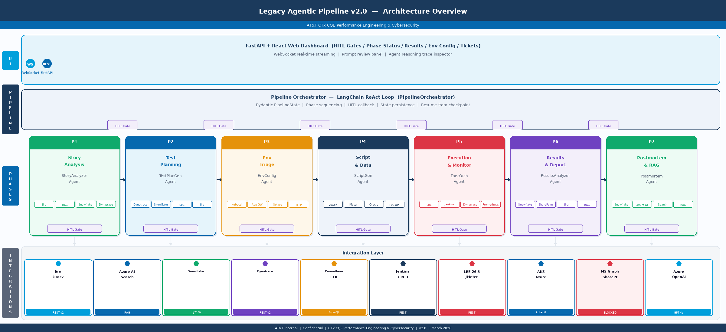
Figure 1. Full 7-phase pipeline: UI / Dashboard layer → Pipeline Orchestrator → Phase agents P1–P7 → Integration layer (14 systems). HITL gates enforce human review at every phase boundary.

# | Phase | Agent | Key Inputs | Key Outputs
1 | Story Analysis | StoryAnalyzerAgent | Jira stories, PIDs/E1s, RAG docs (AskATT API), Snowflake baselines | Test cases, SLA targets, risk profiles
2 | Test Planning | TestPlanGeneratorAgent | Test cases, Dynatrace metrics, app configs, Snowflake baselines | Test plan, workload model, scenarios, Jira stories
3 | Env Triage | EnvConfigAgent | YAML reference configs, AKS/AppGW endpoints, Solace SEMP | Golden config baseline, drift report, remediation commands
4 | Script & Data | ScriptGeneratorAgent | Test plan, protocol specs, bulk data requirements | VuGen .c scripts, JMeter .jmx, bulk data provisioned
5 | Execution | ExecutionOrchestratorAgent | Scripts, golden config, SLA targets | Peak/Break/Stability results, anomaly log, Jira defects
6 | Reporting | ResultsAnalyzerAgent | Execution data, Dynatrace/Prometheus metrics, baselines | Word report, SharePoint publish, Jira defects archived
7 | Postmortem | PostmortemAgent | Phase logs, anomalies, operator notes, RAG history | Snowflake archive, lessons indexed to RAG knowledge base

2.2 Technology Stack
Layer | Component | Details
Orchestration | LangChain ReAct Agents | Tool-calling loop, max 15 iterations, full reasoning trace
LLM — Reasoning | Azure OpenAI GPT-4o | Phases 1, 2, 4, 5, 6, 7 | 8,192 max tokens | temp 0.1
LLM — Extraction | Azure OpenAI GPT-4o-mini | Phase 3 classification, formatting tasks | cost-optimized
RAG | Azure AI Search | Pre-indexed MS Graph (SharePoint, ServiceNow, PowerBI)
State Persistence | Pydantic v2 + JSON | PipelineState persisted to disk between phases
Data Platform | Snowflake | Baselines, execution results, golden configs, postmortem archive
API Server | FastAPI + WebSocket | Real-time HITL dashboard, REST pipeline controls
Dashboard | React (Babel UMD) | HITL gates, phase status, env config editor, ticket tracking
Test Harness | LRE 26.3 + JMeter | VuGen C scripts, JMX test plans, Jenkins trigger
Monitoring | Dynatrace + Prometheus + ELK | Real-time anomaly detection during Phase 5
CI/CD | Jenkins (or GitHub Actions) | Scheduled drift checks, harness job triggers, build orchestration
Source Control | Git (internal mirror) | Workspace mono-repo with JSX/Python/YAML/SQL artifacts

2.3 Integration Map
The pipeline integrates with 10 distinct external systems. Each integration has an active status as of this document's revision date.

System | Integration Type | Status | Notes / Blockers
Jira (iTrack) | REST API v2 | Active — Read-only | Full read; create/update blocked by current permission scope
Azure AI Search | Semantic Search API | Active – LevelUp MCP | RAG index pre-populated via MS Graph connectors
MS Graph / SharePoint | MSAL client credentials | BLOCKED | Internal MS Graph endpoint not yet exposed; pending Network/IAM
Snowflake | snowflake-connector-python | PENDING | DDL complete; all 7-phase tables pending. Cost analysis/budget approval pending.
Dynatrace | REST API v2 | Active | APM metrics, service topology, real-time problems
Prometheus | PromQL HTTP API | Active | AKS pod metrics, JVM heap, GC pause
ELK | Elasticsearch REST | Active | Error log search, timeout pattern detection
LoadRunner Enterprise | LRE REST API 26.3 | BLOCKED | REST API upgrade pending LRE 26.3 deployment; timeslot booking manual
Jenkins | REST + Build API | Active | Job triggers, JMeter execution, daily drift cron
Azure AKS | kubectl / Azure CLI | Active | Read-only deployment/config inspection
Azure AKS | Azure AKS deployment | PENDING | Agentic pipeline cloud deployment. Cost analysis/budget approval pending.

3. Phase-by-Phase Work Breakdown
Each phase below lists discrete implementation work items and their current completion status. Status legend: Complete = delivered and passing validation; In Progress = partially implemented; Blocked = external dependency; Pending = not yet started.
Figure 2: Pipeline Code Execution Flowchart — _execute_phases() Logic
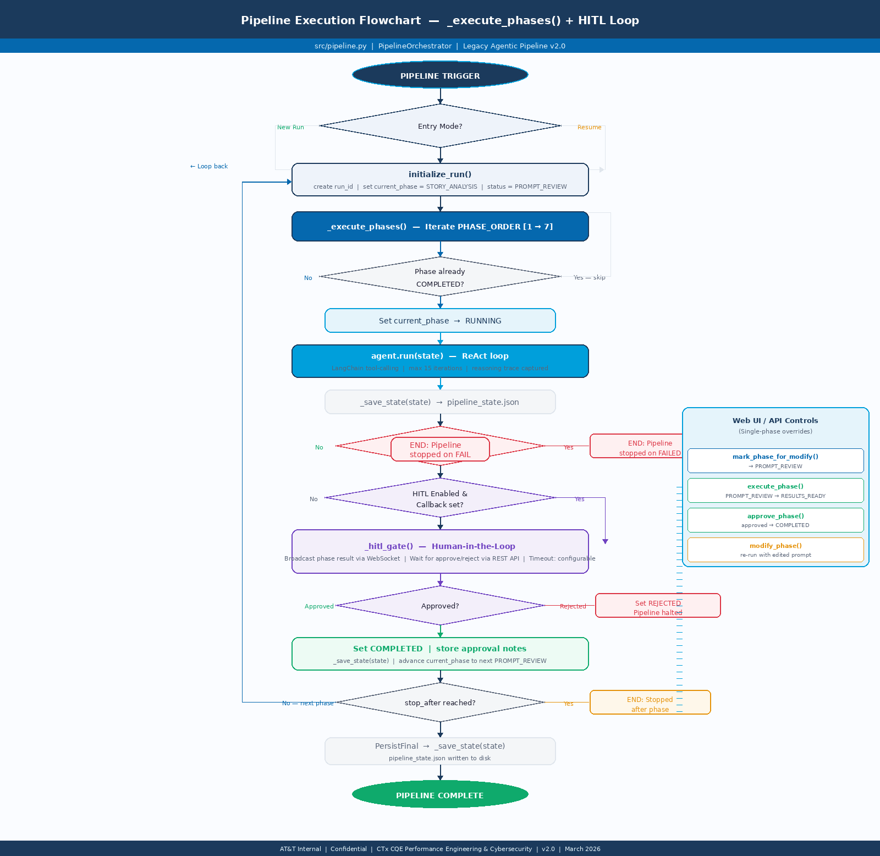
Figure 2. Code execution flowchart for PipelineOrchestrator._execute_phases(). Shows phase sequencing, HITL gate logic, approval/rejection paths, stop_after handling, and single-phase Web UI override controls.

3.1 Phase 1: Story Analysis (StoryAnalyzerAgent)
Phase Status: Complete
Work Item | Status
Jira REST client — multi-story fetch and sprint JQL | Complete
Azure AI Search RAG retrieval (semantic + filtered) | Complete
Snowflake baseline lookup (transaction p90/p95/TPS) | Complete
Dynatrace service discovery and topology mapping | Complete
Test case + SLA target extraction (GPT-4o) | Complete
Risk level classification (HIGH / MEDIUM / LOW) | Complete
Harness recommendation (LRE vs JMeter) logic | Complete
User artifacts augmentation (free text, doc blocks, Jira links, file placeholders) | Complete
StoryAnalysisOutput Pydantic model + persistence | Complete
HITL approval gate + prompt review UI (Phase 1) | Complete

3.2 Phase 2: Test Planning (TestPlanGeneratorAgent)
Phase Status: Complete
Work Item | Status
Workload model generation: TPS, VUser, transaction mix (must sum 100%) | Complete
Scenario definition: LOAD, STRESS, ENDURANCE, SPIKE | Complete
App config .md reader tool integration | Complete
Dynatrace 7-day production metric ingestion for workload calibration | Complete
Environment specification and data preparation steps | Complete
Entry/exit criteria builder | Complete
Risk register generation | Complete
Jira story creation for perf test planning artifact | Complete
TestPlan Pydantic model + Word document generation (placeholder) | Complete
HITL approval gate + prompt review UI (Phase 2) | Complete

3.3 Phase 3: Env Triage (EnvConfigAgent)
Phase Status: Complete
Work Item | Status
Manifest-aware YAML reference store (per-app, multi-lab, multi-release) | Complete
AKS deployment config inspection tool (kubectl / Azure CLI) | Complete
Azure App Gateway backend pool validation | Complete
Solace SEMP queue/VPN config check | Complete
HTTP endpoint health probe tool | Complete
QC pointer detection and CRITICAL mismatch flagging | Complete
Graduated remediation model (ALERT_ONLY / SUGGEST_FIX / AUTO_REMEDIATE) | Complete
Golden config snapshot save to Snowflake | Complete
Daily drift check via Jenkins cron (06:00 UTC) | Complete
Dashboard YAML editor (view, edit, save env reference files) | Complete
App catalog CRUD: add, edit, archive applications | Complete
HITL approval gate + prompt review UI (Phase 3) | Complete

3.4 Phase 4: Script & Data (ScriptGeneratorAgent)
Phase Status: Complete
Work Item | Status
VuGen C script generator (Action.c, vuser_init.c, vuser_end.c, globals.h) | Complete
Correlation rule insertion (web_reg_save_param, regexp patterns) | Complete
Parameterization with CSV data files | Complete
JMeter .jmx generator (REST/JSON, SOAP/XML, Solace JMS) | Complete
Script syntax validation tool | Complete
Single-user dry-run execution tool | Complete
LRE script upload tool (blocked pending LRE API upgrade) | Blocked
Bulk data provisioning: SQL insert, API provisioning, Amdocs data tools | Complete
Data integrity check (row counts, dedup, FK validation) | Complete
ScriptDataOutput Pydantic model | Complete
HITL approval gate + prompt review UI (Phase 4) | Complete

3.5 Phase 5: Execution (ExecutionOrchestratorAgent)
Phase Status: In Progress
Work Item | Status
Pre-flight golden config drift check (Phase 3 reuse) | Complete
LRE test run trigger and polling (start / status / results) | Blocked — LRE API
Jenkins JMeter trigger and artifact retrieval | Complete
Dynatrace real-time monitoring (60s polling loop) | Complete
Prometheus PromQL polling (CPU, memory, JVM heap, GC, pod count) | Complete
ELK error pattern and timeout log search | Complete
Anomaly detection and severity classification | Complete
Anomaly routing table (per system / team) | Complete
Jira defect creation for CRITICAL/ERROR anomalies | Complete
Peak Point identification algorithm | Complete
Breakpoint identification algorithm | Complete
Stability / Endurance monitoring (4-hour sustained) | Complete
SPIKE test with AKS autoscaler tracking | Complete
ExecutionOutput Pydantic model | Complete
HITL approval gate + prompt review UI (Phase 5) | Complete

3.6 Phase 6: Reporting (ResultsAnalyzerAgent)
Phase Status: In Progress
Work Item | Status
SLA compliance table (p90/p95 per transaction) | Complete
Snowflake historical baseline comparison + trend (IMPROVING/STABLE/DEGRADING) | Complete
Peak/breakpoint summary and headroom margin calculation | Complete
Stability analysis (p90 drift, memory trend, queue depth) | Complete
Anomaly timeline compilation | Complete
Defect severity classification (BLOCKER/CRITICAL/MAJOR/MINOR) | Complete
Word report generator via python-docx | Complete
SharePoint upload via MS Graph (blocked — MS Graph not exposed) | Blocked
Go / No-Go / Conditional recommendation logic | Complete
Snowflake EXECUTION_RESULTS archival (36+ row baseline) | Complete
HITL approval gate + prompt review UI (Phase 6) | Complete

3.7 Phase 7: Postmortem (PostmortemAgent)
Phase Status: Complete
Work Item | Status
Issue cataloging by phase and category (environment/data/tooling/process/technical) | Complete
Time lost calculation per issue | Complete
Lessons learned synthesis (GPT-4o) | Complete
Pattern detection via RAG search across prior cycles | Complete
Snowflake POSTMORTEM_ENTRIES and LESSONS_LEARNED archival | Complete
Azure AI Search RAG indexing of lessons (feedback loop) | Complete
Feedback loop verification (re-query after indexing) | Complete
PostmortemOutput Pydantic model | Complete
HITL approval gate + prompt review UI (Phase 7) | Complete

3.8 Dashboard & Infrastructure
Work Item | Status
React HITL Dashboard — 5-page navigation (Home, New Test, Env Config, History, Tickets) | Complete
New Test wizard: app selector, story keys, PID/E1 context IDs, schedule | Complete
Context Summary generation via /api/context/summary (Jira + RAG + GPT-4o) | Complete
Environment Configuration YAML editor (view / edit / save) | Complete
App catalog CRUD UI (Add App, Edit App, Delete App) | Complete
Test History table with run drill-down and phase output inspector | Complete
Tickets/Defects page (Jira iTrack integration, batch open) | Complete
Pipeline Log terminal (real-time, color-coded by level) | Complete
Agent Reasoning trace viewer (tool calls summary + step-by-step) | Complete
Prompt review panel — per-phase prompt editor + context input | Complete
FastAPI backend: all REST endpoints + WebSocket streaming | Complete
WebSocket broadcast for real-time HITL event streaming | Complete
Snowflake DDL — all 14 tables + 4 views | Complete
Per-phase .txt prompt files + @lru_cache loader | Complete
Jenkins drift check cron pipeline | Complete
AI Governance approval submission | Pending

4. Risk Register & Active Blockers

4.1 Active Blockers (P0)
The following blockers must be resolved before full production deployment. Each has an identified owner and mitigation path.

Blocker | Impact | Owner | Mitigation | Target Date
MS Graph API not internally exposed | Phase 6 SharePoint publish unavailable; report distribution manual | IAM / Network Ops | Manual upload via SharePoint UI in interim; escalate to Network for API gateway exposure | Q2 2026
Jira API — read-only constraints | Cannot auto-create defect tickets from Phase 5/6 agents | Jira Admin (iTrack) | Pre-create defect templates; agents draft Jira payloads for manual submission | Q2 2026
LRE REST API — pending upgrade | Phase 4 script upload and Phase 5 LRE run trigger unavailable | LRE Platform Team | JMeter + Jenkins as primary harness fallback; LRE reserved timeslots booked manually | Q3 2026
AI Governance approval — pending | Pipeline cannot run autonomously in production until approved | AI Governance Board | Full documentation package submitted; interim demo mode with HITL gates active | Q2 2026

4.2 Risk Register
# | Risk Description | Likelihood | Impact | Mitigation | Owner
1 | LLM hallucination in test case extraction produces invalid SLA targets | Medium | High | GPT-4o @ temp 0.1; structured JSON output schema enforced; HITL review mandatory before Phase 2 | Performance Engineer (HITL)
2 | Azure OpenAI rate limiting under concurrent agent execution | Low | Medium | GPT-4o-mini used for extraction tasks; tenacity retry with exponential backoff; queued execution | Azure Platform Team
3 | Environment config drift between Phase 3 validation and Phase 5 execution | Medium | High | Daily Jenkins drift check at 06:00 UTC; Phase 5 pre-flight re-validates golden config before any run | CSTEM / Phase 3 agent
4 | QC environment pointers missed by automated checks — invalid test results | Low | Critical | CRITICAL mismatch regex on all QC2/QC3/qc-* patterns; test halted on any mismatch | EnvConfigAgent
5 | Snowflake archival failure corrupts baseline data | Low | High | Write validation after each insert; Snowflake FAIL_SAFE and TIME_TRAVEL enabled; daily backup | Data Engineering
6 | Solace MQ queue saturation from ramp-up too fast | Medium | High | Stepped ramp-up enforced (10–20 VUsers/step); queue depth monitored every 60 seconds | Middleware Team
7 | RAG index staleness — agents reference outdated architecture docs | Medium | Medium | RAG index refresh scheduled monthly; postmortem lessons indexed per cycle to supplement | Performance Eng.
8 | HITL approver availability bottleneck between phases | Medium | Medium | Async approval model via web dashboard; email notification on HITL pending; configurable timeout | Pipeline Orchestrator
9 | VuGen script correlation failure for OPUS dynamic values | Low | High | Dry-run validation mandated in Phase 4; correlation syntax validated before LRE upload | ScriptGeneratorAgent
10 | Amdocs proprietary protocol changes break RAG templates | Low | Medium | RAG template versioned; change control notification from CSTEM; quarterly template review | RAG / Amdocs Team

5. Resource Requirements

5.1 Human Resources
Role | Allocation | Phase Involvement | Responsibilities
Performance Engineer (Lead) | 100% (FTE) | All phases | Pipeline orchestration, HITL approval decisions, prompt tuning, escalation
Performance Engineer (2nd) | 50% (0.5 FTE) | Phases 3–6 | Env validation support, execution monitoring, results review
CSTEM Coordinator | 20% (0.2 FTE) | Phase 3 | Environment remediation, QC pointer resolution, golden config sign-off
Middleware Team Lead | Ad-hoc | Phases 3, 5 | Solace MQ, GDDN, CSI config validation and anomaly resolution
DBA (Oracle / Cassandra) | Ad-hoc | Phases 3, 5 | Connection string validation, bulk data schema, query performance
Platform Engineering | Ad-hoc | Phases 3, 5 | AKS replica counts, resource limits, pod autoscaler tuning
Jira Admin (iTrack) | One-time | Pre-launch | API permission scope review; label and project key alignment
AI Governance Reviewer | One-time | Pre-launch | Governance package review, risk assessment sign-off
Azure Platform / IAM | One-time + on-call | Pre-launch | MS Graph API gateway exposure, Azure OpenAI quota, MSAL app registration
LRE Platform Team | One-time + Q3 | Pre-launch + Q3 | LRE REST API upgrade coordination, timeslot reservation process

5.2 Infrastructure Resources
Resource | Current Status | Sizing / Spec | Notes
Azure OpenAI (GPT-4o) | Active | TPM quota: 40K+ | Shared tenant; confirm quota headroom for concurrent phase runs
Azure OpenAI (GPT-4o-mini) | Active | TPM quota: 80K+ | Phase 3 and formatting workloads; cost-optimized
Azure AI Search Index | Active | enterprise-knowledge index | Monthly refresh cycle required; semantic config deployed
Snowflake Warehouse (PERF_WH) | Active | Medium | auto-suspend 5m | PERF_TESTING DB with all DDL applied; PERF_ENGINEER role configured
AKS Cluster (PERF) | Active | aks-perf-cluster | Read-only kubectl access confirmed; Phase 3 inspection only
Jenkins Server | Active | jenkins.internal.att.com | Drift check cron job deployed; JMeter job template configured
LoadRunner Enterprise 26.3 | Active (manual) | lre.internal.att.com | REST API not available; timeslot booking manual until Q3 2026
Python Runtime | Active | >= 3.11 | .venv | All 50-file codebase installed; pyproject.toml dependencies pinned
Node.js (dashboard build) | Active | Node 18+ | npm | regen_dashboard_html.js + Babel UMD pipeline
Git Repository (internal) | Active | Mono-repo | main branch | perf-test-agent/ + dashboard JSX/HTML at workspace root

6. Milestones & Timeline

6.1 Release Roadmap
The pipeline follows a four-milestone release cadence aligned to AT&T sprint cycles. Each milestone represents a tested, HITL-approved increment, with Milestone 4 constituting full production readiness.

MS | Name | Target | Scope | Exit Criteria
M1 | Demo & Governance Package | Q2 2026 — Apr | All 7 phases in simulation mode; HITL dashboard fully operational; AI Governance submission complete | Governance package submitted; demo walkthrough with stakeholders complete; simulation passes end-to-end
M2 | Live Backend — Phases 1–3 | Q2 2026 — May | Phase 1 (Jira + RAG), Phase 2 (planning), Phase 3 (env validation) connected to live systems; MS Graph blocker resolved | 3 consecutive live runs complete; golden config established on PERF; HITL approval latency < 30 min
M3 | Live Backend — Phases 4–6 | Q3 2026 — Jul | Script generation (JMeter/VuGen), execution (Jenkins/LRE), reporting (Snowflake + Word); LRE API unblocked | Full Phase 1–6 live run delivered; peak/break/stability results captured; Word report published to SharePoint
M4 | Full Production — Phase 7 + RAG Loop | Q3 2026 — Sep | Postmortem + RAG feedback loop; all 14 integrations live; AI Governance approval granted; team onboarded | AI Governance approved; 5 consecutive sprint cycles executed autonomously; lessons RAG-indexed each cycle

6.2 Sprint-Level Task Schedule
Sprint / Week | Milestone | Key Deliverables | Dependencies
Sprint 26.3 Apr Wk 1–2 | M1 | Finalize AI Governance package; stakeholder demo of HITL dashboard (simulation); complete Phase 1–7 documentation | Governance template from AI CoE
Sprint 26.3 Apr Wk 3–4 | M1 | AI Governance submission; demo dry-run with leadership; resolve any package feedback | AI Governance Board availability
Sprint 26.4 May Wk 1–2 | M2 | MS Graph API gateway exposure (IAM); MSAL app registration; test Phase 6 SharePoint upload | Network Ops / IAM ticket
Sprint 26.4 May Wk 3–4 | M2 | Phase 1 live run (real Jira stories); Phase 2 test plan generation; Phase 3 golden config on PERF | Jira API permissions; Azure Search quota
Sprint 26.5 Jun Wk 1–2 | M2 | Phase 1–3 end-to-end live run x2; HITL timing benchmarks; prompt tuning from live results | CSTEM env readiness
Sprint 26.5 Jun Wk 3–4 | M2→M3 | Phase 4 JMeter script generation live; bulk data provisioning (TLG API, Oracle SQL) | Data provisioning scripts
Sprint 26.6 Jul Wk 1–2 | M3 | Phase 5 execution via Jenkins/JMeter; Dynatrace + Prometheus live monitoring loop | LRE timeslot (manual) or Jenkins JMeter
Sprint 26.6 Jul Wk 3–4 | M3 | Phase 6 live results analysis; Word report + Snowflake archival; Phase 1–6 end-to-end run | SharePoint unblocked (M2 dep.)
Sprint 26.7 Aug Wk 1–2 | M3→M4 | LRE REST API upgrade (if available); Phase 4 LRE script upload automation | LRE Platform Team delivery
Sprint 26.7 Aug Wk 3–4 | M4 | Phase 7 postmortem live; RAG lesson indexing; feedback loop verification | Azure AI Search indexer refresh
Sprint 26.8 Sep Wk 1–2 | M4 | AI Governance approval follow-through; team onboarding and runbook finalization | Governance Board approval
Sprint 26.8 Sep Wk 3–4 | M4 | Production go-live; Sprint 26.8 test cycle as first autonomous run; retrospective | All M1–M3 exit criteria met

6.3 Completion Summary
Component | Work Items | Complete | Completion %
Phase 1 — Story Analysis | 9 | 9 | 100%
Phase 2 — Test Planning | 10 | 10 | 100%
Phase 3 — Env Triage | 12 | 12 | 100%
Phase 4 — Script & Data | 11 | 10 | 91% (LRE upload blocked)
Phase 5 — Execution | 15 | 13 | 87% (LRE trigger blocked)
Phase 6 — Reporting | 11 | 10 | 91% (SharePoint blocked)
Phase 7 — Postmortem | 9 | 9 | 100%
Dashboard & Infrastructure | 16 | 14 | 88% (Governance pending)
Integration Connections (14 total) | 14 | 10 | 71% (4 blocked)

7. Document Control
This document is maintained by the CTx CQE Performance Engineering & Cybersecurity team. Updates are published to the SharePoint CTxCQE site upon each milestone completion.

Version | Date | Author | Change Summary
2.0.0 | March 2026 | CTx CQE Performance Engineering | Initial v2.0 implementation plan — full pipeline scope
2.0.1 | (next revision) | — | Update following AI Governance approval and M1 demo

