rSENSE testing:

1. rsense-dev.cs.uml.edu
2. To delete user name PW: **fieilds** UN: **isenseproject@gmail.com**
3. the version number is at the bottom of the page

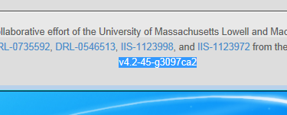

4. Saving a visualization is at the bottom right hand corner of the page

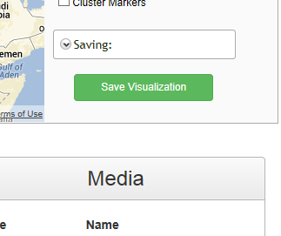

5. To give a saved visualization a subtitle click the gear to the right of the title and click edit summary

