**User stories:**

UML Alerts is an Android app which is designed to provide safety to students in hazardous situations. The initial idea was to help users reach UML Police quickly during emergency situations.

Now, the goal is more so to create simple preset alerts that users can set up to send to specific contacts.

The main ideas of the app are:

**Alerts** - these are quick messages that can be customized by the user for different situations. Various alerts could be saved in the app, for different situations. Some ideas / problems that the app can address:

- Being stalked at night

- Assaults in deserted / empty areas

- Robberies

- Accidents

- Medical emergencies

There are also non emergency situations that we have thought of that the app could be used for as well:

- “I’m leaving the office now” -> alert wife / parents / etc that you are on your way home, and person at home can now start cooking dinner / know when you should be home should anything happen.

- “I’m stuck in traffic” -> alert people at home that you will be late. Or whoever you are meeting.

- “Okay”, “No.”, “Yes”, etc -> simple messages to let others know you got there message

**Contacts** - these are people you want to be alerted. Could be family, friends, coworkers, etc. All the user needs to enter is a name, phone number and email. This could also just pull directory from the user’s contact book (would be easier for both the user and the developers), and display only the relevant information (name, phone number, email).

More information about our app can be found in the “UML-Alert-App.pptx”, a powerpoint that we made for the Difference Makers program. Our app did not make it to the semi finals, although we did try our hand at making it.

**System Map**

I’m not entirely sure what is required for this.

**App Flow**

Users will have a few options to press on, mainly an “alerts” tab or button, and a “contacts” tab/button. The app flow will be quite basic, since the app will be designed to be quick to use in case of emergencies.   
  
Users will likely do something like the following:

1. Open app
2. View contacts, make sure they have everyone added that they want to send alerts to. If not, add given contact(s) now.
3. Add an alert(s), with a message to be sent to either a phone number or email address (or both)
4. Once contacts and alerts are set, the user should have an option to quickly launch a page with the given alerts - the other tabs should go away in this mode, which should like a “quick launch” mode, toggable from somewhere in the settings. This will allow users to quickly send the alerts once they are set up.
5. User exits app, goes about their day.
6. Situation comes up that requires an alert to be sent - user opens app, clicks on the alert they want to send, presses a button to send it, a small “Are you sure?” pop-up shows up to make sure the user doesn’t accidently text/email someone by mistake.   
   If the user clicks “Yes”, the app sends the alert to the given contact(s)

If the user clicks “No”, the app goes back a step to the alerts page.

At this point, the user is free to go back and forth from the app to other apps. The alerts app lives in the background, ready to go whenever the user needs to send an alert.

**Data Attributes**

The app shouldn’t use a ton of data, since we should be able to pull directly from the user’s contact book, and the alerts will be simple string messages to be delivered to the given contact when a button is pressed.

We will likely use some sort of array to store these strings, and we will need to store the alerts and other relevant data for when the user closes / reopens the app. We wouldn’t want the user to have to re-enter alerts should the app crash or their phone be rebooted.

**Screen Requirements**

Any screen size should be supported.

Mainly smart phones will be targeted, since our app will need location via GPS / Wifi / Network, and will likely be used by people on the go.

A simple tablet view could be made though in case someone wants to use the app on their tablet or even their largish “phablet” smart phone.

**UI Sketches**

See the github repository here for our initial project:

<https://github.com/JasonD94/UML-Alerts>

The “UML-Alerts” directory has an Android Studio project, with some UI components to play around with.

Here are some screenshots from what the app currently looks like:

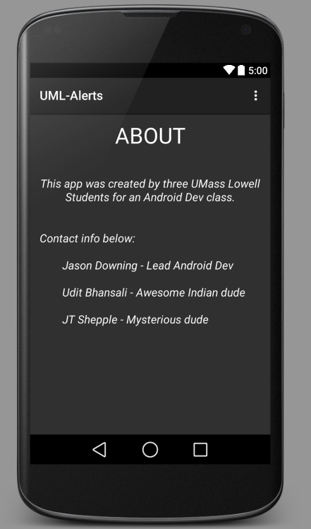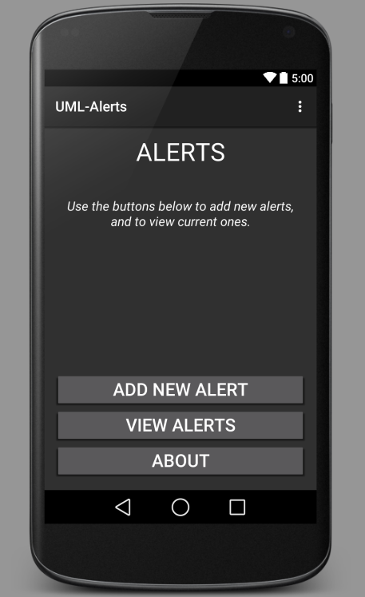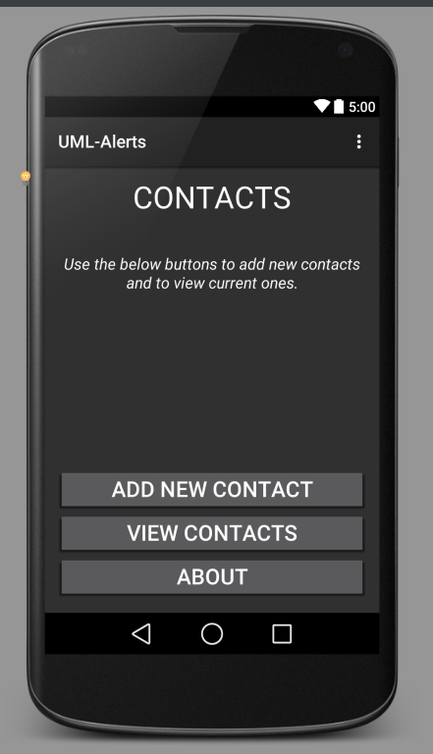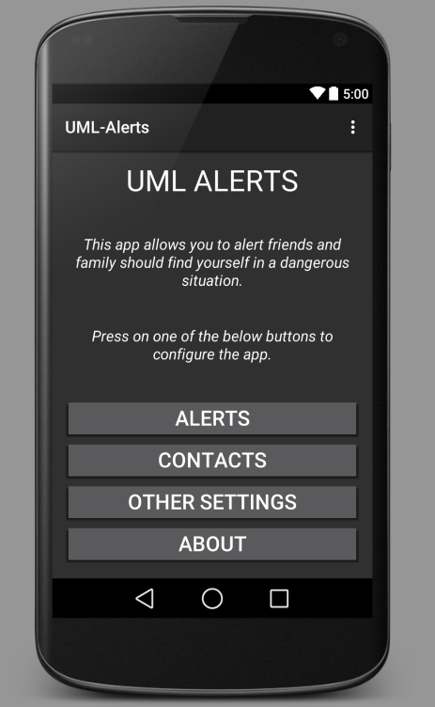

There are also UI Sketches below, but are subject to change as we flush out the design.

