Game Design Document
Senior Project

Game Overview:
The dark caverns and mysterious catacombs call to all of us in a one way or another. But sometimes it takes more than one hero to complete the quests he will face. After conjoining at a local tavern you and three fellow travelers have decided to go for gold and riches, but it won’t be as simple as it looks, everyone will play apart in this adventure in order to gain fame and glory. So now you must adventure into the dark realms that will challenge both your brain and brawn as you claw your way through dastardly puzzles, deadly bosses, and hazardous traps. Go.
Gameplay:
The game will be controlled in two means, either with a Gamepad (Xbox 360 Controller) or Arcade Stick (This will be discussed more during second semester). The controls will be similar to gauntlet in that you control the character with the joystick and can interact with the environment using the buttons.
A – Jump
B – Special Attack
X – Basic Attack
Y – Class Action Ability
Each character will have a different skillset that they bring to the table; this is CORE to the design of the game as each character provides a function to push the party forward throughout the levels. Since the key concept here is to work as a team there will be no solo option for the game. (This can be added LATER if needed.)

Characters:
Warrior
Brute in strength and size, a moving wall between good and evil.
Basic Attack – Sword (Swing Swing Smash (Hit, Hit, Cleave))
Special Attack – Whirlwind
Class Ability – Shield Wall, Pull Out Sheild -50% Movement Speed, blocks projectiles.
Rogue
Dark and cunning, sticks to the shadows and attacks with precision.
Basic Attack – Dagger (Stab, Does 3x Damage if Behind Target)
Special Attack – Envenom (Stabs Enemy doing X-Damage Over Y-Seconds)
Class Ability – Stealth (Enemies do not persue, traps/turrets do not engage)
Wizard
Uses mystical tomes and ancient magic to change the battlefield.
Basic Attack – Fireball (Shoots a projectile that deals damage on hit and over time)
Ice Bolt (Pierces the Enemy hitting up to 3 Enemies)
Special Attack – Firestorm (Does a frontal cone of fire hitting all enemies in range DOT)
Blizzard (Does a cone of ice slowing enemies)
Class Ability – Change Books (Changes Element Type from Fire<->Ice)
Adventurer
Both Dexterous and Deft, completes goals and ignores terrain.
Basic Attack – Double Shot (Shoots two projectiles which deal burst damage)
Special Attack – Lasso (Uses whip to pull in and stun the enemy, only damage on bosses)
Class Ability – Swing (Uses whip to interact with various objects)

World:
The world will be split into Dungeons, each dungeon will be made up of 6-10 rooms, and each room will have various puzzles certain classes can solve. Once the ‘puzzle’ is solved a door will open to the next room. The last room will open a door to either an event or boss room.
Each room will be constructed of various squares; these squares each will have different properties.
Squares will include:
Traps Blank Squares Switches
Turrets Intractable Environments
Objects

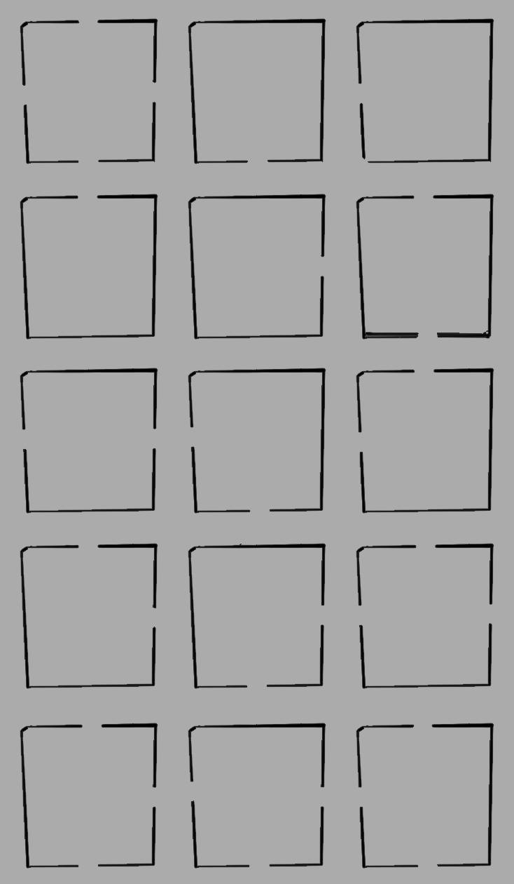

Player Abilities and Interactions
To start off with stating each player is ‘unique’ would be an undertaking, but each class really is its own key to solving the puzzle elements that exist within the game. One basic thing to keep in mind is each class at a base level has just enough ability to solve one major element in the game. As which will be described below, but together they can solve complex puzzles which can requires multiple abilities being used in parallel or in order to get to the objective on each map.
Warrior
The warrior uses his massive shield as an object to interact with the environment. By pulling his shield out in front of him he can block incoming arrows, fire, charging enemies, rushing water just as some examples of hazards which need to be stopped (He is an Immovable Object).
Wizard
The wizard (or sorceress) is a complex class who has to use wit to solve his or her puzzles. With two different spell books to choose from she/he can change how the map can be manipulated with the flick of a button. Bundle of Hay blocking the door? Cast a fireball on it. Is there a river between you and a switch? Freeze It. Find a bomb and a broken wall? Well it has a fuse doesn’t it? Oh, and don’t worry about taking down enemies from afar. No matter how many enemies fill the screen the Wizards AOE will do quick work on small mobs.
Rogue
Master of the shadows and able to be unseen by sentries the rouge acts as an infiltrator throughout many otherwise impossible challenges the game may purpose. Say there is a pressure plate or a roaming guard who can see the party causing part of the floor to give way. Well, just have the rogue stealth by and quickly dispatch of the foe, then able to flip a nearby switch on the other side he becomes a tool for the party to progress deeper into the vast rooms of the dungeon.
Adventurer
Jack of all trades and master of speed and dexterity, he quickly moves to conquer even the greatest gaps and jumps that would otherwise seem nigh impossible. Be it his ranged damage or his ability to pull in key targets closer to the party. He can conquer any small challenge presented. Oh, and he can jump and swing off the walls. Seems like those gaps aren’t so huge any more.

Bosses + Events
When coming up with some of the features in the game, my mind kept drifting back to Smash TV. Smash TV was a classic arcade game in which two contestants were put into a life or death game show and had to kill all of the enemies in each room before progressing to the next. I really like this mechanic because it is simple to script for and it drives the player naturally to play the game. So when the adventurers enter a new room they are greeted with a new objective before the doors unlock again. This can/could include.
- Boss Battles
(In which the players must dodge certain attacks / environment hazards while they do damage to the Boss, typically in the middle of the room)
- The Master Lever
Some switch in the room which stops enemies from spawning and opens the doors again.
- Kill the Horde.
An Endless line of enemies in which the players must take down each foe before the room opens again.
- Dungeon Crawl.
Various player abilities are required to get to the end of the level combining each of these abilities to get to a door on the other side.
Arcade Cabinet
Jason Ashworth, John Wilson, and with the help of Andrew Holbrook will have a side project throughout development to finish an Arcade machine (which will be started very soon into development so that the controls can be mapped to the joy sticks and buttons) for the game, our intentions are to have this presentable by Shawnee 13.0 and be able to present it at any additional conferences if that is a possibility, everyone will be credited in the games credits for all to see (obviously) and it will allow people to play various releases of the game (We want to be hitting the “Beta” stage of development by this time in November anyhow which really shouldn’t be such a stretch goal).

Artist Assets Needed (In Order)
Charecters
Objects
Enviroments

Game Flow
The players will enter the game by each joining the party (coining into the arcade machine) once four players have joined the game, the game will load the scripts to start generating the dungeon.
We will discuss lower player options (1-3) at a later time, as for now we are designing for 4 players.
The players Enter a basic room and one of the events is set to happen, apon completing it they are given access to the next room, and rinse and repeat the next room also has an event.
The Final Room will be a boss battle, in which once the boss is slain the players are given a sudo ranking and the top player will be given a crown during the next dungeon.

Programmer Milestones
Alpha
Stage One (August – September)
Stage Two (October – Shawnee Conference)
Preperation for Shawnee Conference
Beta
Stage Three (Post Conference – Winter Break)
Winter Break
Stage Four (January – Febuary)
Stage Five (March – April)
Preperation for Final Release
Release
Last Minute Polish, Importing all Final Assets
Graduate.

Future Goals. *Stretch Goals*
Randomized Dungeon Generations (If possible a way to randomly generate puzzle-based rooms)
Temporary Power Ups
A “Horde Arena” For 1-3 Players to enjoy, using power ups and random environment effects.

