Game Design Document
Senior Project
Content By:
John Wilson
Alex Ashie
Nick Linton
Drew Jackson

Game Overview:
The dark caverns and mysterious catacombs call to all of us in a one way or another. But sometimes it takes more than one hero to complete the quests he will face. After conjoining at a local tavern you and three fellow travelers have decided to go for gold and riches, but it won’t be as simple as it looks, everyone will play apart in this adventure in order to gain fame and glory. So now you must adventure into the dark realms that will challenge both your brain and brawn as you claw your way through dastardly puzzles, deadly bosses, and hazardous traps. Go.
Gameplay:
The game will be controlled in two means, either with a Gamepad (Xbox 360 Controller) or Arcade Stick (This will be discussed more during second semester). The controls will be similar to gauntlet in that you control the character with the joystick and can interact with the environment using the buttons.
A – Jump
B – Special Attack
X – Basic Attack
Y – Class Action Ability
Each character will have a different skillset that they bring to the table; this is CORE to the design of the game as each character provides a function to push the party forward throughout the levels. Since the key concept here is to work as a team there will be no solo option for the game. (This can be added LATER if needed.)

Characters:
Each character has a defined “Play Style” or Role that they bring to the table inside the game. Each character is able to use a Basic Attack, Special Attack, and Class Ability. Each Class also has a unique resource mechanic in order to keep them in balance. Stats are broken up into 3 Ranks of aptitude in which A is Best (Ei 10/10) and C is Average (Ei 6/10)
Warrior
- Play Style
  - Slow and tanky, able to take a lot of damage. Not primarily a damage dealer but is the only character that can block. Contributes to the team by defending other players and shielding them from enemy attacks or dungeon traps. Pick this character if you want to be on the front lines. You’ll be able to take a lot of damage while also dealing out a solid amount yourself.
- Basic Attack
  - 3 hit combo (must time attacks right to combo)
  - First two swipes are light attacks with short rectangular range in front of player
  - Third swipe is a shield bash on the ground which creates a shockwave with a much larger area of effect, damage, and knockback force
- Special Attack
  - Rotating spin attack that damages and knocks back surrounding enemies
  - Brief charge-up time between button being held down and spin attack beginning
  - Makes 6 full rotations over a second or two
  - Can travel while spinning
  - Basically the spin attack from Zelda
- Class Ability
  - Hold button down to pull out shield that nullifies all damage from player’s front side
  - Can be used to block enemy attacks, projectiles, or traps (such as flamethrowers)
  - Does not block insanely lethal objects (such as rolling boulders)
  - Stops projectiles/traps so that party members can safely follow behind the blocking player
  - Emits a light that can be used to navigate dark rooms
  - Slows movement by X%, and cannot attack while active
- Ability Point System
  - Rage
  - Landing basic attacks on enemies fills up the rage bar
  - Using the special attack consumes the rage bar
- Stats
  - Health: A
  - Speed: C
  - Attack: B

Sorceress
- Play Style
  - Frail and squishy but lethal from afar, the sorceress prefers to hang back behind the others. Dealing high amounts of damage with ranged elemental attacks, the sorceress is the ultimate damage dealer. Crowd control is another one of her fortes, as her spells can be used to slow enemies or alter the environment in the party’s favor. Pick this character if you want to be the destruction dealer of the party, just make you don’t let the enemies get too close.
- Basic Attack
  - Different depending on active (either fire or ice)
  - Fire hits the enemy and does damage over a short period of time
  - Ice hits the enemy and slows their movement for a short period of time
  - Can fire rapidly with very short delay between shots (just enough so the player can’t “machine gun” projectiles)
- Special Attack
  - Different depending on active spell (either fire or ice)
  - Fire shoots out a large fireball that explodes on contact with an enemy or object, dealing splash damage to all enemies in a short range
  - Ice shoots out in a short distance cone that freezes all enemies in place for a few seconds
  - Both have a short charge time between holding the button and the attack activating
- Class Ability
  - Pressing this button switches the active spellbook between fire and ice
  - The player cannot cast any spells while in the process of switching spellbooks
- Ability Point System
  - Mana
  - Regenerates slowly over time
  - Casting special attacks will consume mana
- Stats
  - Health: C
  - Speed: B
  - Attack: A

Rogue
- Play Style
  - Nimble and quick, the rogue dices through enemies with light, quick attacks while zipping across the battlefield. While he can’t take much damage, he doesn’t need to, as his hit and run tactics allow him to get in and out of danger quickly. The rogue is a kinetic fighter, relying heavily on the player dashing behind enemies to backstab them and escaping with stealth when necessary. Pick this character if you want to dash around the battlefield and take enemies off-guard with stealth and hit and run tactics.
- Basic Attack
  - Rapid short range stab that can be spammed as quickly as the player can mash the attack button
  - Damage done by this attack from behind the enemy is increased (backstab)
- Special Attack
  - The attack begins with a rapid dash in the direction the joystick is being held
  - If the player makes contact with an enemy, he is teleported behind them and does a backstab for massive damage, leaving the enemy open for more backstabs
  - Little to no cooldown afterwards but drains a lot of energy
- Class Ability
  - Tapping button switches between stealthed and not stealthed
  - While stealthed, enemies cannot see the player and won’t attack him
  - Attacking or taking damage will cause the player to become unstealthed
  - Slowly drains energy over time
- Ability Point System
  - Energy
  - Depleted by both special attack and class ability
  - Regenerates slowly over time
  - Basic attacks slightly restore energy
  - Backstabs moderately restore energy
- Stats
  - Health: C
  - Speed: A
  - Attack: B

Woodsman
- Play Style
  - Aiming his shots carefully, the woodsman is the deadly sniper from afar. Powerful and precise ranged attacks with a bow along with the woodsman’s hawk companion make the woodsman the ultimate hunter. Although he’s not quick, he likes to stay as far away from enemies as possible and can take a bit of damage if he needs to. His hawk can be used to distract and thin out enemies, and access important out-of-reach places. Pick this character if you want to pick off enemies from afar with calculated shots and a little help from your companion.
- Basic Attack
  - Fires an arrow with a brief cooldown (can’t fire as rapidly as the sorceress)
  - A ray is projected from the player to show where the shot will be fired, allowing the player to be more precise with shots
- Special Attack
  - Can be charged up to increase the power of the shot
  - Charged arrows do more damage and can pierce through multiple enemies depending on how long they were charged
  - Player is stationary while charging and moving the joystick controls the aim of the shot (a ray is projected from the player to help aim)
- Class Ability
  - Using the ability will cause the hawk on the adventurer’s shoulder to fly out in the direction the player is facing, or if the hawk is already out then pressing the button will bring it back
  - Hawk will go after nearby enemies, attacking them for a brief while before moving on to other nearby enemies (behaving like a slower chain lightning)
  - Hawk will also interact with objects and can flip switches, pick up keys to bring them back, etc. (basically can be used to reach objects the players can’t reach normally
- Ability Point System
  - Stamina
  - Regenerates slowly over time
  - Depletes slowly over time while the hawk is out making chaos
  - If stamina runs out while the hawk is active, the hawk will return to the adventurer’s shoulder
- Stats
  - Health: B
  - Speed: C
  - Attack: A

World:
The world will be split into Dungeons, each dungeon will be made up of 6-10 rooms, and each room will have various puzzles certain classes can solve. Once the ‘puzzle’ is solved a door will open to the next room. The last room will open a door to either an event or boss room.
Each room will be constructed of various squares; these squares each will have different properties.
Squares will include:
Traps Blank Squares Switches
Turrets Intractable Environments
Objects
Rooms:
Room Naming Convention is bellow, name will be “mapName_11” to represent the top corner room, up to _43 and _34
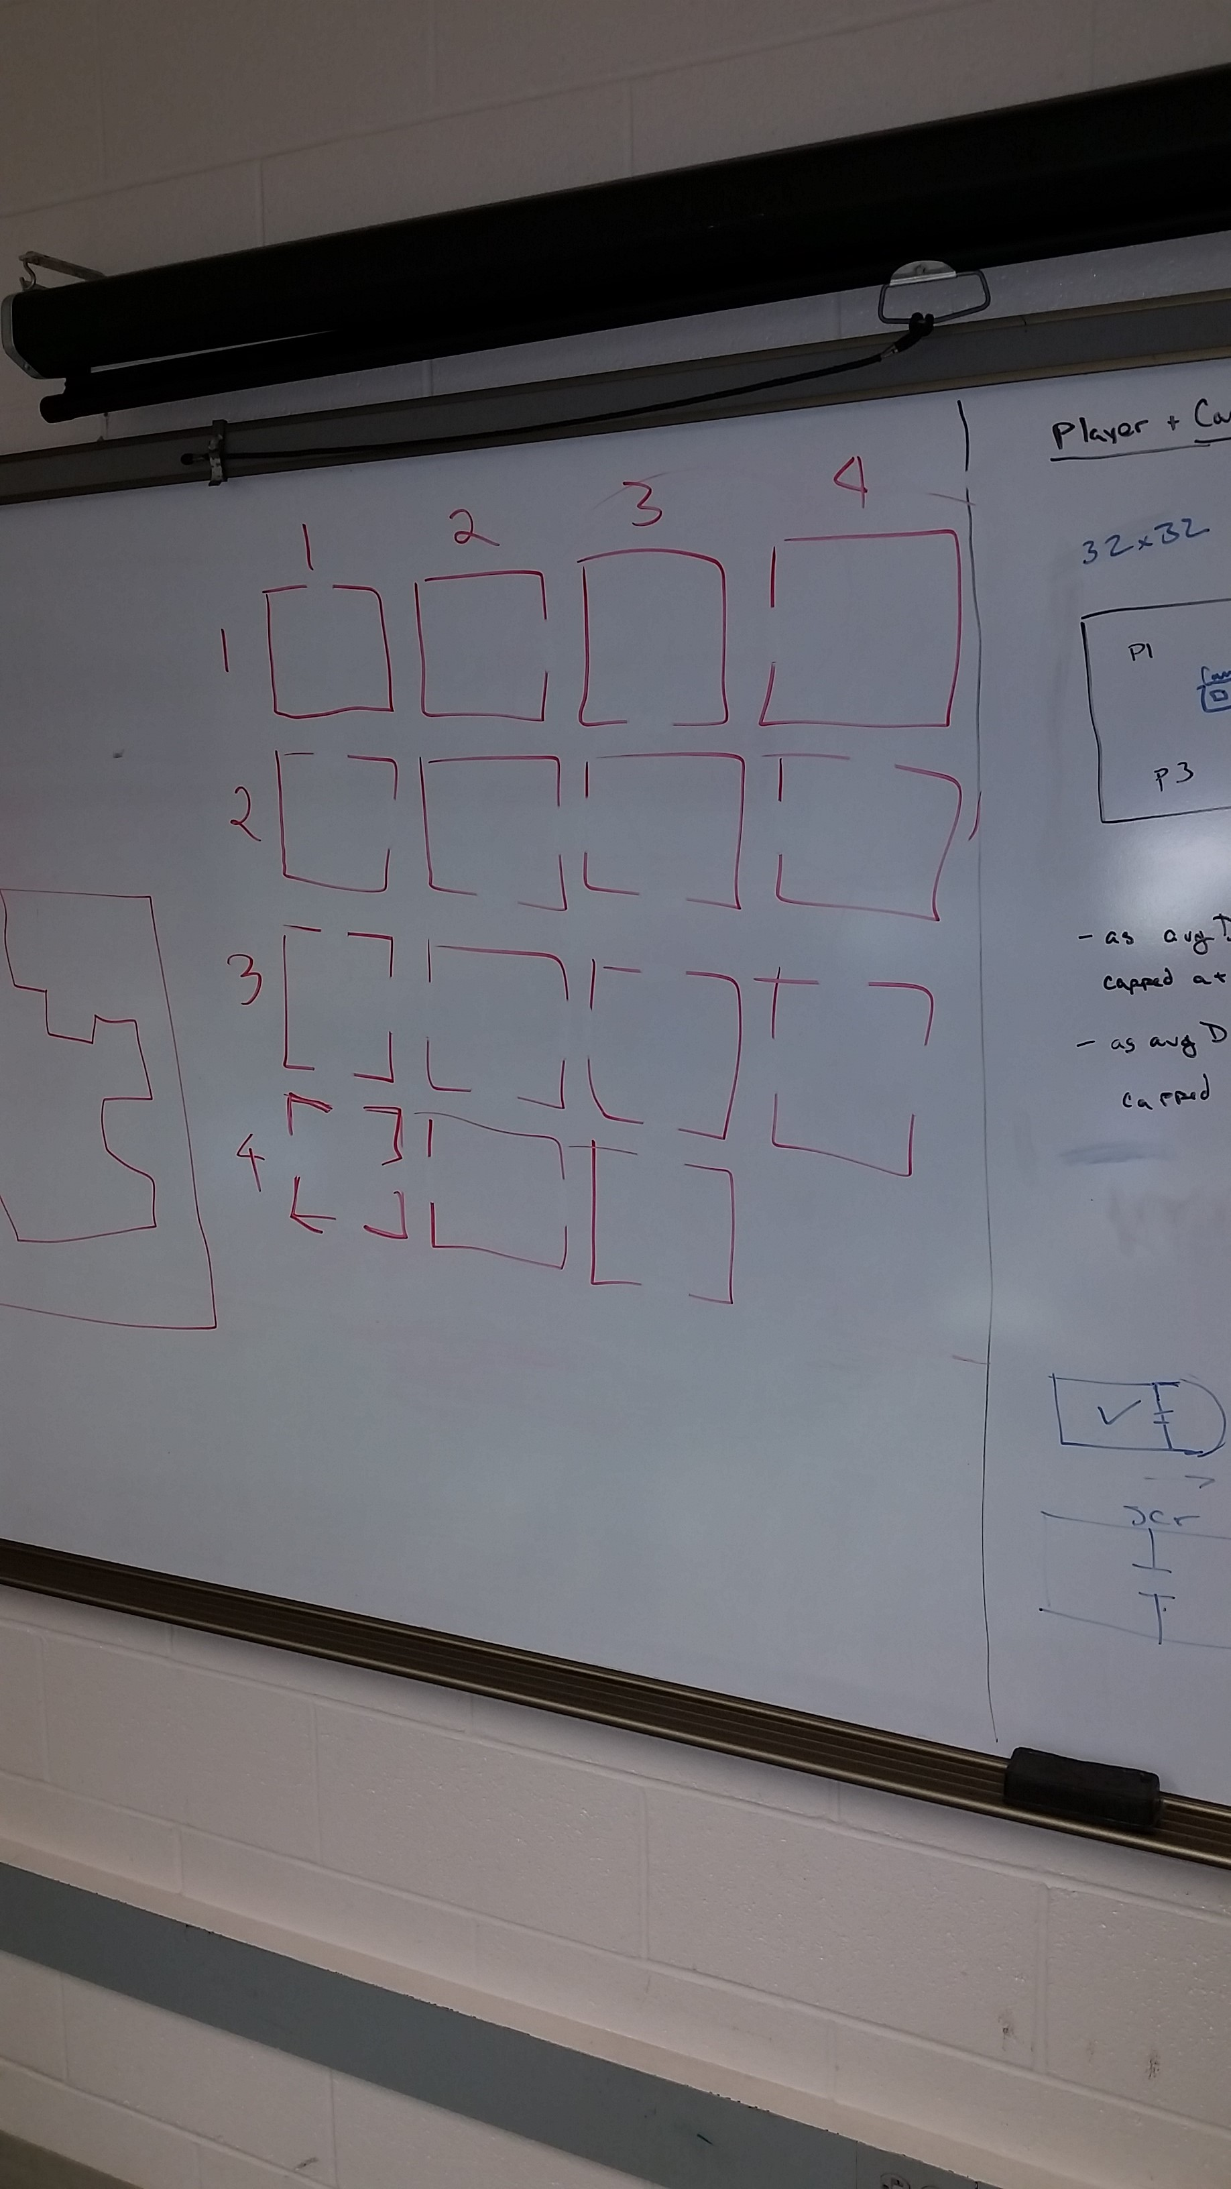

Bosses + Events
When coming up with some of the features in the game, my mind kept drifting back to Smash TV. Smash TV was a classic arcade game in which two contestants were put into a life or death game show and had to kill all of the enemies in each room before progressing to the next. I really like this mechanic because it is simple to script for and it drives the player naturally to play the game. So when the adventurers enter a new room they are greeted with a new objective before the doors unlock again. This can/could include.
- Boss Battles
(In which the players must dodge certain attacks / environment hazards while they do damage to the Boss, typically in the middle of the room)
- The Master Lever
Some switch in the room which stops enemies from spawning and opens the doors again.
- Kill the Horde.
An Endless line of enemies in which the players must take down each foe before the room opens again.
- Dungeon Crawl.
Various player abilities are required to get to the end of the level combining each of these abilities to get to a door on the other side.

Arcade Cabinet
Jason Ashworth, John Wilson, and with the help of Andrew Holbrook will have a side project throughout development to finish an Arcade machine (which will be started very soon into development so that the controls can be mapped to the joy sticks and buttons) for the game, our intentions are to have this presentable by Shawnee 13.0 and be able to present it at any additional conferences if that is a possibility, everyone will be credited in the games credits for all to see (obviously) and it will allow people to play various releases of the game (We want to be hitting the “Beta” stage of development by this time in November anyhow which really shouldn’t be such a stretch goal).

Game Flow
The players will enter the game by each joining the party (coining into the arcade machine) once four players have joined the game, the game will load the scripts to start generating the dungeon.
We will discuss lower player options (1-3) at a later time, as for now we are designing for 4 players.
The players Enter a basic room and one of the events is set to happen, apon completing it they are given access to the next room, and rinse and repeat the next room also has an event.
The Final Room will be a boss battle, in which once the boss is slain the players are given a sudo ranking and the top player will be given a crown during the next dungeon.

Artist Assets Needed (In Order)
Charecters
Warrior Model
Sorceress Model
Huntsman Model
Objects
Enviroments

Programmer Milestones
Alpha
Stage One (August – September)
Stage Two (October – Shawnee Conference)
Preperation for Shawnee Conference
Beta
Stage Three (Post Conference – Winter Break)
Winter Break
Stage Four (January – Febuary)
Stage Five (March – April)
Preperation for Final Release
Release
Last Minute Polish, Importing all Final Assets
Graduate.

Future Goals. *Stretch Goals*
Randomized Dungeon Generations (If possible a way to randomly generate puzzle-based rooms)
Temporary Power Ups
A “Horde Arena” For 1-3 Players to enjoy, using power ups and random environment effects.

