1. Short Answers  
   1. Both PageRank and HITS are ways of ranking webpages without looking at the content of the documents. They both use link analysis and take the pointing website into account when evaluating the website. HITS divides websites into Hubs and authorities, while PageRank does not classify webpages. In HITS, a hub is a website that points to authority pages, and a good hub points to many authority pages for a topic. Also, in HITS, an authority is a page with content about a topic, and a good authority is linked to by many good hubs. In PageRank, the value of the pointer website is determined by the websites that point to it. Both solutions use a recursive model to determine the value of webpages.
2. Problem Solving – PageRank  
   1. 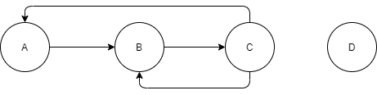
3. Problem Solving – Hubs and Authorities  
   1. 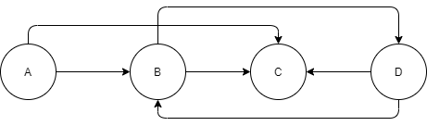  
        
      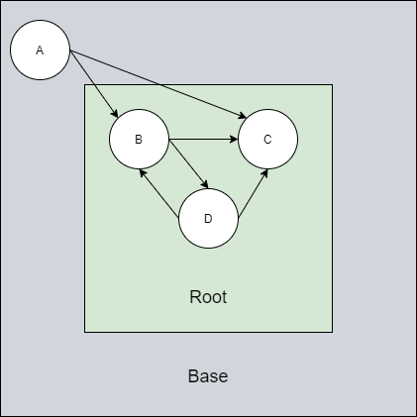

|  |  |  |
| --- | --- | --- |
| **Page** | **Initial Auth** | **Initial Hub** |
| A | 1 | 1 |
| B | 1 | 1 |
| C | 1 | 1 |
| D | 1 | 1 |

|  |  |  |  |  |  |  |
| --- | --- | --- | --- | --- | --- | --- |
| **Page** | **Initial Auth** | **Initial Hub** | **Iter 1 Auth** | **Iter 1 Hub** | **Iter 2 Auth** | **Iter 2 Hub** |
| A | 1 | 1 | 0 | 2 | 0 | 5 |
| B | 1 | 1 | 2 | 2 | 4 | 4 |
| C | 1 | 1 | 3 | 0 | 6 | 0 |
| D | 1 | 1 | 1 | 2 | 2 | 5 |