Aerial Pathfinding Reconnaissance

Jason Gilman

Max Griffith

Mark Johnson

Dilanka Weerasinghe

**Concept of Operations**

REVISION 2 Draft

20 September 2020

Concept of Operations

for

Aerial Pathfinding Reconnaissance

Team 2

Approved by:

_____________________________

Jason Gilman Date

_____________________________

Prof. S. Kalafatis Date

_____________________________

Souryendu Das Date

**Change Record**

|  |  |  |  |  |
| --- | --- | --- | --- | --- |
| **Rev.** | **Date** | **Originator** | **Approvals** | **Description** |
| **1** | 9/6/2020 | Jason Gilman |  | Draft Release |
| **2** | 9/20/2020 | Jason Gilman |  | Networking Subsystem Edits |

Table of Contents

Table of Contents III

List of Figures IV

1. Executive Summary 1

2. Introduction 2

2.1. Background 2

2.2. Overview 3

2.3. Referenced Documents and Standards 4

3. Operating Concept 4

3.1. Scope 4

3.2. Operational Description and Constraints 4

3.3. System Description 4

3.4. Modes of Operations 6

3.5. Users 6

3.6. Support 6

4. Scenario(s) 7

4.1. Aiding Natural Disaster Relief 7

4.2. Expanding Navigation Apps 7

4.3. Military Scouting 7

5. Analysis 8

5.1. Summary of Proposed Improvements 8

5.2. Disadvantages and Limitations 8

5.3. Alternatives 9

List of Figures

Figure 1. High-Level System Overview 1

Figure 2. Functional Block Diagram 3

# Executive Summary

Autonomous vehicles are becoming more popular for a litany of reasons, including safety, efficiency, and convenience. However, autonomous ground vehicles often suffer from a lack of situational awareness in attempting to navigate their environments. To combat this, product development in this field has tended towards increasing sensory capabilities – at a rapidly rising price point. Drones, while agile in their movement capabilities, suffer from poor cargo capacity. On the other hand, aerial drones offer a convenient platform for gathering data over large swathes of land. By combining the efficiency of autonomous data gathering with the capabilities of a ground vehicle, we can reduce sensory costs while maintaining its facilities.

This project’s intent is to develop a prototype system which implements this relationship. To accomplish this, our proposed system will take a two-phase approach. First, the drone will survey a user-defined area and collect topographical data to be forwarded to a desktop application. The application will analyze this data to produce a map of obstacles in the area, and using the dimensions of the ground vehicle, determine a suitable path between the user’s chosen endpoints. The application will then send navigation instructions to the ground vehicle to execute this path.

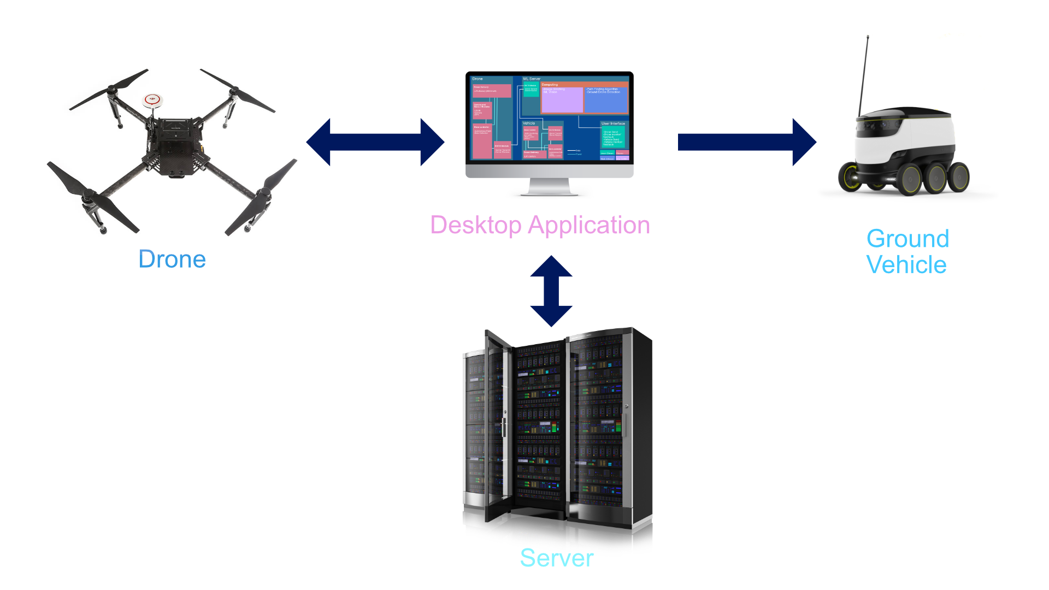

Figure 1. High-Level System Overview

# Introduction

This document is an introduction to the Aerial Pathfinding Reconnaissance System (APRS), a system that will monitor a given area and provide a safe, reliable path for an otherwise-blind ground vehicle. This system applications are widespread, including navigation of natural disaster areas to military scouting. The APRS will serve as a protectant to the drone and the user as it eliminates human error in flight and provides an efficient and safe path to the land traveler.

## Background

Aerial reconnaissance has special applications in military and industrial environments alike. Among these domains, drones equipped with LiDAR technology are sometimes used to supplement or replace traditional land surveys to provide an even more accurate and detailed physical map of the land. However, for some practical applications of aerial recon, the use of LiDAR may not be entirely appropriate, as it runs the risk of incurring unnecessary expense, complexity, and in extreme failure cases, even physical injury.

For example, consider land pathfinding. Pathfinding does not require the same degree of precision and accuracy as other industrial or military applications. In theory, the problem of pathfinding on land can, in general, be reduced to a simple distinction between traversable space and obstacles on a two-dimensional surface. For this purpose, the use of LiDAR is beyond excessive, as a reasonably accurate determination of this data can be made with much simpler hardware, such as an ordinary video camera.

The process of creating a map of an area using image data from a drone is referred to as *drone photogrammetry,* and it is a far cheaper process than an equivalent LiDAR solution, with industrial LiDAR drone mapping systems reaching prices between 2.5x and 10x the cost of a high-end photogrammetry system.[1] With a cost-efficiency motivation and a particular use-case in mind, this project focuses on the development of an even more hardware-flexible and economical approach than ordinary LiDAR-equipped solutions, trading a high degree of accuracy for practicality and mission-specific functionality.

## Overview

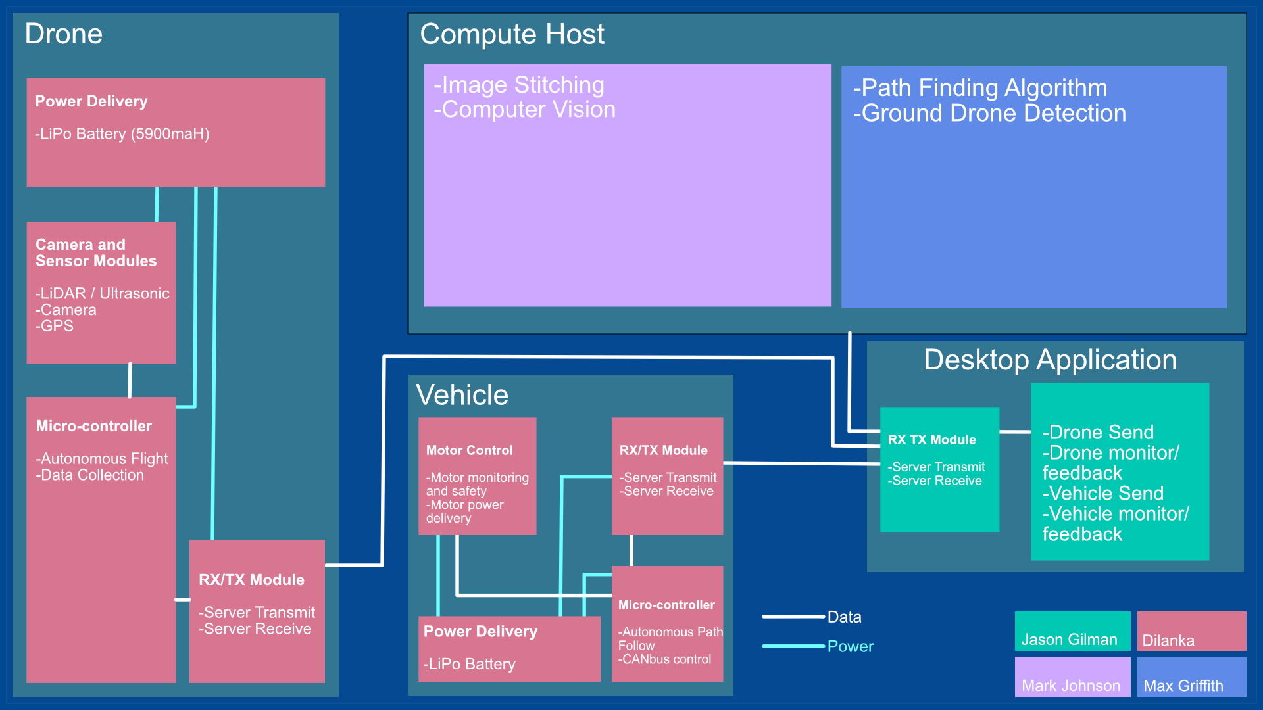

Figure 2. Functional Block Diagram

Our system uses video captured by a drone to provide a path that a user can blindly follow to its destination. We will first create a land map using video from a drone. Using an Aerial Pathfinding Reconnaissance System (APRS) application, the user will provide an area that the drone will survey. The drone will then navigate the chosen area at an altitude provided by the user.

The APRS system will utilize an array of LiDAR and ultrasonic sensors for object avoidance in the air and the drone will exclude any areas it is incapable of navigating. If it detects an area it is not capable of maneuvering it will utilize object avoidance techniques to continue on its path. Upon returning from flight, data is sent to a locally run desktop application that will stitch the land-map together and begin to detect obstacles. Using computer vision algorithms, it will be programmed to detect stationary obstacles and moving obstacles on the map of the area.

Once the full map is completed and the obstacles are pinpointed on the map the program will path-find an efficient and safe path for the land vehicle to follow. At this point the path is relayed to a small land vehicle and the vehicle is programmed to follow the path blindly until it reaches its given destination.

## Referenced Documents and Standards

1. “Drone Photogrammetry vs. LIDAR: What Sensor to Choose for a given Application” <https://wingtra.com/drone-photogrammetry-vs-lidar/>
2. IEEE 802.11 <https://standards.ieee.org/standard/802_11-2016.html>
3. FAA Part 107 <https://www.faa.gov/uas/media/RIN_2120-AJ60_Clean_Signed.pdf>

# Operating Concept

## Scope

Functions of the APRS:

The Aerial Pathfinding Reconnaissance System (APRS) will include two drones, an aerial drone and a land drone. The aerial drone will survey an area and transfer its data to an application which will plan out a specific path for a land drone to follow. This system will allow vehicles to safely navigate terrain without any human interaction or monitoring once the data is transported to the land drone.

Features of the APRS:

The drone will be using camera that will locate and distinguish fixated objects from objects that can be removed (e.g. humans or other animals) and will have a distance sensor to accurately calculate the size of objects and the correct travel distances for the land drone to follow.

## Operational Description and Constraints

The Aerial Pathfinding Reconnaissance System will be operated to identify a safe ground path through terrain that can be surveyed by a flight drone within the timeframe of 20 minutes. Once the aerial drone has surveyed the area, the data collected from surveillance will be manipulated with machine learning to create a map that then will be deployed to a land drone that will be able to blindly follow the designated path.

A constraint that will occur will be limitations with the video capturing device. In low light, using pure surveillance could potentially obstruct views. Any usage that would be as a means for stealth will be impacted. Furthermore, the operating range of the drone is constrained by battery capacity and the computational power available to the user.

## System Description

**Data Collection and Drone Control:** The hardware for this project will handle the data collection to be used by the Computer Vision and Mapping program. On the drone there will be sensors to handle aerial obstacle avoidance and recording the ground. The ground vehicle will lack sensors as it will follow the provided path blindly. It will have its necessary controllers to perform its required movement. The following are the smaller subsystems related to hardware on the drone and the ground vehicle:

* **Power Distribution (Aerial and Ground):** The drone will be using Lithium Ion Batteries for high efficiency, reliability under extreme weather and weight constraints. This system will power the drone cameras, sensors and transmission to the application. The drone is capable of holding two 5900mAh LiPo batteries and this will allow for 40 minutes of flight time. A LiPo battery will also be used to power the ground vehicle. A series of buck/boost converters will translate the LiPo voltage that will power the microcontroller, motor controller and motors on the system.
* **Camera (Aerial):** The camera will take video of the ground at certain points in the user provided area. These data taken points will be relayed back the application and will define the main components of the map.
* **LiDAR (Aerial):** LiDAR stands for Light Detection and Ranging. It operates by shooting a condensed laser or light beam at an area and waiting for the frequency of light to return to its sensor. The distance is calculated by using the speed of light and the time it takes for the light to return to the sensor. This system will not be using LiDAR to detect obstacles on the ground or to create a 3-dimensional map of the surrounding area. The drone will only be using its integrated LiDAR to handle its own obstacle avoidance in the sky.
* **GPS (Aerial and Ground):** GPS connects to orbiting satellites to triangulate the location of a sensor on the earth. GPS will be used to triangulate the precise location of the drone so that the computer vision can create an accurate map of the area. Without the GPS the camera data would not be connected to a given location. A GPS will also be held in the ground vehicle to calculate its location as it is following the path.
* **DJI Drone Controller (Aerial):** All system sensors are monitored through the DJI controller. This controller also handles the flight path generated by the user preferences. This controller is a proprietary DJI product. Using DJI’s SDK it can be modified to accommodate for any flight path and sensor detection needed. This drone controller will also have the wireless data transmission capabilities that will relay information back to the application.
* **Ground Controller:** The control of the ground vehicle is monitored and controlled by an STM32. Connected to the control unit is a Sabretooth motor driver that will act as the bridge from command to motor.

**Computer Vision and Mapping:** Once video data has been received by the desktop application, a set of custom software will analyze the data and produce an overhead view of the entire traversable ground area. First, the video data will be consumed in pieces to produce stereographic ground views, with moving obstacles eliminated from the data. These stereographic views of each area will then be analyzed further to produce a depth estimation map. With some lightweight mathematics performed over this field, a final map can be produced which delineates areas in which too great of a height difference is encountered at once, forming an obstacle.

**Pathfinding and Drone Detection:** The video data will also be analyzed by another system which locates the land vehicle’s starting and finishing positions within the environment. After determining these values, it will use the dimensions of the vehicle and a two-dimensional map of obstacles to produce a path, converting these directions and distances into commands for the land vehicle to follow.

**Device Networking and UI**: Utilizing a locally run desktop application, and microcontrollers onboard the drone and autonomous land vehicle, data will be routed through a wireless network in our system. A UI will keep the user informed of the system’s progress, as well as act as a controller for the system. The system can be launched, paused, and stopped through use of the UI. Optionally, a cloud server may be utilized for increased computational power when running software analysis.

## Modes of Operations

The Aerial Pathfinding Reconnaissance System will have a single mode of operation. Initially, data is collected from sensors onboard an aerial drone. Upon returning from flight, the data will be sent through a wireless network to a local machine that is running the systems application. The application will analyze the collected data and generate navigation instructions. Finally, the navigation instructions will be sent through a wireless network to an autonomous vehicle. A user interface on the application will be utilized to launch, track, and update the system.

## Users

The installation for the Aerial Pathfinding Reconnaissance System will be simple. The data and means of operating this system will be on a user interface contained in a desktop application, which will come with the drone.Any of this information will be in a user manual.

The controlling of the aerial done will require a coordinate system so that the drone will only survey a specified area with height requirements that the drone will follow. The parameters of this system will have to be determined by the user.

## Support

Support for the Aerial Pathfinding Reconnaissance System will be provided in the form of user manuals outlining setup, UI navigation, system maintenance, system usage. The user manual will describe how to read incoming feedback from the drone and from the programmed vehicle. This user manual would be locating in the help section of the application and provided to the user in a printed format. A setup pamphlet will be provided detailing network setup as well as assembly of the drone and land vehicle.

# Scenario(s)

## Aiding Natural Disaster Relief

The Aerial Pathfinding Reconnaissance System could provide exceptional navigation assistance in dangerous environments. Natural disasters often create problems with physically getting relief to disaster sites. Utilizing an aerial drone to capture video data of disaster areas, and optimizing the object detection to avoid floods, blocked roads, or fires could expedite the arrival of aid to areas impacted by disaster.

## Expanding Navigation Apps

Navigation apps such as Google Maps and Apple Maps utilize databases to find the fastest route for the user, although these databases often take a long time to map newly built roads. The Aerial Pathfinding Reconnaissance System could be deployed to newly developed areas to quickly detect roads and obstacles, map the area, and update the apps’ databases.

## Military Scouting

The Aerial Pathfinding Reconnaissance System can have a profound impact in a military application. By mapping dangerous environments, detecting obstructing or dangerous objects, and creating navigation instructions, military transport vehicles would be able to shift towards autonomy. This has the potential to save lives and expedite the transportation of soldiers, equipment, or aid.

# Analysis

## Summary of Proposed Improvements

The primary benefit of using advanced image processing over LiDAR technology is the potential for extreme cost reduction and maintainability in applications. As LiDAR sensors are expensive and sensitive devices, those wishing to use aerial reconnaissance for pathfinding are limited to options with potentially excessive upkeep.

Aside from being notoriously expensive, three-dimensional LiDAR is known to require extreme amounts of bandwidth. Potential alternatives, such as using multiple two-dimensional LiDAR sensors, requires the extra work of joining these very large datasets accurately on top of the initial cost. By using video, however, we have more control over the amount of data, and therefore bandwidth, required to function.

Leveraging advanced computer vision algorithms may potentially result in performance improvements as well, as processing hardware will be able to deal with the sensory data in discrete chunks, as opposed to arbitrarily large point clouds.

Furthermore, the use of video data as a primary source of sensory input can result in more hardware adaptability. For example, a LiDAR-based system may have the need to be finely tuned for a specific sensor to function effectively. Important details such as a sensor’s operating range and environment may require special consideration, while in a purely video-based solution, any sufficiently detailed imaging will suffice.

Beyond practical advantages, video mapping also has the advantage that it may be safer to use in inhabited areas. Many LiDAR sensors, especially more powerful models, may use powerful lasers that can cause eye damage upon malfunction. Meanwhile, video recordings by themselves are never capable of directly causing physical harm.

## Disadvantages and Limitations

The strongest limitation of a video-based approach, when compared to LiDAR, is its ability to function in low-light settings. For LiDAR sensors, which emit their own lasers or infrared light already, this is of no concern. However, an ordinary camera sensor will not be able to function in low light without its own lighting, or the use of a more expensive infrared camera.

One potential concern with using video to survey an area may be related to privacy concerns. LiDAR data is not sufficient to reasonably identify anyone without extreme precision and facial recognition. On the other hand, video data includes far more information about those observed by it. However, assuming that the system is only ever used in a public setting (i.e. in which no individual has any reasonable expectation of privacy), potential legal issues related to privacy are avoided altogether.

## Alternatives

* LiDAR
  + More accurate depth estimation
  + Sensors alone are very expensive
  + Higher bandwidth requirements
  + More dangerous on failure, in some cases
* Machine learning
  + More direct detection of static and dynamic obstacles
  + High setup cost, requires long training sessions
  + High runtime cost, requires powerful hardware to run
  + Difficult to configure “black box” design
* Live Pathfinding
  + More stringent synchronization requirements
  + May require real-time computing onboard
  + Sensitive to network failure