ECEN 449 Lab 4: Linux boot-up on ZYBO Z7-10 board via SD Card

02/20/2020

Jason Gilman

**Introduction:**

In this lab, we will load linuxOS onto a SD card. Next the SD card will be used to boot the linuxOS system on the Zybo-10 FPGA system. Linux is a lightweight OS so it makes it a good candidate for the FPGA system.

**Procedure:**

* First, a hardware block diagram needs to be made. This requires adding the ip Zynq Processing system to the newly created block diagram.
* Next, the multiply IP from last lab was added to the block diagram, this was used to tell the OS what ports are being used on the zybo-10 system.
* An HDL wrapper was then made for the block diagram, with the hardware being exported to the SDK.
* Next, the files necessary for linux need to be prepared. To do this various software files need to be unzipped.
* First, the u-boot file must be generated and compiled. This is the universal boot loader.
* When the boot loader is compiled, the .elf file is generated. This tells the software what files to run and how.
* In the SDK, all the files will be added that will allow the system to begin booting the linuxOS system.
* The linux image needs to be generated, and placed on the SD card, along with the devicetree.dtb which is like a driver for the zybo-10 board for the OS. Other files necessary for booting the linuxOS were also loaded onto the SD card.
* After getting the zybo-10 board ready and inserting the SD card, the picocom was run on the linux terminal. This will allow us to see the output of whatever is being run on the FPGA board.
* To begin the bootup process from the SD card on the FPGA, the reset button must be pushed, and the FPGA must be in SD card mode which is located in the JP5 pins.

**Result/Output:**

The following is the output in the linux terminal of the linuxOS bootup process from the SD card.

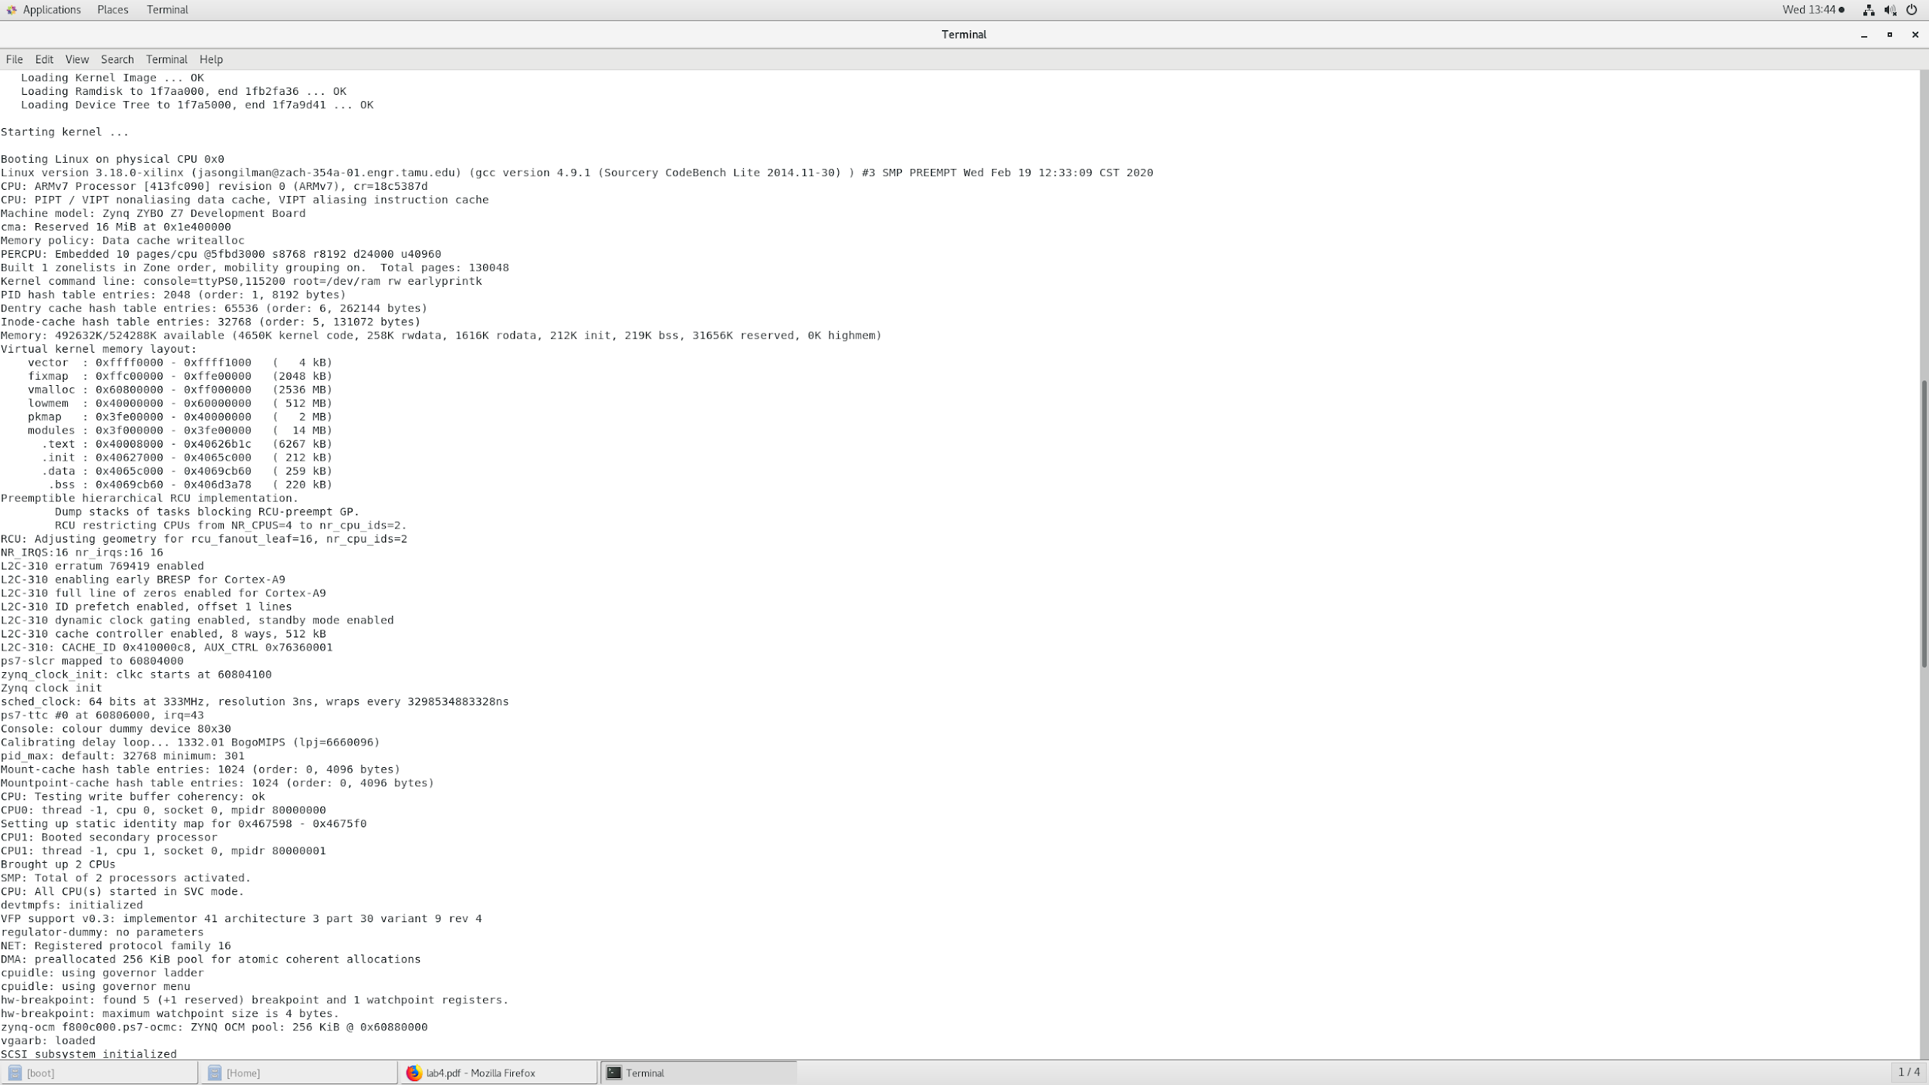

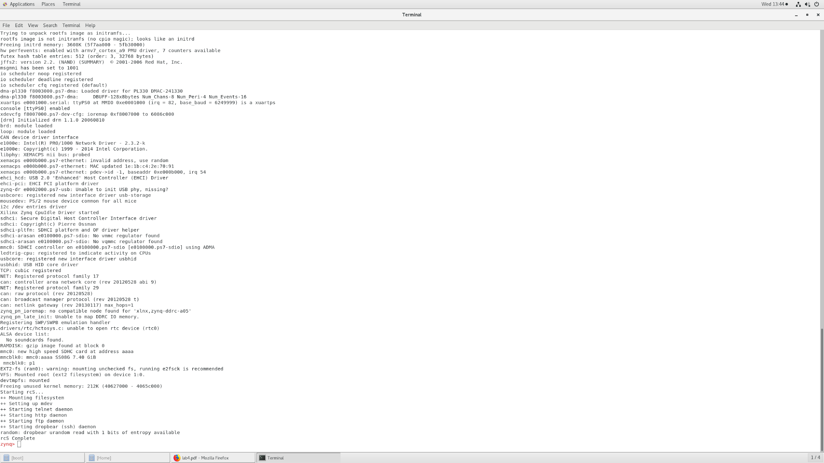

**Conclusion:**

This lab demonstrated that it is possible to run an operating system on the zybo-10 FPGA board. The linuxOS is a lightweight and portable operating system, so it was perfect to be run on the zybo system. After generating a few files, and adding them to an SD card, it was possible to boot up linux from the external storage.

**Post Lab Questions:**

1. Local memory serves as a quick access to important values that need to be stored. Compared to memory stored on a drive, local memory can be found and read very fast. Local memory exists in the processor chip on any standard motherboard.
2. The only directories that are not writable are the ones reserved for the system, and the ones that are necessary for bootup functions. These include, /proc and /sys. If you write to a file, the changes won't be saved, because when you restart the zybo-10 board, the whole linuxOS begins a fresh bootup. Thus, it is overwriting the things you wrote to. If the things you wrote were recorded onto the SD card, when you reboot the system, the changes would still exist.
3. If more hardware was added, the devicetree.dtb would need to be generated again. This file allows the linuxOS to know how to interact with the hardware. This is like the driver for the hardware so the OS knows how to work with the hardware.