**ECEN 454**

**LAB 2**

**NAME:** Jason Gilman

**UIN:** 126006979

**SECTION:** 511

**TA:** Guaynu Gao

**INVERTER**

Schematic - inverter

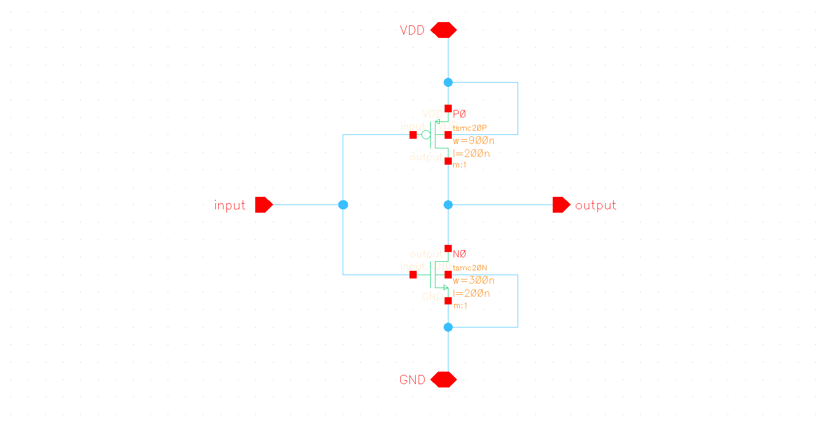

Symbol - inverter

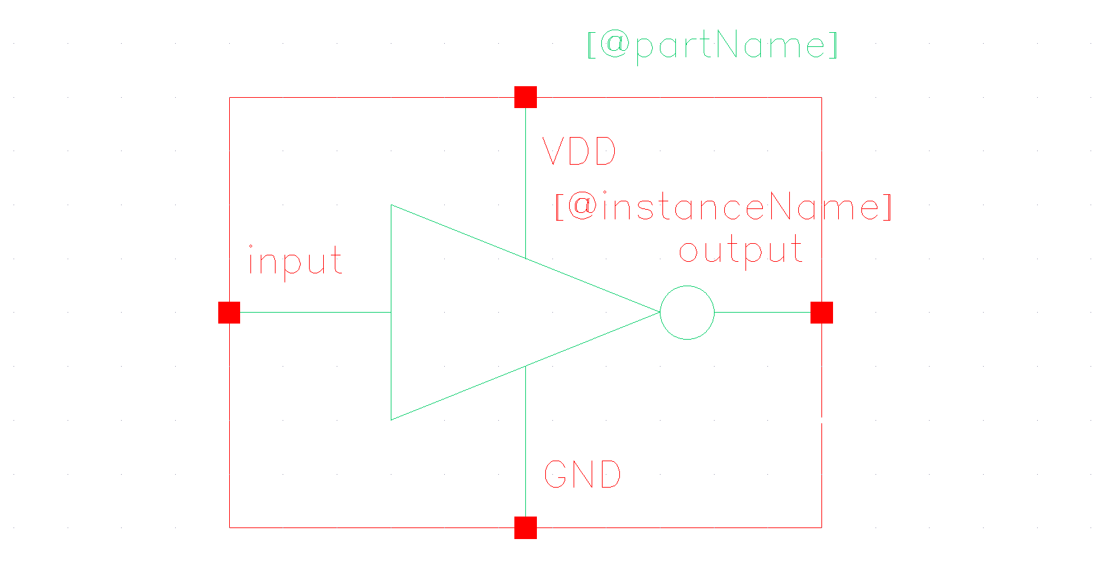

Layout – inverter

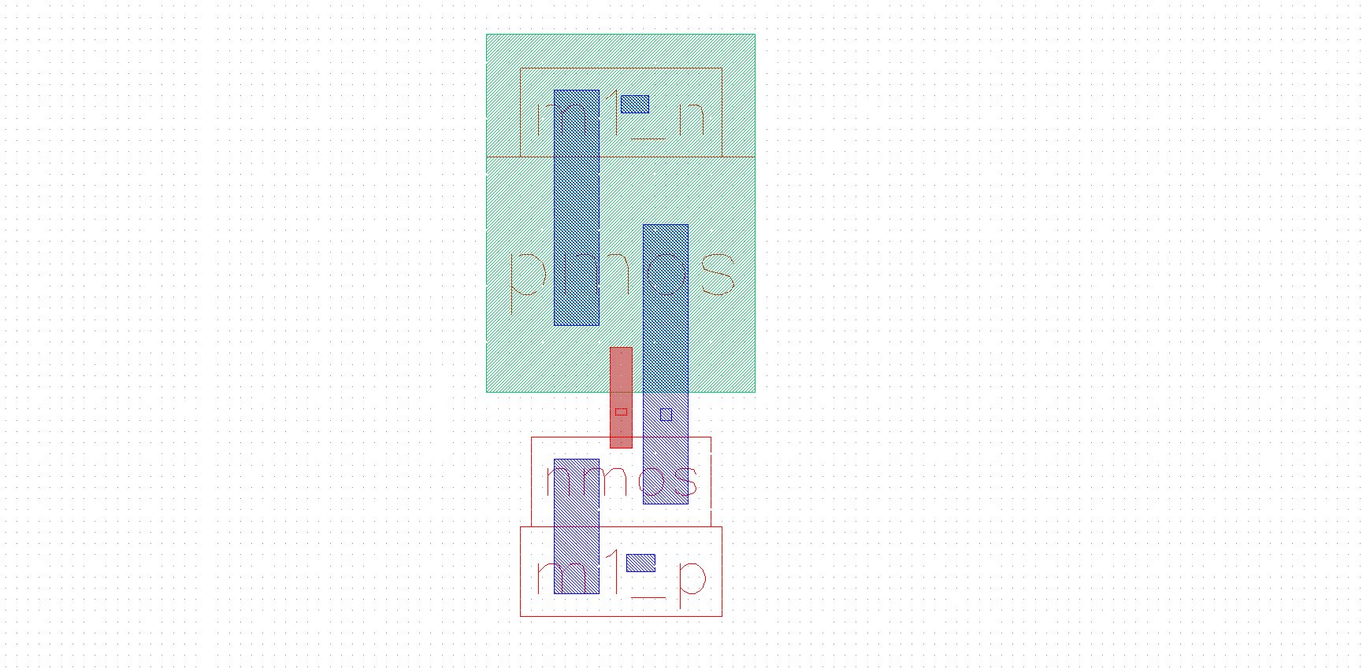

Extracted – inverter

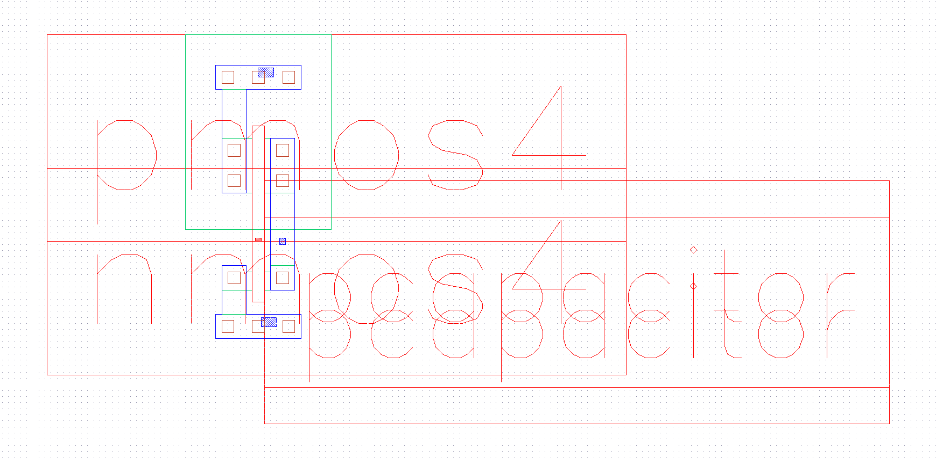

LVS Output – inverter

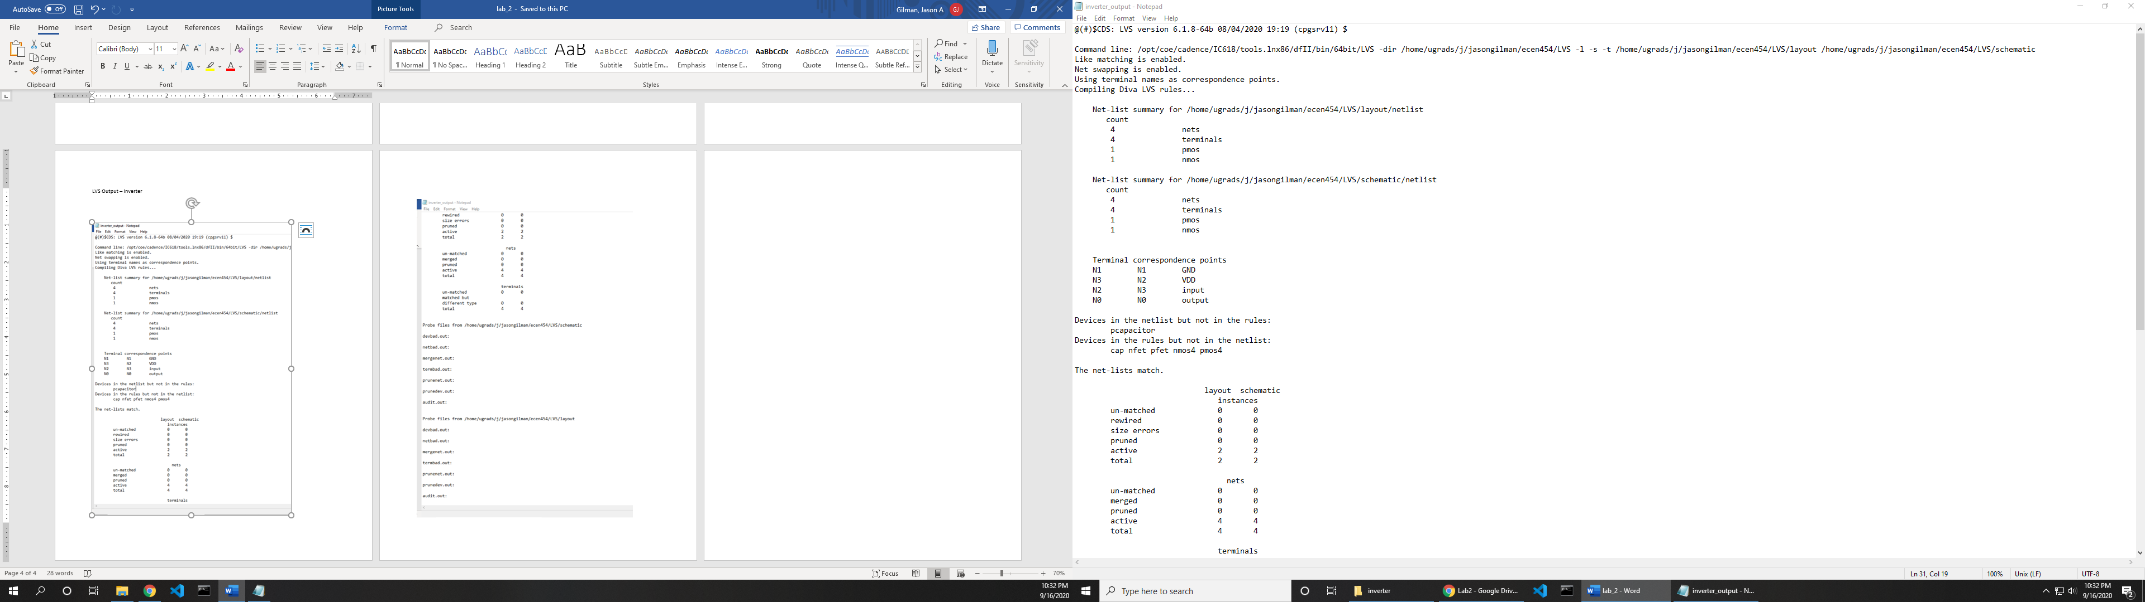

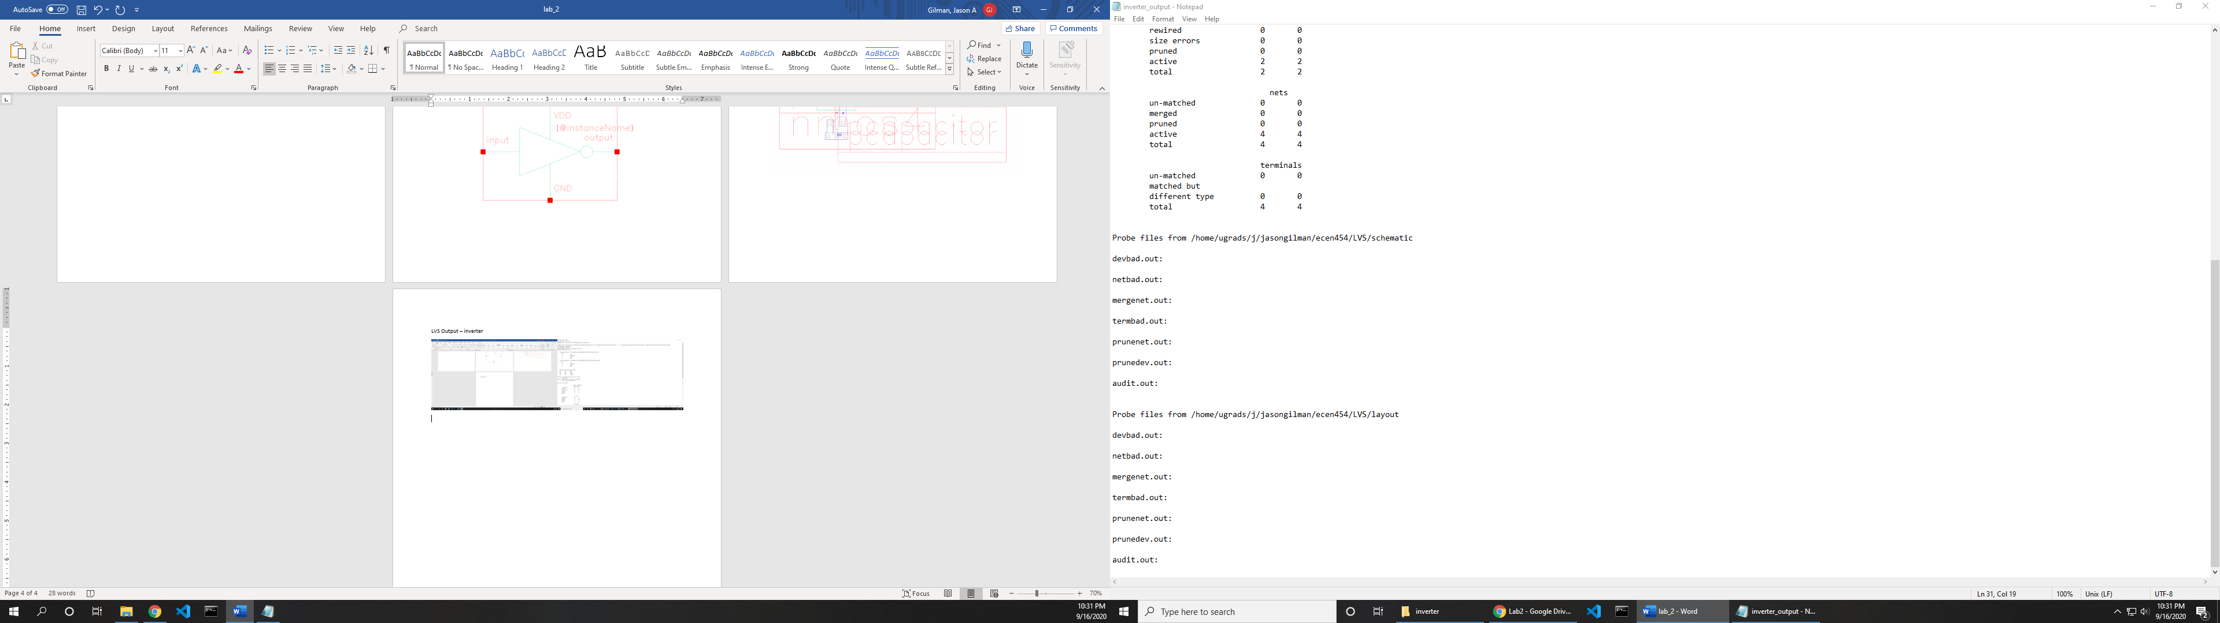

**NAND**

Schematic – nand

Sybol 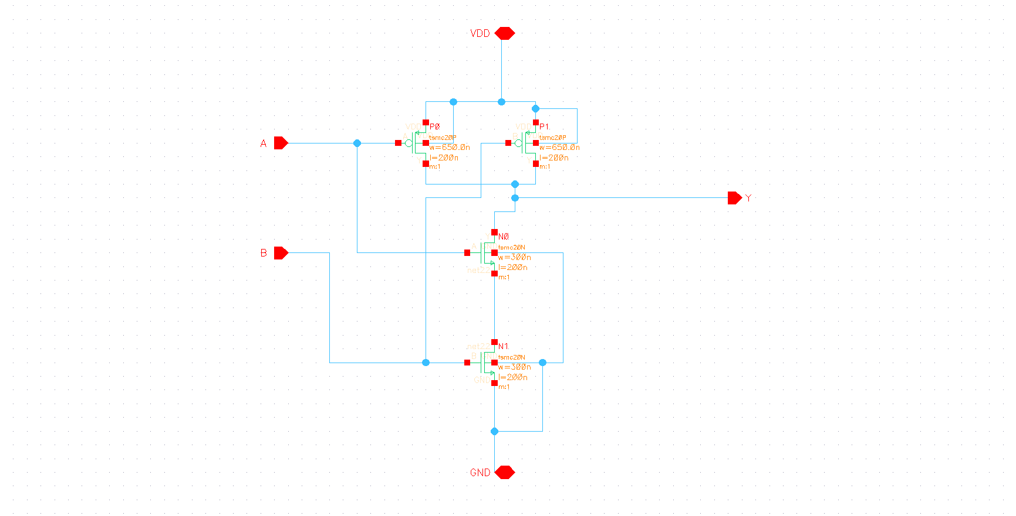

Symbol – nand

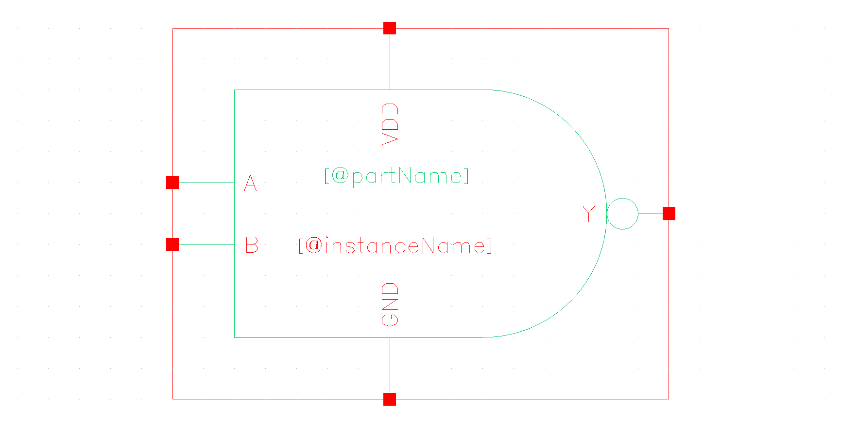

Layout – nand

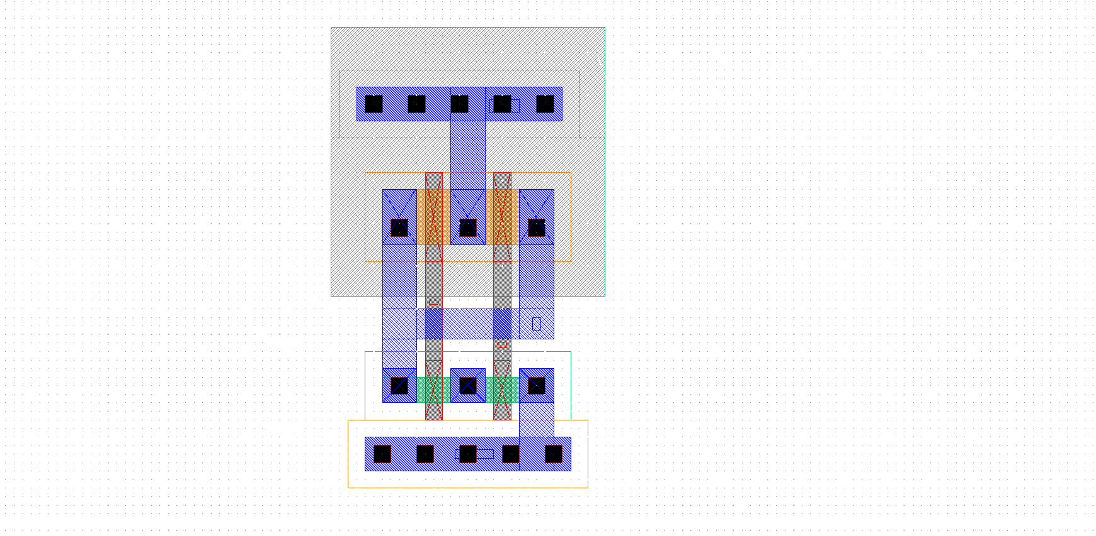

Extracted – nand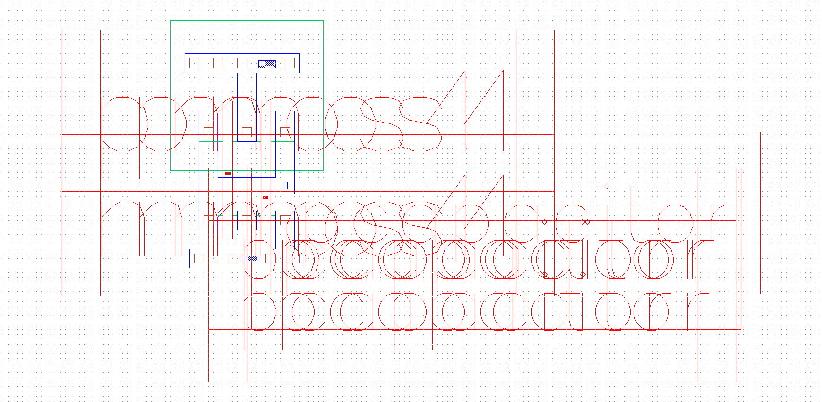

LSV Output – nand

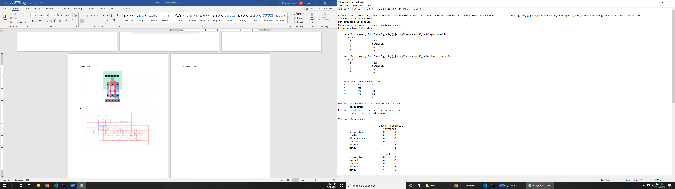

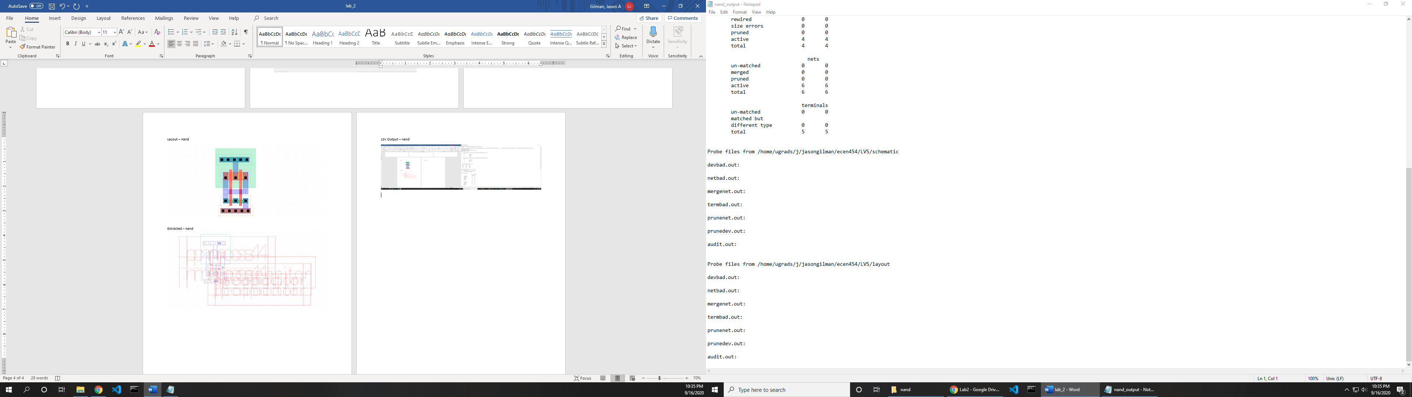

**XOR**

Schematic – xor

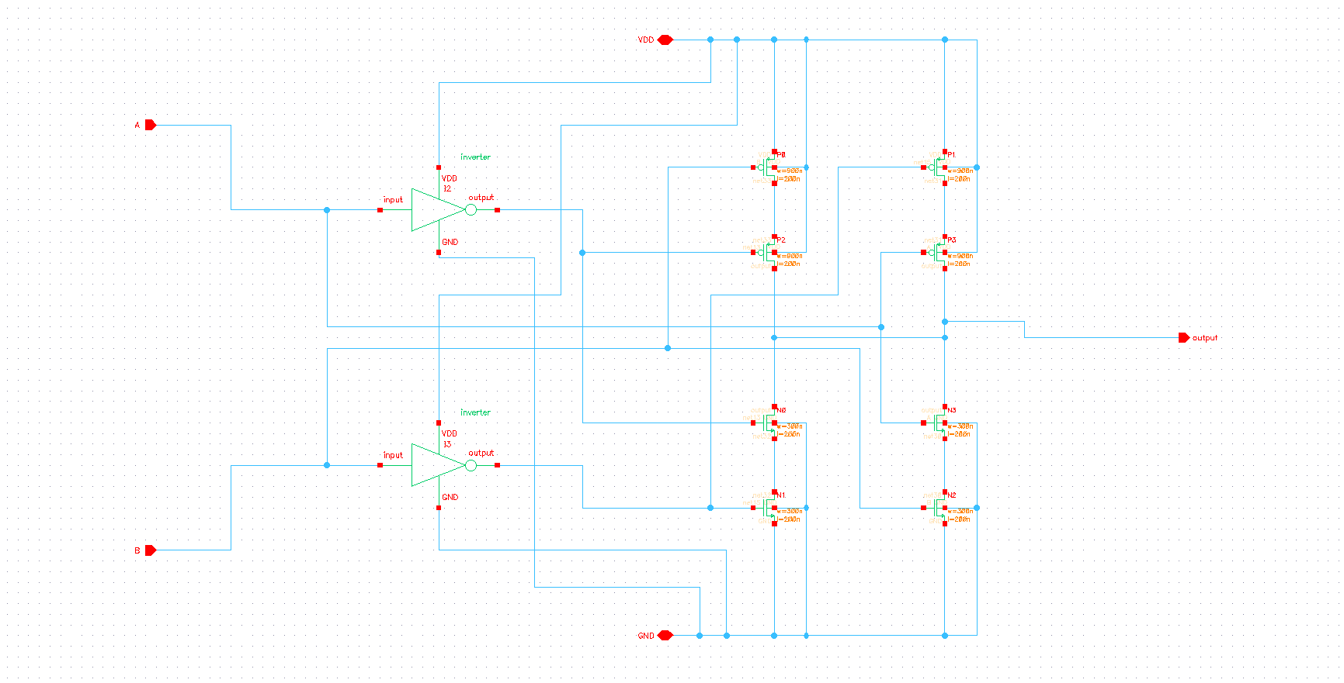

Symbol – xor

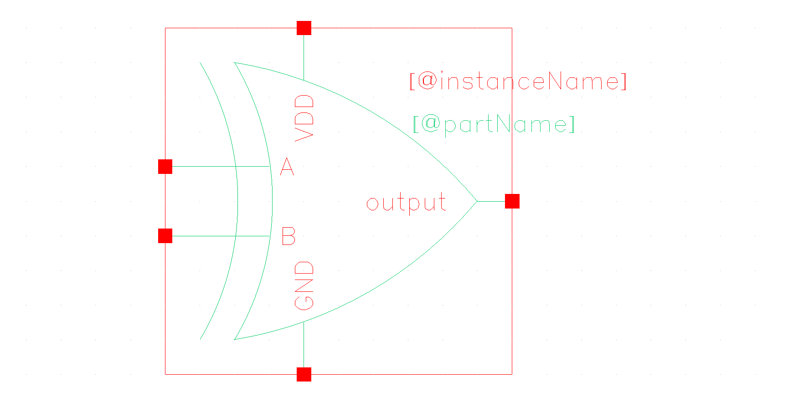

Layout – xor

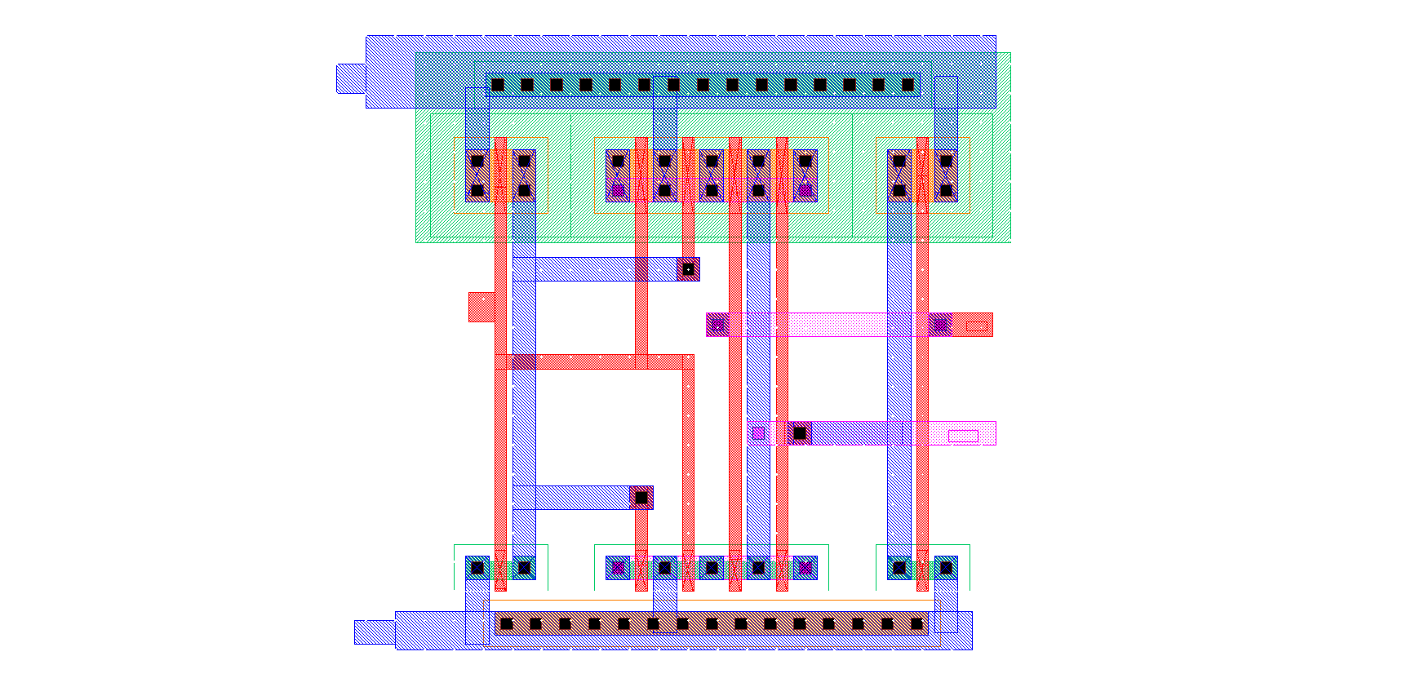

Extracted – xor

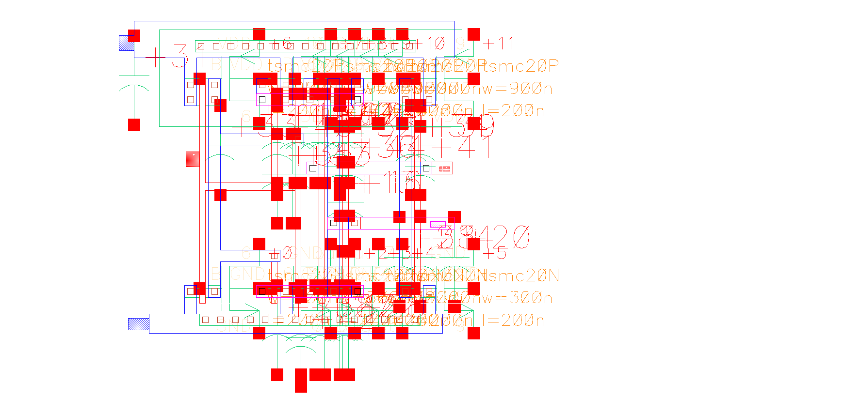

LSV Output – xor

