**ECEN 454**

**LAB 4**

**NAME:** Jason Gilman

**UIN:** 126006979

**SECTION:** 511

**TA:** Guaynu Gao

**1-Bit Adder**

Schematic

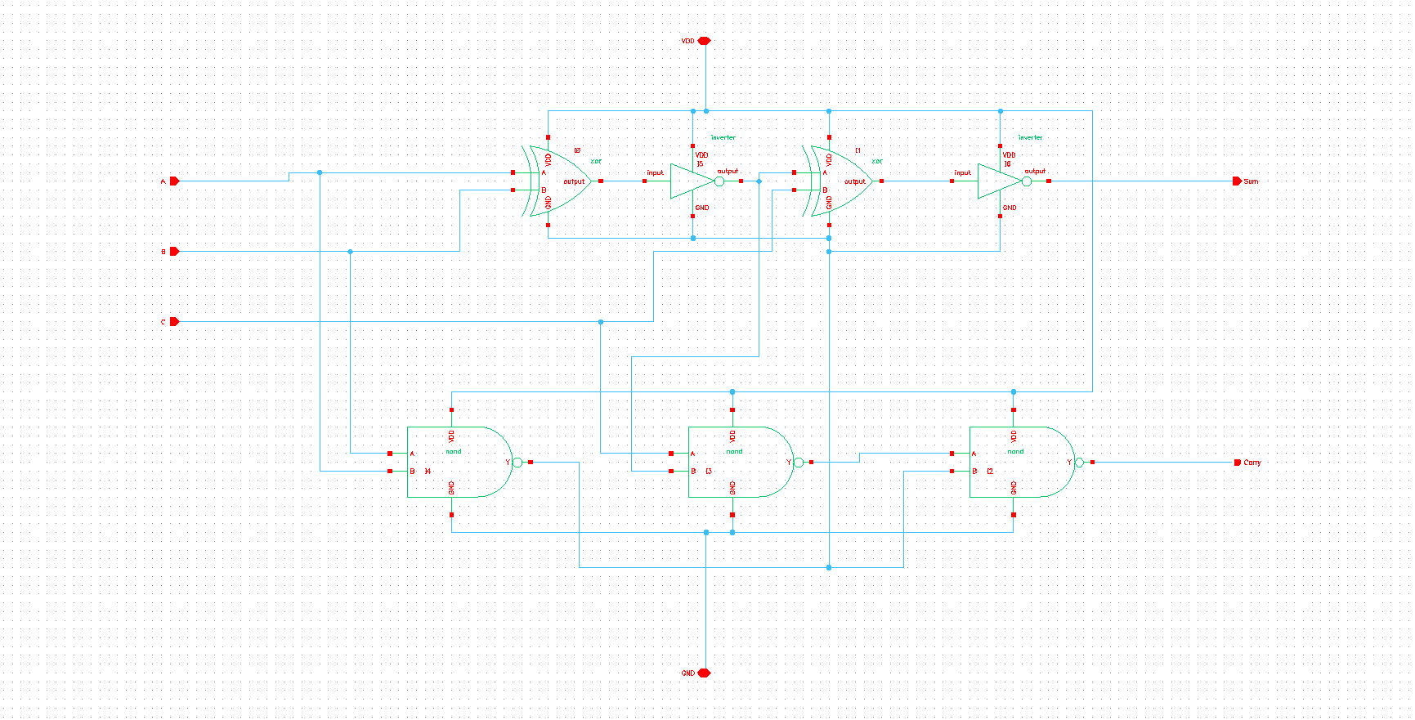

Layout

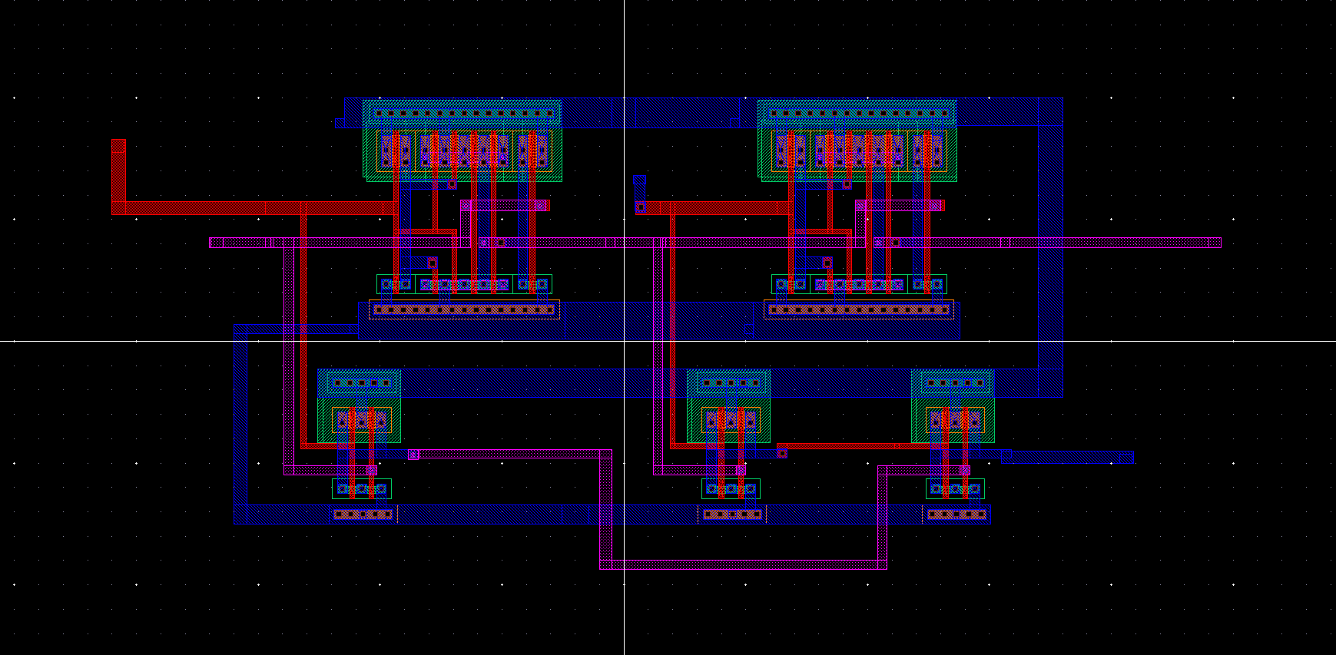

DRC

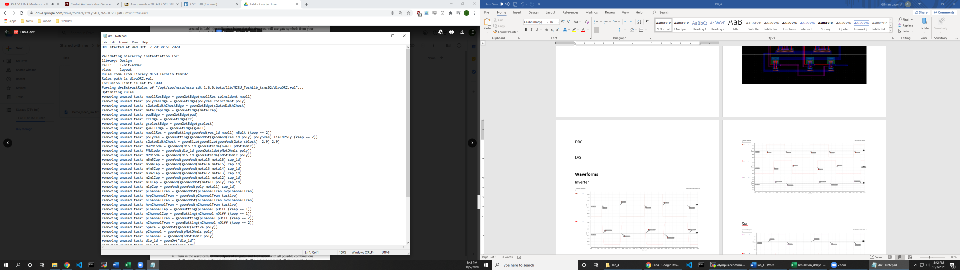

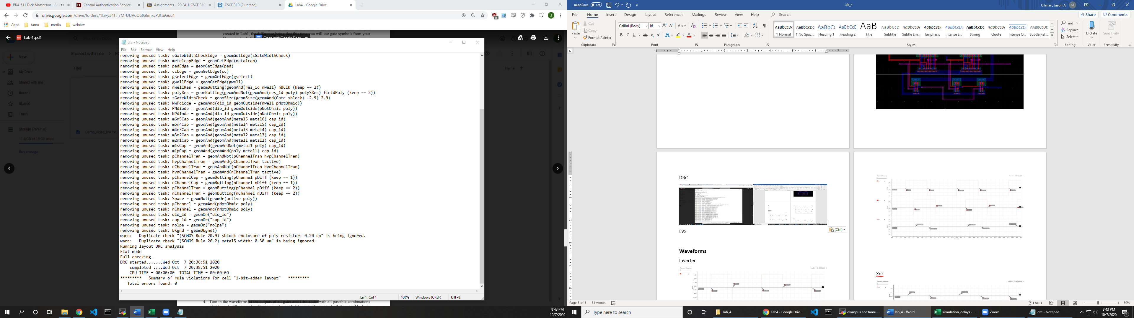

LVS

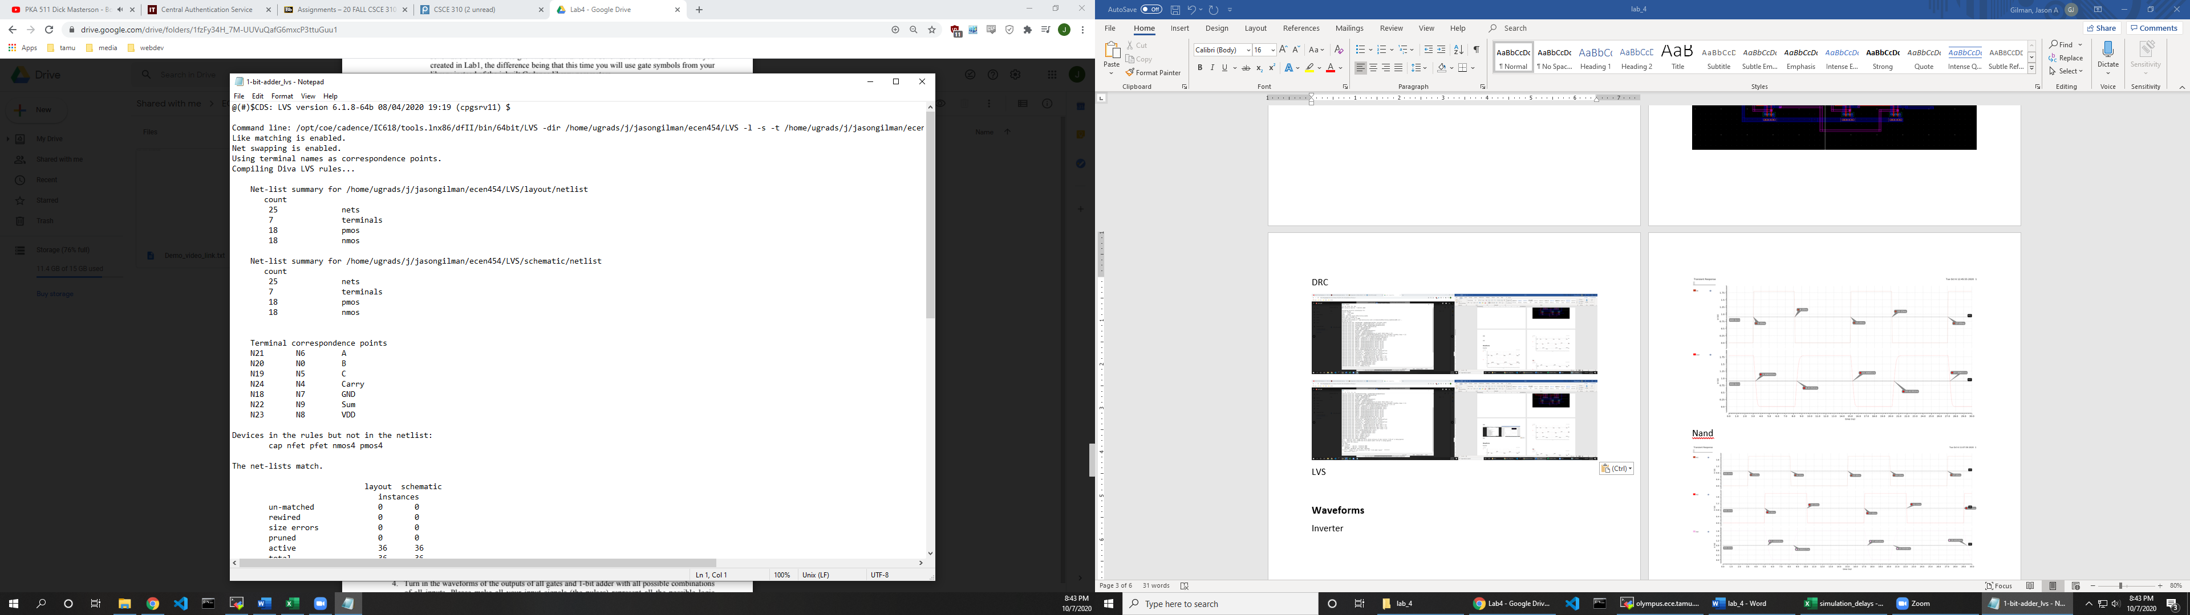

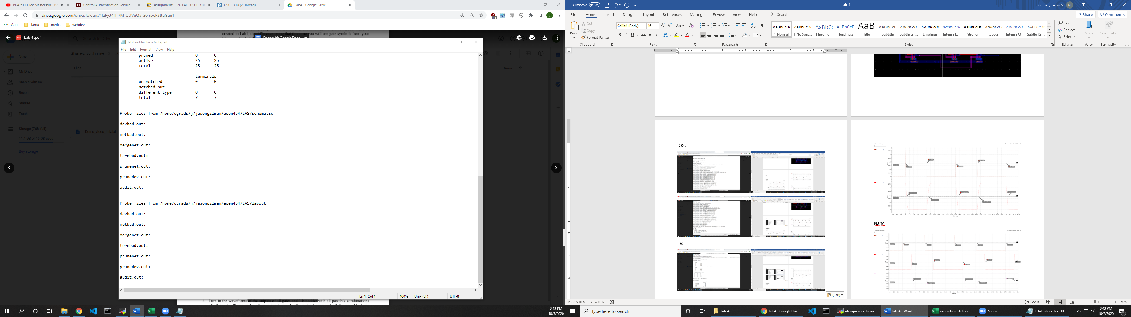

**Waveforms**

Inverter

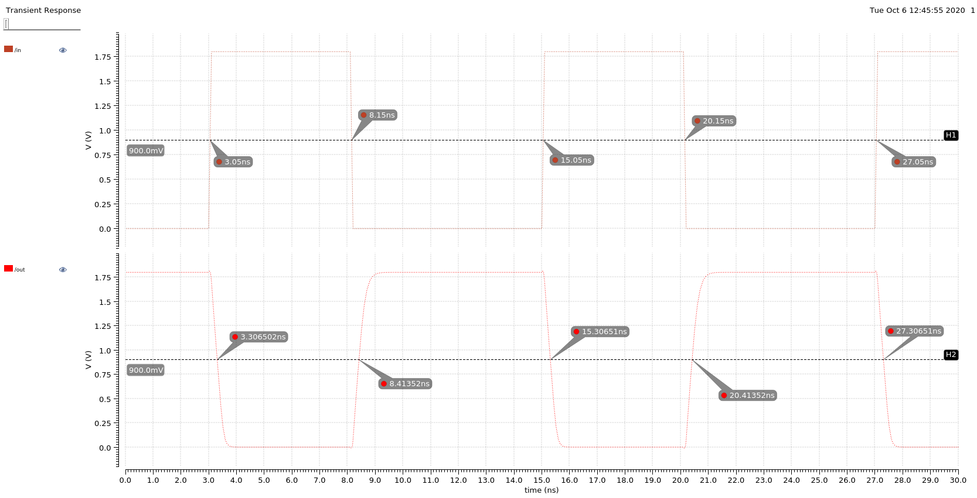

Nand

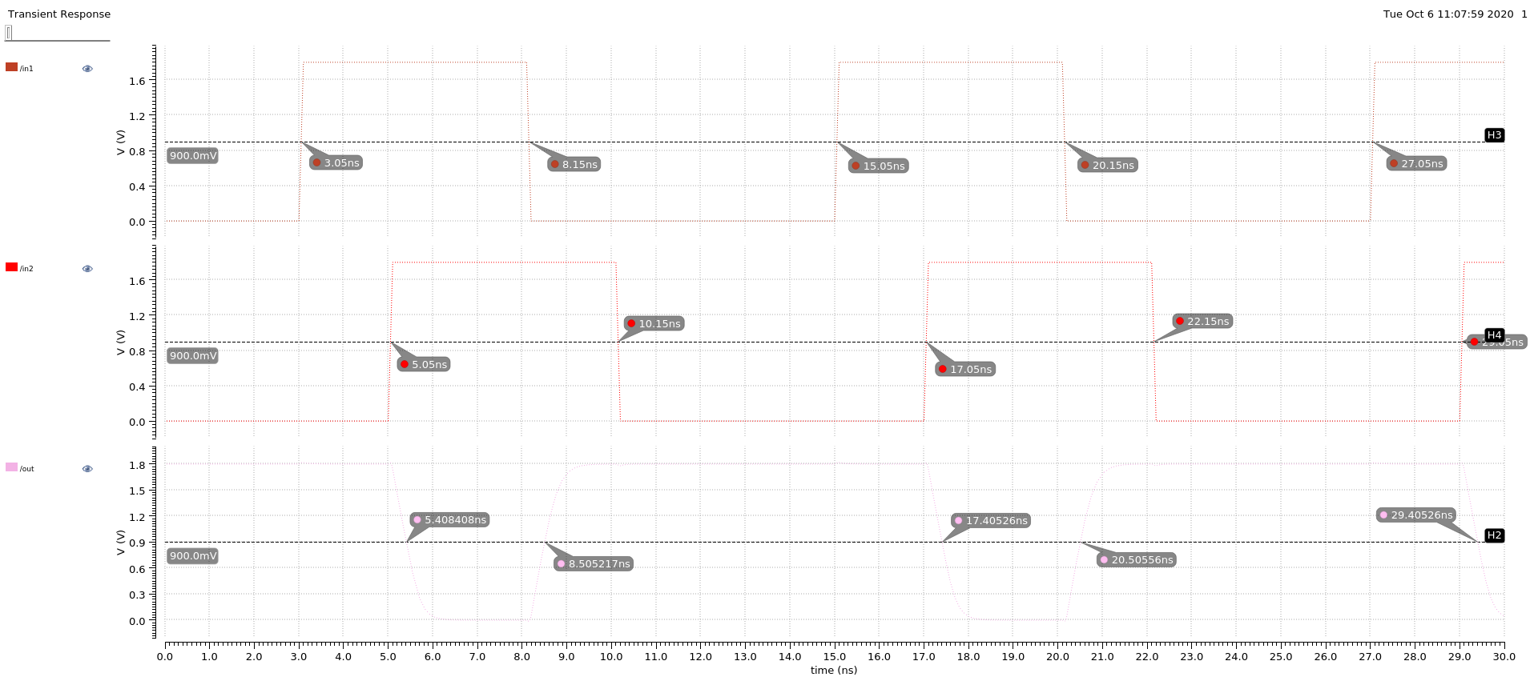

Xor

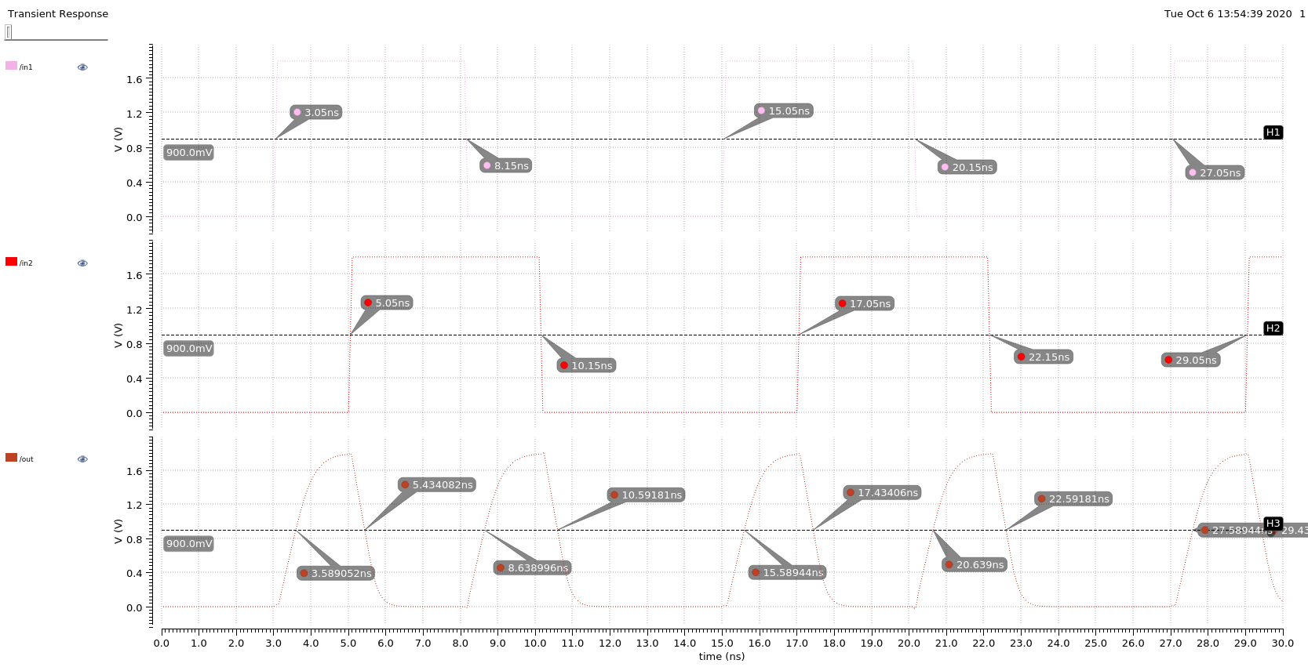

1-Bit Adder

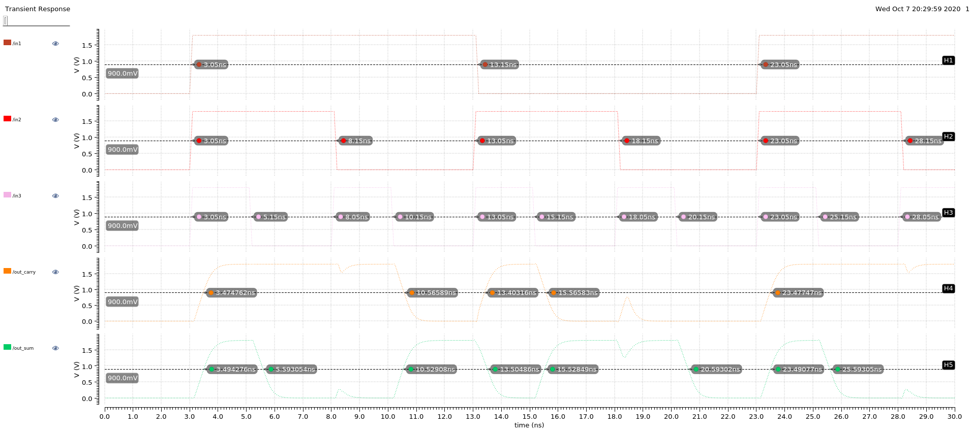

**Delays**

|  |  |  |  |
| --- | --- | --- | --- |
| **Component** | **Rising Delay (pS)** | **Falling Delay (pS)** | **Error (%)** |
| inverter | 263.52 | 256 | 2.94 |
| nand | 356 | 355.8 | 5.62 |
| xor | 488.996 | 384.082 | 27.32 |
| 1-bit adder | 379.08 | 454 | 19.76 |

**Power Distribution**

|  |  |
| --- | --- |
| Component | Power Distribution |
| inverter | 0.808 |
| nand | 0.527 |
| xor | 0.5278 |
| 1-bit adder | 0.613 |

**Maximum Frequency: 4 MHz**

