**ECEN 454**

**LAB 5**

**NAME:** Jason Gilman

**UIN:** 126006979

**SECTION:** 511

**TA:** Guaynu Gao

**4-bit-adder**

Schematic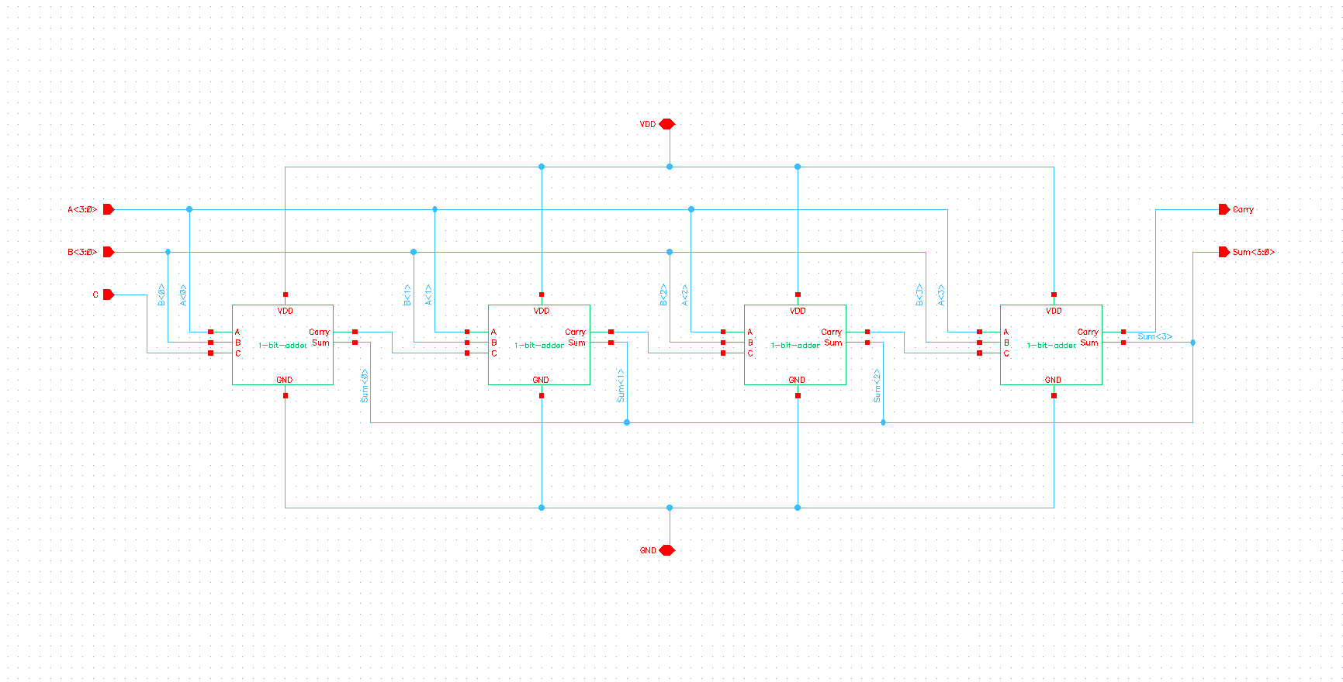

Layout

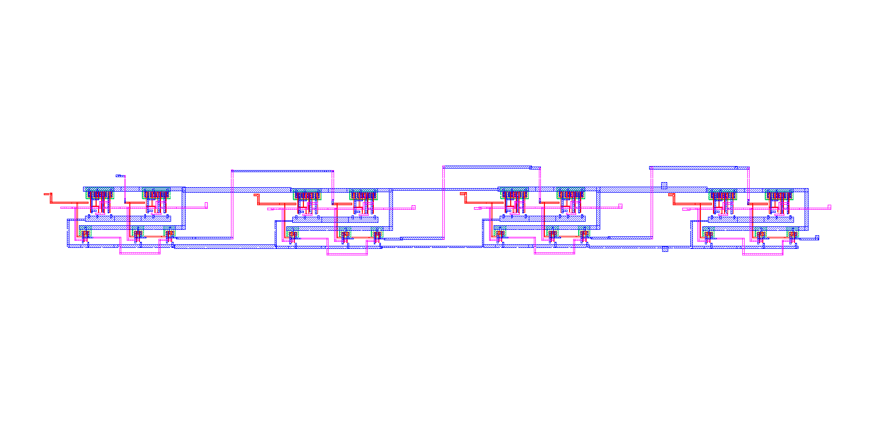

LVS

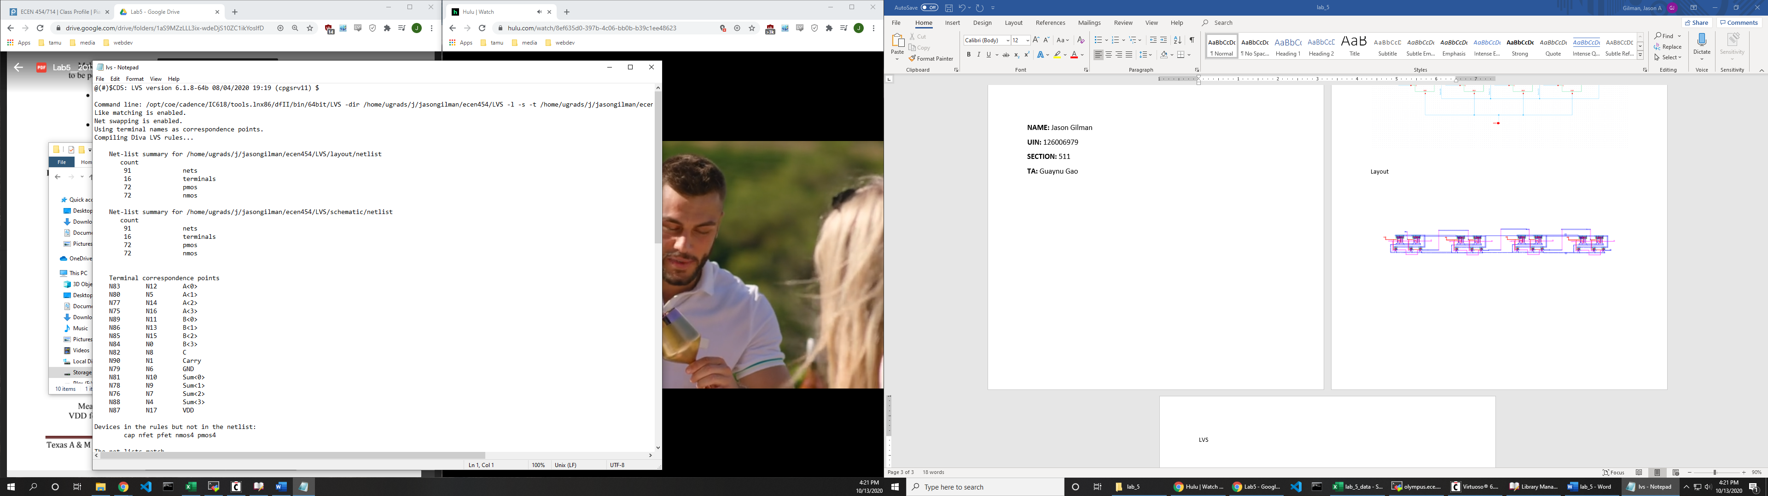

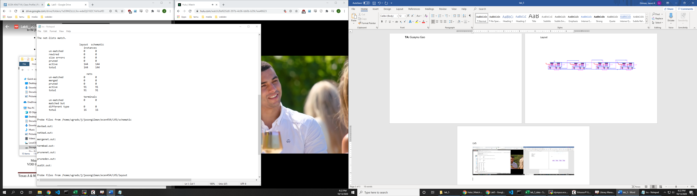

**Waveforms**

A=0000 B=1111 C=1

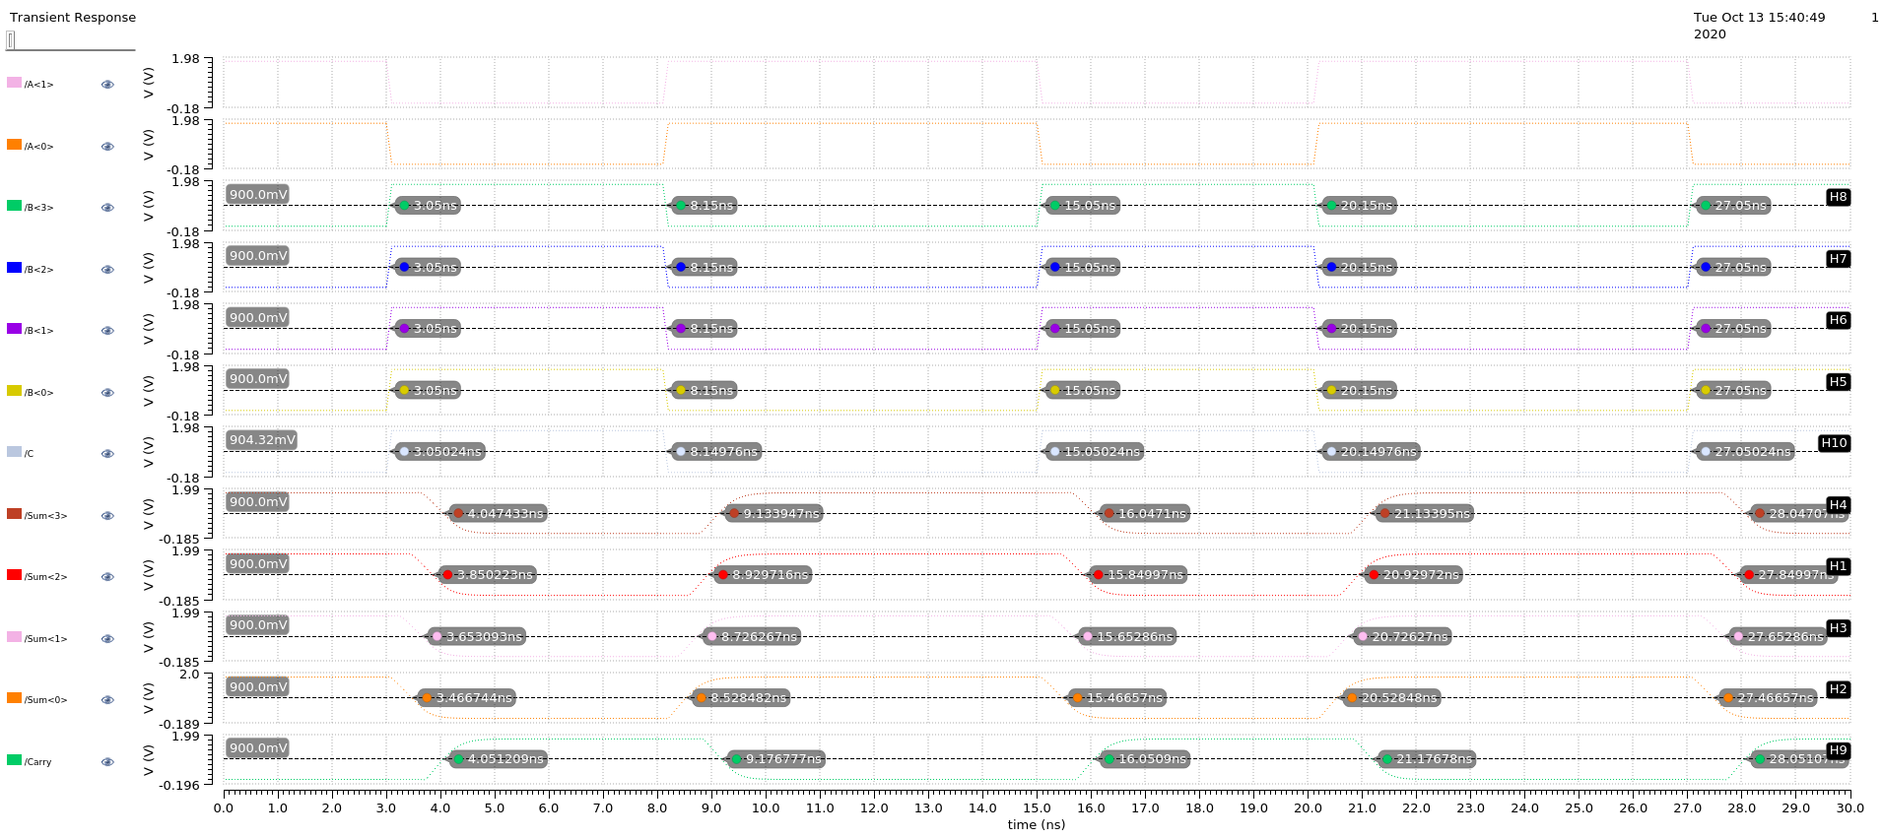

A=1010 B=0101 C=0

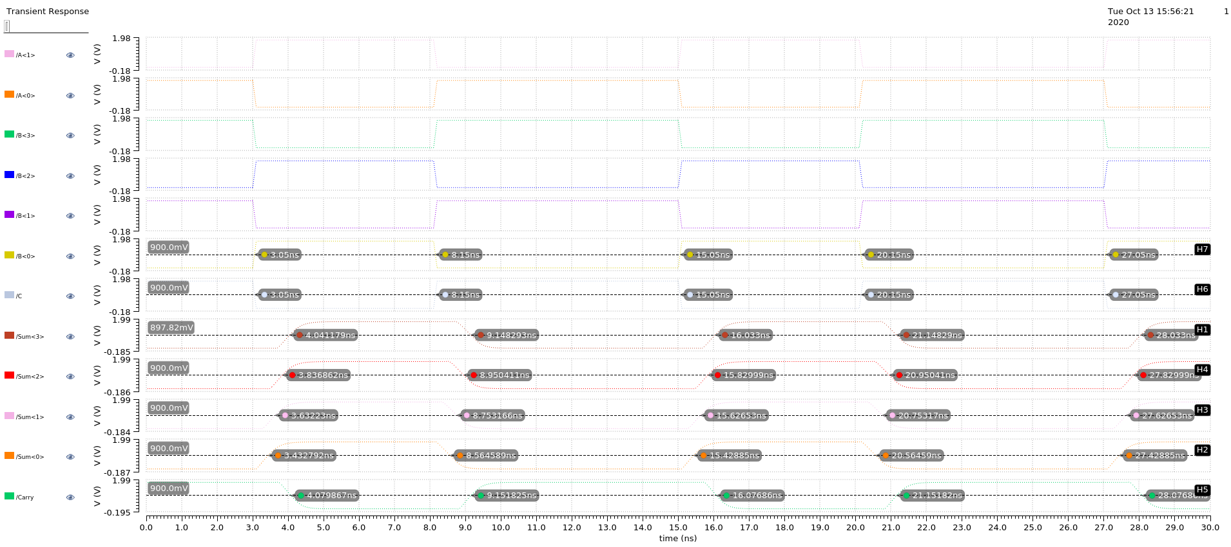

A=1010 B=0101 C=1

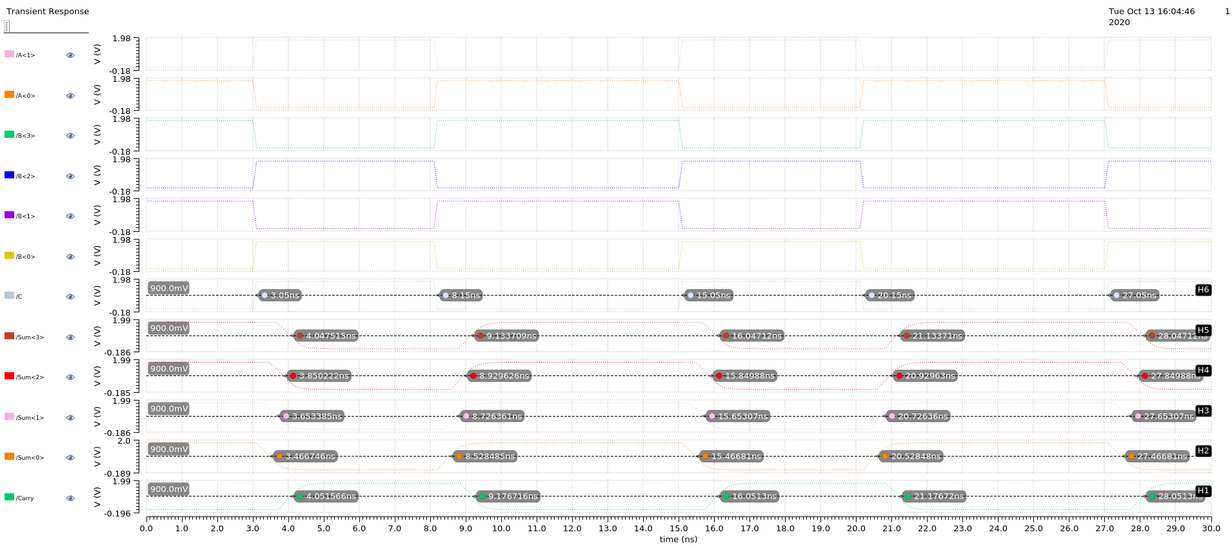

A=1100 B=1000 C=0

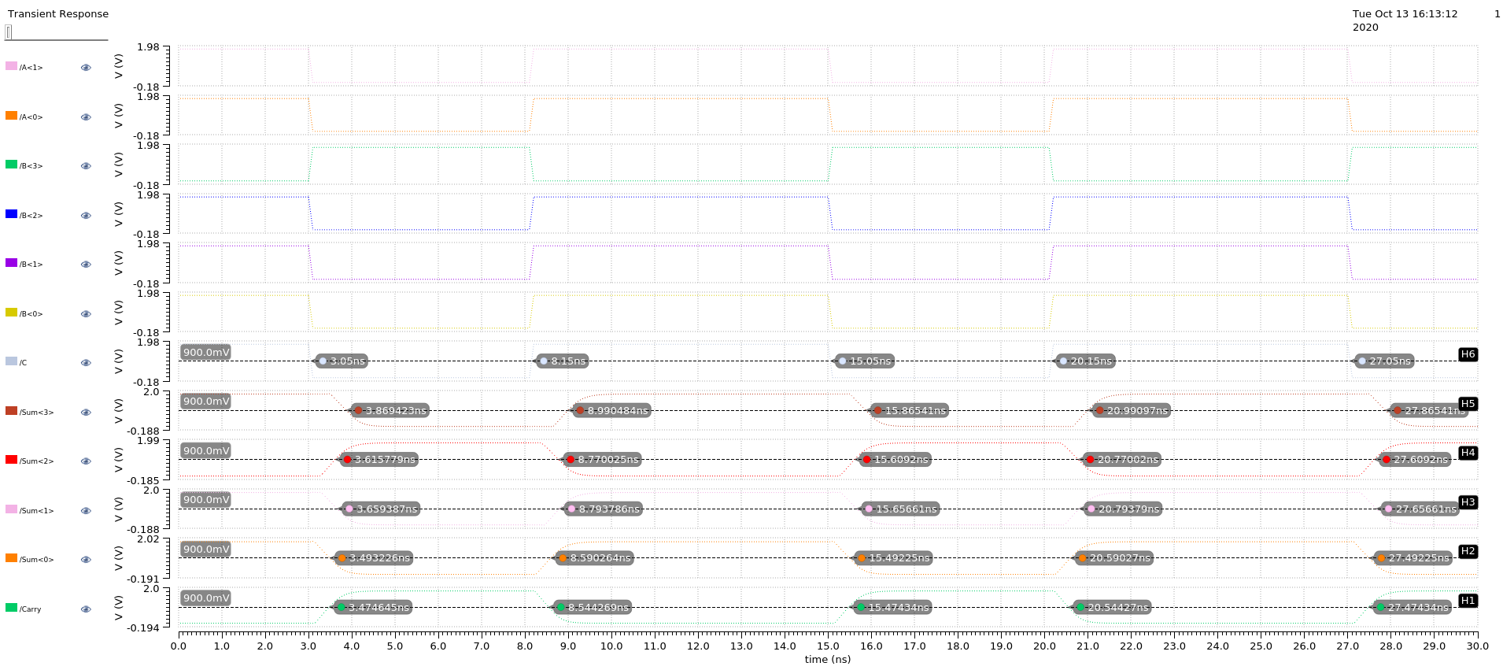

**Delay**

|  |  |  |  |  |  |
| --- | --- | --- | --- | --- | --- |
| **Input (A/B/C)** | **Sum<3> (ns)** | **Sum<2> (ns)** | **Sum<1> (ns)** | **Sum<0> (ns)** | **Carry (ns)** |
| 0000/1111/1 | 0.997433 | 0.800223 | 0.603093 | 0.416744 | 1.001209 |
| 1010/0101/0 | 0.991179 | 0.786862 | 0.58223 | 0.38279 | 1.02986 |
| 1010/0101/1 | 0.997515 | 0.800222 | 0.603385 | 0.416746 | 1.001566 |
| 1100/1000/0 | 0.819424 | 0.565779 | 0.609387 | 0.44322 | 0.42464 |

**Power Consumption**

|  |  |
| --- | --- |
| **Input (A/B/C)** | **Power Consumption (uW)** |
| 0000/1111/1 | 18.33 |
| 1010/0101/0 | 39.56 |
| 1010/0101/1 | 18.87 |
| 1100/1000/0 | 17.52 |