**ECEN 454**

**LAB 6**

**NAME:** Jason Gilman

**UIN:** 126006979

**SECTION:** 511

**TA:** Guaynu Gao

**Flip-Flop Schematic**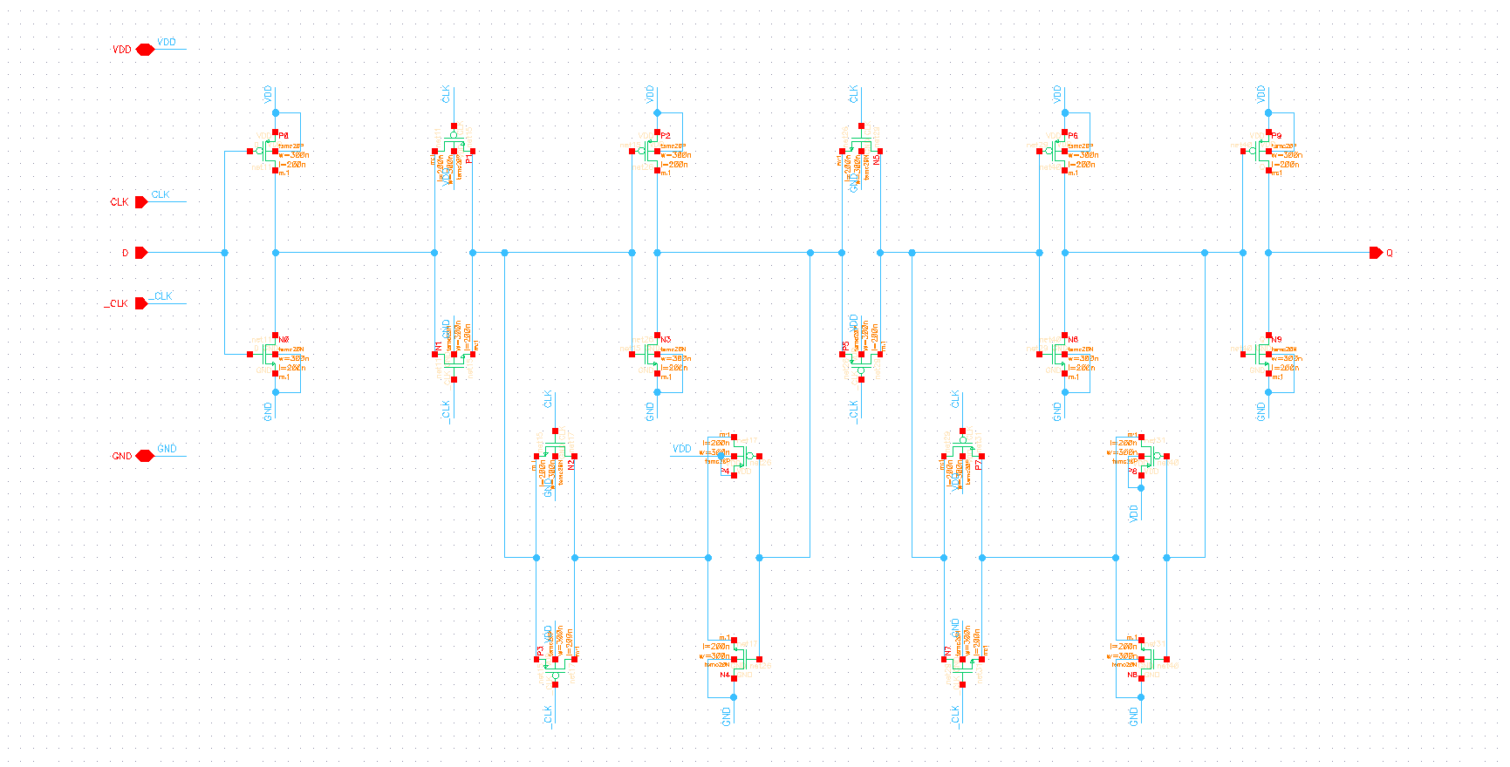

**Flip-Flop Layout**

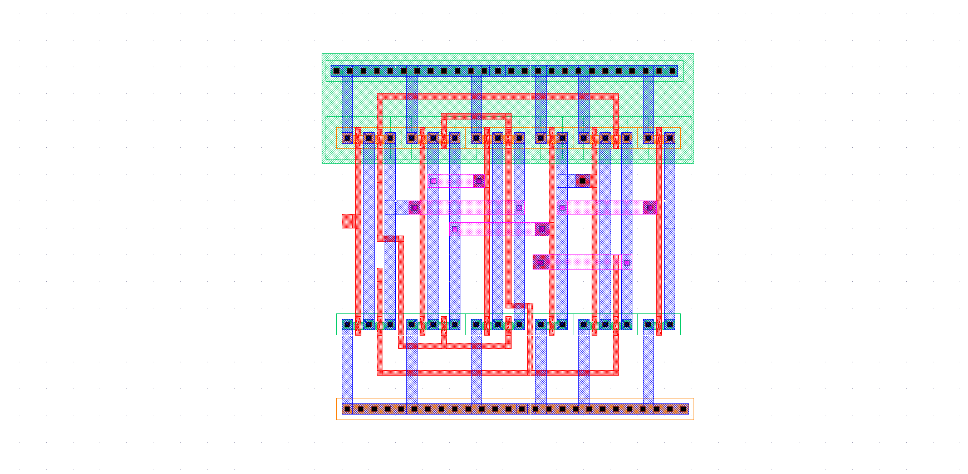

**LVS**

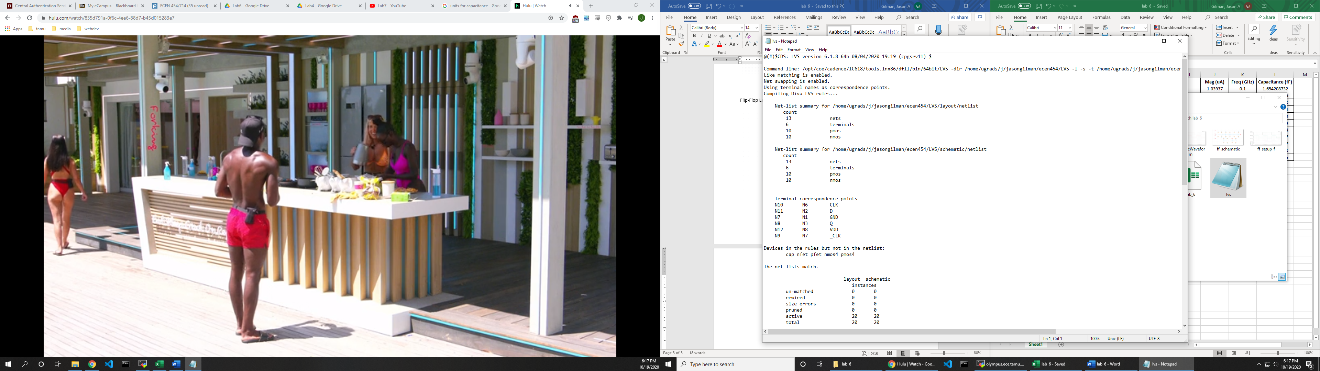

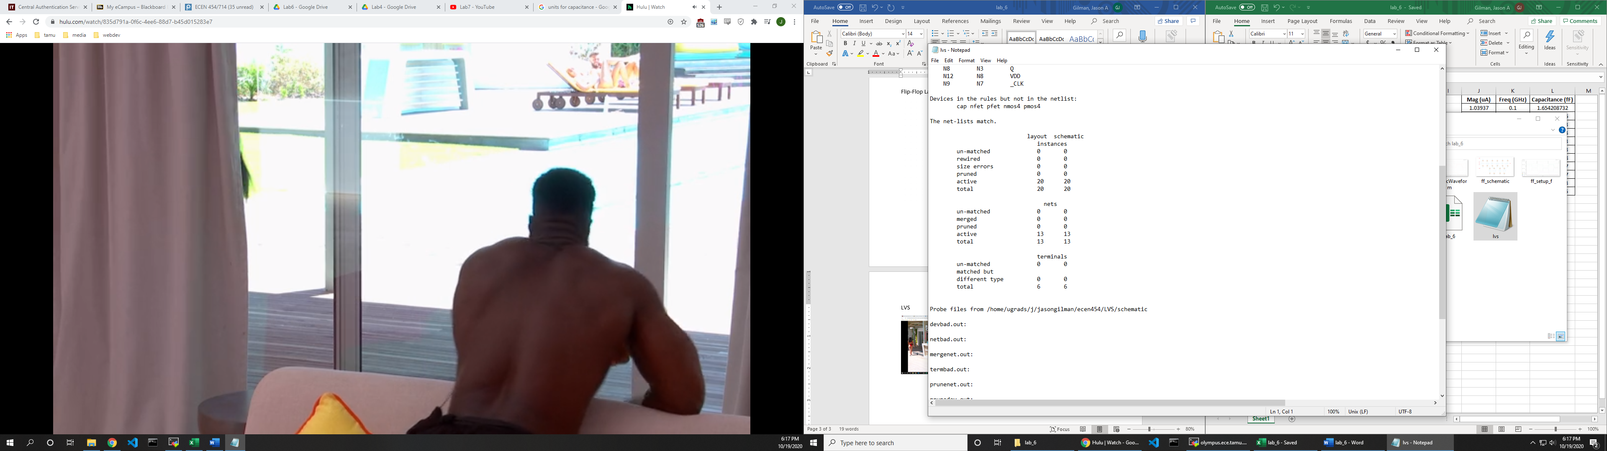

**Waveform**

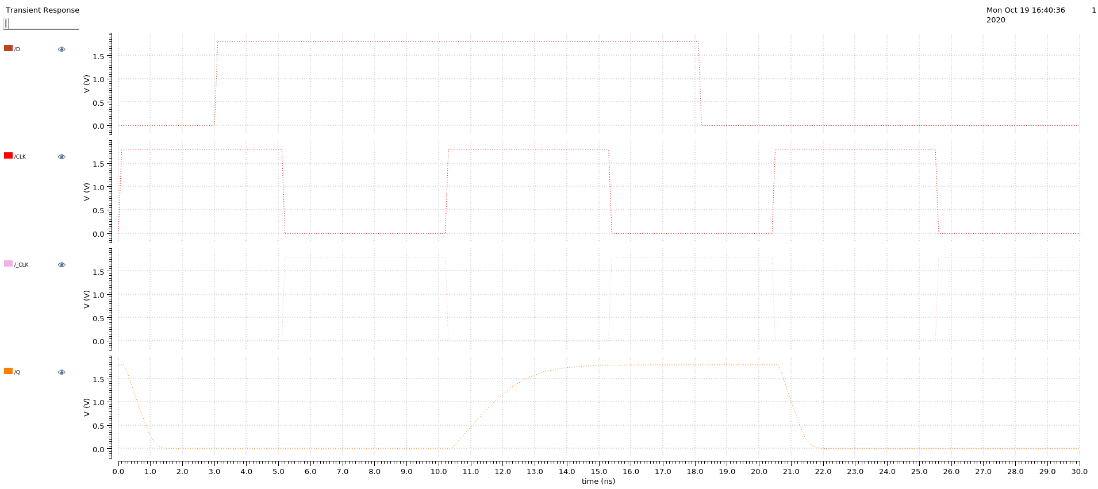

|  |  |  |  |  |  |  |  |
| --- | --- | --- | --- | --- | --- | --- | --- |
| **C = 100f F** | | | **Delay (ns)** | **C = 50f F** | | | **Delay (ns)** |
| **Rising** | 11.58229 | 10.25 | 1.33229 | **Rising** | 10.9964 | 10.25 | 0.7464 |
| **Falling** | 21.05861 | 20.45 | 0.60861 | **Falling** | 20.8393 | 20.45 | 0.3893 |
|  |  | **% error** | 0.543185 |  |  | **% error** | 0.47843 |
| **C = 90f F** | | | **Delay (ns)** | **C = 40f F** | | | **Delay (ns)** |
| **Rising** | 11.46 | 10.25 | 1.21 | **Rising** | 10.8803 | 10.25 | 0.6303 |
| **Falling** | 21.0148 | 20.45 | 0.5648 | **Falling** | 20.7955 | 20.45 | 0.3455 |
|  |  | **% error** | 0.5332231 |  |  | **% error** | 0.451848 |
| **C = 80f F** | | | **Delay (ns)** | **C = 30f F** | | | **Delay (ns)** |
| **Rising** | 11.34 | 10.25 | 1.09 | **Rising** | 10.7645 | 10.25 | 0.5145 |
| **Falling** | 20.97 | 20.45 | 0.52 | **Falling** | 20.7514 | 20.45 | 0.3014 |
|  |  | **% error** | 0.5229358 |  |  | **% error** | 0.414189 |
| **C = 70f F** | | | **Delay (ns)** | **C = 20f F** | | | **Delay (ns)** |
| **Rising** | 11.231 | 10.25 | 0.981 | **Rising** | 10.6475 | 10.25 | 0.3975 |
| **Falling** | 20.92699 | 20.45 | 0.47699 | **Falling** | 20.7066 | 20.45 | 0.2566 |
|  |  | **% error** | 0.5137717 |  |  | **% error** | 0.354465 |
| **C = 60f F** | | | **Delay (ns)** | **C = 10f F** | | | **Delay (ns)** |
| **Rising** | 11.11338 | 10.25 | 0.86338 | **Rising** | 10.53027 | 10.25 | 0.28027 |
| **Falling** | 20.88304 | 20.45 | 0.43304 | **Falling** | 20.65892 | 20.45 | 0.20892 |
|  |  | **% error** | 0.4984364 |  |  | **% error** | 0.254576 |

**AC Simulation**

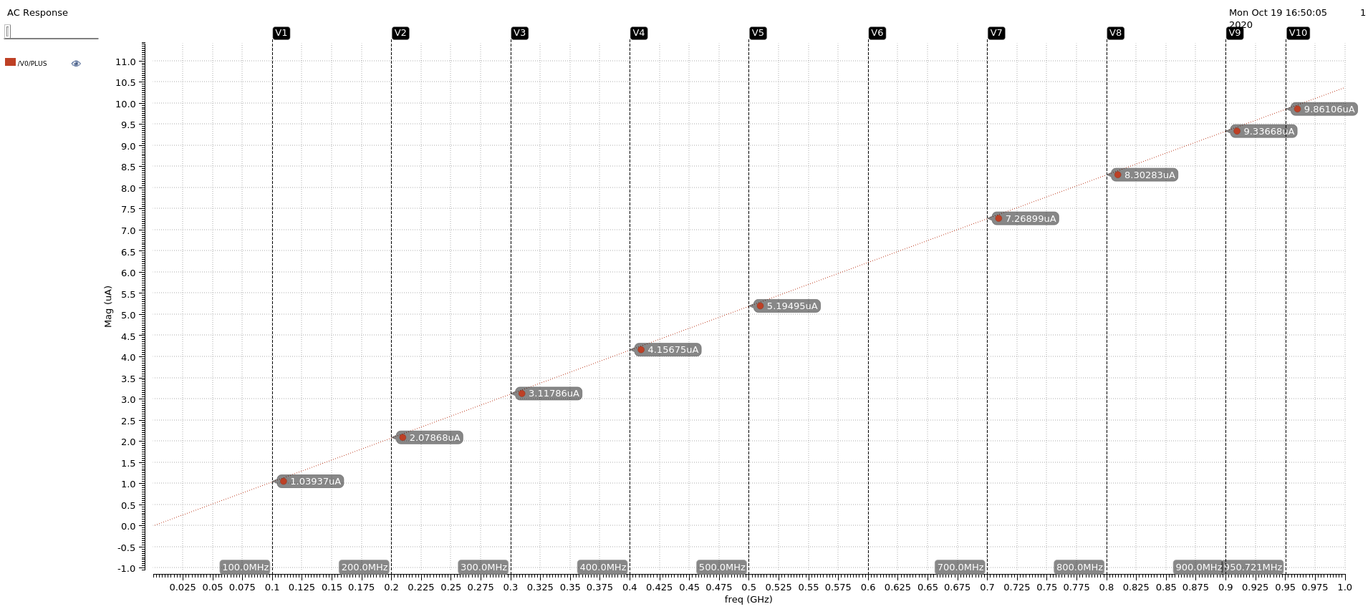

|  |  |  |
| --- | --- | --- |
| **Mag (uA)** | **Freq (GHz)** | **Capacitance (fF)** |
| 1.03937 | 0.1 | 1.654208732 |
| 2.07868 | 0.2 | 1.654160986 |
| 3.11786 | 0.3 | 1.654076103 |
| 4.15675 | 0.4 | 1.653918274 |
| 5.19495 | 0.5 | 1.653603943 |
| 6.23274 | 0.6 | 1.653285633 |
| 7.26899 | 0.7 | 1.652708128 |
| 8.3028 | 0.8 | 1.651789577 |
| 9.33668 | 0.9 | 1.651087527 |
| 9.86106 | 1 | 1.569436443 |
|  | **Mean** | 1.644827535 |

**Setup Time**

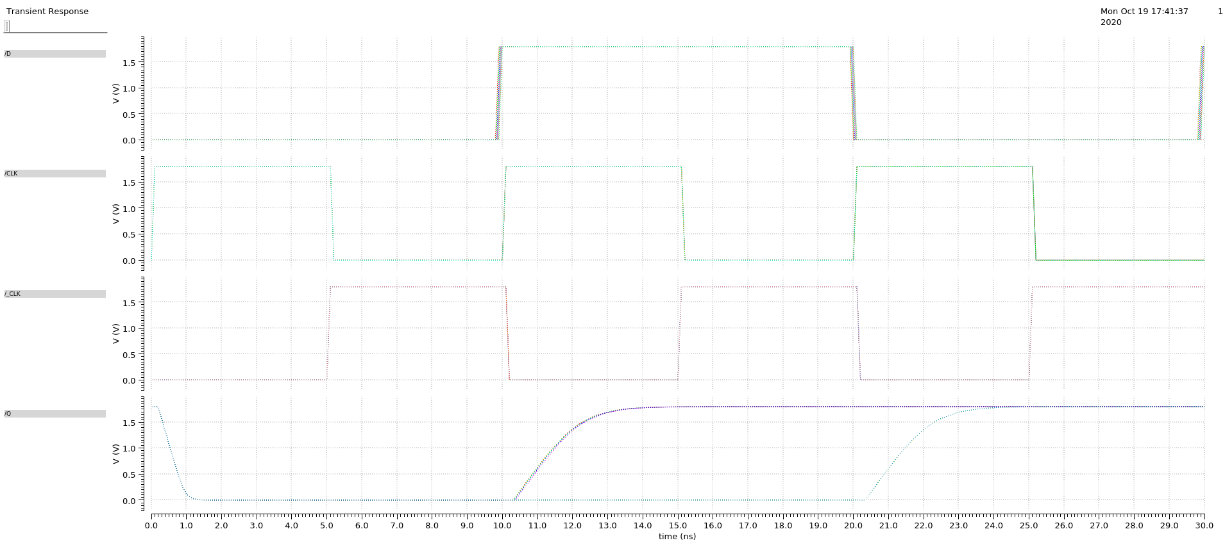

Setup_r = .15ns

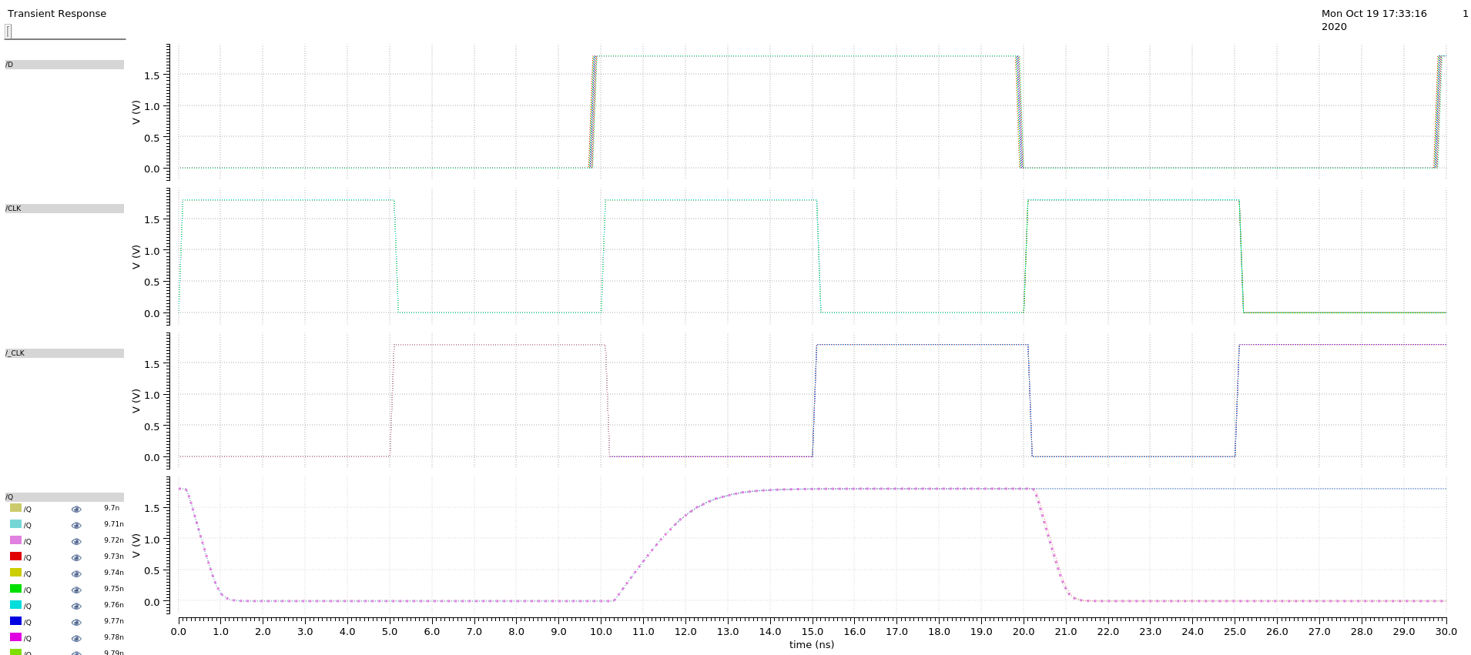

Setup_f = .28 ns

The Setup time is .28ns since it is the greatest value out of the setup rise and setup fall times.