**ECEN 454**

**LAB 9**

**NAME:** Jason Gilman

**UIN:** 126006979

**SECTION:** 511

**TA:** Guaynu Gao

**Critical Path**

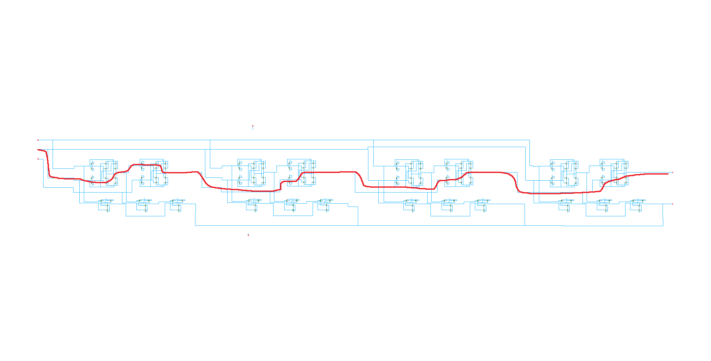

**Waveforms**

0000-1111-1

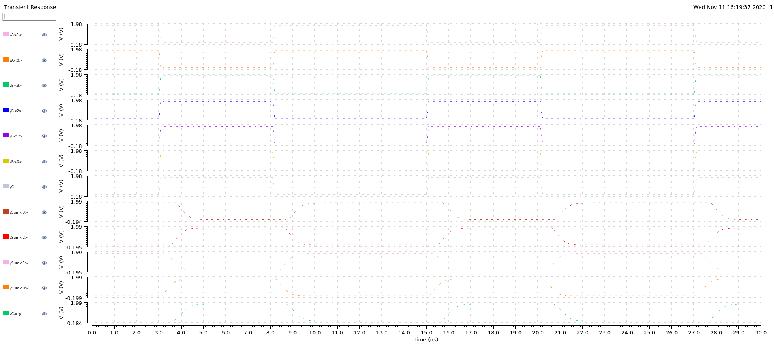

1010-0101-0

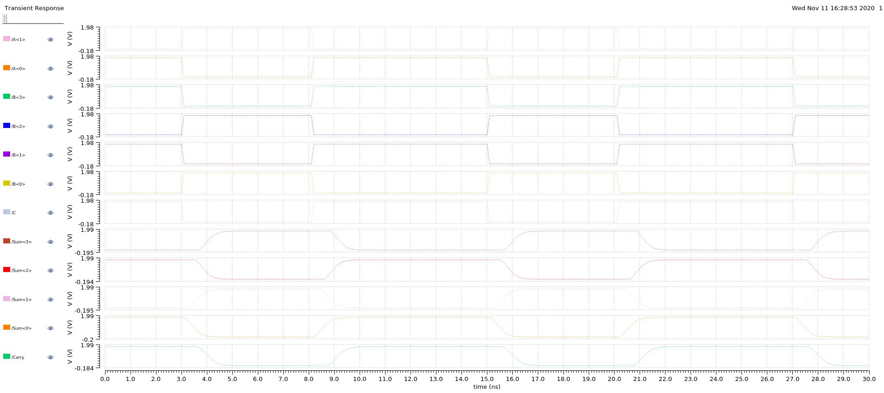

1010-0101-1

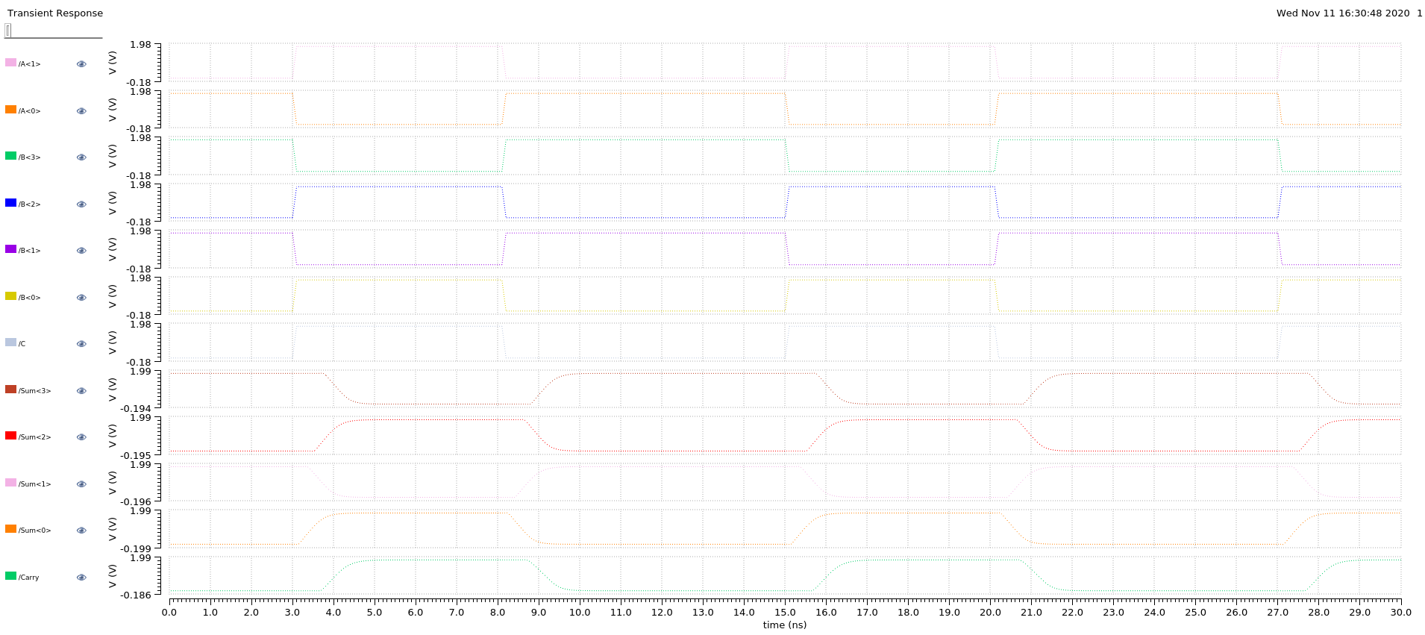

1100-1000-0

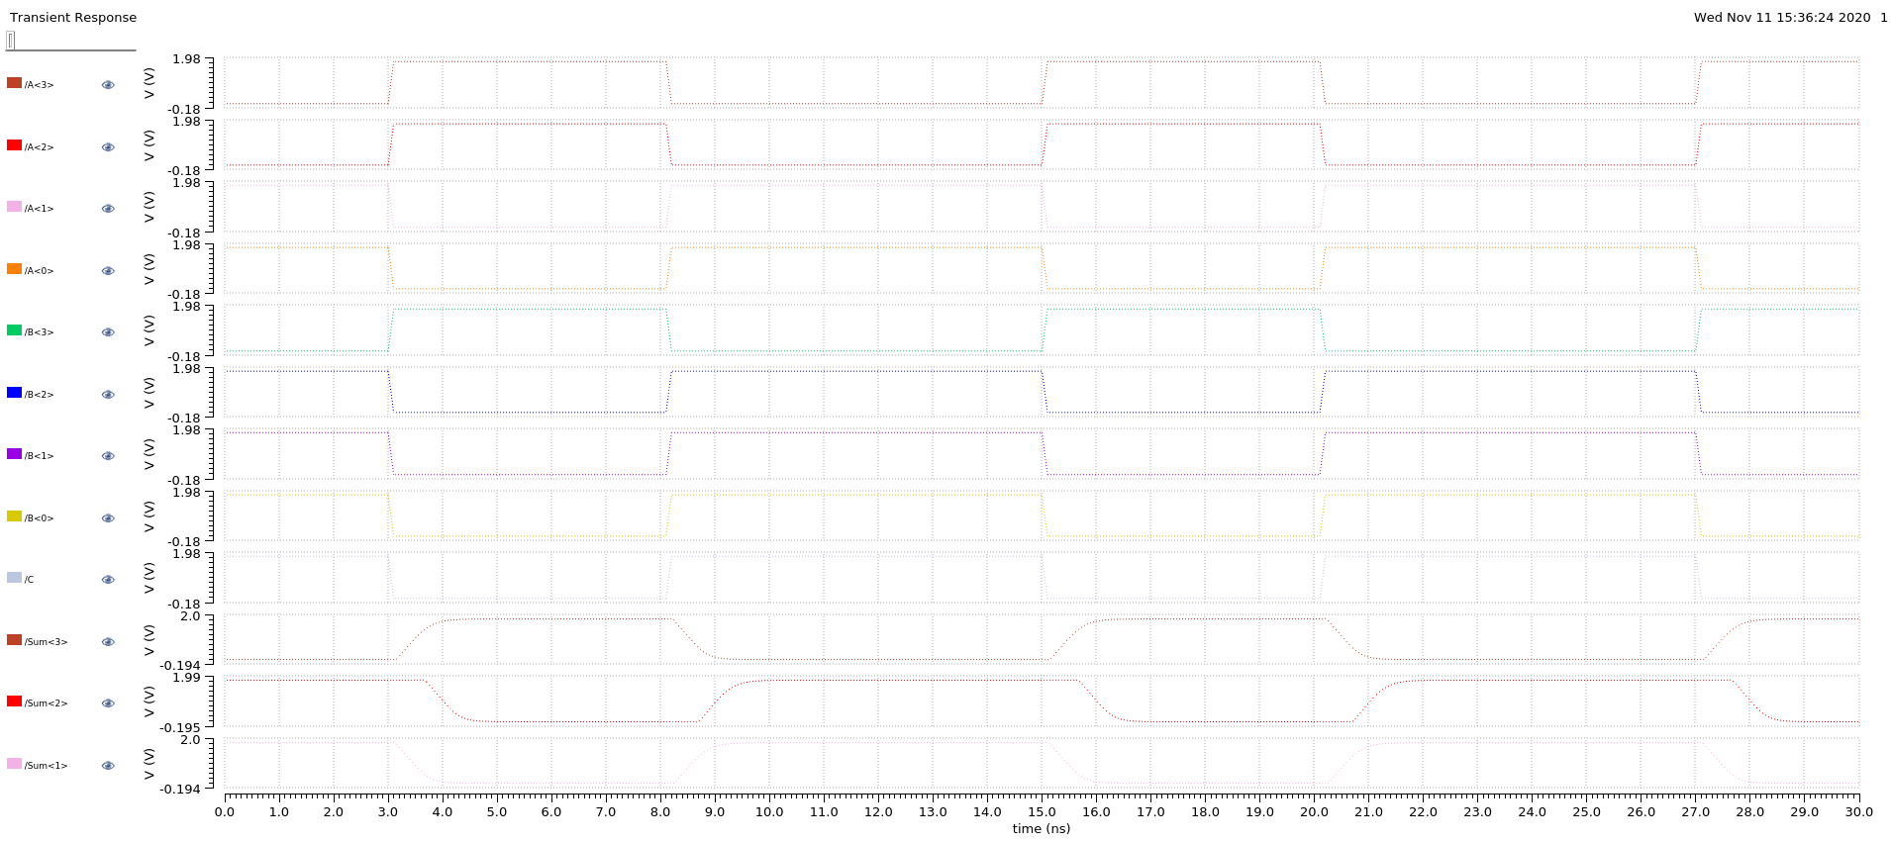

**Delay – not optimized**

|  |  |  |  |  |  |
| --- | --- | --- | --- | --- | --- |
| **Input (A/B/C)** | **Sum<3> (ns)** | **Sum<2> (ns)** | **Sum<1> (ns)** | **Sum<0> (ns)** | **Carry (ns)** |
| 0000/1111/1 | 0.997433 | 0.800223 | 0.603093 | 0.416744 | 1.001209 |
| 1010/0101/0 | 0.991179 | 0.786862 | 0.58223 | 0.38279 | 1.02986 |
| 1010/0101/1 | 0.997515 | 0.800222 | 0.603385 | 0.416746 | 1.001566 |
| 1100/1000/0 | 0.819424 | 0.565779 | 0.609387 | 0.44322 | 0.42464 |

**Delay – optimized**

|  |  |  |  |  |  |
| --- | --- | --- | --- | --- | --- |
| **Input (A/B/C)** | **Sum<3> (ns)** | **Sum<2> (ns)** | **Sum<1> (ns)** | **Sum<0> (ns)** | **Carry (ns)** |
| 0000/1111/1 | 0.632433 | 0.544623 | 0.438093 | 0.204744 | 1.301209 |
| 1010/0101/0 | 0.779979 | 0.677162 | 0.572358 | 0.36739 | 0.60806 |
| 1010/0101/1 | 0.995395 | 0.801842 | 0.609585 | 0.418846 | 1.10165356 |
| 1100/1000/0 | 0.601624 | 0.547079 | 0.608175876 | 0.44091 | 0.43336 |

**Power Consumption – not optimized**

|  |  |
| --- | --- |
| **Input (A/B/C)** | **Power Consumption (uW)** |
| 0000/1111/1 | 18.33 |
| 1010/0101/0 | 39.56 |
| 1010/0101/1 | 18.87 |
| 1100/1000/0 | 17.52 |

**Power Consumption – optimized**

|  |  |
| --- | --- |
| **Input (A/B/C)** | **Power Consumption (uW)** |
| 0000/1111/1 | 37.336 |
| 1010/0101/0 | 42.209 |
| 1010/0101/1 | 35.915 |
| 1100/1000/0 | 18.062 |

**Area – not optimized**

18640000

**Area – optimized**

28730000