MASSACHUSETTS INSTITUTE OF TECHNOLOGY
Experimental Study Group
Physics 8.012

Exam 2 Solutions

Problem 1 (30 points): A block of mass sits at rest on a frictionless table; the block has a circular surface of radius as shown in the figure. A small cube of mass and speed is incident upon the block; the cube slides without friction on the table and slides without friction up the block. At the top of the block, the cube compresses a spring of spring constant until it momentarily comes to rest a height above the table. The cube then slides back down until it leaves the block.

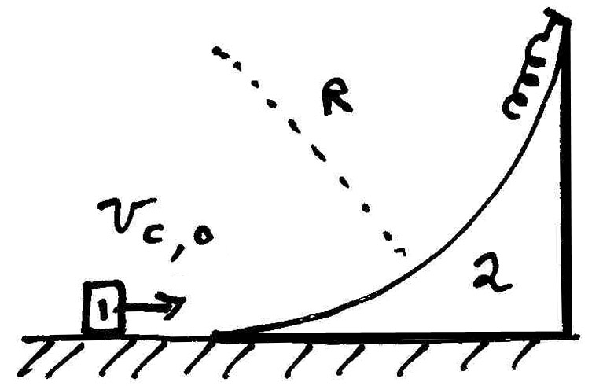

- How much did the spring compress?

- What is the final speed of the block when the cube is no longer on it?

Solution: If we take as our system, the cube and block, energy and momentum are both constant since the contact surface is frictionless and normal forces do no work. When the cube has reached its maximum height, the cube and block are moving with the same final speed .
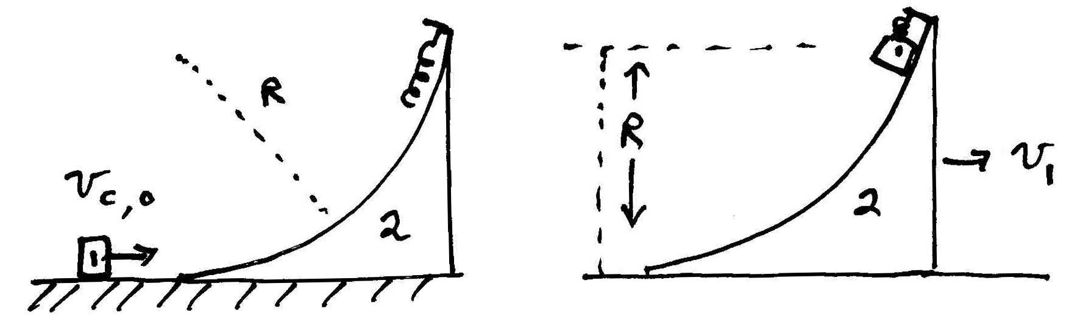

Therefore the momentum of the system is

which we can solve for the speed of the cube and block when the cube is at rest relative to the block.

.

The energy of the system is

.

Substituting Eq. into the energy condition yields

.

We can rewrite this in terms of the change in potential energy

where

is the reduced mass. This should not be surprising. Because the collision is elastic,

.

The final relative speed and the initial relative speed is , so Eq. becomes

in agreement with Eq. . So the amount that the spring was compressed is

.

We show the momentum diagram when the cube comes back down the block along with the momentum diagram before the cube went up the block in the figure below.

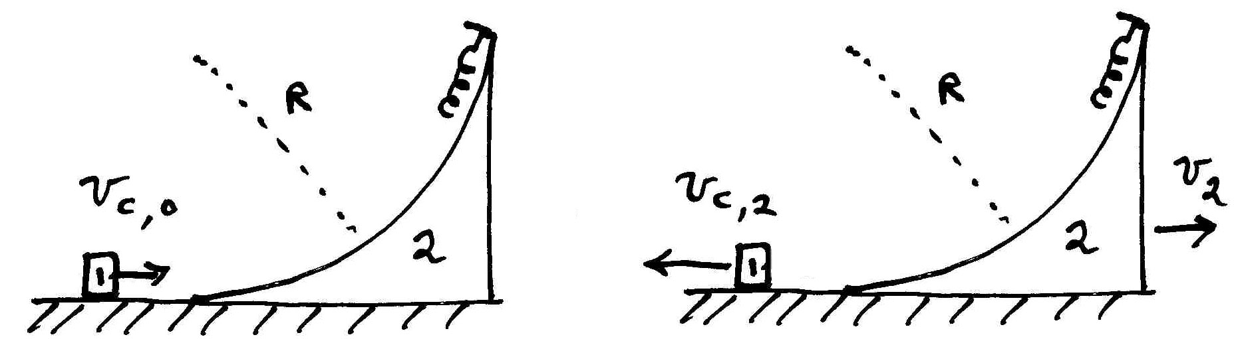

We can again apply the condition that the momentum of the system is constant,

which can be rewritten as

.

The condition that the energy of the system is constant becomes

.

We can rewrite the energy equation as

which after factoring becomes

.

Dividing Eq. by Eq yields

or
.

Note that Eq. can be rewritten as which is just our condition that the relative speed remains unchanged . We can substitute Eq. into Eq. and find that

.

We can solve Eq. for the speed of the block when the cube leaves the block,

.

Suppose we view the condition from the center of mass frame.

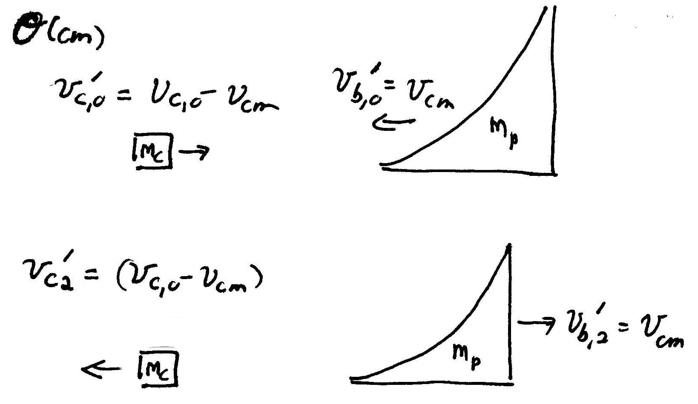

Then the block has an initial speed equal to the center of mass speed

.

After the collision the block reverses direction but maintains the same speed in the center of mass frame so

.

In the lab frame the speed of the block is then

.

Agreeing with Eq. .
Problem 2 (35 points):

A particle initially sits on top of a large smooth sphere of radius as shown in the figure. The particle begins to slide along the surface of the sphere. There is a friction force between the particle and the surface that varies with the angle according to

where is a constant. Let denote the gravitational constant.

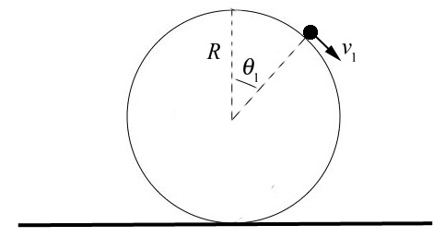

- Determine the angle with respect to the vertical at which the particle will lose contact with the surface of the sphere.

- What is the speed of the particle at the instant it loses contact with the surface of the sphere.

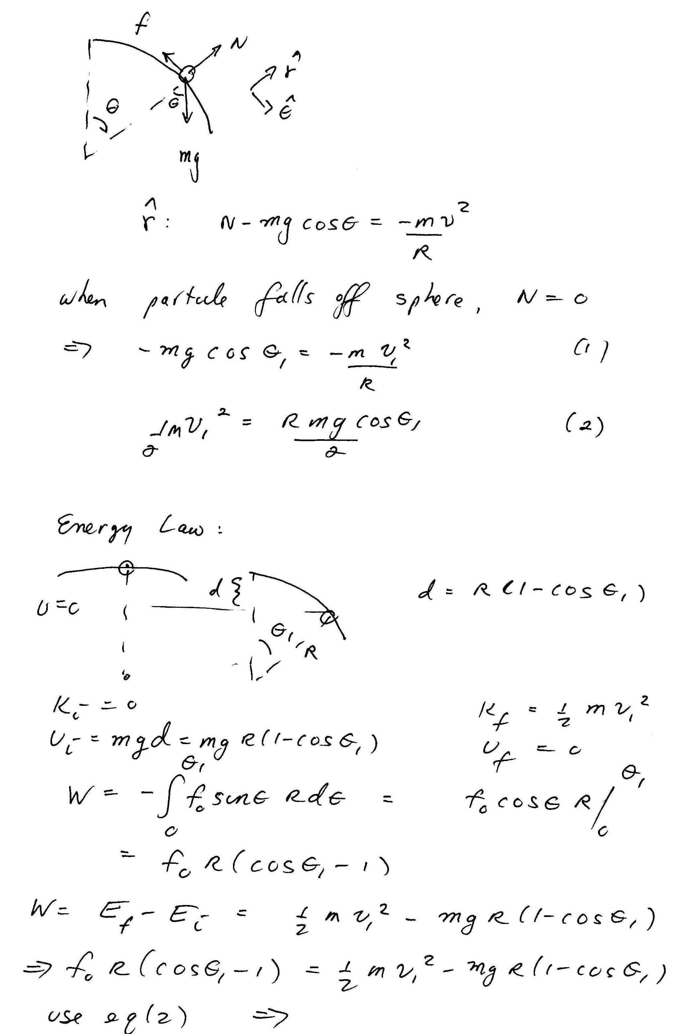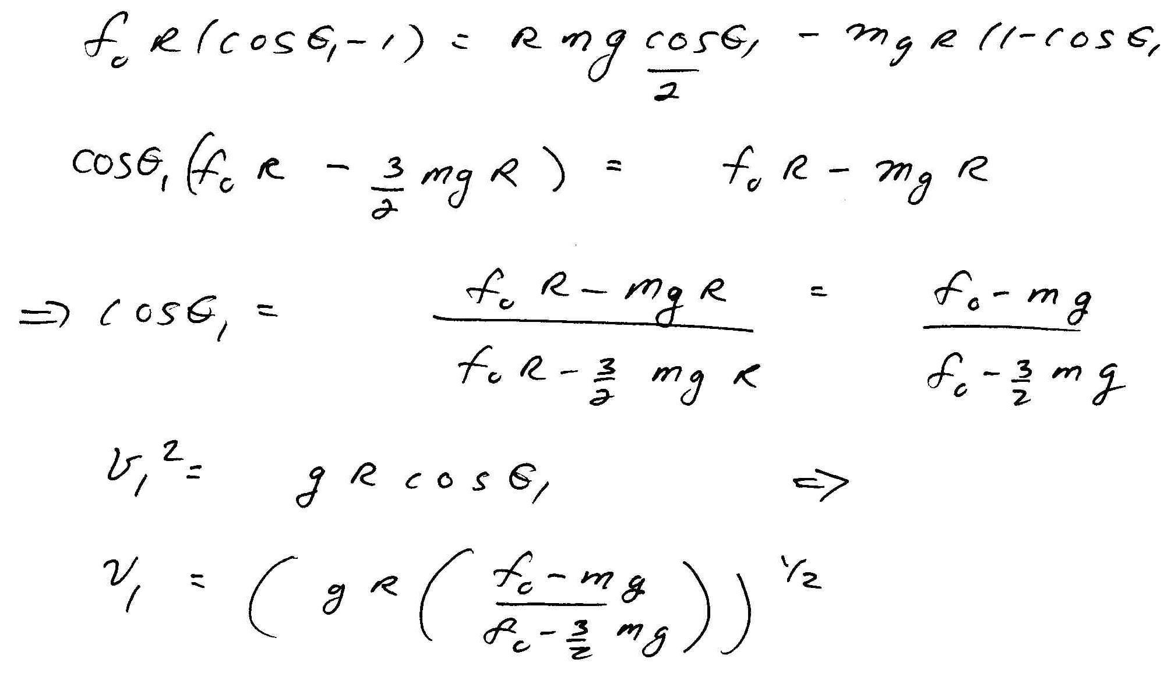
Problem 3 (35 points):

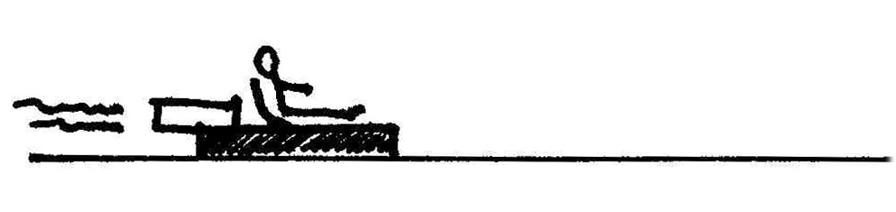

A rocket sled ejects gas backwards at a speed relative to the rocket sled. The mass of the fuel in the rocket sled is equal to one half the initial total mass (including fuel) of the sled. The rocket sled starts from rest on a frictionless track. You may ignore air resistance.

- Derive a relation between the differential of the speed of the rocket sled, , and the differential of the total mass of the rocket, .

- Integrate the above relation to find the speed of the rocket sled as a function of mass, , as the rocket sled speeds up.

- What is the final speed of the rocket sled after all the fuel has been burned? Express your answers in terms of the quantities , and as needed.

- After reaching its final speed, the sled enters a rough portion of the track that begins at with a coefficient of kinetic friction that varies with distance where is a positive constant. How far did the sled slide before it came to rest in that portion of the track? Express your answers in terms of the quantities , , and as needed.

Solution:
Take as the system the rocket sled, fuel, and the small amount of fuel of mass that is ejected during the interval . Let the positive -direction be to the right in the figures below. We first show the momentum diagram at time :
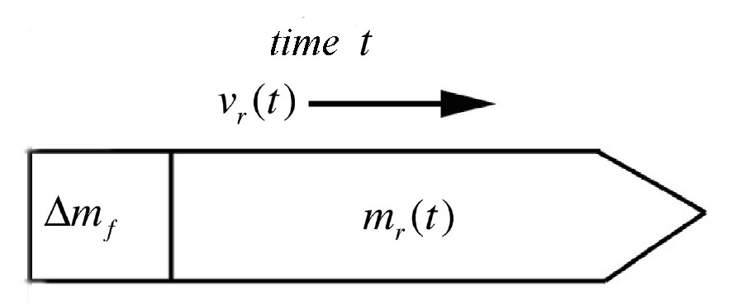

The smaller square represents the small amount of fuel of mass that is ejected during the interval . In the above figure is the combined mass of the rocket sled, the dry mass of the rocket sled plus the mass of fuel inside the rocket sled at time that does not leave the rocket sled during the interval. The -component of the velocity of the rocket sled is denoted by . In analyzing our momentum diagrams we shall drop the explicit reference to time dependence for the mass of the rocket and the -component of the velocity of the rocket sled, denoting them respectively by and Returning to our momentum diagram we see that at time , the -component of the momentum of the system is given by

By the end of the interval the rocket has recoiled forward with -component of the velocity . The fuel is ejected backwards relative to the rocket sled with speed , hence with a speed relative to the fixed reference frame depicted in the figures. After the interval has ended the momentum diagram of the system is shown below.

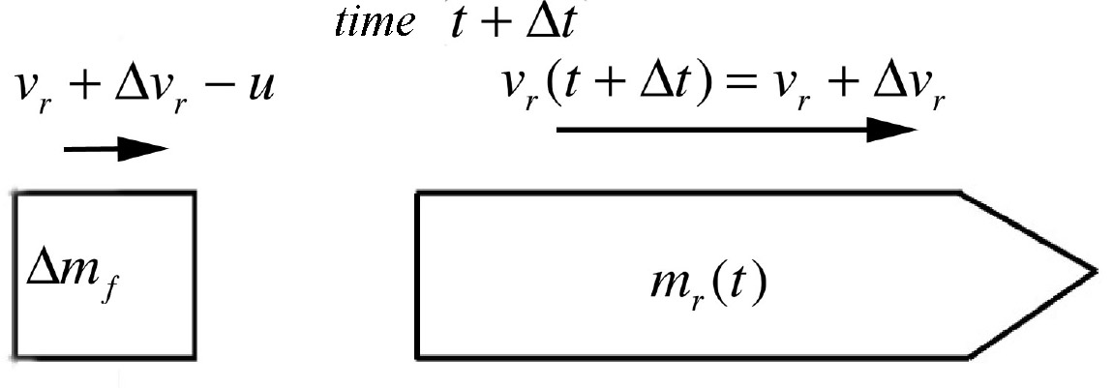

At time , the -component of the momentum of the system is given by

and so the change in -component of the momentum of the system during the interval is

.

There are no external forces acting in the -direction, therefore the momentum principle

becomes
.

We note that
.

Then using the definition of the derivative, we find that the differential equation describing the motion of the system is given by

Because the fuel is being ejected at a positive rate and the mass of the rocket sled is the rate of decrease of the mass of the rocket sled is negative we have that

We can now substitute Eq. into the Eq. and find that

.

We can solve this equation by the technique of separation of variables. First rewrite the equation as

.

Multiple each side by and divide by through by . Thus

.
- Integrate the above relation to find the speed of the rocket sled as a function of mass, , as the rocket sled speeds up.

We can integrate both sides of Eq.

.

Integration yields

- What is the final speed of the rocket sled after all the fuel has been burned? Express your answers in terms of the quantities , and as needed.

Because , the final speed of the rocket sled after the fuel has been burned is

- After reaching its final speed, the sled enters a rough portion of the track that begins at with a coefficient of kinetic friction that varies with distance where is a positive constant. How far did the sled slide before it came to rest in that portion of the track? Express your answers in terms of the quantities , , and as needed.

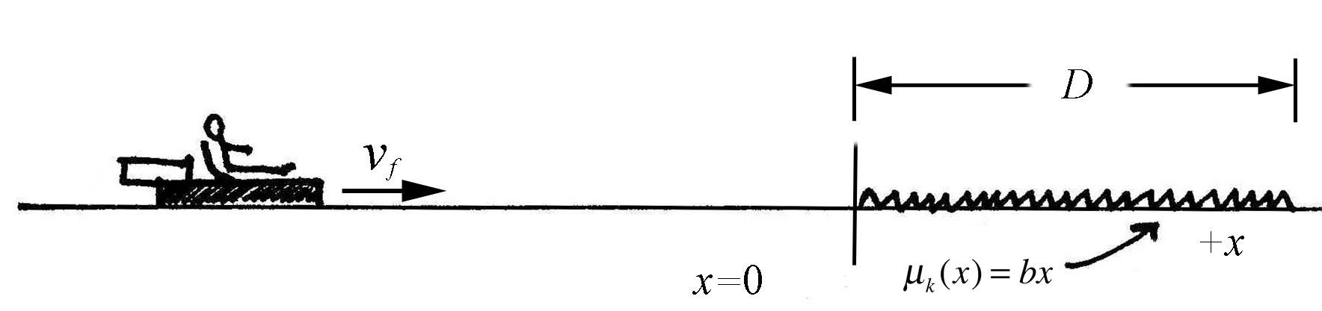

We shall use the energy law that

.

The non-conservative work is due to friction

The final mechanical energy is zero,

and the initial mechanical energy is jus the kinetic energy of the sled after the fuel as been burned,

.

Substituting Eqs. , , and into Eq. yields

.

We can solve Eq. for the distance that the sled slid before it came to rest

.

