MASSACHUSETTS INSTITUTE OF TECHNOLOGY
Experimental Study Group

Physics 8.012 Fall Term 2010

Exam 1

Problem 1: A car is driving through a green light at located at with an initial speed. The acceleration of the car as a function of time is given by

.

A bicycle rider is riding at a constant speed of and at is behind the car. The bicyclist reaches the car when the car just comes to rest at time .

- Find the time that the car has just come to rest.
- Find the speed of the bicycle.

Solution:

Getting started. We choose a coordinate system with the car and bicycle moving in the positive x-direction, and label the position of the car as a function of time by and the position of the bicycle as a function of time by . We choose the origin such that at , the car is at the origin and the bicycle is . The initial x-component of the velocity of the car is . The initial x-component of the velocity of the bicycle is denoted by and is the quantity we are trying to find.

Strategy: We first identify that the car has two stages of motion, and that at some instant during the second stage of motion, the bicycle and car intersect when x-component of the velocity of the car is zero. We can express these two conditions as

Because we are given the piecewise function for the x-component of the acceleration of the car for the two stages of motion, the initial conditions, and the length of the first stage of motion, we can integrate the x-component of the acceleration to find the x-component of the velocity of the car. We can find by solving Eq. . We can integrate the x-component of the velocity of the car to find the position of the car . We are also told that the car is moving at a constant speed so we can easily find the position function which will be a depend on the unknown initial speed . We can then use Eq. to solve for .

Carrying out the plan. For the first stage of motion of the car during the interval
, the car is not accelerating so the speed is constant and hence

.

For the second stage of motion

Keep in mind that the end conditions of the first stage of motion are the initial conditions for the second stage of motion so . Thus after integrating we get

Now substitute the endpoint so the integral to finally yield

Thus the x-component of the velocity of the car for the entire motion is given by

We can use now Eq. to find the time that the car came to rest,

.

Solving for (using the positive square root)

Note: We have two solutions: or . The second solution does not apply to our time interval.
For this one dimensional motion the change in position of the car as a function of time for the first stage of motion is given by

Because the car started at the origin, the position at the end of the interval is given by

.

For the second stage of motion, the change in position is given by the integral of the x-component of the velocity for stage two (Eq. ),

Upon integration we have

So after substituting and substituting in the endpoints of the integration interval we have that for the second stage of motion

Combining our results, the position of the car as function of time is given by

We can find the position of the car when the x-component of velocity of the car is zero, by setting in Eq. and noting that finding

b) Graph the speed and position of the car as a function of time.

Solution: The graph of the x-component of the velocity of the car and the position of the car as functions of time are shown below.

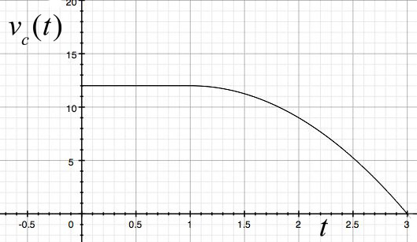

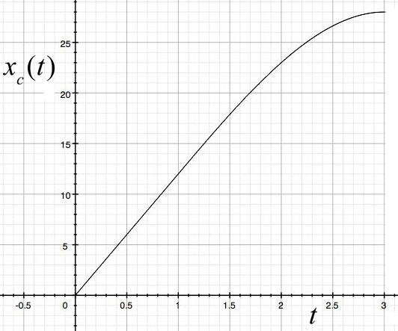

- A bicycle rider is riding at a constant speed of and at is behind the car. The bicyclist reaches the car when the car just comes to rest. Find the speed of the bicycle.

Solution: Since the bicycle is traveling at a constant speed with an initial position , the position of the bicycle as a function of time is given by

.

At ,

Because the bicycle and car intersect at , we can now use Eq. , Eq. and Eq. to find the initial speed of the bicycle

.

So the speed of the bicycle is

.
Problem 2 (25 points):

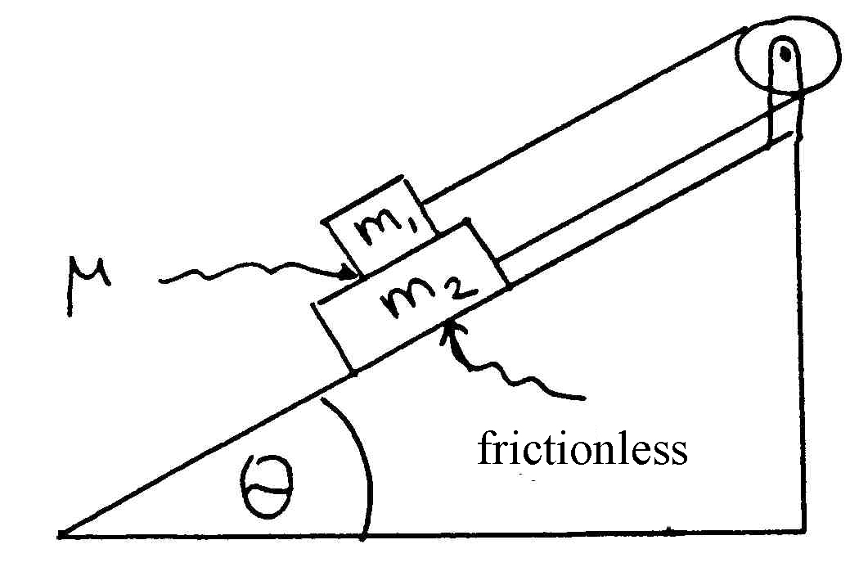

Two blocks with masses and such that are connected by a massless inextensible string and a massless pulley as shown in the figure below. The pulley is rigidly connected to the top of a wedge with angle . The coefficient of friction between the blocks is . The surface between the lower block and the wedge is frictionless. What are the magnitudes of the acceleration of the two blocks?

Solution: We shall apply Newton’s Second Law to each block. Since the blocks are constrained by the rope, the accelerations of the blocks must be related. We should be able to then simultaneously solve the equations of motion for each block to find the magnitude of the acceleration. We begin by choosing a coordinate system shown in Figure 2.1.
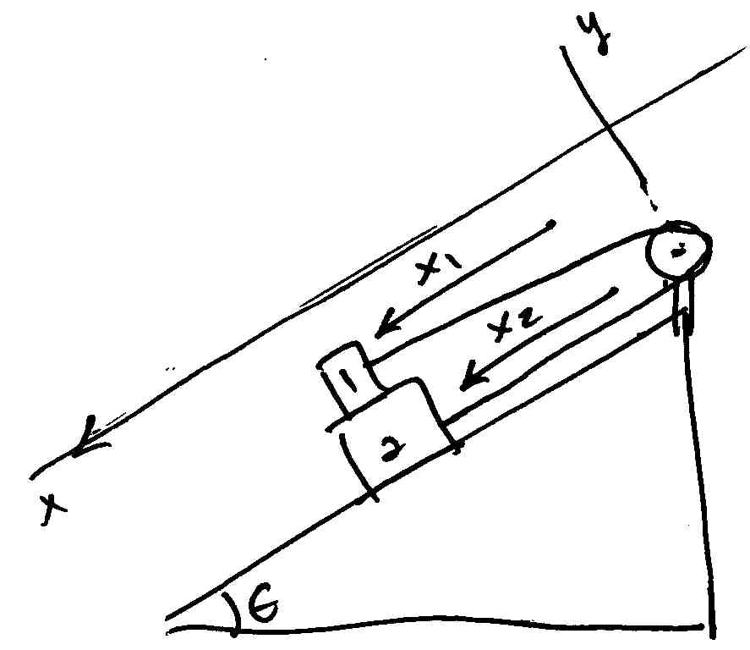

Figure 2.1

We then draw free body force diagrams for each object. We show these in Figure 2.2a and figure 2.2b.

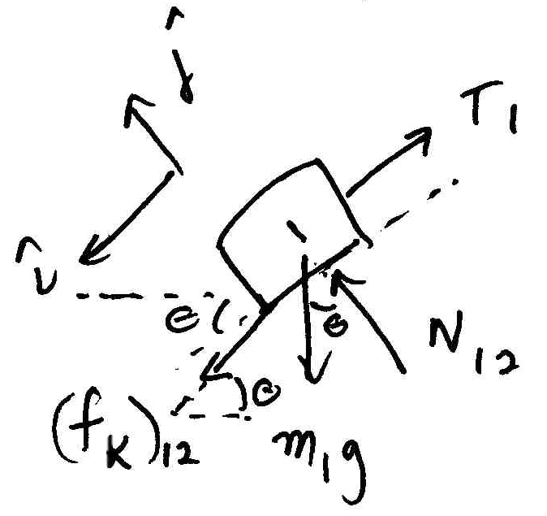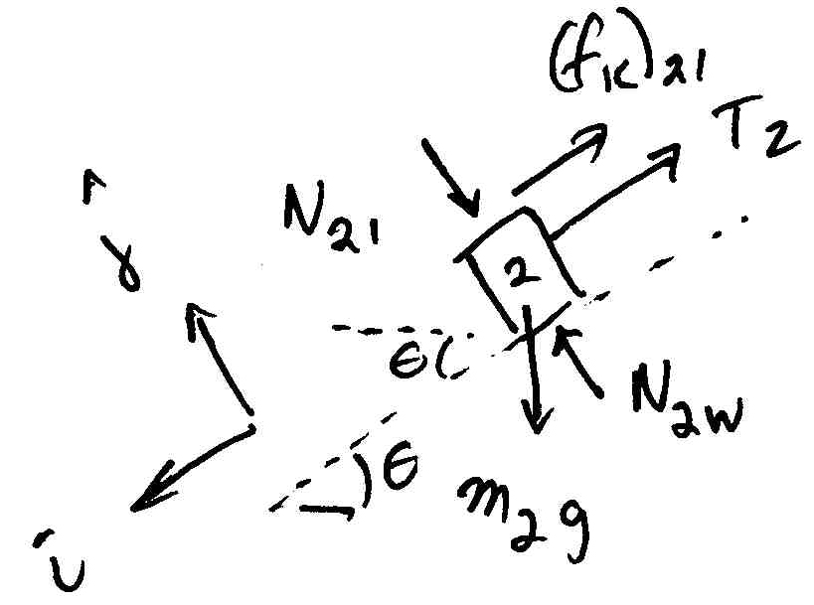
Figure 2.2a Figure 2.2b

Newton’s Second law on object 1 becomes

.

Newton’s Second law on object 2 becomes

.

We can use Eq. to solve for the normal force between the surfaces,

We note that because we assumed that the string is massless and inextensible the tension in the string is uniform, so

.

We note that the contact force between the blocks form an action-reaction pair. When we decompose this force into its tangent (kinetic friction) and perpendicular (normal force) components, we have that
.
From Eq.

.

Also we model the kinetic friction by the force law

.

Finally we note that the x-components of the accelerations of the two objects are related by

.

Note that is also the magnitude of the acceleration fo the blocks because we expect that . Thus using Eqs. , , , , and , we can rewrite Eqs. as

and Eq. as

.

We have two unknowns and , and two independent equations so we can algebraically solve for the magnitude of the acceleration of the blocks.

We subtract Eq. from Eq. yielding

.

Eq. simplifies to

.

Thus we can solve Eq. for the magnitude of the acceleration of the blocks

.

Remark: If the constraint condition Eq. 1.9 is not immediately obvious, consider that the length of the string is given by

,

where is the radius of the pulley. Since the length of the string is constant we can differentiate Eq. twice with respect to time and find that

.

Since and are constants

.

Therefore Eq. becomes

Thus justifying Eq. .

Problem 3 (25 points):

A U-control airplane of mass is attached by a wire of length and negligible mass to the “pilot” who controls the “lift” provided by the wing, ”, the force that is normal to the plane of the wings keeping the plane aloft and hence in a direction perpendicular to the wire. The plane’s engine keeps it moving at constant speed and the wire make an angle with the ground. The gravitational acceleration is . Express your answers to the following questions in terms of , , , , and as needed.

- Find the tension in the wire when the plane is flown overhead in a circle when the wire make an angle with the ground.

- Find a condition that the speed of the plane must satisfy such that the tension in the string is never zero for all values of , the angle the wire makes with the ground. .

- Find the magnitude of the “lift”, the force that is normal to the plane of the wings keeping the plane aloft.

- Based on your result form part d), is possible?

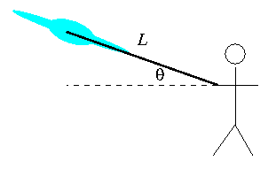
Problem 4 (25 points): A bucket of water spins with angular speed . What shape does the water’s surface assume. i.e. find an equation for the surface of the water. Clearly show your coordinate system, free body diagram, and all relevant work.

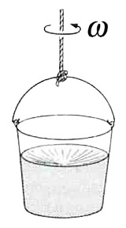
Solution: Choose polar coordinates. The free body force diagram is shown below.
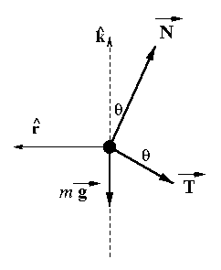
Then Newton’s Second Law in the vertical direction becomes

.

Newton’s Second Law in the radial direction becomes

where is the radius of the circular orbit of the plane.

Multiply Eq. by yields

Multiply the Eq. by yields

Substract Eq. from Eq. and use the identity to get an expression for the tension:

b) The tension in the wire is zero when
.

Because , if then the tension is never zero for any possible angle .

- Multiply Eq. by yields

.

Multiply the Eq. by yields

Add Eq. and Eq. , use the identity , and after some rearranging get an expression for the magnitude of the lift force:

d) When , , and hence which is not possible.

