MASSACHUSETTS INSTITUTE OF TECHNOLOGY
Experimental Study Group
Physics 8.012

Exam 2 Equation Summary

Momentum:
, ,
Impulse:
Work-Change in Mechanical Energy:
,
Kinematics Circular Motion:
Kinematics:
,

Constant Acceleration:
Universal Law of Gravity:
Surface of earth:
Coulomb’s Law:
Contact force:
Static Friction:
direction depends on applied forces
Kinetic Friction:opposes motion
Hooke’s Law:, restoring
Center of Mass:

Velocity of Center of Mass:
Kinetic Energy:
;
Work: ;
Work- Kinetic Energy:

Power:

Potential Energy:
Potential Energy Functions with Zero Points:

Constant Gravity:
.
Inverse Square Gravity:
.
Hooke’s Law:

MASSACHUSETTS INSTITUTE OF TECHNOLOGY
Experimental study Group
Physics 8.012 Fall Term 2009

Exam 2

Name _______________________________

The following exam consists of three problems. Answers without work shown will not be given any credit. Good luck!

Problem 1 (30 points) ____________

Problem 2 (35 points) ____________

Problem 3 (35 points) ____________

Total (100 points) ____________

Problem 1 (30 points): A block of mass sits at rest on a frictionless table; the block has a circular surface of radius as shown in the figure. A small cube of mass and speed is incident upon the block; the cube slides without friction on the table and slides without friction up the block. At the top of the block, the cube compresses a spring of spring constant until it momentarily comes to rest a height above the table. The cube then slides back down until it leaves the block.

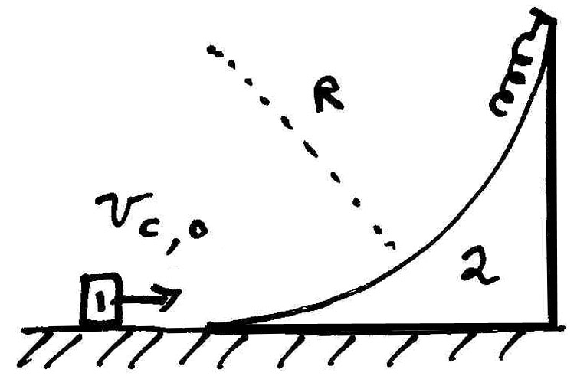

- How much did the spring compress?

- What is the final speed of the block when the cube is no longer on it?

Problem 2 (35 points):

A particle initially sits on top of a large smooth sphere of radius as shown in the figure. The particle begins to slide along the surface of the sphere. There is a friction force between the particle and the surface that varies with the angle according to

where is a constant. Let denote the gravitational constant.

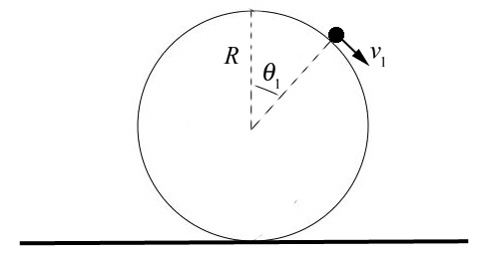

- Determine the angle with respect to the vertical at which the particle will lose contact with the surface of the sphere.

- What is the speed of the particle at the instant it loses contact with the surface of the sphere.
Problem 3 (35 points):

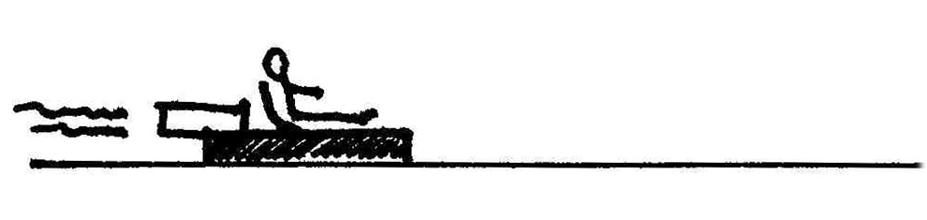

A rocket sled ejects gas backwards at a speed relative to the rocket sled. The mass of the fuel in the rocket sled is equal to one half the initial total mass (including fuel) of the sled. The rocket sled starts from rest on a frictionless track. You may ignore air resistance.

- Derive a relation between the differential of the speed of the rocket sled, , and the differential of the total mass of the rocket, .

- Integrate the above relation to find the speed of the rocket sled as a function of mass, , as the rocket sled speeds up.

- What is the final speed of the rocket sled after all the fuel has been burned? Express your answers in terms of the quantities , and as needed.

- After reaching its final speed, the sled enters a rough portion of the track that begins at with a coefficient of kinetic friction that varies with distance where is a positive constant. How far did the sled slide before it came to rest in that portion of the track? Express your answers in terms of the quantities , , and as needed.

