Uni: hj2602

Project 1 Full Project Writeup

**0.1**

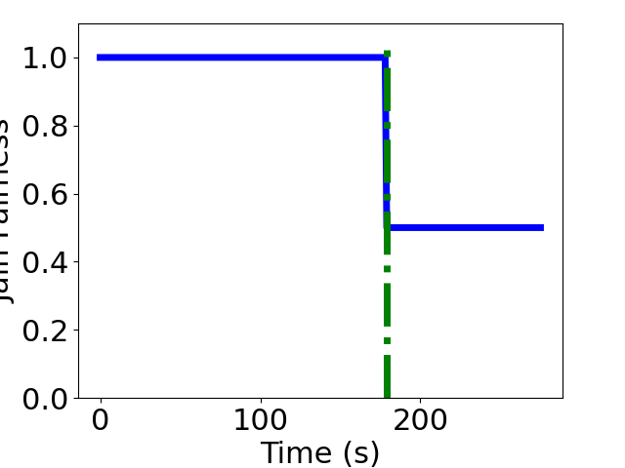

Utilization

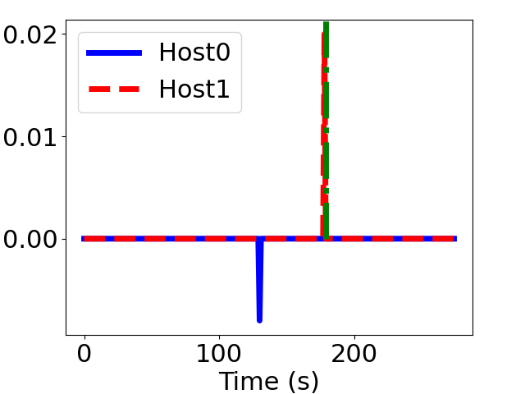

Smoothness

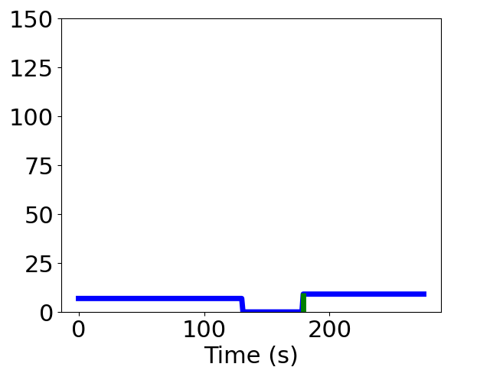

Fairness

**0.5**

Utilization

Smoothness

Fairness

**0.9**

Utilization

­­

Smoothness

Fairness

Writeup:

The three utilization graphs show that as the alpha value gets closer to 1, the throughput changes dynamically being able to utilize the bandwidth in a more efficient manner. To support this argument, I tried another alpha value of 0.3 which showed a better distinction between 0.5 and 0.9 as below:

With regards to smoothness for bigger alpha values, streaming from host0 tended to have greater spikes leading into more disruptive output whereas host1 showed a stable horizontal line. Alpha value with 0.1 on the other hand had a disruptive signal for host1 making it less smooth for the videos to be played. This makes sense as alpha value 0.3 had an effect of both having disruptive signals displayed at both ends as below:

Lower alpha value tends to have less range of fairness displayed whereas higher alpha values had a strong fairness of graph representation. This result can be interpreted as a tradeoff between efficiency and fairness – as the program attempts to find a tradeoff between the two measures with competing downloads.