This laboratory assignment accompanies the book, [*Embedded Systems: Real-Time Interfacing to ARM Cortex M Microcontrollers, ISBN-13: 978-1463590154*](https://www.amazon.com/Embedded-Systems-Real-Time-Interfacing-Microcontrollers/dp/1463590156), by Jonathan W. Valvano, copyright © 2021.

**Goals**  • To design an embedded system,

• To study issues of power, clock, reset, and programming for an embedded system,

• To layout a PCB board.

**Review**  • Data sheets for your microcontroller

**Starter files** **EE445L** library for Eagle, see Lab 6

<https://www.dropbox.com/s/0ejc0y3xmyl91u8/EE445L.lbr?dl=1>

Micro USB socket <https://www.dropbox.com/s/z9mt2cnoqn3vkdu/105017-0001.lbr?dl=1>

**Lab7.sch**, **Lab7.brd** starter files, **(Spring 2022 Eagle version)**<https://www.dropbox.com/s/d7ic0eswcok70x5/EE445L_Lab_7_Starter.sch?dl=1>

<https://www.dropbox.com/s/2smhs00bga2ofv8/EE445L_Lab_7_Starter.brd?dl=1>

**Lab7BOM.xls (Spring 2022 version)**[**https://www.dropbox.com/s/jh1j5m19z04pavr/Lab7BOM.xlsx?dl=1**](https://www.dropbox.com/s/jh1j5m19z04pavr/Lab7BOM.xlsx?dl=1)

**Team Size: 4**

 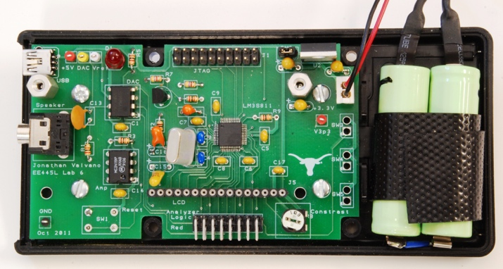

*Figure 7.1. Example mock-up and eventual Lab 11 system.*

## Background

In Lab 7, you will use the CAD program **Eagle** to layout an embedded system. The design of the system must satisfy certain requirements. Rather than simply redesigning one of the previous labs like you would have done in Lab 6, this embedded system must do something useful. There are some ideas posted at <http://users.ece.utexas.edu/%7Evalvano/EE445L/projectideas.htm> , but you have flexibility to define exactly what it is to do. If you look at [Sparkfun.com](https://www.sparkfun.com/) you will see lots of ideas of I/O devices you could attach to the system. The scope of the project is a microcontroller-based embedded system demonstrating the educational objectives of this class.

## Requirements

* The TM4C123 LaunchPad will be attached to the top or bottom of the PCB you produce. We will not be placing any surface mount parts on the PCB this semester. You can use the larger TM4C LaunchPad (MSP432E/TM4C1294) or two TM4C123 LaunchPads
* A PCB layout of the system must be used, having been created with **Eagle** (if you wish to use another design tool, such as KiCAD, all team members must agree, and the team will be responsible for ordering and paying for their PCB.)
* Each group will produce one PCB layout (a .SCH plus a .BRD file with **Eagle**)
* There must be at least two inputs, two outputs, and two interrupt service routines
* The final system (Lab 11) will be an actual device with chips soldered onto the PCB
* The final system (Lab 11) must fit into an appropriate enclosure (wood, metal, plastic or cardboard)
* The system should perform something useful.
* The system must contain four of more identifiable subcomponents (each team member must be responsible for at least one major subcomponent).
* TAs will judge if the project is sufficiently complicated.
* Each team of 4 can order one two-layer 30-in2 PCB from JLCPCB (or equivalent) if the PCB is designed with Eagle.
* All components must be through hole (no surface mount parts without approval from the instructor)
* You can use the ESP8266 from the hardware kit. Do NOT solder it to the board. Pick up a socket

## Constraints

* Each **PCB** must be done using the JLCPCB design rule checks  
  <https://jlcpcb.com/capabilities/Capabilities>
* The starter files have minimum trace and other distance metrics that cannot be changed
* ECE lab checkout EER 1.824 has through-hole resistors (1/4 watt) and through-hole capacitors you can checkout (solder onto your PCB and never return)
* **Lab7BOM.xls** has a specific list of parts that we will be able to give you
* You must purchase, borrow, or get free samples for any additional parts that you require
* You can use two motors from the Lab 10 supplies to build a robot (we have matching wheels), but the motors and wheels must be returned
* You should NOT use a copper pour because it makes modifying or repairing the board exceptionally challenging if you were to make a design or layout error.

## Processor Selection

***Implementation option 1****.* We expect all students to design a complete system by attaching the TM4C123 LaunchPad onto the PCB. Furthermore, we recommend if you have any unused pins, that you route the pins away from the processor and connect to vias or logic analyzer pins. This way you can convert unused pins to debugging pins or use them to fix mistakes that you have discovered during testing. You must include a power regulator on your PCB because most systems need more 3.3V current than available from the LaunchPad itself.

***Implementation option 2****.* You can implement a complete system using a microcontroller chip soldered onto one PCB, like Lab 6. For this option you will need to have prior experience with soldering surface mount components. You will need to work closely with the professor and your TA during the design and layout. In order to salvage your project and grade during Lab 11, we suggest you add at least one via (any size) along the trace of all I/O pins used in the project. This way if the TM4C123GH6PM microcontroller never boots up, you can unsolder the TM4C123GH6PM, attach individual wires to the I/O pins and complete the project with your EK-TM4C123GXL LaunchPad board. You must include a power regulator on your PCB. If you are using a processor other than the TM4C123GH6PM, you must sample it or buy it. It must arrive before your final PCB files are submitted. For example, if you turn in your final PCB files before the parts arrive, it might arrive too late to complete the lab and you may not be able to finish. We will have enough samples of the TM4C123GH6PM.

## Optional Components to Consider

**Other microcontrollers.** Your PCB must have a TM4C123 or MSP432E/TM4C1294. However, in addition to the TM4C, your system may include microcontrollers. Some students add a Raspberry Pi to provide for quantum boost in processing power. If you use a microcontroller in addition to the TM4C, you can get full credit, but will not be eligible for the “best design” award

**ESP8266 wifi.** If you are adding the ESP8266 be aware the device requires up to 70 mA (although the data sheet reports up to 200 mA). Therefore, select a +3.3V regulator that can supply this required current (i.e., do not use the LP2950, rather use the LM2937-3.3). For more information on the ESP8266 refer back to Lab 4.

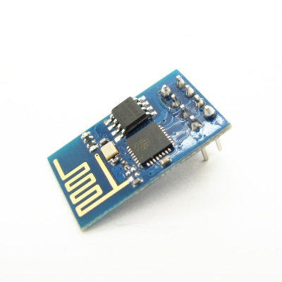

*Figure 7.2. ESP8266 version 1.*

**Audio amp.** For single channel you can use an audio amp like the MC34119 or the TPA731. For stereo sound, use two separate audio channels and two speakers (4 wires). You should order free samples from one of the chip vendors like Analog Devices.

**Accelerometers and other sensors**. There lots of devices available as free samples. However, be very careful because most of them are very difficult to solder because the pins are underneath the device. The best way to add acceleration is to get a module (chip soldered onto a board) from a hobby store like Sparkfun, Adafruit , or Pololu.

### Enclosure

There are many approaches for the enclosure. Please check with the Texas InventionWorks  staff before cutting, drilling, or milling boxes. NOTE: You will need to be trained on the equipment you want to use.

Approach 1) We will give you a Hammond 1591ESBK for your Lab 7,8,11 project if you wish. This box is general purpose Acrylonitrile-Butadiene-Styrene, GP-ABS. This material will outgas chlorine if melted, so it cannot be cut with the laser cutter, but it can be safely cut with a saw or drilled with a drill. This box is 7.5" by 4.3" by 2.2" and the data sheet is

<http://users.ece.utexas.edu/~valvano/EE345L/Labs/Fall2011/Hammond1591E.pdf>

Approach 2) You may purchase a box and count it towards your $60 budget.

Approach 3) You may build your own box. You may use any material, such as wood, plastic, metal, or cardboard. You will not be judged on the beauty of the enclosure, rather you will be judged on the functionality of the system. Texas InventionWorks **is** open this semester**.** <https://wikis.utexas.edu/display/utmakerstudios/COVID-19+Rules+and+Regulations>

Approach 4) You may build your own box at the Texas InventionWorks . Any costs for raw material used to build the box does NOT count towards your $60 out of pocket limit. Note that students can successfully complete labs 7,8,11 without spending any out-of-pocket money. Design the box in a CAD program like Fusion 360, create 2-D pdf files for the 6 sides and cut the pieces out of acrylic/wood on the laser cutter.

## Final Design Competition

There will be a “Science Fair”-like public demonstration for Lab 11. We will present special awards to the team with the best design. The judging will be performed by the other EE445L students by watching a YouTube video and voting on Canvas. The YouTube videos will be public, but the Canvas voting will be private. <Competition format is to be determined>

Some students will put extra electronics off the PCB, because it doesn’t all fit on the PCB. If you do have off-board electronics, then you will need a connector or something to create the bridge. You can get good grades in Labs 7, 8 and 11 with off board electronics, but you will not be eligible to win “best design”. Your grade depends on if the required tasks are completed on-time, and if your eventual project (I/O, microcontroller, and software) works.

To win “best design” you will need to meet the following restrictions:

Uses only TM4C123, MSP432E, or TM4C1294 LaunchPads

All electronics (resistors, capacitors, ICs) are on the PCB

LCD displays, switches, sensors, LEDs, speakers, keypads, and microphones can be off the PCB

Your team of 4 spends less than $60 on extra components

This $60 extra expense can be negotiated with your TA

*$60 Limit*

There are two system costs you will add up. The first cost is the sum of all the components regardless of where the part was obtained. This would be the cost to manufacture the system. The second cost is the sum of all the parts you purchased to put into the device. Components from ECE lab checkout or from Lab7BOM.xls do not count against your maximum of $60 additional components. Free samples, the PCB, batteries, and components checked out of the ECE lab checkout desk do not count towards your $60 limit but should be listed with fair market price in Procedure e. Passive components (resistors, capacitors, male-male header pins, test-points) you get from the ECE lab checkout desk do not have to be returned. Solid state parts from checkout may have to be returned, so please ask at the checkout counter. If you wish to use a part you already own, or a part given/lent to you by another, then you must find the part in stock and report the cost as part of your $60 limit.

## Pre-preparation (due Friday 3/11 )

Write a one-page **Requirements Document** for the system. Refer to Labs 3 and 5 for general information about requirements documents. We expect this document to change, so keep it up to date as you progress through the design, implementation, and testing phases. Please use this outline

**1. Overview**

**1.1. Objectives:** Why are we doing this project? What is the purpose?

**1.2. Roles and Responsibilities:** Who will do what? Who are the clients?

**1.3. Interactions with Existing Systems:** Include this if you are connecting to another board

**2. Function Description**

**2.1. Functionality:** What will the system do precisely?

**2.4. Performance:** Define the measures and describe how they will be determined.

**2.5. Usability:** Describe the interfaces. Be quantitative if possible.

**3. Deliverables**

**3.1. Reports:** Simply state the reports for Labs 7 and 11 will be written

**3.2. Outcomes:** Simply copy/paste the Lab 7 and Lab 11 deliverables.

## Parts (should arrive before Demo2)

1. Parts you get from ECE lab checkout (1/4-W resistors, capacitors, male-male headers, and test points)
2. Parts you plan to buy from places like Sparkfun, Adafruit, or Pololu.
3. Parts you plan to get from the professor’s cabinet.

## Preparation (show BOM, SCH, and PCB to your TA at the start of your lab period)

1. Create a bill of materials using the **Lab7BOM.xls** template and collect as many of the components you can. The bill of materials should include all components such as LEDs, resistors, capacitors, connectors, and your enclosure. Additionally, connectors and cables should be included in the BOM.
2. Draw the circuit diagram (SCH file) using Eagle. Refer to the suggestions and guidelines described in Lab 6. We suggest you begin with the **Lab7.sch**, **Lab7.brd** starter files. Rename both **.sch** and **.brd** files to some name that easy for you to identify. Make sure you have the 2021 version. Add features such as test points and labels that will make it easy to test the hardware. You must also ensure you are following these rules:
   1. No net names that begin with **N0**;
   2. All components need labels (e.g., U1 R1 C1 J1 etc.), shown both on the board and the circuit diagram.
   3. Each IC should have a bypass capacitor, placed on the PCB as close to the chip as possible.
   4. For resistors, specify wattage (1/4 watt) and tolerance (5% carbon).
   5. For capacitors, specify type as 20% Z5U ceramic, or 10% tantalum.
3. Be clear how the system will be powered, and how the power can be turned on and off. You must use a regulator on the PCB. The typical configuration has battery or USB plug into the PCB, an off-board power switch, and then the LM2937-3.3 regulator for 3.3V supply. In this configuration, the TM4C123 gets its power from the LM2937-3.3, and the 2-pin jumper on the LaunchPad is removed.
4. Does the operator need to hit the reset button? If so, bring the reset pin out to a user-reachable negative logic switch.
5. See **Common Mistakes that delay the board for the entire class.**

## Valvano Review (due by 3/25)

1. Email both SCH and BRD files to [valvano@mail.utexas.edu](mailto:valvano@mail.utexas.edu), and come to an office hour for a quick review. All members need not be present. Perform this review as soon as most of the SCH file is complete and none of the PCB file has been started. There will be expanded office hours the week of 3/21-25
2. After your Valvano review, update your **Lab7BOM** excel sheet as needed, and make a copy of it, delete all rows except where column L specifies **Cabinet**. Put ALL team members in cell **A:3**. Delete all columns except

A) Quantity

D) Description

L) Where to get it

Print the excel sheet on one piece of paper and bring to class. Valvano will put parts in a bag and leave the bag with your printed excel sheet in lab.

## Procedure Demo1 (due during lab period)

1. Place all components with the PCB area. **Do not move components around PCB or start routing until completing the TA design review of your SCH.** The data sheets of many ICs offer suggested values and placements of capacitors, to improve performance. Make sure the **Snap to Grid** mode is active (experiment with different settings of the snap). Place all though-hole components on the top side. If possible, align all chips in the same direction. Configure the board so that most though-hole soldering occurs on the bottom side.
2. Consider how the PCB will fit in the box. How will the PCB be mounted to the box? Consider the 3-D size of the LaunchPad and LCD. How will you reach the test points for analog debugging?

You will place a male-male header on the PCB to simplify using the low-cost logic analyzer to digital pins. Connect strategic **digital** pins to the low-cost logic analyzer. Add test points at strategic points to assist in analog debugging. One simple way to make an analog test point is to place two 0.029-in holes 0.1 in apart. During Lab 11 you will solder a U wire into it. A second way is to make a 0.043 in hole. During Lab 11 you will solder a test point into the one hole (get from ECE lab checkout).

1. How does the operator reach the switches? How does the operator see the LEDs?
2. Can you place the LCD on the PCB so no cable is required? How will the LCD be mounted?
3. Estimate or measure the supply current required by the entire system, including microcontroller and I/O devices. You measured the supply current during Labs 3 and 5.

## Procedure Demo2 (due during lab period)

1. Collect all parts needed to complete the project and verify the parts match the footprints on the PCB. This should include the enclosure.
2. **Do not start routing until the TA has approved your parts placement.** Finish PCB layout using Eagle. The SCH-PCB file combination must pass all design rule checks and fit within 30in2.

Add Top Silk labels for your initials, your TA’s initials, the date, and the purpose of the board,

Add Top and bottom silk labels that will assist you in construction and debugging,

Avoid 90-degree turns, convert them to two 45 degree turns (enable the Miter option),

Avoid loops (circles in the PCB traces) because they are a source of noise.

1. Measure your board dimensions. You may not create two designs on one PCB and cut it in half. To view your X and Y dimensions, click on your board outline and execute the info command. You will get the following popup:

5000 is the X-dimension and 5000 is the Y-dimension. Note: the values are in “mils”, so 5000 is 5.000”. The total area must be less than or equal to 30 sq. inches. Make sure you have Your names, Project name, **Board Part Number** on your board in silk screen. The TAs will have to compile all this information and all of your files so we can send it off for manufacturing. If you have questions or aren't sure how to make sure you deliver the files in the correct way, ask before the deadline. Any fixes we must do to your files/naming/anything after the deadline will result in 10 points being deducted. This includes missing board outlines and deleting internal routes (internal routing is NOT ALLOWED, use pads/vias to make holes.) **If you don't follow these directions, you will lose 10 points on Lab 7.**

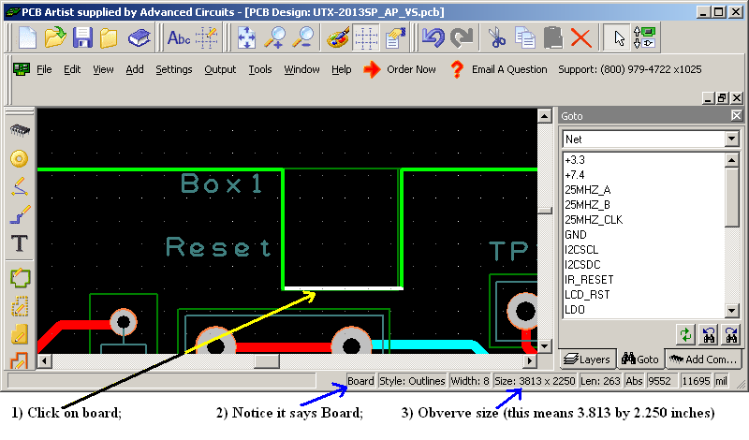

*Figure 7.3. Process for determining board size.*

1. If you have included a bottom silk layer on your PCB, ensure that you have put something in the bottom silk layer. Failure to put something in the included layer will delay your board for 1 day. Go through the PCB ordering process detailed in Lab 6 and verify that the board can be ordered for around $10 plus shipping. Do not order the board yourself.
2. Print out the PCB on paper and glue the two pieces together. Punch and drill holes in order to place components on the simulated “PCB”. Verify that all components fit in the spaces allocated for them. See Figure 7.4.

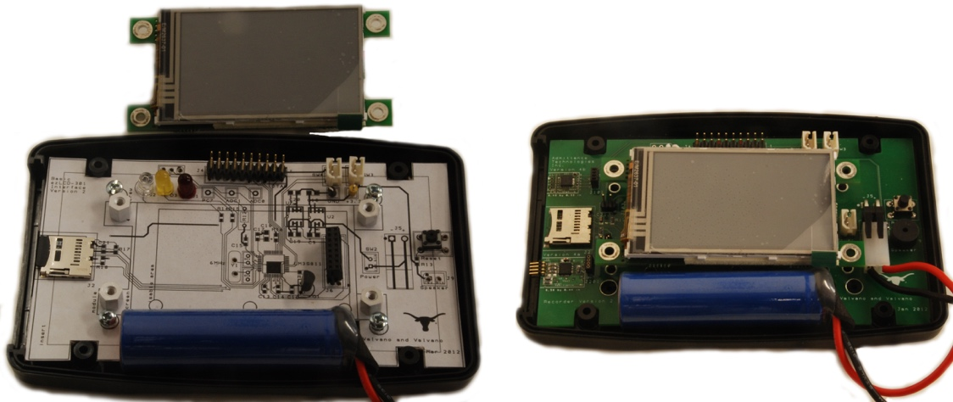

*Figure 7.4. Example mockup of layout using paper printout glued on cardboard (LM3S811 into PacTec box).*

1. Take the simulated PCB and place it inside the enclosure with all components on the simulated PCB. Ensure that you can close the lid. This will ensure that the PCB is able to fit inside the enclosure in 3D.
2. Estimate the cost of the entire system including parts given or lent to you, parts that you already own, PCB cost, Launchpad Cost, and any parts you purchased.
3. Upload your “Design Block” (i.e., PCB and SCH) file to canvas by the deadline. This is a hard deadline for PCB submission. Specifically:
   1. Get an xxx part number from your TA (**UTX-2022Sxxx**).
   2. Place the part number on the Top Silk of the PCB
   3. Save your SCH and PCB files to a “Design Block”

Figure 7.5

using the **UTX-2022Sxxx** name (from part a.)

* 1. Your schematic must be ERC clean, and the PCB must be DRC clean. We do not have time to fix your schematics or layout.
  2. If you do not finish by this time, you must pay the manufacturing + shipping costs.

## Demo2 Checkout

1. Open your BRD file within Eagle and show that it passes all design rule checks, fits within 30in2.
2. Explain how the system will be powered. Even if you are using the TM4C LaunchPad, you still are required to have a regulator. You should be able to explain how the regulator works.
3. Show the TA that your breadboard circuit is functional and that there are no major design flaws
4. Explain your testing procedure for when the PCB arrives. This needs to be a list of 4 or 5 steps, detailing the bottom-up construction and test procedures. Each step will include hardware to be built, software to be written, debugging tools to be used, and expected results to be collected.
5. Show any connectors, I/O devices, or other devices that will connect to the PCB. Explain how they will be powered and communicate with your system.
6. Show that the simulated PCB has correct sizing of the components and that it fits within the enclosure

## Bonus

1. Have at least 1 member of your team complete 3-D printing or laser cutting training in the Texas InventionWorks. There are sign up sheets for training on the 0 floor of the Texas InventionWorks. **(5)**
2. Use a TM4C123 chip in your design instead of the launchpad. Follow the instructions in processor implementation option 2. **(10)**

## Deliverables (exact components of the lab report)

1. Objectives:

1-page requirements document (updated with changes occurring during Lab 7 process)

1. Hardware Design

SCH BRD Files

Printout of PCB Layout Top and Bottom taped to cardboard

1. Software Design

Any software you wrote to test hardware should be uploaded to GitHub Repository

1. Measurement Data

Current Estimation

Cost Estimation

1. Analysis and Discussion

How will you debug the system? Demo 4 checkout #4.

## Lab 7 grading

**Pre-preparation (10)**

You will be judged on the clarity of thought you have about your project. At a very abstract level you should be able to explain your TA what you intend to do and how you intend to do it. You can go through your Requirements document while you explain it to the TA. This will be like a MRD (Marketing Requirements Document) presentation to your TA. MRD is what it does from a user perspective (how can we sell it).

1.1. Objectives: Why are we doing this project? What is the purpose?

1.4. Interactions with Existing Systems: How will it fit in?

1.5. Terminology: Define terms used in the document.

2.1. Functionality: What will the system do precisely?

2.5. Usability: Describe the interfaces. Be quantitative if possible.

3.3. Outcomes: What are the deliverables? How do we know when it is done?

**Preparation (10)**

By the prep-day you should have a very clear idea about your project. So, you should be able to describe the lower-level interface of your system. You can go through your schematic and BOM while you explain it to the TA. While you do this you would also like to point out your hardware and software design boundaries. This will be like a PRD (Product Requirements Document) presentation to your TA. PRD is how it will be developed from an engineering perspective (how do we build it).

1.2. Process: How will the project be developed?

1.3. Roles and Responsibilities: Who will do what? Who are the clients?

2.2. Scope: List the phases and what will be delivered in each phase.

2.3. Prototypes: How will intermediate progress be demonstrated?

2.4. Performance: Define the measures and describe how they will be determined.

**Demo1 Check out (10)**

**Demo2 Check out (30)**

Complexity (10) - You should be able to convince your TA that you have taken up a challenging project. Indicate the cool features of your project and the effort you will have to put in to make it work. Be as specific as possible.

Planning (10) - For every big project it is important to plan things out ahead of time. There should be at least four major subcomponents, and each team member must be responsible for at least one subcomponent. Break up your work into smaller steps and assign a deadline to each one. Remember to adhere to them.

PCB Layout (10) – Final PCB Due at 10am Thursday 3/31 (This is HARD deadline)

**Oral Questions (10)**

**Timely submission (10) (Completion grade for Valvano review)**

**Report (20)**

Requirements Document (10) - Due with Pre-Prep, but updated with appropriate changes

Schematic (10) - A significant amount of this grade will be on how you plan to debug your board

**Precautions**

1. Please download and use Eagle Design Rule Check Deck 2-layer JLCPCB because the built in one is too generic. Fix all errors in the DRC. You should see a window like this when you open DRC:

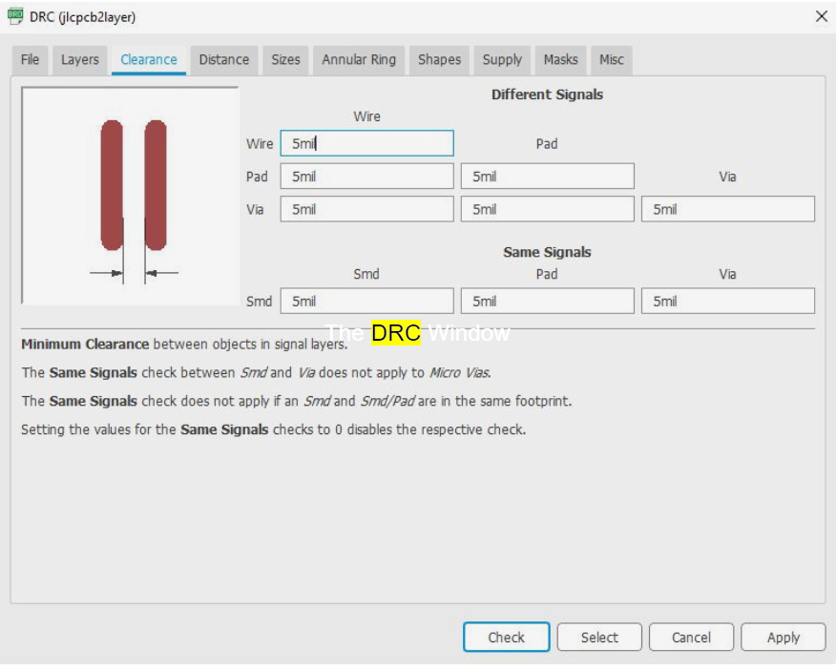

1. The components at the back of board need to be mirrored. In Eagle, in "board view" (where you design the PCB), select the "i" tool (the tool that brings up the "properties" dialog) and click on the component you want on the other side of the board, check "mirrored.” This changes from the top layer to the bottom layer. You will see that the silk screen related items which are on tPlace, tNames, tValues will change to be on bPlace, bNames and bValues. You can also try turning off the visibility of the top layers (tPlace, tNames, etc.) to see whether Eagle thinks your connector is still on the top.
2. Please check if the distance between the wire and the wire, the wire and the component pad, the wire and the through-hole, the component pad and the through-hole, the through-hole and the through-hole are reasonable, and whether they meet the production requirements. Generally, the distance between the wires and the wires must be at least 4 mils. The minimum line spacing is also the line-to-line, line-to-pad distance. From a production point of view, the larger the better, the more common is 10 mils.
3. Please make sure your 3D dimensions are also reasonable. Some students have difficulties enclosing their embedded system because the TM4C bulges out of the enclosure.
4. JLCPCB only places top silk on layers 21-tPlace and 25-tNames (not 27-tValues). Similarly, JLCPCB only places bottom silk on layers 22-bPlace and 26-bNames (not 28-bValues). I suggest you toggle 27-tValues on and off in View->Layersettings to see if there is any text in 27-tValues you wish to move to 25-tNames. Similarly, I suggest you toggle 28-bValues on and off to see if there is any text in 28-bValues you wish to move to 26-bNames.

### Common mistakes that will delay the boards for the entire class

1) Having traces/holes/spacings too small (verify settings as shown in Figure 7.6)

2) Having drill holes closer to each other than 10 mil (verify settings as shown in Figure 7.7)

3) Asking for bottom silk, but not giving any bottom silk

4) Not asking for bottom silk, but giving a bottom silk layer

5) Board name does not match GoogleDoc submission

6) Entering the wrong size in GoogleDoc

7) Trying to cheat the company by creating two boards on one PCB file

*Figure 7.6. Execute Edit->DesignRules and check the above settings.*

You may **not** create more than one board using one PCB file. This type of submission is not allowed. This semester we will get 5 copies of your design. The following two PCBs were not allowed and students who submitted these PCB files caused all boards for the entire class to be delayed by two days.

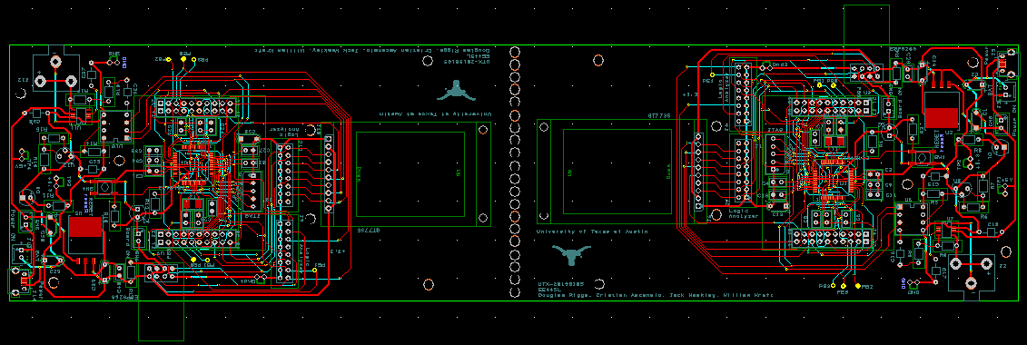

Creating multiple boards from one PCB file is NOT allowed.

## Hints:

Creating multiple boards from one PCB file is NOT allowed.

0) You should collect ALL parts of the design while you are doing Lab 7 so you can be sure they fit on the PCB.

Show examples of a) battery input, b) USB power input, c) off board power switch, e) off board GPIO switch, off board LED (SCH, BRD, photo)

1) There are two types of LEDs you can get from the professor’s office. Low current red/yellow/green HLMP-D150 LEDs can be connected directly to a microcontroller output using just a 680  or 1 k resistor. The other colors and sizes that we have require 10 mA and will need an interface (like a 2N2222 and a 100  resistor.) You should test the LED/resistor circuit on a breadboard to make sure the brightness is acceptable.

2) My advice is to do a little bit of Lab 7, and then have someone check it. DO NOT DO THE COMPLETE DESIGN SCH/PCB THEN GET IT CHECKED. To have Lab 7 checked, you can contact your TA, or email the SCH and PCB files to your professor. We will evaluate your

SCH files for gross design errors in the I/O interface

PCB files for style (line width, mitered corners)

3) The datasheets for the components used in this cabinet tab of the BOM can be found on the datasheets page

<http://users.ece.utexas.edu/~valvano/Datasheets/>

4) Sparkfun and Adafruit have a large number of low-cost displays. The Nokia 5110 is a very low cost display, and you will find lots of starter code for it. We have starter code for the Kentec display. See

<http://users.ece.utexas.edu/~valvano/arm/#HumanInterfaces>

5) Everyone’s embedded system must be placed in a box, so you should create a 3-D mock-up of the system including the box during Lab 7. Starting to think about squeezing all the components into the little box once you get to Lab 11 will be difficult. Placing components in the proper place on the PCB during Lab 7 will greatly simplify the box-building process. See Figures 7.1 and 7.7.

6) Eagle has a feature that allows for ground planes (copper pour). WE DO NOT ALLOW you to use this feature. Ground planes are useful for high frequency and/or low noise systems. The ground plane makes it much harder to visually see what wire connects to what pin, it makes it much harder to cut/add traces in Lab 11 to fix mistakes, and it makes it harder to create good solder joints without using a high-temperature soldering iron.

7) One common mistake new PCB layout designers can make is placing two wires too close to each other. Subsequently, during fabrication, these two wires may become shorted because of the tolerances of the manufacturing process. A general rule of thumb is that you should allow enough space between two wires to fit the smallest allowable trace between them. For this PCB manufacturer, separate all traces by at least 0.007 inch.

8) Male-male header pins. This photo shows a straight header with 0.1in separation. This can be broken into any number of pins and used for connectors or mode selection.

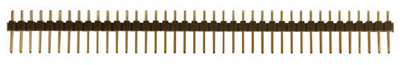

2-pin jumper, [SJ-1], $0.10

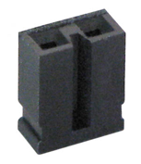

A computation music game, do a web search for Otomata:

<http://earslap.com/projectslab/otomata/?q=5s6x3m2g402z4o6k4q8k480z6g512x3p1z4t7k44>

<https://www.youtube.com/watch?v=lHCdHh1eSi0>

9) Web site references

===== Enclosure Manufacturers =====

<http://www.OKW.CO.UK/> OKW

<http://www.TEKOENCLOSURES.COM/> TECO

<http://www.PACTECENCLOSURES.COM/> PACTEC

Most box manufacturers will not ship samples to students.

==== General Purpose Awesomeness ====

<http://www.SPARKFUN.COM> Spark Fun - Transducers, Buttons, Displays, etc. Lots of cool stuff.

<http://www.allelectronics.com> All Electronics - All sorts of random stuff

==== LCDs ====

<http://www.newhavendisplay.com/> New Haven Displays - LCD Manufacturer. Has a bunch of displays around $10

<http://www.varitronix.com/> Varitronix - LCD Manufacturer.

<http://www.crystalfontz.com/> Crystalfontz - good quality and price LCD's

<http://www.sparkfun.com/products/710> $20 Sparkfun LCD-00710 64 by 128 LCD

<http://www.circuit-ed.com/128x64-BLWH-TOUCHSCREEN-GLCD-P146.aspx> $26 64by128 LCD touch screen

<http://www.sparkfun.com/commerce/product_info.php?products_id=8977> Touch Screen

==== Batteries ====

<http://www.powerstream.com/> PowerStream - Batteries

<http://www.batteryjunction.com/> Battery Junctiton - Li-Ion packs

==== Industrial Suppliers ====

<http://www.digikey.com/> Digikey - Useful parametric search. Lots of standard components. This is the easiest way to find multiple manufacturers of something common like connectors

<http://www.mouser.com/> Mouser - Pretty much any standard chip you want is available here. Ships from Dallas, so usually faster than Digikey, but sometimes a bit pricier.

<http://www.avnet.com/> Avnet - Some higher-end stuff and hard to get chips can be found here.

<http://www.newark.com/> Newark - Similar to Avnet

==== Misc Info ====

<http://www.ladyada.net/library/procure/samples.html> Getting Samples - How to get free samples

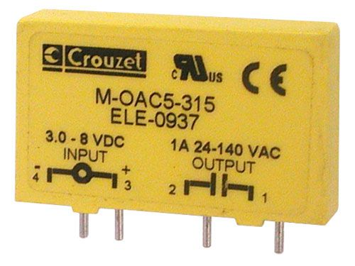 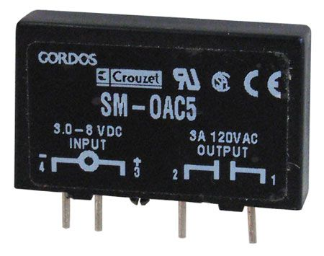

CAT# SRLY-503 [www.Allelectronics.com](http://www.Allelectronics.com)

http://www.crouzet-ssr.com/english/products/download/M_output_modules.pdf

18-bit color, 128*160, 1.8" TFT LCD display, Sitronix ST7735R, [www.Adafruit.com](http://www.Adafruit.com) part number 358, $19.96

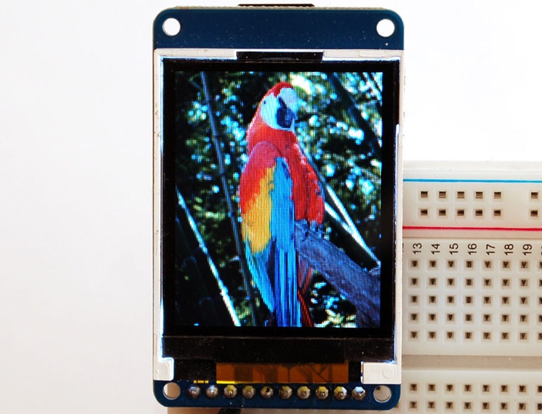

If a project is so much more complicated than the typical EE445L project that they need two boards, please see your professor. One option for creating more than one device is to make one with the PCB layout and make the second one by soldering parts onto an EE319K project board

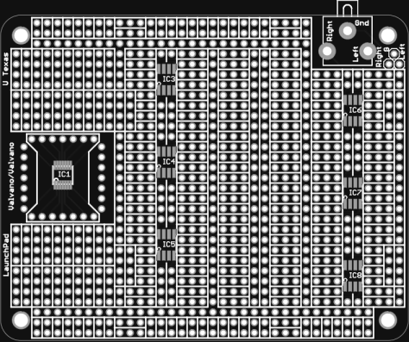

*Figure 7.6. EE319K Project Board.*

If you want to learn much more about PCB design (details beyond what is needed for EE445L, but awesome if you wish to create PCBs professionally, Matthew Yu created two playlists with many hours of educational material.

<https://www.youtube.com/playlist?list=PLqUBXn7oPxmxXZYo1X_91ucJfMEAJdrzt> (PCB Design)

<https://www.youtube.com/playlist?list=PLqUBXn7oPxmzVwcAnNQxI12CLg_SvGdOF> (PCB Backlog)