**Learn_Git_and_Github**

**master、origin master 与 origin/master 有什么区别？**

<https://blog.twofei.com/695/>

**svn与git的区别（总结）：**

<https://blog.csdn.net/qq_14935437/article/details/78339489?utm_medium=distribute.pc_relevant.none-task-blog-BlogCommendFromMachineLearnPai2-1.nonecase&depth_1-utm_source=distribute.pc_relevant.none-task-blog-BlogCommendFromMachineLearnPai2-1.nonecase>

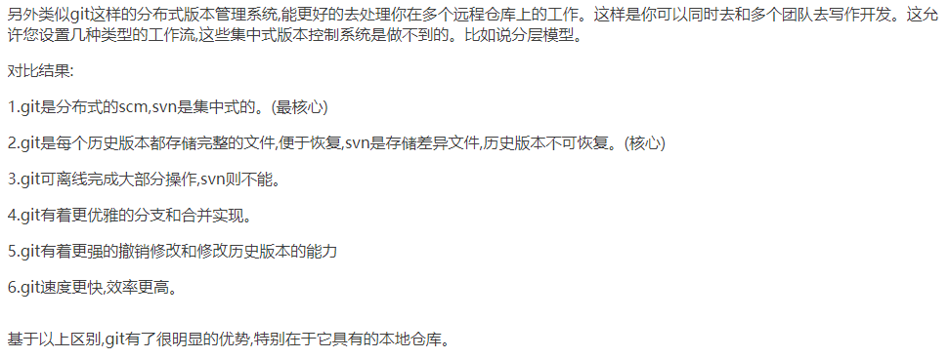

**Git版本控制软件结合GitHub从入门到精通常用命令学习手册：**

<http://www.ihref.com/read-16369.html>

创建分支

<https://www.cnblogs.com/jiangyongtao/p/8451867.html>

git checkout命令详解

