# Analysis of the Carpentry's Long-Term Feedback Survey

[Kari L. Jordan](https://github.com/kariljordan)  
**May 2017**

# Introduction

Data and Software Carpentry launched a [long-term assessment survey](https://www.surveymonkey.com/r/carpentrieslongtermassessment) in March 2017. The goal of this survey is to hear from our respondents about what has transpired in their work and career since completing a Carpentry workshop. Read our about our long-term assessment strategy on our [blog](http://www.datacarpentry.org/blog/long-term-assessment-strategy/) and see how the community was involved with the development of this survey.

A [PDF](https://github.com/carpentries/public-survey-info/blob/master/documents/surveys/2017-04-17-carpentry-long-term-feedback-survey.pdf) of the survey questions, the data used in this analysis, and the .RMD file are located in the [long-term feedback survey report](https://github.com/carpentries/public-survey-info/tree/master/documents/reports/Carpentry-Reports/Long-Term-Feedback-Survey-Report) folder on GitHub. We have already received several pull requests from community members interested in this data. Feel free to use the data and [tell us](mailto:%20kariljordan@carpentries.org) about your findings.

This analysis includes 510 responses to the long-term feedback survey. Not all respondents answered each of the 26 questions.

# Highlights

Provided below are a few highlights from our data.

* 77% of our respondents reported being more confident in the tools that were covered during their Carpentry workshop compared to before the workshop.
* Respondents daily programming usage increased from 19% to 22% post-Carpentry workshop.
* 86% of our respondents were motivated to seek more knowledge about the tools they learned in their Carpentry workshop.
* 54% of our respondents have made their analyses more reproducible as a result of completing a Carpentry workshop.
* 70% of our respondents have improved their coding practices as a result of participating in a Carpentry workshop.
* 65% of our respondents have gained confidence in working with data as a result of completing the workshop.
* 74% of respondents have recommended our workshops to a friend or colleague.

# Respondent Demographics

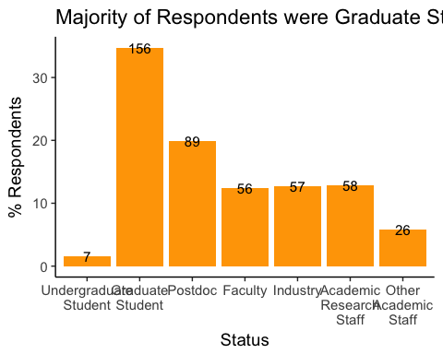

Carpentry workshops are open to individuals from all backgrounds and fields. Attendees vary from students (undergraduate and graduate) and faculty to staff and industry. The majority of our learners responding to the survey were graduate students (n = 156).

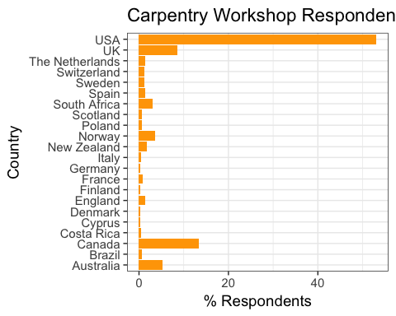

Provided is a breakdown of our respondents by the Country where they attended a Carpentry workshop. A large portion of Carpentry learners responding to the survey attended a workshop in the United States (n = 231), followed by the UK (n = 37), Canada (n = 58), and Australia (n = 23).

The Carpentries continue to endeavor to improve our workshop content and operations. We were therefore interested in knowing how many workshops respondents attended, and how long it has been since respondents completed a workshop. If there are spikes in the trends of our data, knowing when respondents completed a workshop will help us pinpoint whether or not our changes are related to learner responses in the data.

We found that nearly 75% of respondents participated in a Carpentry workshop more than one year ago, and the majority of respondents have attended only one Carpentry workshop.

The majority of respondents attending a workshop more than one year ago speaks to their level of involvement with the Carpentries. It can be difficult, in survey research, to collect responses from participants a year later. It is great to see that learners are still receptive to our e-mail communication and have taken time to complete our survey.

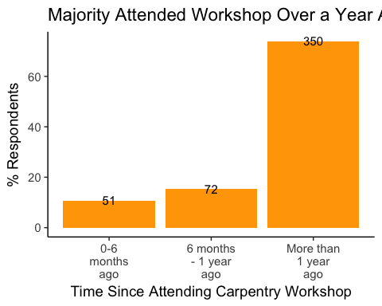 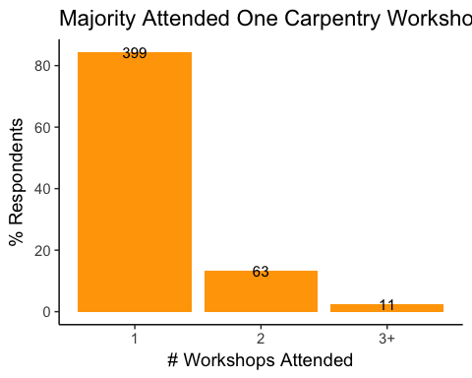

### Workshop Content

Data Carpentry's [lessons](http://www.datacarpentry.org/lessons/) include data organization in Spreadsheets, data cleaning with OpenRefine, data management with SQL, and data analysis and visualiztion in R and Python.

Software Carpentry's [lessons](https://software-carpentry.org) include the Unix Shell, version control with Git and Mercurial, programming with Python, R, and MATLAB, databases with SQL, and Automation and Make.

|  |  |
| --- | --- |
| Content | n |
| Git | 362 |
| Python | 289 |
| Unix Shell | 274 |
| R | 186 |
| SQL | 134 |
| OpenRefine | 28 |
| Spreadsheets | 20 |
| Cloud Computing | 11 |
| MATLAB | 5 |
| Mercurial | 3 |

From the table we see that a large majority of respondents learned Git, Python, and Unix Shell. On the low end were Spreadsheets (20), Cloud Computing (11), MATLAB (5), and Mercurial (3).

### Programming Usage Pre- and Post Workshop

A goal for this assessment is to understand respondents' programming usage before attending a Carpentry workshop compared to after. Our hope is that the workshop they attended influenced their usage of the programming tools covered during their workshop.

##### CHANGE

Twenty percent of the learners who responded to our survey had not been using the tools they learned in our workshop before completing a workshop, but nearly 30% responded having used the tools on a daily basis before completing a workshop. combine less than once per year

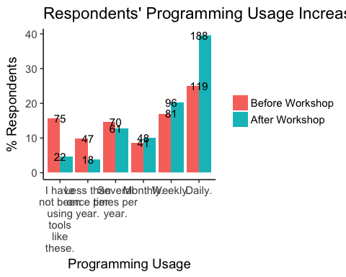

The most compelling change in responses was a decline in the percentage of respondents that 'have not been using these tools' (-11.1%), and an increase in the percentage of those who now use the tools on daily basis (14.5%). 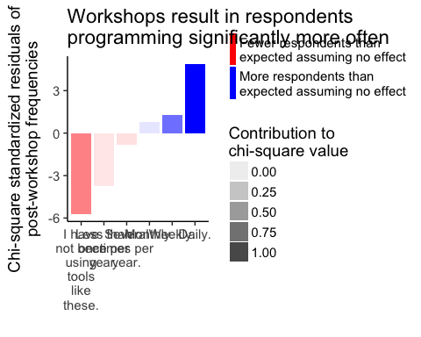

A chi-square test indicates that there is a significant difference in the frequencies of the pre- and post-workshop responses about programming use. The chi-squared standardized residuals for the post-workshop values show that significantly more respondents do programming daily after the workshop than expected if the workshop had no effect. Similarly, significantly fewer respondents program less than once per year after the workshop.

# Workshop Impact

Respondents were asked to reflect on ways in which completing a Carpentry workshop may have impacted them by rating their level of agreement (1-Strongly disagree to 5-Strongly agree) with the following statements:

* I have used skills I learned at the workshop to advance my career.
* I have been motivated to seek more knowledge about the tools I learned at the workshop.
* I have made my analyses more reproducible as a result of completing the workshop.
* I have received professional recognition for my work as a result of using the tools I learned at the workshop.
* I have improved my coding practices as a result of completing the workshop.
* My research productivity has improved as a result of completing the workshop.
* I have gained confidence in working with data as a result of completing the workshop.

The following plot was created using the [Likert](http://jason.bryer.org/likert/) package, and presents an analysis of learner responses to the statements above. We see an overwhelmingly positive indication that respondents left their workshop feeling motivated to seek more knowledge and having gained confidence in working with data. Additionally, more than 80% of respondents improved their coding practices, made their analyses reproducible, improved their research producitvity, and believe the skills they learned helped them advance their career. Fourty percent of our respondents have received professional recognition as a result of using the tools they learned in a Carpentry workshop.

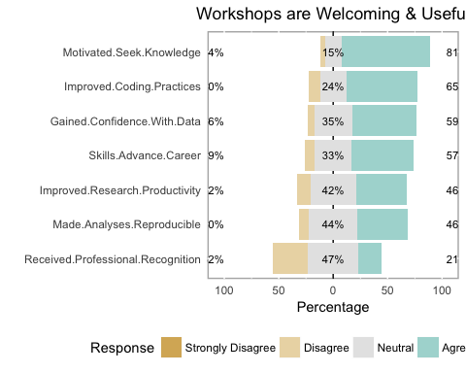

### Behaviors Adopted

We asked respondents to identify the behaviors they adopted as a result of completing a Carpentry workshop. We are happy to report that more than half of the respondents who answered this question (n= 361) have improved their data management and project organization practices, used programming languages for automation, and used version control to manage code. Additionally, respondents are **more confident** now in using the tools than before they completed a Carpentry workshop.

|  |  |
| --- | --- |
| Behaviors | n |
| Using programming languages like R or Python, or the command line to automate repetitive tasks. | 260 |
| Improving data management and project organization. | 198 |
| Using version control to manage code. | 185 |
| Reusing code. | 169 |
| Sharing code or data publicly on places like GitHub or FigShare. | 122 |
| Using databases, scripts and queries to manage large data sets. | 119 |
| Using version control to collaborate online (in public or private repositories). | 119 |
| Transforming step-by-step workflows into scripts or functions. | 111 |
| Developing a data management and analysis plan. | 74 |

### Change in Confidence

Our goal is for learners to leave a workshop having an increase in their confidence to use the tools they learned. More than 75% of the respondents are more confident now in using the tools they learned than they were before attending a Carpentry workshop. 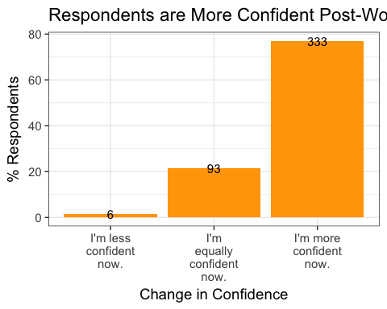

### Usage of Tools for Research and/or Work

We identified specific outcomes that learners may experience after completing a Carpentry workshop that are directly related to their research and/or work. Respondents have identified that the tools they learned improved their overall efficiency, and ability to manage and analyze data.

|  |  |
| --- | --- |
| How.Tools.Learned.Help | n |
| They are improving my overall efficiency. | 245 |
| They are improving my ability to analyze data. | 217 |
| They are improving my ability to manage data. | 203 |
| I am not using the tools I learned. | 61 |
| The tools I learned have not helped me with my work. | 28 |

Only () respondents said the tools they learned have not helped them, and () respondents have not been using the tools that were covered in their workshop.

### Contributions to Academic Writing

Another possible outcome of attending a Carpentry workshop is that the tools learned may contribute to academic writing (i.e. grant proposal, journal article). 118 respondents said that the tools they learned contributed to their academic writing.

|  |  |
| --- | --- |
| Tools Helped Writing | n |
| No. | 193 |
| Not sure. | 123 |
| Yes. | 118 |

### Continuous Learning

One of our primary outcomes is that learners continue on in their learning once they've completed a workshop. This can take many forms including participating in short-courses (in-peson and online) and using self-guided material. We asked respondents to tell us which learning activities (for data management and analysis) they've participated in since completing a Carpentry workshop. The majority of respondents have used non-Carpentry self-guided material, though 68 responded having used Carpentry self-guided material. Additionally, we see participation in meetups and in-person short courses.

|  |  |
| --- | --- |
|  | Continuous Learning Post-Workshop |
| Participated in an in-person short course. | 59 |
| Participated in an online short course. | 45 |
| Participated in a Meetup | 35 |
| Participated in a semester long course. | 24 |
| Used self-guided Carpentry lesson material. | 68 |
| Used non-Carpentry self-guided material. | 127 |

## Involvement in the Carpentries

Another outcome of attending a Carpentry workshop is that learners become involved with Software and/or Data Carpentry by way of joining a mentoring group, becoming a workshop helper, or even becoming an instructor. The table provided below shows how respondents have been involved with the Carpentries since completing a workshop. Respondents were asked to check all that apply.

|  |  |
| --- | --- |
| Involvement Since Attending a Carpentry Workshop | n |
| Subscribed to the newsletter. | 120 |
| Became a workshop helper. | 31 |
| Became a Carpentry instructor. | 26 |
| Attended at least one community call. | 18 |
| Contributed to a Carpentry lesson. | 18 |
| Joined a mentoring group. | 12 |
| Participated in a Twitter chat. | 11 |
| Joined a committee. | 6 |

# Summary

We value our learners because when they have successful experiences in our workshops, they share their experience with others. We asked respondents if they had already recommended our workshop, and 74% said yes!

This initial look at how Carpentry workshops have impacted learners long-term has been extremely insightful. In general, our workshops are helping learners improve their efficiency with managing and analyzing data. Learners are taking advantage of online resources to improve their skills, and becoming involved with our community.

We will take another look at this data to compare responses of learners having taken a workshop more than a year ago versus those having taken a workshop 0 to 6 months ago and 6 months to 1 year ago. Additionally, every 6 months we will collect data using this survey from new learners to see how they're doing.

OpenRefine, Spreadsheets, and Cloud Computing being low indicate the we had low responses from Data Carpentry.