Name:

Quiz 4

## Instructions: Absolutely no talking during a quiz. Complete answers as best as you can in the time allowed. If you need additional space, you can write on the back, but space provided should be sufficient so try to be succinct. If there is a problem, please raise your hand for help.

## Note: Answer 5 of 6. If you attempt to answer more than 5 questions, please circle the questions you want me to grade.

## Bonus: Name of the piece playing (1/2 credit) composer (1/2 credit) or Style of music (rondo, chaconne, passacaglia, etc. (full credit) :_________________________

1. PCR allows us to *specifically* amplify (copy) pieces of DNA. a) List the 3 main steps of the PCR reaction, b) indicate at which step we select a specific piece of DNA to amplify c) explain how only a specific portion of DNA is selected.

________________________________________________________________________________________________________________________________________________________________________________________________________________________________________________________________________________________________________________________________________________________________________________________________________________________________________________________________________________________________________________________________________________________________________________________________________________________________________________________________________________________________________

2. In DNA Barcoding we are attempting to identify an unknown species; this process involves several steps including a) collecting a specimen, b) extracting the DNA, amplifying the DNA by PCR (followed by electrophoresis), c) sequencing and finally using bioinformatics to analyze the d) sequence. Choose **one** of the enumerated steps (a-d) and present a potential mistake that could happen at this step, **and** explain what we could do to minimize the risk of mistake. (I am looking for well-reasoned answers, not simply “right/wrong”

________________________________________________________________________________________________________________________________________________________________________________________________________________________________________________________________________________________________________________________________________________________________________________________________________________________________________________________________________________________________________________________________________________________________________________________________________________________________________________________________________________________________________

3. What genes are used in DNA barcoding to identify a) plants, b) animals?

__________________________________________________________________________________________________________________________________________________________________________

4. Given the steps in our DNA extraction protocol (Covered so far in class), briefly explain what the purpose of each step is.

a) Adding Nuclei Lysis Buffer __________________________________________________________________________________________________________________________________________________________________________

b) Heating and grinding a sample

__________________________________________________________________________________________________________________________________________________________________________

c) Adding RNAse

__________________________________________________________________________________________________________________________________________________________________________

d) Adding Protein Precipitation Solution

__________________________________________________________________________________________________________________________________________________________________________

e) Centrifuging after adding Protein Precipitation Solution

__________________________________________________________________________________________________________________________________________________________________________

f) Adding Isopropanol to the supernatant from the centrifugation step

__________________________________________________________________________________________________________________________________________________________________________

5. Please list and explain (one sentence) 4 of the major chemical /molecular components of the PCR reaction.

a) Template DNA __________________________________________________________________________________________________________________________________________________________________________

b) dNTPs

__________________________________________________________________________________________________________________________________________________________________________

c) Primers __________________________________________________________________________________________________________________________________________________________________________

d) Taq-polymerase __________________________________________________________________________________________________________________________________________________________________________

6. Discrimination is one of the characteristics that makes one region/gene a better choice to use for DNA barcoding. In this context, explain what discrimination is, and which of the three following comparisons of the DNA sequence is most likely to be useful in barcoding:

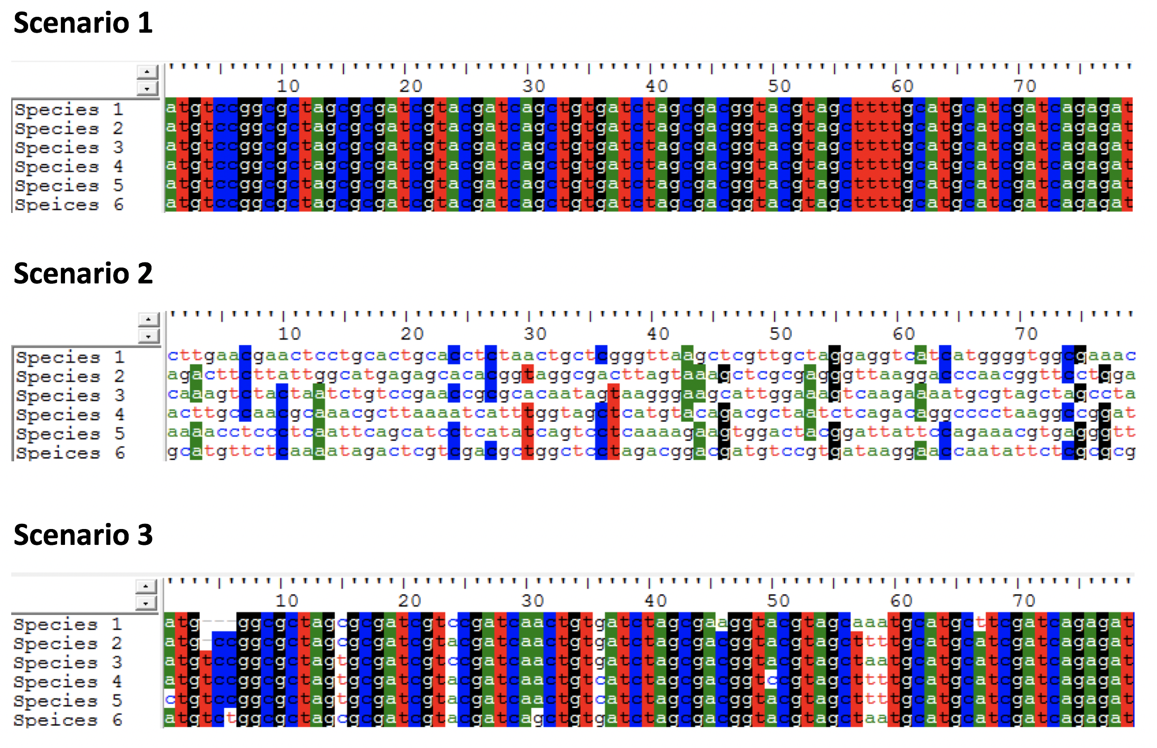

________________________________________________________________________________________________________________________________________________________________________________________________________________________________________________________________________________________________________________________________________________________________________________________________________________________________________________________________________________________________________________________________________________________________________________________________________________________________________________________________________________________________________

**BONUS:** In class, we described DNA extraction as using a series of filters. Recreate the diagram we came up with in class by arranging the following words to match the order we used in our DNA extraction protocol

Word list: **Cell membrane**, **DNA**, **Organism/tissue**, **Cell**, **Proteins**, **RNA**

__________ > __________ >__________ >__________ >__________ >__________