Detailed Sections for Final paper

**Submit for feedback deadline: June 6th**

**Final submission deadline: June 24st**

**(Calibri or Times New Roman 11pt font; single-spaced)**

**Goal –** Analyzing plants, insects, or foods using DNA Barcoding

**Description –** Each group will propose a research question that uses DNA barcoding to identify species and/or their genetic relationships. You will need to collect samples (appropriately) and we will work to barcode those organisms and analyze the data generated. The final project will be captured in a 3-5-page paper (including figures and images). The paper will have the following sections.

**1) Abstract**: This should be a 50-100-word summary of what your project was about, as well as any results.

**2) Introduction**: *(0.25-0.5 page)* Introduce what DNA Barcoding is and tell about the idea for your project. This should be interesting to someone who does not know much (or anything) about DNA, barcoding, etc. It should clearly convey why you did this project with the samples you chose. State your hypothesis about what you thought you might find.

**3) Material and methods**: (1-1.5 pages) Step-by-step instructions on the following:

* Sample collection
* DNA extraction
* PCR and electrophoresis
* DNA Sequencing
* DNA Subway

Some parts of this I will simply provide info for. Much of the DNA extraction, PCR, and DNA subway section can be written now from the manual and from your notes; you can edit these parts when we have finished our work.

**4) Data:** (Varies) This section should include sample information for each sample and sequence information. Be sure to use charts and other labeled figures where appropriate.

In this section you will have photos and tables. Include any photo(s) of your collected samples. **Each photo or table must have a legend.** I have provided examples in the templates, be sure that you modify these appropriately for your data. You must include a photo of your PHYLIP-NJ tree.

*You should provide your gel photo* ***with labeled lanes****.**Use a photo editing software to add a number to each lane.*

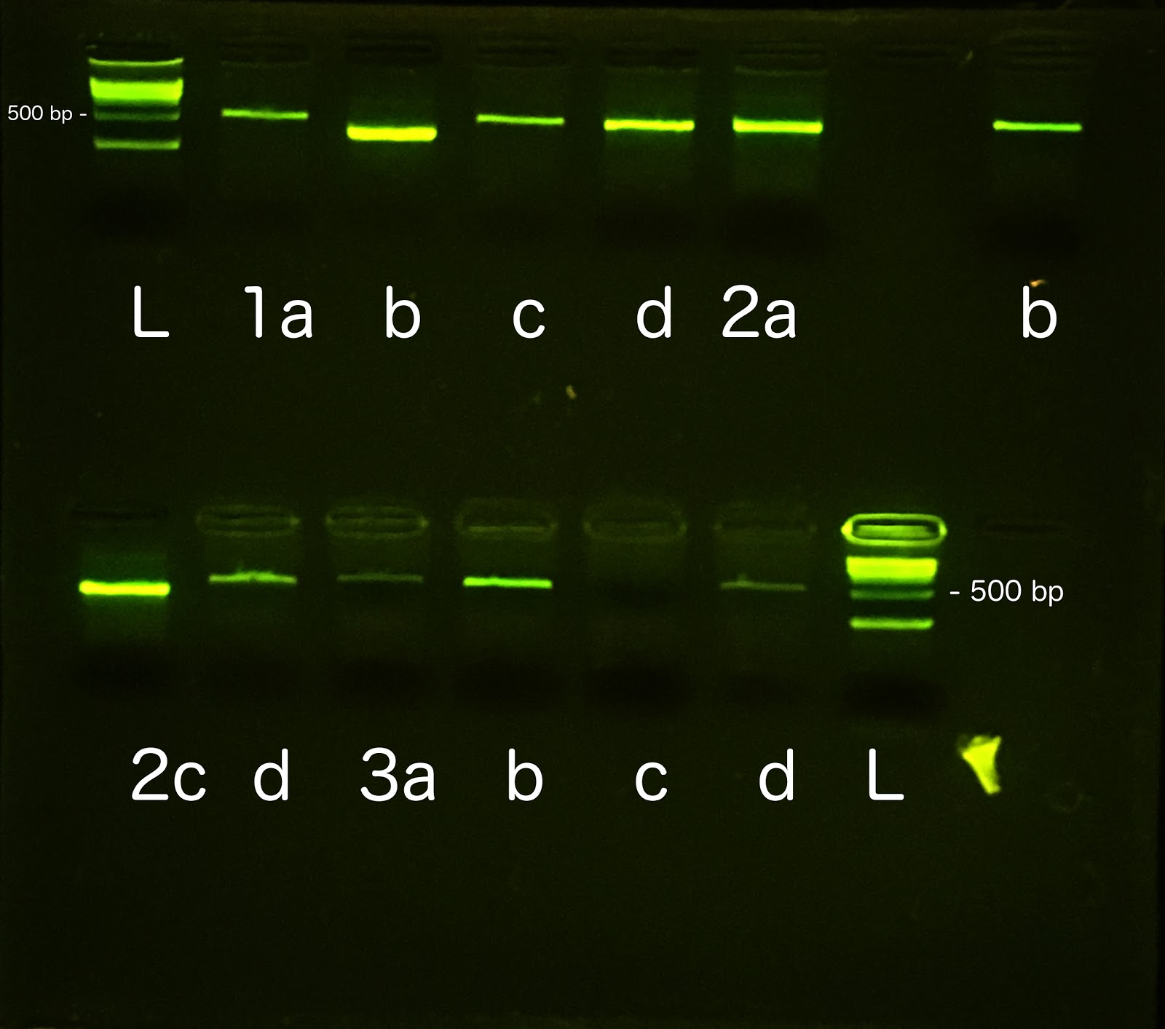

**Gel 1:** Lane (L) is a 1KB ladder. (1a) is… (b)... (c)...

*You should provide a table indicating what samples you generated and information on what species they were and if DNA Sequencing succeeded. You can modify the one below:*

|  |  |  |  |  |
| --- | --- | --- | --- | --- |
| **Sample Name** | **Sample identity (if known)** | **Collection site** | **DNA extraction Notes** | **DNA Sequencing results** |
| sm-1 | Potato leaf (Solanum tuberosum ?) | Supermarket | None | No quality warning: 600bp |
| sm-2 | Tomato leaf (Solanum lycopersicum?) | Supermarket | No pellet visible | Low quality warning: 200bp |

**Table 1:** *Enter a title for your table*

*You should provide a table describing the BLAST results for your samples.  You can modify the one below:*

|  |  |  |  |
| --- | --- | --- | --- |
| **Sample Name** | **BLAST** | **Top BLAST hit** | **Mismatches** |
| sm-1 | Yes | Solanum tuberosum | 0 |
| sm-2 | No - quality too low | N/A | No pellet visible |

**Table 2:** *Enter a title for your table*

**Figure 1. Neighbor-joining phylogenetic tree.**

**5) Conclusion and Discussion:** (Varies) This section “tells the story” and should include actual analyses such as information on how many mutations you found between different family members. Can you comment on how diverse (~∝ to how many mutations) a family is based on your data? Are there other corroborating data on this? Your phylogeny (NJ and ML trees) should be included here.

**6) Citations:** (Varies) Cited works (included websites) in the following form: <http://en.wikipedia.org/wiki/Vancouver_system>

**Plant Identification resources**

Encyclopedia of life: <http://eol.org/>

Leafsnap (an app for iphone/ipad – website is also very useful!) <http://leafsnap.com/>

iNaturalist (a free app): <https://www.inaturalist.org/>

iNaturalist seek (a free app): <https://www.inaturalist.org/pages/seek_app>

OSU online woody plant identification: <http://oregonstate.edu/dept/ldplants/plant_ident/>

Plant leaf types: <http://www.botanical-online.com/hojastiposangles.htm>

Plants of NY atlas: <http://newyork.plantatlas.usf.edu/>

**General Collection Instructions (avoid poisonous plants** <http://www.cdc.gov/niosh/topics/plants/> )**:**

1. Collect plant samples Be sure to record a note and give a sample name/number to each collection.
2. Before pressing, take a small sample of the plant and collect in a 1.5 ml tube. Freeze this in the school lab. Make sure these collections are appropriately labelled!
3. We will PCR and sequence all the samples, then make DNA identifications to compare with a known sample.
4. We will also write a computer program to tell us the amount of difference between our sequences and any sequence in Genbank.

**Insect identification resources:**

BugGuide: <http://bugguide.net/node/view/15740>

Insectidentification.org <http://www.insectidentification.org/>

Pestguide: <http://www.pestworld.org/pest-guide/>

**General Collection Instructions (avoid stinging/biting insects):**

1. For small insects, simply capture in labeled tube and freeze. During collection, avoid damaging distinguishing traits (antennae, legs, etc.).
2. Larger insects can be bagged in a small ziploc, and also frozen.

All collected insects can be kept in a Styrofoam container with ice and completely frozen in lab refrigerator to avoid mixing with foods.