2025-26 Science Institute Final Paper

- Submit for feedback deadline: June 21
- Final submission deadline: June 25 - Noon
- Aptos, Calibri, or Times New Roman 11pt font; single-spaced
- Each student will work in a team of 2-3 for a shared assignment paper grade

Experimental Description

In your experiment you will attempt to identify non-native plants in your area (plant’s not native to the northeastern United States).

To do so you will need to choose plants (from your yard, a park, etc.) and identify them using the iNaturalist Seek app (https://www.inaturalist.org/pages/seek_app ) and DNA Barcoding.

You will collect the plants (more info below), and get an identification from the app. In some cases, the app may be able to give you a genus and a species for the plant (but sometimes it may not be able to identify it or perhaps may give you more limited information such as what family it is in). With what information you have, you should look for information online about the plant. I also suggest using a plant identification key (such as https://gobotany.nativeplanttrust.org/simple/)

With a sample of the plant collected, you will do a DNA extraction with the provided materials and start sequencing the plant DNA on our field trip (Monday May 11th). Bring your plant samples and lab notebook with you for the Monday trip.

Collecting plants

You will need to choose plants that are accessible and avoid plants that may be dangerous (e.g. Poison Ivy/Oak, thorns, etc. – “leaves of three leave it be” – see this guide: https://www.almanac.com/content/poison-oak-identification-and-treatment and https://www.almanac.com/poison-ivy-garden ). In public parks, you will also need to avoid significantly damaging plants, and since we normally need only a leaf this is quite possible.

How to pick plants

For your experiment each team may select up to 10 plants. You could choose plants that are familiar (e.g. an Oak tree), but some of the most interesting plants may be weeds, vines, or even patches of grass. If you are looking for plants that are non-native, where might you be most likely to find them? Many but not all cultivated plants (e.g. potted plants) will be non-native. Some parks try to only plant native species. Many species of plants are also invasive (See: https://www.fs.usda.gov/wildflowers/invasives/index.shtml ). Try to get an identification with the Seek App, but if you cannot ID the plant, it may be even more interesting to barcode. Remember, if you are unsure if the plant is dangerous, do not touch it.

Sampling the plant

We only need a small amount of the plant to get DNA. However, we do need to take a lot of notes when collecting it. (Here are some professional instructions on plant collecting, a little too much for what we are doing now, but interesting to read: https://fwbg.org/science-conservation/herbarium/plant-collection-and-preservation/ ).

Here are the minimum collections notes

- You must have a note on where the sample was collected. One way to do this is to get GPS coordinates. You can do this by going to http://maps.google.com , finding the site you collected at, and placing a “pin” down as close to the collection site as possible/

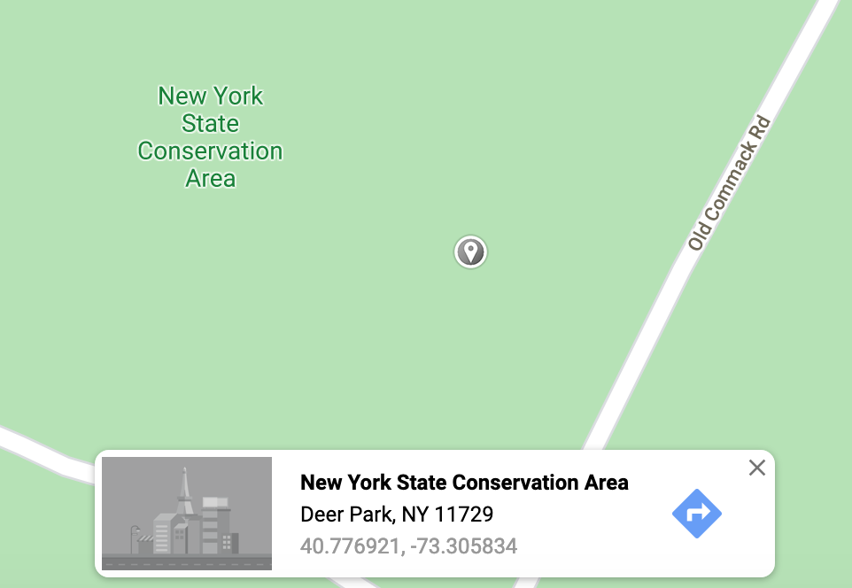

- Write a description of the plant including your estimate of its height (in cm or m). What color is it? Does it have bark? How are the leaves shaped? (see: this guide https://www.treehugger.com/id-trees-using-leaf-shape-venation-1343511 ) Are there flowers or buds?

- Take a few good photos of the plant.

- Finally, take sample of a few leaves. The most concentrated DNA are in the smallest leaves/buds usually at the tip of the plant this time of year.
- Depending on when you collect the plant, you may store your samples in between sheets of newspaper or absorbent paper. If you are collecting several days before our field trip, it’s important to keep the plants in a cool, dark, place such as a refrigerator if it will be more then 3 days. Otherwise, plants may mold. If it’s less than three days a basement or other cool spot outside of direct sunlite should suffice.

Barcoding

In class, we will follow the

Rapid DNA Protocol, Followed by Nanopore sequencing

- Rapid protocol: https://nanopore4edu.org/latest/annotated_experiments/dna_barcoding/#__tabbed_1_1

- Nanopore sequencing protocol:

  - rbcL PCR: https://nanopore4edu.org/latest/annotated_experiments/dna_barcoding/#pcr
  - Magnetic bead cleanup: https://nanopore4edu.org/latest/annotated_experiments/dna_barcoding/#ampure-xp-solid-phase-reversible-immobilization-spri-bead-pcr-clean-up-optional
  - Barcode adapter attachment: https://nanopore4edu.org/latest/annotated_experiments/dna_barcoding/#rapid-adapter-attachment
  - Flow cell loading: https://nanopore4edu.org/latest/annotated_experiments/dna_barcoding/#flow-cell-loading

Writing the Paper

Your team paper will have a layout with the following sections:

- Abstract: This should be a 50-100-word summary of what your project was about, and your results.

- Introduction: (0.25-0.5 page) Introduce what DNA Barcoding is and tell about the idea for your project. This should be interesting to someone who does not know much (or anything) about DNA, barcoding, etc. It should clearly convey why you did this project with the samples you chose. State your hypothesis about what you thought you might find.

3) Material and methods: (1-1.5 pages) Step-by-step instructions on the following:
- Sample collection
- DNA extraction
- PCR*
- DNA Sequencing *
- DNA Subway
*you do not need to include the protocol steps in your write up but cite the protocol
Some parts of this I will simply provide info for (i.e. PCR settings and information about the DNA sequencing). Much of the DNA extraction, PCR, and DNA subway section can be written now from the manual and from your notes; you can edit these parts when we have finished our work.

4) Data: (Varies) This section should include sample information (including your plant collection notes) for each sample and sequence information. Be sure to use charts and other labeled figures where appropriate.

You should provide a table indicating what samples you generated and information on what species they were and if DNA Sequencing succeeded. You can modify the one below:

Sample Name | Sample identity (if known) and notes | Collection site | DNA Sequencing results
sm-1 | Potato leaf (Solanum tuberosum ?) | Supermarket | No quality warning: 600bp
sm-2 | Tomato leaf (Solanum lycopersicum?) | Supermarket | Low quality warning: 200bp

Table 1: Enter a title for your table

You should provide a table describing the BLAST results for your samples and comparing the predictions made by the SEEK app. You can modify the one below:

Sample Name | BLAST | Top BLAST hit | Mismatches | iNaturalist Seek App predicion
sm-1 | Yes | Solanum tuberosum | 0 | Tomato
sm-2 | No - quality too low | N/A | No pellet visible | Fern

Table 2: Enter a title for your table

5) Conclusion and Discussion: (length varies) This section “tells the story” and should include actual analyses such as information on how many mismatches you found between different samples.. You should comment on how your Seek App identification matched (of failed to match) your DNA Barcoding results.

6) Citations: (length varies) Cited works (included websites) in the following form: http://en.wikipedia.org/wiki/Vancouver_system

Plant Identification resources
Encyclopedia of life: http://eol.org/
Leafsnap (an app for iphone/ipad – website is also very useful!) http://leafsnap.com/
iNaturalist (a free app): https://www.inaturalist.org/
iNaturalist seek (a free app): https://www.inaturalist.org/pages/seek_app
Plant leaf types: http://www.botanical-online.com/hojastiposangles.htm
Plants of NY atlas: http://newyork.plantatlas.usf.edu/

INSRUCTIONS FOR FEEDBACK AND SUBMISSION

- Your entire report must be submitted to be as a Google Doc.
- In our class Google Folder 2025-26 Science Institute
  - https://drive.google.com/drive/folders/1vI5DF_1DfS4LrFMv4xl7jYGUg8Vr7uZt?usp=sharing
- Each team will have a folder, to place your paper.
- For my feedback - Email me with a link to the paper and letting me know it is ready for review by the feedback due date.
- I will start grading by Noon on deadline, all changes you make must be done by then.

Peer Review

(optional) Teams may elect to review and leave at least one comment on another team’s paper. The reviewing team will get 1 additional point on their paper grade. Peer reviews must be done by the feedback date.

- Confirm with the other group that you are willing to review their paper (only one review per paper will count, and although someone may need to review for more than one person, only one point will be added to reviewer’s final team paper grade.
- Have the author of the paper share the link/permission with the reviewer
- The reviewer should write “Reviewed by: Team” at the top of the paper they are reviewing and include the names of the team members who participated in the review.
- They should use the comment function in Google docs to leave comments. Comments should be professional and constructive. For example, spotting something you think is unclear, incomplete, or is a factual error.

