2023-24 Science Institute Final Assignment and DNA Barcoding and 16s Nanopore sequencing

- This is a collaborative take-home test. You will complete this in TWO steps and submit TWO documents
  - 1. As INDIVIDUALS you will answer the questions below and return your individual assignment with your name in the Google Drive: https://drive.google.com/drive/folders/1Mn0dq7JKGQKeD_-cv73DNO50LzKGpVJB?usp=drive_link
  - 2. You and your lab partner(s) will meet and review your answers. Then you will submit a GROUP response for a final grate in the same Google drive.
  - 3. I will provide a grade only on the GROUP document. However it should be clear that I see progress and differences between your individual and group documents as you collaborate on your answers, and provide responses that are proofread, and represent your best work.
Resources

- All notes in class as well as any online resources you can use for original research (e.g. published papers, primary source websites, secondary source websites such as Wikipedia. No AI).
- Sanger DNA Sequencing results from your plant DNA Barcoding Experiment
  - Gel photo and Sanger sequence results available shortly.
- Nanopore DNA sequencing results from your 16s experiment:
  - See this link (reports tab): https://epi2me.nanoporetech.com/shared-report-460000?tokenv2=f941a2f1-728f-4711-bba1-90b30939d569
  - Under the “Reads per Barcode ID” select “EXCLUDE ALL” and then select “INCLUDE” for your barcode number.

QUESTIONS

- What are some key differences between SANGER sequencing and NANOPORE sequencing?

- In your plant DNA Barcoding DNA sequencing results, label (using your choice of software) and interpret the photograph of the Agarose gel

Row 1 – 100bp ladder followed by sample 1A, 2A, 3A, 4A, and 5A
Row 2 – 100bp ladder followed by sample 1B, 2B, 3B, 4B, and 5B

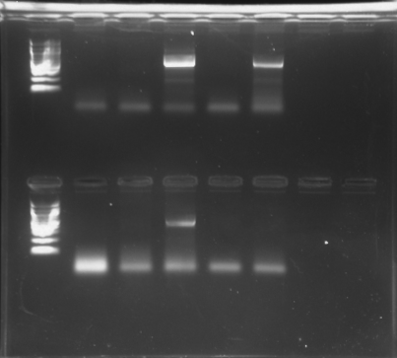

- Using DNA Subway and these instructions, what species(s) can you identify from the DNA sequence(s) obtained using BLAST?

  - Log into DNA Subway (https://dnasubway.cyverse.org/).
  - Start a blue line project.
  - Under 'Select Project Type' select the project type to be ‘rbcL’ barcoding.
  - Under ‘Select Sequence Source’ choose ‘Import Sequence from DNALC’ – you will be provided with a tracking number once it is available.
  - Select one or more files from the list. Click to “Add selected files”.
  - Provide a title in the "Name Your Project" section.
  - Click "Continue" to load the project into DNA Subway.
  - Follow instructions to view, pair, and generate a consensus sequence, and then use BLAST (https://dnabarcoding101.org/lab/bioinformatics.html section II. Determine Sequence Relationships Using the Blue Line)

- How did the results of the BLAST search compare with any identification you may have gotten from the iNaturalist app?

- From your Nanopore sequencing project, what genus(s) of bacteria were you able to identify from your shoe(s) that made up at least 3% of the minimum abundance cutoff?

- Provide an image of the phylogenetic tree generated by your Nanopore sequencing (3% minimum abundance cutoff). Tip: Use a screenshot software or the “Export PNG” link on the Nanopore report page.

- Doing your own research on these geniuses, are there any commonalties you can find, or are there any results that are particularly interesting to you? How did you results compare with those of your lab partner(s)?

