2021-22 Science Institute Final Paper (DRAFT VERSION)

- Submit for feedback deadline: June 17
- Final submission deadline: June 22 - Noon
- (Calibri or Times New Roman 11pt font; single-spaced)
- Each student will work in a team of 2-3 for a shared assignment paper grade

Experimental Description
In your experiment you will attempt to identify non-native plants in your area (plant’s not native to the northeastern United States).

To do so you will need to choose plants (from your yard, a park, etc.) and identify them using the iNaturalist Seek app (https://www.inaturalist.org/pages/seek_app ) and DNA Barcoding.

You will collect the plants (more info below), and get an identification from the app. In some cases, the app may be able to give you a genus and a species for the plant (but sometimes it may not be able to identify it, or perhaps may give you more limited information such as what family it is in). With what information you have, you should look for information online about the plant. I also suggest using a plant identification key (such as https://gobotany.nativeplanttrust.org/simple/)

With a sample of the plant collected, you will do a DNA extraction with the provided materials. You will generate some DNA extract which you will sample using a piece of filter paper. Once the paper has dried, you will send it back to me where I can do PCR, electrophoresis, and sequencing. With the DNA Sequencing, you will analyze the data on DNA Subway.

Collecting plants

You will need to choose plants that are accessible and avoid plants that may be dangerous (e.g. Poison Ivy/Oak, thorns, etc. – “leaves of three leave it be” – see this guide: https://www.cdc.gov/niosh/topics/plants/identification.html and https://www.almanac.com/content/poison-oak-identification-and-treatment ). In public parks, you will also need to avoid significantly damaging plants, and since we normally need only a leaf this is quite possible.

How to pick plants
For your experiment each team may select up to 5 plants. You could choose plants that are familiar (e.g. an Oak tree), but some of the most interesting plants may be weeds, vines, or even patches of grass. If you are looking for plants that are non-native, where might you be most likely to find them? Many but not all cultivated plants (e.g. potted plants) will be non-native. Some parks make an effort to only plant native species. Many species of plants are also invasive (what is an invasive plant? See: https://www.fs.fed.us/wildflowers/invasives/ ). Try to get an identification with the Seek App, but if you cannot ID the plant, it may be even more interesting to barcode. Remember, if you are unsure if the plant is dangerous, do not touch it.

Sampling the plant

We only need a small amount of the plant to get DNA. However, we do need to take a lot of notes when collecting it. (Here are some professional instructions on plant collecting, a little too much for what we are doing now, but interesting to read: https://www.brit.org/plant-collecting-how/data-record-and-photography).

Here are the minimum collections notes
- You must have a note on where the sample was collected. One way to do this is to get GPS coordinates. You can do this by going to http://maps.google.com , finding the site you collected at, and placing a “pin” down as close to the collection site as possible,
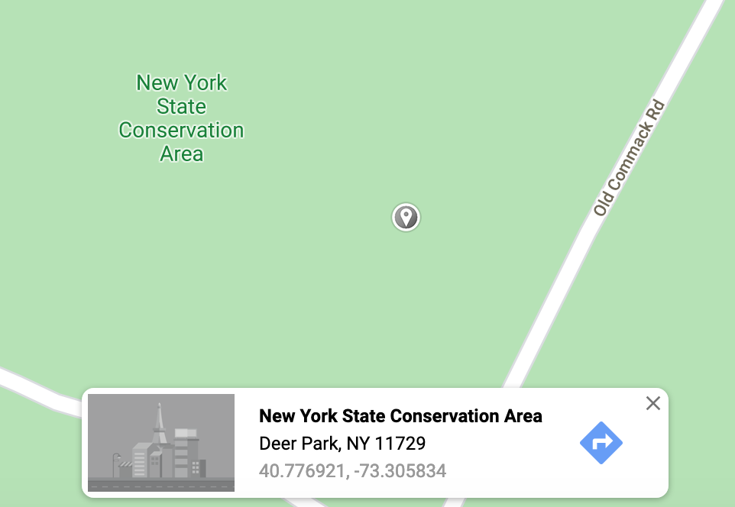

- Write a description of the plant including your estimate of its height (in cm or m). What color is it? Does it have bark? How are the leaves shaped (see: this guide https://www.thoughtco.com/id-trees-using-leaf-shape-venation-1343511 )? Are there flowers or buds?
- Take a few good photos of the plant.
- Finally, take sample of a few leaves. The most concentrated DNA are in the smallest leaves/buds usually at the tip of the plant this time of year.

Barcoding

In class, we will follow the

Rapid DNA Protocol
https://dnabarcoding101.org/lab/protocol-2.html#standard

Writing the paper

Your team paper will have a layout with the following sections:

- Abstract: This should be a 50-100-word summary of what your project was about, and your results.

- Introduction: (0.25-0.5 page) Introduce what DNA Barcoding is and tell about the idea for your project. This should be interesting to someone who does not know much (or anything) about DNA, barcoding, etc. It should clearly convey why you did this project with the samples you chose. State your hypothesis about what you thought you might find.

3) Material and methods: (1-1.5 pages) Step-by-step instructions on the following:
- Sample collection
- DNA extraction
- PCR and electrophoresis
- DNA Sequencing
- DNA Subway

Some parts of this I will simply provide info for (i.e. PCR settings and information about the DNA sequencing). Much of the DNA extraction, PCR, and DNA subway section can be written now from the manual and from your notes; you can edit these parts when we have finished our work.

UPDATE – Here is a paragraph that must insert in your paper’s method section. You can copy and paste verbatim:

A filter paper disc was soaked overnight in TE buffer to elute the DNA. 2μl of the eluted DNA was added to a PCR mix containing rbcL primers for plant DNA barcoding. This PCR was then amplified (35 cycles; 94C 15 seconds, 54C 15 seconds, 72C 30 seconds). 5μl of sample was then run on a 2% agarose gel. Samples were then sent to GENEWIZ for sequencing.

4) Data: (Varies) This section should include sample information for each sample and sequence information. Be sure to use charts and other labeled figures where appropriate.
In this section you will have photos and tables. Include any photo(s) of your collected samples. Each photo or table must have a legend. I have provided examples in the templates, be sure that you modify these appropriately for your data. You must include a photo of your PHYLIP-NJ tree.

You should provide your gel photo with labeled lanes. Use a photo editing software to add a number to each lane. You will be provided with a gel photo for the PCR I do for you.

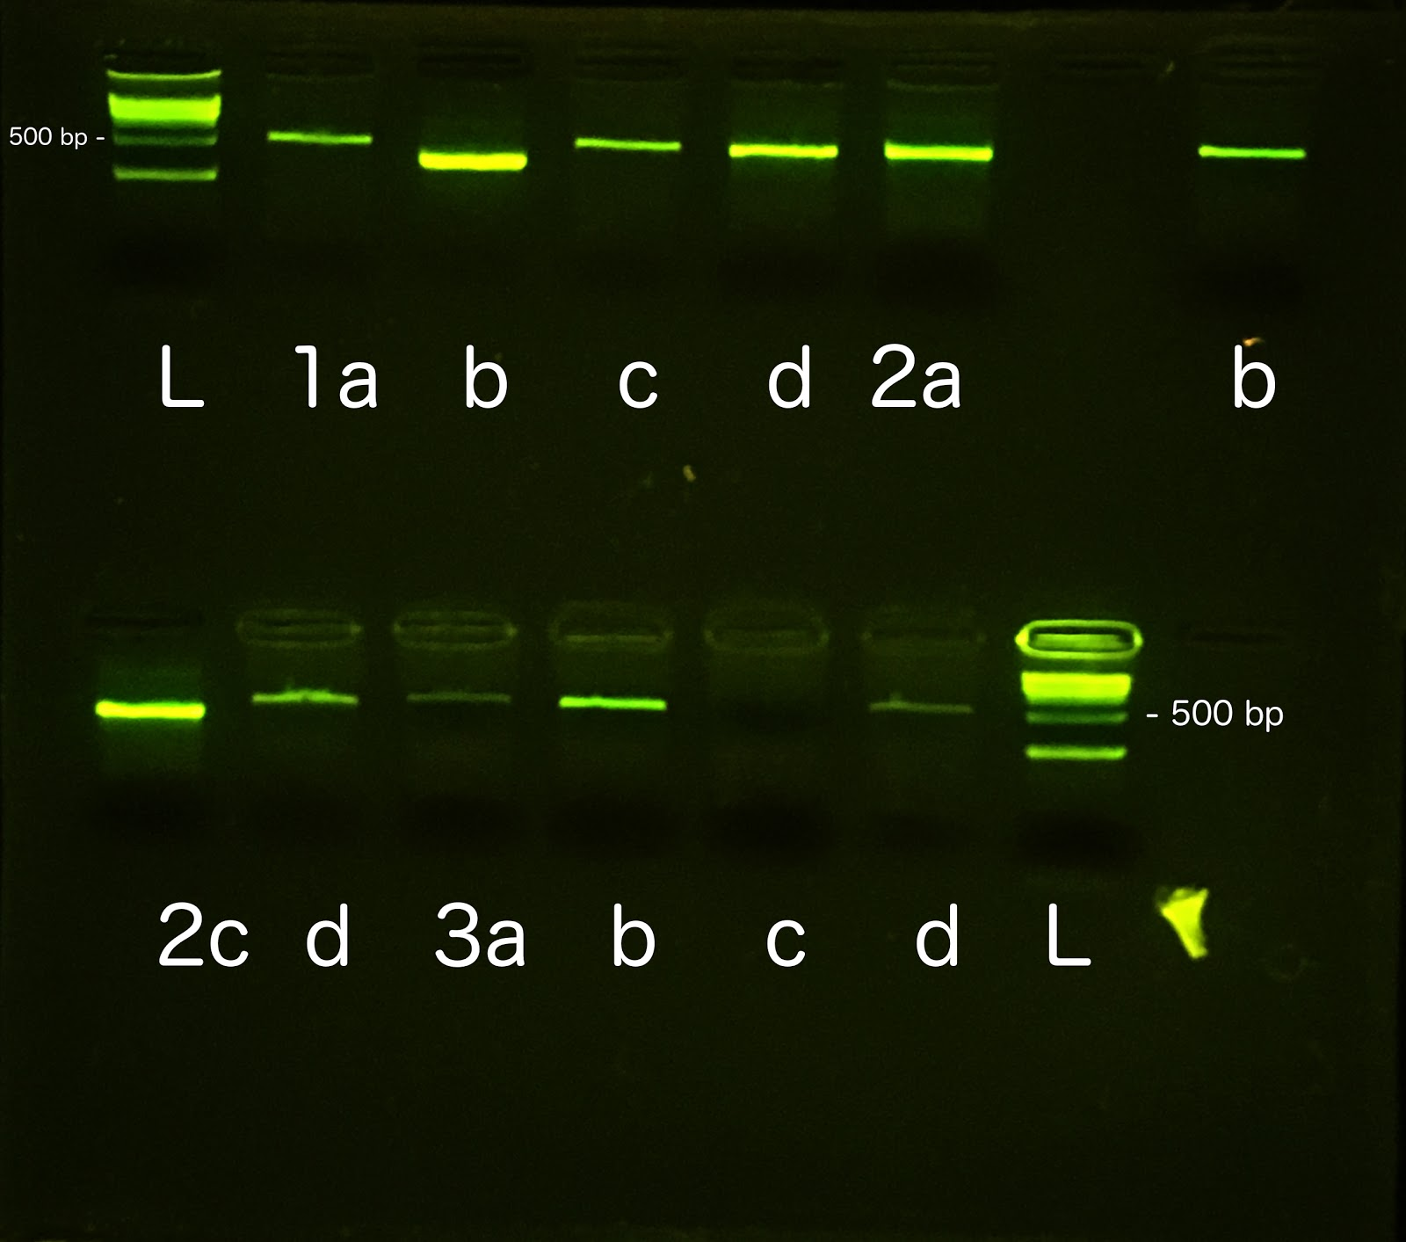
Gel 1: Lane (L) is a 1KB ladder. (1a) is… (b)... (c)...

You should provide a table indicating what samples you generated and information on what species they were and if DNA Sequencing succeeded. You can modify the one below:

Sample Name | Sample identity (if known) and notes | Collection site | DNA Sequencing results
sm-1 | Potato leaf (Solanum tuberosum ?) | Supermarket | No quality warning: 600bp
sm-2 | Tomato leaf (Solanum lycopersicum?) | Supermarket | Low quality warning: 200bp

Table 1: Enter a title for your table

You should provide a table describing the BLAST results for your samples. You can modify the one below:

Sample Name | BLAST | Top BLAST hit | Mismatches
sm-1 | Yes | Solanum tuberosum | 0
sm-2 | No - quality too low | N/A | No pellet visible

Table 2: Enter a title for your table

Figure 1. Neighbor-joining phylogenetic tree. Make sure to add a caption describing what the tree is showing (e.g. are any of your samples closely related? Do your BLAST hits have close relationships with your samples). On DNA Subway there is a link to download the image on the lower left of the tree displayed.

5) Conclusion and Discussion: (length varies) This section “tells the story” and should include actual analyses such as information on how many mutations you found between different samples. Can you comment on how diverse (~∝ to how many mutations) a family is based on your data? Are there other corroborating data on this? Your phylogeny (NJ and ML trees) should be included here. You should comment on how your Seek App identification matched (of failed to match) your DNA Barcoding results.

6) Citations: (length varies) Cited works (included websites) in the following form: http://en.wikipedia.org/wiki/Vancouver_system

Plant Identification resources
Encyclopedia of life: http://eol.org/
Leafsnap (an app for iphone/ipad – website is also very useful!) http://leafsnap.com/
iNaturalist (a free app): https://www.inaturalist.org/
iNaturalist seek (a free app): https://www.inaturalist.org/pages/seek_app
OSU online woody plant identification: http://oregonstate.edu/dept/ldplants/plant_ident/
Plant leaf types: http://www.botanical-online.com/hojastiposangles.htm
Plants of NY atlas: http://newyork.plantatlas.usf.edu/

INSRUCTIONS FOR FEEDBACK AND SUBMISSION

- Your entire report must be submitted to be as a Google Doc.
- In our class Google Folder 2021-22 Science Institute
- Each team will have a folder, to place your paper.
- For my feedback - Email me with a link to the paper and letting me know it is ready for review by the 17th. I will get review back by the Monday before the final due date.
- I will start grading by Noon on Wednesday the 22nd, all changes you make must be done by then.

Peer Review

(optional) Teams may elect to review and leave at least one comment on another team’s paper. The reviewing team will get 1 additional point on their paper grade. Peer reviews must be done by the 17th.

- Find a team who will allow you to review their paper (only one review per paper will count, and although someone may need to review for more than one person, only one point will be added to reviewer’s final team paper grade.
- Have the author of the paper share the link/permission with the reviewer
- The reviewer should write “Reviewed by: Team” at the top of the paper they are reviewing and include the names of the team members who participated in the review.
- They should use the comment function in Google docs to leave comments. Comments should be professional and constructive. For example, spotting something you think is unclear, incomplete, or is a factual error.

