Make a Fake Variable Using the rchisdd() Function and the CHIS Data Dictionary

Table of contents

Intro 1

Too Long Did Not Read Version 2

Setup 2

Detailed Usage 3

Categorical 3

Categorical: Universe is entire sample 3

Categorical: Universe is a subset 5

Continuous 7

Continuous: Universe is entire sample 7

Continuous: Universe is a subset 8

Optional Labels 11

# Intro

This quick tutorial shows you how to use the rchisdd() R function to create a fake random chis dummy data variable according to user provided information from the CHIS data dictionary.

This is useful when you **do not** see a particular variable in the dummy data set file you have, but you **do** see it in the dac confidential data dictionary linked below

<https://healthpolicy.ucla.edu/chis/data/confidential-data/Documents/2021/CHIS%202021%20Data%20Dictionary%20-%20Source%20-%20Adult%20Oct%202022.pdf>

You can intentionally create an example place holder of that variable in your dummy data set with the rchisdd() function. After all, the dummy data set is a place holder for the real data in the dac.

The dummy variable you create will mimic the ‘name’ and the marginal distribution that you specify. This is information you find from the data dictionary.

Once in the dac, you can assume the variable exists in the confidential dac dataset and you do not need to create it inside the dac.

# Too Long Did Not Read Version

Below is a brief example

# categorical 'INTVLANG2'  
  
# VALUE FREQ from data dictionary  
info_dd = data.frame(VALUE = c(1,2,3,4,5,8),  
 FREQ = c(22606, 1116,129,201,396,5))  
  
INTVLANG2_fake = rchisdd(info_dd,n_ss=24453)  
df_dummy_pretend$INTVLANG2 <- INTVLANG2_fake  
  
# continuous 'SRAGE'  
  
# N MIN MAX MEAN from data dictionary  
info_dd = data.frame(N = 24453,  
 MIN = 18,  
 MAX = 117,  
 MEAN = 53.52)  
  
SRAGE_fake = rchisdd(info_dd,n_ss=24453)  
df_dummy_pretend$SRAGE <- SRAGE_fake

# Setup

Get the rchisdd() function  
<https://github.com/mikejacktzen/chismisc/blob/main/rchisdd/rchisdd.R>

source(paste0(getwd(),"/rchisdd.R"))  
args(rchisdd)

function (info_dd, n_ss, lgl_floor = TRUE)   
NULL

The two input arguments and the output result are:

#' @param info_dd a data.frame that contains c('VALUE','FREQ') if categorical or c('N','MIN','MAX','MEAN') if count/continuous  
#' @param n_ss an integer for the number of rows in your data set (sample size)  
#' @param lgl_floor TRUE/FALSE if you want the output values rounded to their integer floor  
#'  
#' @return a numeric vector of values generated according to the user supplied `info_dd`

library(dplyr)  
library(haven)  
  
fp_parent = getwd()  
fp_dat_dummy = paste0(fp_parent,"\\ADULT_STATA_DUMMY_2021\\Stata\\ADULT_with_format.dta")  
df_dummy = haven::read_dta(fp_dat_dummy) %>% rename_all(toupper)

Note the number of rows in the dummy dataset. Use it as the overall sample size n_ss

# sample size of dataset  
nrow(df_dummy); n_ss = 24453

[1] 24453

# Detailed Usage

In the data dictionary:

A categorical variable will have a Value with its respective Frequency.

A continuous variable will have the eligible universe sample size N, Min, Max, and Mean.

Below, we show you how to use the above information to create a placeholder fake variable and attach it to your dummy dataset.

## Categorical

For a categorical variable, our function will return a vector of values that match your specified categorical values and their frequencies.

### Categorical: Universe is entire sample

We will pretend the 2021 dummy data does **NOT** have the categorical variable **INTVLANG2** (even though it does).

df_dummy$INTVLANG2 %>% summary

Min. 1st Qu. Median Mean 3rd Qu. Max.   
 1.000 1.000 1.000 1.135 1.000 8.000

INTVLANG2_original = df_dummy$INTVLANG2  
  
# remove INTVLANG2  
df_dummy_pretend = df_dummy %>% select(-INTVLANG2)

For each data dictionary ‘VALUE’, replicate it ‘FREQ’ number of times.

In a data frame, store the values you see from the data dictionary into a vector called VALUE. Likewise, store its respective ‘frequency’ into a vector called FREQ .

# categorical version  
# INTVLANG2  
  
# VALUE FREQ from data dictionary  
info_dd = data.frame(VALUE = c(1,2,3,4,5,8),  
 FREQ = c(22606, 1116,129,201,396,5))  
  
vec_val_freq = rchisdd(info_dd)  
  
# attach labels (if desired) not done here  
  
INTVLANG2_fake = vec_val_freq  
  
'INTVLANG2' %in% names(df_dummy_pretend)

[1] FALSE

df_dummy_pretend$INTVLANG2 <- INTVLANG2_fake  
'INTVLANG2' %in% names(df_dummy_pretend)

[1] TRUE

df_dummy_pretend$INTVLANG2 %>% table

.  
 1 2 3 4 5 8   
22606 1116 129 201 396 5

df_dummy_pretend$INTVLANG2 %>% hist

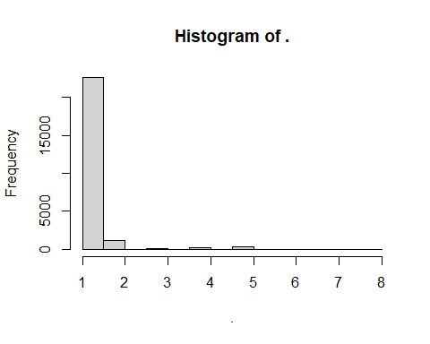

Note that there are 0 FREQ negative VALUE categories. All respondents meet the universe definition “UNIVERSE: ALL ADULTS”.

### Categorical: Universe is a subset

We will pretend the 2021 dummy data does **NOT** have the categorical variable **LATIN2TP** (even though it does).

df_dummy$LATIN2TP %>% summary

Min. 1st Qu. Median Mean 3rd Qu. Max.   
-1.0000 -1.0000 -1.0000 -0.4545 -1.0000 2.0000

LATIN2TP_original = df_dummy$LATIN2TP  
  
# remove INTVLANG2  
df_dummy_pretend = df_dummy %>% select(-LATIN2TP)

For each data dictionary ‘VALUE’, replicate that value ‘FREQ’ number of times.

Store the values you see from the data dictionary into a vector called VALUE. Likewise, store its respective ‘frequency’ into a vector called FREQ .

info_dd = data.frame(VALUE = c(-1,1,2),  
 FREQ = c(18426, 3989, 2038))  
  
vec_val_freq = rchisdd(info_dd)

returning categorical draws

# attach labels (if desired) not done here  
  
LATIN2TP_fake = vec_val_freq  
  
'LATIN2TP' %in% names(df_dummy_pretend)

[1] FALSE

df_dummy_pretend$LATIN2TP <- LATIN2TP_fake  
'LATIN2TP' %in% names(df_dummy_pretend)

[1] TRUE

df_dummy_pretend$LATIN2TP %>% table

.  
 -1 1 2   
18426 3989 2038

df_dummy_pretend$LATIN2TP %>% hist

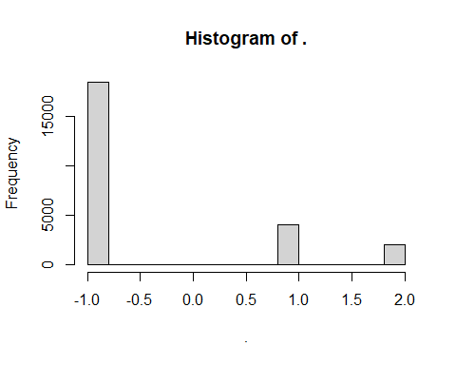

#### Fill in non-Universe Values

Note that there are 18426 negative values -1, for the non-latino respondents. These non-latino respondents do not meet the universe definition “UNIVERSE: ADULTS WHO ARE LATINO OR HISPANIC”. However, the information of the frequencies for the negative values are **still** displayed in the data dictionary which you can hardcode into the info_dd data frame (as we did above).

For categorical variables, the frequency of the negative and non-negative values will sum to the sample size

table(info_dd$FREQ)

2038 3989 18426   
 1 1 1

sum(info_dd$FREQ)

[1] 24453

n_ss

[1] 24453

## Continuous

For a continuous variable, our function will squeeze/stretch a vector of values to your specified [min,max] range while approximately preserving your specified mean. It will try to solve for a power p that satisfies the range and mean summaries.

### Continuous: Universe is entire sample

We will pretend the 2021 dummy data does **NOT** have the continuous variable **SRAGE** (even though it does).

# pretend   
SRAGE_original = df_dummy$SRAGE  
  
# remove SRAGE  
df_dummy_pretend = df_dummy %>% select(-SRAGE)

For SRAGE, all N=24453 samples in the dummy data are eligible to take on values in the range [18,117] with a mean of 53.52 .

Save this information from the data dictionary into a data.frame

# continuous version  
# SRAGE  
  
# N MIN MAX MEAN from data dictionary  
info_dd = data.frame(N = 24453,  
 MIN = 18,  
 MAX = 117,  
 MEAN = 53.52)  
  
vec_val_cont = rchisdd(info_dd,n_ss=24453)

returning continuous draws with 0 "-1" categories

Rounding to the floor since lgl_floor=TRUE

length(vec_val_cont)

[1] 24453

info_dd$N

[1] 24453

n_ss

[1] 24453

# note any difference between number sample size of dataset and eligible universe size  
n_ss - info_dd$N

[1] 0

# SRAGE is applicable to all n_ss, so (n_ss - pick_params$N) == 0  
# do not need the final step to fill ddict value for the 'rest' of the (n_ss - pick_params$N) rows  
  
SRAGE_fake = vec_val_cont  
  
'SRAGE' %in% names(df_dummy_pretend)

[1] FALSE

df_dummy_pretend$SRAGE <- SRAGE_fake  
'SRAGE' %in% names(df_dummy_pretend)

[1] TRUE

df_dummy_pretend$SRAGE %>% summary

Min. 1st Qu. Median Mean 3rd Qu. Max.   
 18.00 44.00 52.00 53.02 61.00 117.00

hist(df_dummy_pretend$SRAGE)

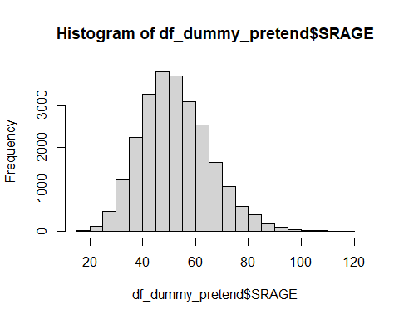

### Continuous: Universe is a subset

We will pretend the 2021 dummy data does **NOT** have the continuous variable **AC210** (even though it does).

# pretend   
AC210_original = df_dummy$AC210  
  
# remove AC210  
df_dummy_pretend = df_dummy %>% select(-AC210)

Similar to the continuous example above, but the UNIVERSE information in the data dictionary should be reviewed and incorporated.

Extra end-step to append negative values for ineligible / non-universe cases

UNIVERSE: ADULTS WHO HAVE HAD AN ALCOHOLIC BEVERAGE IN PAST 30 DAYS

That is, an individual’s response in AC210 is non-negative when their response in AC208 == 1

# AC210 N MIN MAX MEAN from data dictionary  
info_dd = data.frame(N = 14493,  
 MIN = 0,  
 MAX = 90,  
 MEAN = 2.14)  
  
vec_val_cont = rchisdd(info_dd,n_ss=24453)

returning continuous draws with 9960 "-1" categories

Rounding to the floor since lgl_floor=TRUE

length(vec_val_cont)

[1] 24453

info_dd$N

[1] 14493

n_ss

[1] 24453

# note any difference between number sample size of dataset and eligible universe size  
n_ss - info_dd$N

[1] 9960

Notice that info_dd$N is 14493 which is less than the dummy data number of rows n_ss=24453

That is the summary information of the data dictionary for AC210 applies to the 14493 eligible cases, while the remaining cases n_ss - info_dd$N needs to take on a value for ineligible.

#### Fill in non-Universe Values

Note that there should be n_ss - info_dd$N negative values, -1, for the non-universe respondents. These non-universe respondents do not meet the universe definition “ADULTS WHO HAVE HAD AN ALCOHOLIC BEVERAGE IN PAST 30 DAYS”. **UNLIKE** categorical variables, the information of the frequencies for the negative values are **NOT** displayed in the data dictionary. However, you can implicitly back solve for the number of negative values. As shown above, the n_ss argument in the rchisdd(n_ss,...) function does this for you.

For continuous variables, the frequency of the negative and non-negative values will sum to the sample size.

# rchisdd(n_ss=24453,...)  
  
# fake drawn values for eligible cases  
# rep -1 for the ineligible  
  
AC210_fake = vec_val_cont  
  
'AC210' %in% names(df_dummy_pretend)

[1] FALSE

df_dummy_pretend$AC210 <- AC210_fake  
'AC210' %in% names(df_dummy_pretend)

[1] TRUE

df_dummy_pretend$AC210 %>% summary

Min. 1st Qu. Median Mean 3rd Qu. Max.   
-1.0000 -1.0000 0.0000 0.6393 0.0000 90.0000

df_dummy_pretend %>% filter(AC210 >= 0) %>% select(AC210) %>% unlist %>% summary

Min. 1st Qu. Median Mean 3rd Qu. Max.   
 0.000 0.000 0.000 1.766 2.000 90.000

df_dummy_pretend %>% filter(AC210 < 0) %>% select(AC210) %>% unlist %>% table

.  
 -1   
9960

hist(df_dummy_pretend$AC210)

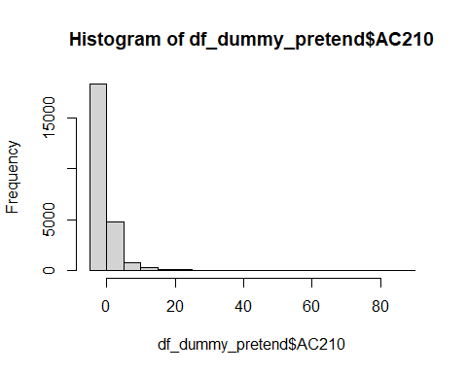

## Optional Labels

To add your own labels, see haven::labelled()

<https://haven.tidyverse.org/reference/labelled.html>

library(haven)  
?haven::labelled()