Cytokine_FCAP_procedure

1. Design: All 10 standards included

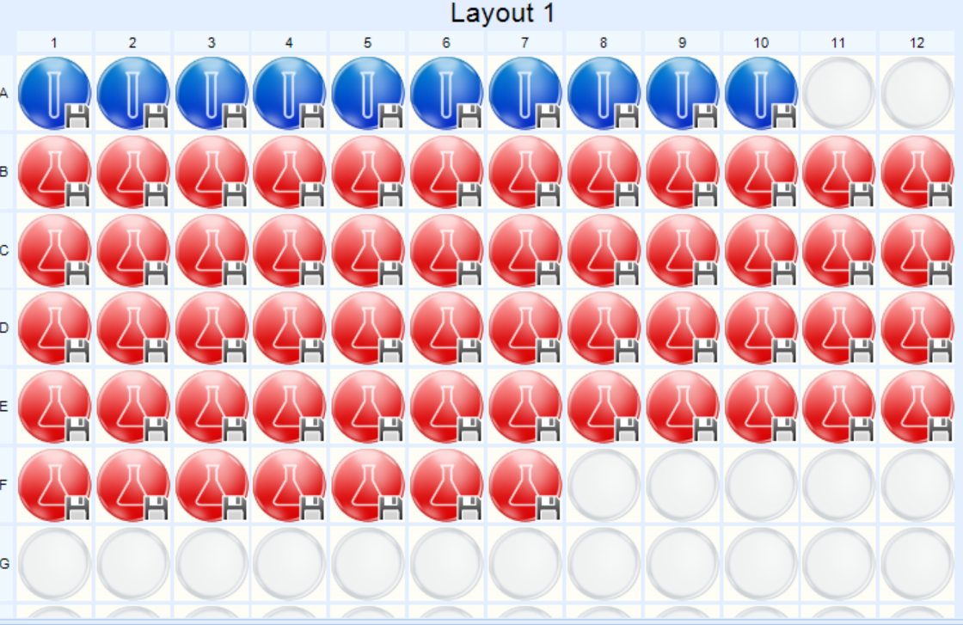

2. Instrument Settings: SSC-H as scatter param, R660-A(FSC-A) as clustering param, Y585-A as reporter param.

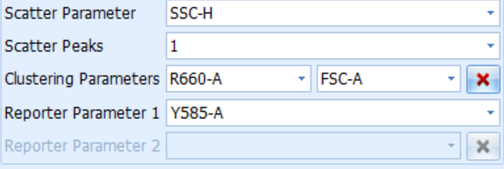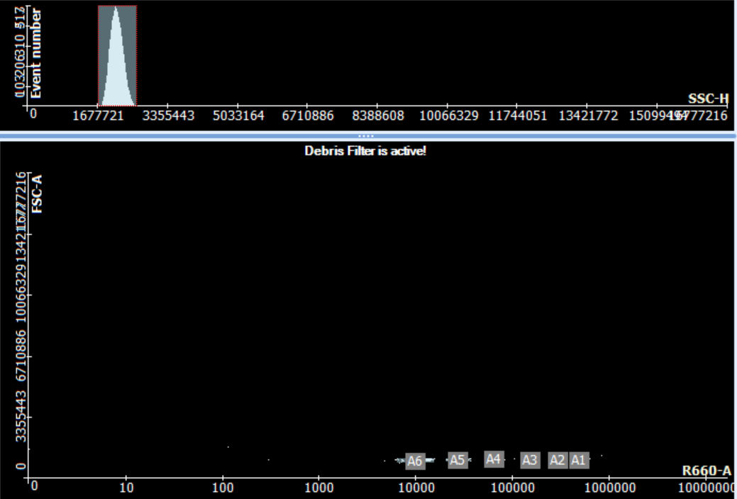

3. Debris Filtering: Manual gating on SSC-A / FSC-H

(Don’t know how to export this figure in 300dpi)

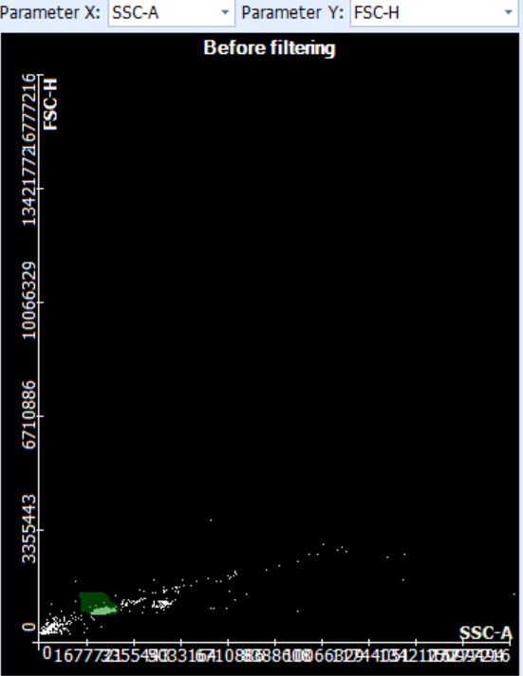

4. Manual clustering: Not applied (All Automatic)

5. Standard settings: 0; 20-5000 (Automatic calculation)

