Jason Kirshner

MyReminder

MyReminder is a tool used by people who are constantly on the run and need to remind themselves of certain tasks that need to be taken care of. MyReminder lets the user set a task and task items along with it and sends you a notification on when the task needs to be completed.

Features

1. Creating the task: setting the name of the task, setting alarm for the task, setting task items.
2. Selecting tasks by pressing down for a certain amount of time.
3. Deleting selected tasks.
4. Canceling the deletion of selected tasks
5. Ability to see the task items from each task
6. Selecting task items within tasks, marking them as complete or incomplete

Wish List Features

1. Save state
2. Notification settings
3. More options for task creation
4. Ability to have notifications sent to all of the user’s Apple devices

Grade

This project deserves an A because all of the data used in this project is dynamic and accounts for many variables that could interrupt the operation. MyReminder is able to create tasks without error and properly assign the designated task items to each task. DRY has been implemented through high cohesion and loose coupling. MyReminder also takes advantage of the long press gesture for selecting tasks. The use of color resembles that of a clean iOS app UI and keeps this familiar look to not confuse or disorient the user. The viewcontrollers are laid out with minimal segues to ensure that this app will not result in accessing the wrong viewcontroller or the accidental creation of a inifnite view.

Describe

The initial view is the RemindersTableVC class where all tasks can be viewed, accessed and modified. The tasks tab or NewTaskVC enables the user to create a task from scratch. The values from the creation of the task are sent to the RemindersTableVC where that data is displayed in a cell and when clicked upon, the data for the task is displayed in cells in the RemindersTaskTableVC.

Document

Above and beyond work would have to be the creation of the set date notification using the DatePicker’s date and time values. I would also say that the implementation of the long press gesture to enable selection of tasks so they could be deleted from the table.

Declare

UserNotification.framework tutorial: <https://code.tutsplus.com/tutorials/an-introduction-to-the-usernotifications-framework--cms-27250>

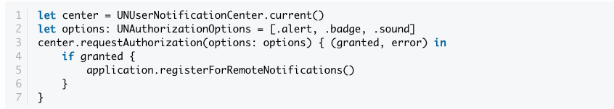

Long Press Gesture tutorial: <https://iosdevcenters.blogspot.com/2017/05/uilongpressgesturerecognizer-tutorial.html>

