Phase One Development and Independent Confirmation Review
  - Controlled synthetic visual memory experiments
19 October 2026

1 Research objective
The overall research goal is to decide which observations a limited visual memory should retain. Phase One tests a prerequisite: does deleting a historical observation cause a reliable change in prediction error that reflects its task importance? A useful deletion signal would justify studying retention strategies next.
This report distinguishes the successful development checks from the independent confirmation that remains unfinished. It also records a GPU allocation failure that exhausted the authorized budget.

Development results
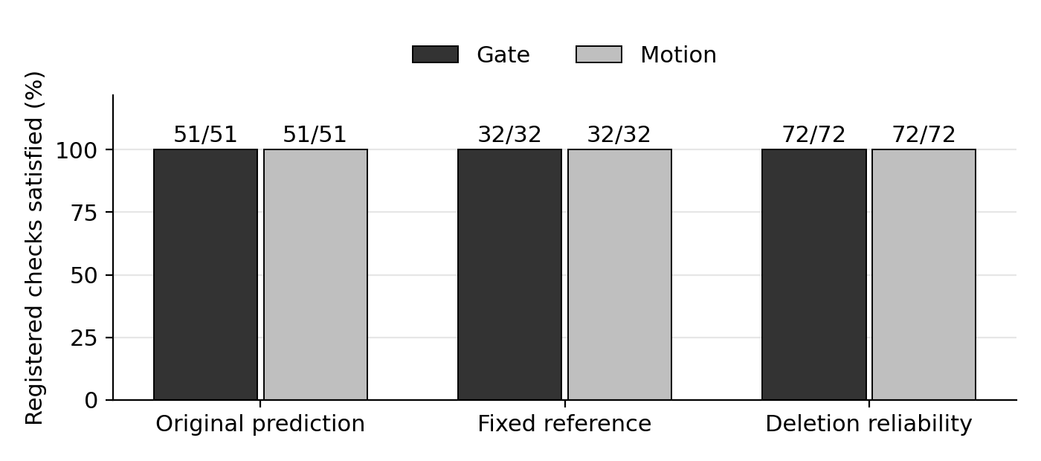
Figure 1. Both tasks satisfy every registered development check. The labels show counts, not separate independent experiments. These are repeatedly inspected seed 6301 results, not fresh confirmation results.
Requirement | Gate | Motion
Original prediction checks | 51/51 | 51/51
Additional fixed reference checks | 32/32 | 32/32
Task specific deletion reliability checks | 72/72 | 72/72
These results are meaningful evidence that the repaired predictor can support the deletion assay on the development distribution. They do not establish generalization to new data or the advantage of a learned retention policy.

2 Experimental design and test meanings
The prototype uses a frozen I-JEPA image encoder and controlled paired Gate and occluded Motion scenes. It is not a V-JEPA or real-video validation. Paired scenes make the older evidence informative while matching recent observations.
Design element | Revealed development | Planned fresh confirmation
Data seed | 6301 | 9137
Training and validation per task | 512 and 96 pairs | 512 and 96 new pairs
Each of 3 test conditions per task | 128 pairs | 256 new pairs
Neural seeds | 17, 29, 43 | 17, 29, 43
Training per neural model | 120 epochs and 7680 steps | Same unchanged schedule
Recent context and retained history | 4 recent observations and budget 2 | Same capacity and inputs
Ordinary means the standard task distribution. Long gap lengthens the interval or occlusion between evidence and the prediction query. Distractor shift changes irrelevant observations to test whether the signal survives distraction. All three conditions retain the paired comparison design.

What each check measures
Original prediction checks test whether historical evidence improves future prediction, whether the model responds to the correct historical content, and whether the registered feature and task errors meet their requirements. Fixed reference checks compare against the original recent-only reference and retain difficult absolute-error requirements. They prevent a weak new baseline from making an apparent improvement look convincing.
Deletion reliability checks compare deletions at the same retained capacity. Gate tests whether removing the task cue is more costly than removing other observations. Motion tests whether deletion rankings selected at one prediction horizon transfer to the other against the registered baselines. These diagnostic pools are not a trained retention policy.

Repair fixed before independent confirmation
Gate disables its time-extrapolation contribution for every tested context. Motion combines a same-history reference prediction, a guarded position estimate, and a fixed one-half observed-geometry innovation correction. The development repair fits two training-only maps; the neural predictors remain frozen during that repair. No test-specific switch or fusion-weight search is part of the locked confirmation.

3 Confirmation execution and resource results
CPU job 8533 completed normally in 282 seconds. Its native proof verifies 9728 input and target samples, 24 validation batches, 240 Gate feature predictions and 468 cached Motion vectors. Every registered equivalence comparison matches exactly. This validates the executor, not a fresh scientific result.
Independent confirmation requirement | Observed status
Fresh neural models completed | 0/12
Fresh Motion maps fitted | 0/2
Fresh training and test data | Not generated
Independent fresh scientific comparisons | Not evaluated
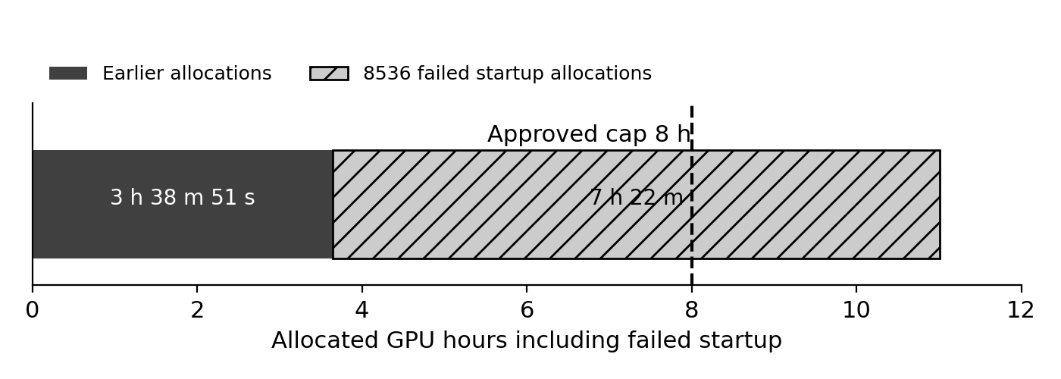
Figure 2. All allocated GPU wall time is charged, including failed configuration. The 11 h 00 m 51 s total exceeds the 8 h cap by 3 h 00 m 51 s . Allocation is not equivalent to useful model computation.
Native allocation accounting | Time
Previously settled GPU allocations | 3 h 38 m 51 s
8536 failed startup allocations | 7 h 22 m 00 s
Total allocated GPU time | 11 h 00 m 51 s
Approved cumulative cap | 8 h 00 m 00 s
Excess allocation | 3 h 00 m 51 s
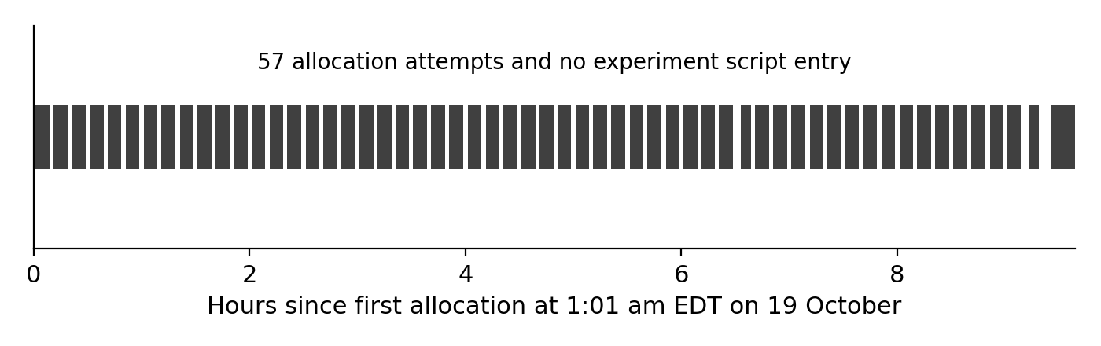
Figure 3. Dark intervals are the 57 nonoverlapping Slurm allocation records for 8536. There were 56 automatic requeues before final cancellation at 10:40 am EDT. No GPU experiment script entry was recorded.

4 Interpretation and next work

What has been established
Both development tasks satisfy 51/51 prediction, 32/32 fixed-reference and 72/72 deletion checks under unchanged requirements. The final repaired development method is therefore supported within this controlled synthetic I-JEPA setting. The native CPU equivalence proof also shows that the staged implementation preserves the checked inputs and accepted predictions.

What remains unestablished
Development data have been inspected repeatedly during repair. Fresh 9137 confirmation is essential to test whether the locked method generalizes without further tuning. None of its 12 new neural models or 2 new maps was trained, and fresh tests were not generated. There is also no learned-policy comparison, V-JEPA confirmation or real-video result.

Why execution stopped
The GPU node never reached its experiment entrypoint. Slurm repeatedly allocated and requeued the startup job. The agent implementation relied on an in-process budget guard and batch time limit; it did not independently stop configuration failures and automatic requeue before the script started. This execution protection defect allowed the allocation budget to be exceeded. It is not a negative fresh result for the scientific hypothesis.

Required before any future GPU work
New GPU submissions are stopped. A future attempt requires a separately frozen execution repair with no-requeue, an independent CPU startup watchdog, duplicate-aware Slurm accounting and a complete remaining-cost check. The watchdog preparation passes 5 software boundary fixtures but has not been deployed or validated on HPC. No further GPU use is authorized by the exhausted 8-hour allowance.
After an explicitly authorized resource plan is available, confirmation must retain all 12 new 120-epoch models, 2 new maps, fresh training-only transforms and the original acceptance rules. Every model and transform must be locked before fresh tests are generated or opened. A failed confirmation must be reported without retuning on9137. Retention-policy training remains closed.

Evidence and reproducibility
The report uses filtered native Slurm allocation records and the 57-row startup allocation CSV. An independent local replay verifies durations, nonoverlap, both native queries, the 11 prior allocations and the total 39651 GPU seconds. All 11 retrieved compact files match native-before, local and native-after SHA256 values. Large weights, feature arrays and raw traces remain on HPC; GitHub was not updated.
Evidence files: startup_recovery/local_final_audit.json; native_settlement8743_final/final_budget_boundary.json; startup_allocation_attempts.csv; native_settlement8743/preflight_cpu.json. Paths are relative to results/phase1_independent_confirmation.

Final conclusion
Phase One is not yet independently confirmed, so entry into the retention-policy stage cannot be justified by the complete Phase One standard. Development checks are fully supported; the missing evidence is fresh confirmation. The present stopping reason is an execution and budget boundary, not a completed scientific rejection.

