Phase 1 Independent Confirmation
  - Carry-over of evidence in bounded visual memory
Fresh seed 9137 | Controlled I-JEPA study | 20 October 2026
Decision: PHASE1_ORIGINAL_STANDARD_NOT_MET
Gate passed every registered check. Motion passed every prediction and fixed-reference check, but 8 of 72 deletion checks failed. The independent audit passed, so this is a scientific threshold result, not an execution or evidence-completeness problem.
Result at a glance | Gate | Motion | Overall
Prediction and fixed reference | 83/83 | 83/83 | 166/166
Deletion reliability | 72/72 | 64/72 | 136/144
Registered checks | 155/155 | 147/155 | 302/310

1 Research objective
The broader project asks which observations a memory-limited model should retain. A practical retention policy cannot be learned until historical visual evidence survives encoding, the predictor uses that evidence, and deleting a useful memory causes a larger prediction cost than deleting a nuisance memory.
Stage objective. Phase 1 tests those prerequisites. It is not a test of a learned retention policy and does not establish transfer to V-JEPA or real video. The purpose of this final study is narrower: repeat the complete agreed test once on untouched seed 9137 data, with newly fitted preprocessing, predictors and readouts, after all models are locked.
Overall outcome. Strict result. Phase 1 does not pass. Gate passes; Motion does not meet its 72/72 deletion requirement. Because the original rule requires every criterion for both tasks, the project cannot move to retention-policy training under the current proposal.

2 Experimental design

2.1 Fresh data and information boundary
Fresh confirmation used seed 9137. Each task contains 512 training pairs, 96 validation pairs, and three separate 256-pair test conditions: ordinary, long gap, and distractor shift. Across both tasks the study contains 5,504 episodes. The 51 original prediction checks, 32 fixed-reference checks, and 72 deletion checks per task were frozen before test access.
Split per task | Matched pairs | Episodes | Role
Training | 512 | 1,024 | Fit normalization, basis, readouts and predictors
Validation | 96 | 192 | Select checkpoint within the frozen schedule
Ordinary test | 256 | 512 | Familiar timing and scenery
Long-gap test | 256 | 512 | 20 to 32 steps before the recent window
Distractor-shift test | 256 | 512 | Changed irrelevant scenery
Total per task | 1,376 | 2,752 | Both tasks: 5,504 episodes

No development weight was evaluated on the confirmation test. The test was generated only after all 12 new models and the two train-only observation maps were locked. The training and validation cache was encoded once and reused.

2.2 What the tasks ask
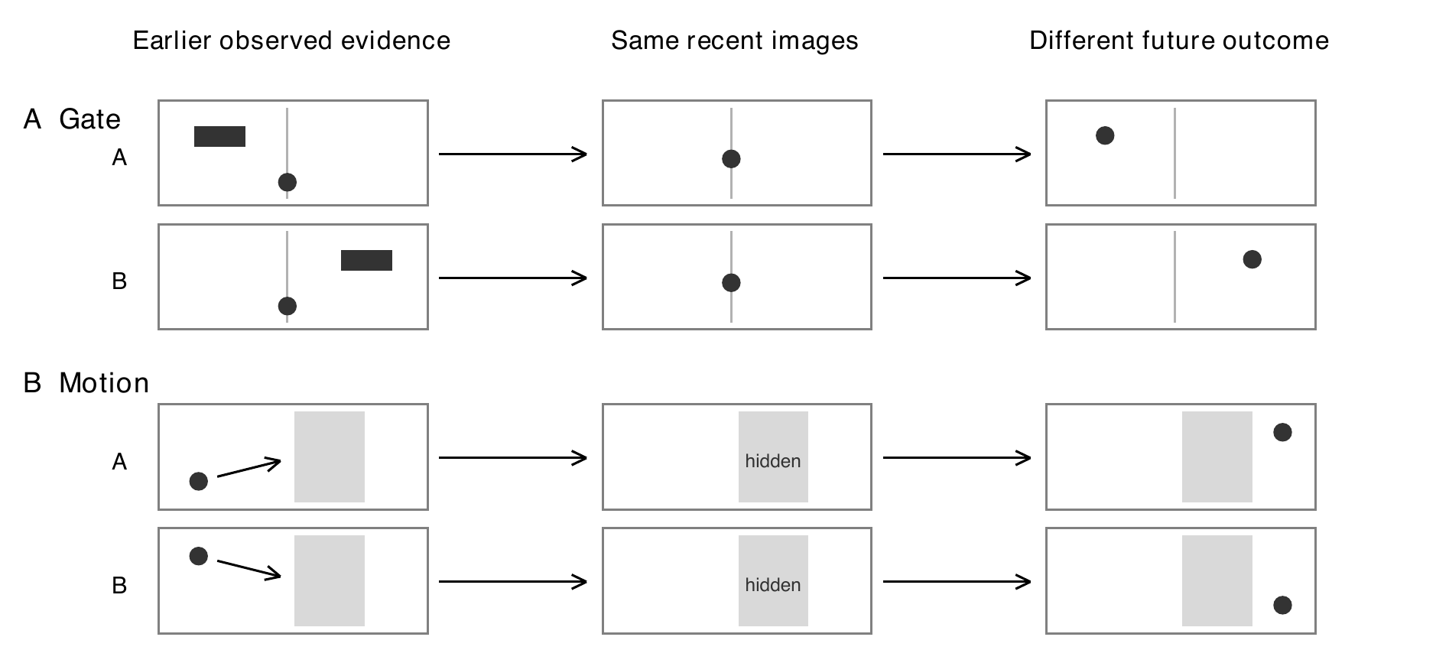
Figure 1. Each matched pair has the same recent image but different earlier evidence, known actions, and future outcomes. Gate requires a transient cue. Motion requires the trajectory observed before occlusion. The drawings explain the task and are not model outputs.
Ordinary uses a short gap and familiar scenery. Long gap holds the task rules fixed but delays the useful evidence by 20–32 steps. Distractor shift keeps the timing but changes irrelevant objects and colours. The recent four-frame window is identical within each pair, so a recent-only predictor cannot distinguish the two futures.
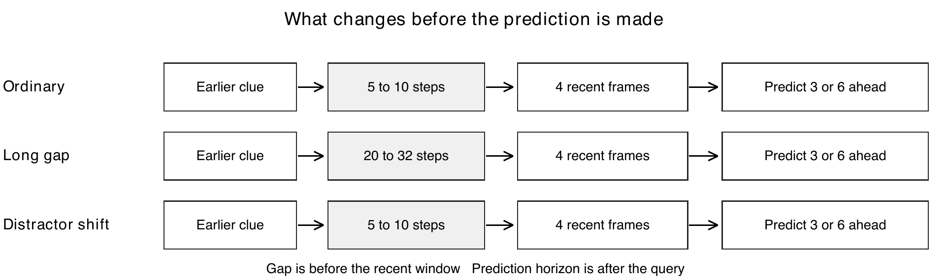
Figure 2. The three conditions change the amount of missing time or the irrelevant visual context. Prediction horizons remain three and six steps after the four-frame query window.

2.3 Processing and predictors
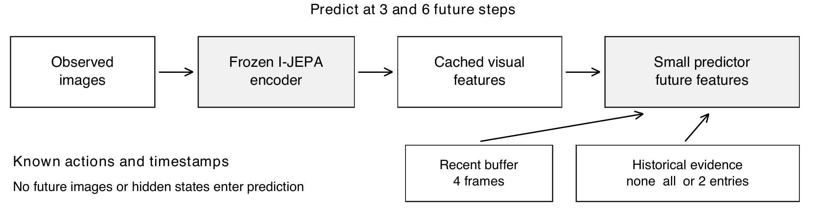
Figure 3. Frozen I-JEPA features are cached. A small predictor reads four recent frames, legal historical entries, timestamps and action continuations. It never receives future images, hidden simulator state or evidence labels.
The encoder is the frozen I-JEPA implementation used throughout the study. Images are processed without a center crop, spatially pooled into four cells, and represented by 5,120-dimensional features. Normalization, the 128-dimensional input basis, readouts, and the two observation maps are fitted on training data only. Full normalized future-feature MSE remains the primary prediction loss.
Each task has a reference that predicts from recent frames plus legal actions and a candidate that adds a corrected historical-evidence branch. The fresh study used three seeds (17, 29 and 43), two roles, two tasks, 120 epochs and 7,680 optimizer steps per model: 12 models in total.
The locked Gate candidate disables the temporal extrapolation branch. The locked Motion candidate combines frozen-reference visual prediction, guarded position, and a fixed 0.5-weight training-only observation innovation map. The position readout is supervised with training data; the guard uses observed RGB. These restrictions matter: this result does not establish a fully self-supervised video memory system.

2.4 Tests and recorded evidence
Test group | What is compared | What it establishes
Evidence readable from features | Linear readout from historical evidence versus the recent-only control | Useful information has not already been erased by encoding
Original prediction checks | History benefit, paired-content intervention, and feature probes | The predictor uses historical content at both horizons
Additional fixed-reference checks | Candidate versus frozen recent-only and same-memory references | Any gain is measured against a stable outside baseline
Critical deletion contrasts | Delete useful evidence versus delete nuisance content at equal capacity | Deletion cost separates useful from uninformative memories
Cross-horizon deletion checks | Select a deletion at one horizon; score the choice at the other | The deletion signal is not confined to one future horizon
Learned-policy advantage and fresh confirmation | Policy comparison and untouched-data replication | Fresh confirmation is completed here; learned policy is not tested

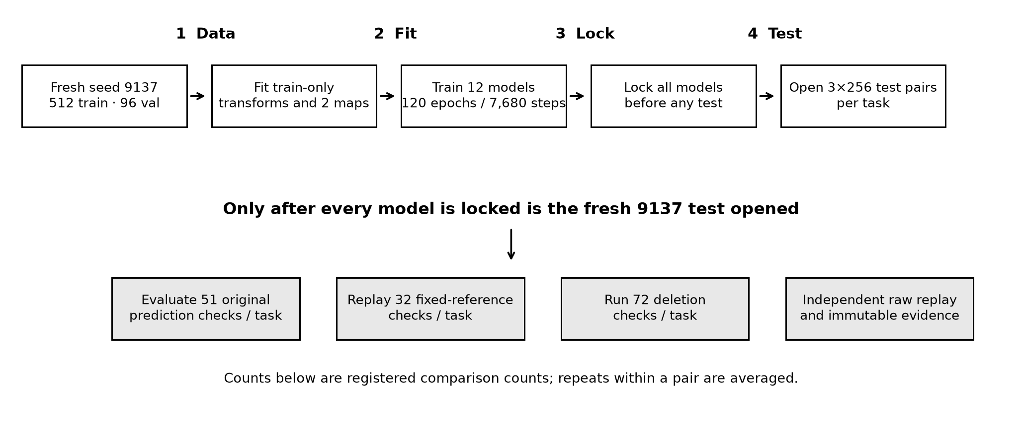
Figure 4. The execution order prevents test leakage. Fresh data and train-only transforms are fixed first; all 12 model checkpoints are locked before the 9137 test is opened. The final audit independently replays decisions from raw rows.

3 Results for each test

3.1 Evidence readable from features
Question. Before testing prediction, can a fixed linear readout recover the history-dependent distinction from the frozen features?
Result. Gate historical evidence is decoded at 100% under all three conditions, while the matched recent-only control stays at chance (50%). Motion history is 100% in ordinary and long-gap conditions and 92.6% under distractor shift; its recent-only control is again 50%. The registered evidence-probe count is 3/3 for both tasks.
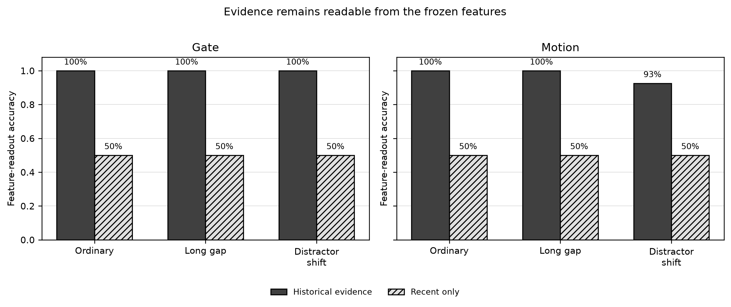
Figure 5. Taller bars mean the answer is easier to decode. Black bars use the historical evidence; hatched bars use only recent frames. The 50% recent-only floor is expected for matched pairs. These are classification readouts, not future-prediction scores.
Interpretation. The distinction required by the tasks survives the encoder and is available in features. This enables the later prediction tests but does not show that a dynamics predictor will use it.

3.2 Original prediction checks
The original 51 checks combine three feature probes, 24 history-benefit checks and 24 paired-content intervention checks. Each task passed all 51: Gate 51/51 and Motion 51/51. The checks cover every condition, both three- and six-step horizons, all three model seeds, and the seed mean.
This is a substantial change from the earlier development run. The fresh confirmation shows that the corrected predictor now uses historical content in both tasks under the registered prediction protocol.

3.3 Additional fixed-reference checks
The 32 checks compare the candidate with a fixed recent-only reference and with a frozen same-memory reference. Both tasks pass 32/32. All intervals exclude no improvement. The seed-mean relative feature-error reductions range from 13.3% to 27.8% for Gate and 38.2% to 55.3% for Motion.
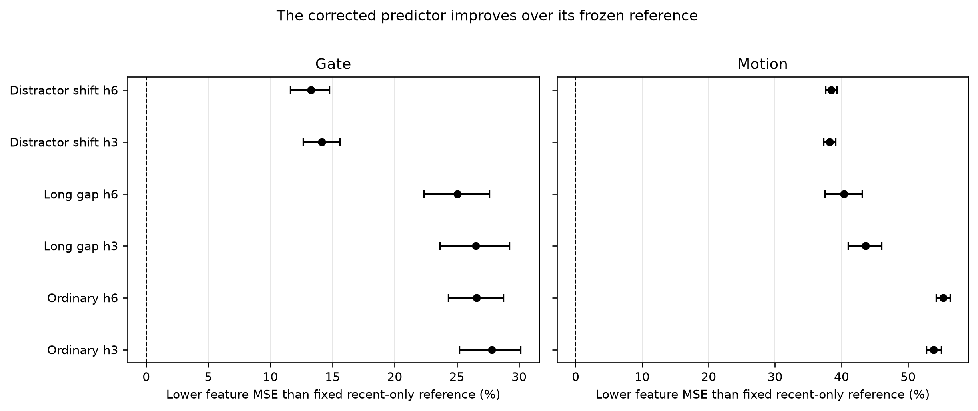
Figure 6. Points to the right are lower feature error than the fixed recent-only reference. Horizontal bars show 95% paired intervals over 256 base pairs, after averaging the three model seeds. Every interval lies above zero.
Task | Ordinary h3 | Ordinary h6 | Long gap h3 | Long gap h6 | Distractor h3 | Distractor h6
Gate | 27.8% | 26.6% | 26.5% | 25.0% | 14.1% | 13.3%
Motion | 53.8% | 55.3% | 43.6% | 40.4% | 38.2% | 38.4%

Interpretation. The candidate's historical branch provides a clear and consistent prediction advantage against a fixed reference in both tasks. This supports the predictor mechanism, but it is not by itself the memory-retention criterion.

3.4 Critical deletion contrasts across all conditions
Each deletion fork keeps exactly two historical entries and the same four recent frames. Gate compares retaining the cue with retaining a nuisance frame across three cue-age pools. Motion's registered reliability test asks whether the chosen deletion continues to help at the other prediction horizon.
Deletion cost is the change in future-feature mean squared error when one stored observation is removed. The assay compares deletions with the same remaining memory capacity. Gate requires at least a 10% critical-versus-nuisance effect and a positive paired 95% lower bound for both metrics. Motion requires positive paired 95% gain lower bounds in feature and decoded-position error against uniform, FIFO, and reject-newest choices. Its 72 checks are three conditions times two horizons times three baselines times four seed summaries (three seeds and their mean).
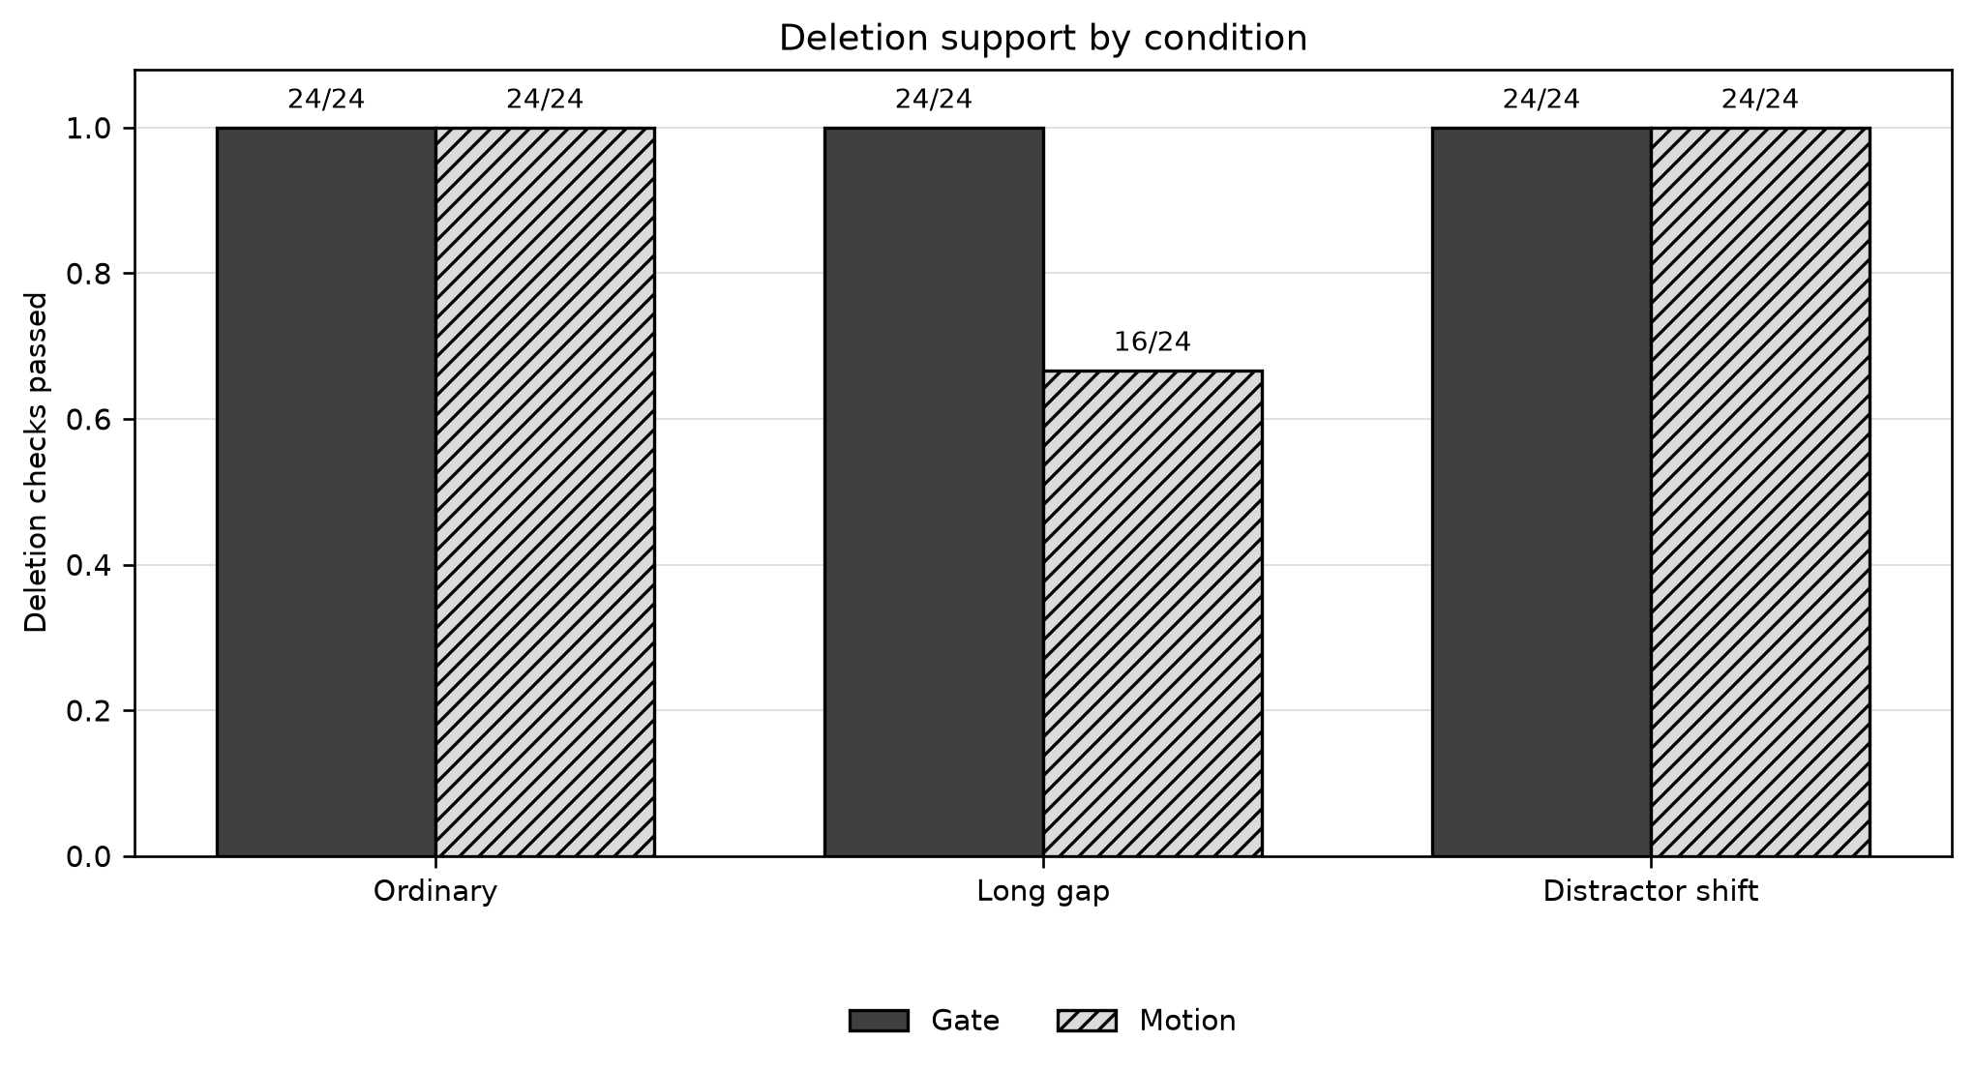
Figure 7. Bars show registered deletion checks passed by condition. Gate passes 72/72. Motion passes 24/24 ordinary, 16/24 long-gap, and 24/24 distractor checks. The eight missing Motion checks are not counted as a rounding loss: each has a 95% interval that fails the positive-both-metrics rule.
Task | Ordinary h3 | Ordinary h6 | Long gap h3 | Long gap h6 | Distractor h3 | Distractor h6 | Total
Gate | 12/12 | 12/12 | 12/12 | 12/12 | 12/12 | 12/12 | 72/72
Motion | 12/12 | 12/12 | 8/12 | 8/12 | 12/12 | 12/12 | 64/72

Interpretation. Gate has complete deletion support. Motion's deletion signal is reliable in ordinary and distractor conditions and unreliable only at long gap.

3.5 Cross-horizon deletion checks
The eight failures are exactly the Motion long-gap comparisons against the strong reject-newest baseline: three seeds and their mean at each of the two score horizons. Feature error still improves by 9.4–11.1% relative to that baseline. The task-position error change is close to zero, with every 95% interval crossing zero and seed 29 slightly negative.
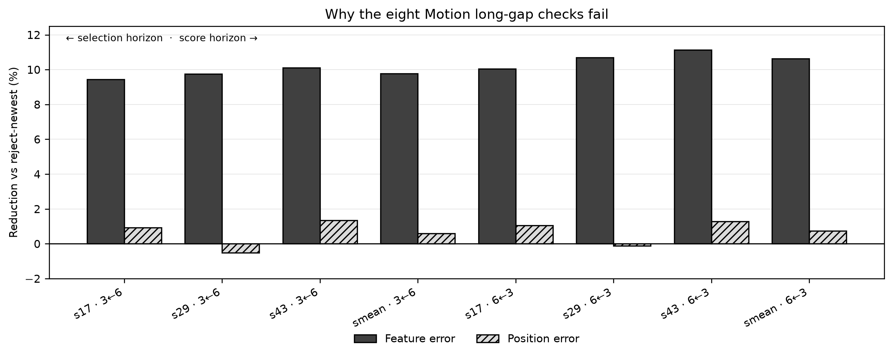
Figure 8. Black bars show feature-error reduction relative to reject-newest; hatched bars show decoded position error. Feature error improves by roughly 9–11%, while position improvement clusters near zero. The deletion choice found a useful feature-space direction that did not transfer reliably to position in the long-occlusion condition.
Seed / horizon | Feature gain vs reject | Task gain vs reject
17, score h3 / select h6 | 9.4% | +0.94%
29, score h3 / select h6 | 9.8% | −0.51%
43, score h3 / select h6 | 10.1% | +1.34%
mean, score h3 / select h6 | 9.8% | +0.59%
17, score h6 / select h3 | 10.0% | +1.04%
29, score h6 / select h3 | 10.7% | −0.13%
43, score h6 / select h3 | 11.1% | +1.29%
mean, score h6 / select h3 | 10.6% | +0.74%

Seed and score horizon | Absolute task gain 95% interval
17 h3 | [-0.000129, 0.000508]
29 h3 | [-0.000392, 0.000218]
43 h3 | [-0.000072, 0.000613]
mean h3 | [-0.000181, 0.000427]
17 h6 | [-0.000104, 0.000589]
29 h6 | [-0.000351, 0.000313]
43 h6 | [-0.000089, 0.000682]
mean h6 | [-0.000163, 0.000514]

Intervals above use absolute decoded-position error reduction, not percent reduction. Every interval contains zero. This means superiority over reject-newest is not established; it does not prove that the two choices are equivalent or that historical memory has no value.
Cause. This is the only scientific failure in the fresh confirmation. The predictor passes all its own checks; the future-informed deletion choice remains useful in feature space but is not reliably better than the simple reject-newest baseline for the decoded position after long occlusion.

3.6 Learned-policy advantage and fresh confirmation
Fresh confirmation. The new-data study itself is complete. All 12 fresh models were locked before test access; the independent audit replayed all 310 registered decision checks and reported a maximum original-statistic difference of 0.0. The audit separately checked 248,832 prediction rows, 248,832 deletion rows, 18,432 paired deletion summaries, and 31,772 actual-input traces.
Learned policy. No retention policy was trained. A future-informed oracle is a diagnostic for available signal, not a deployable policy. Therefore policy learnability and online memory-value estimation remain untested.

4 Overall summary and next steps
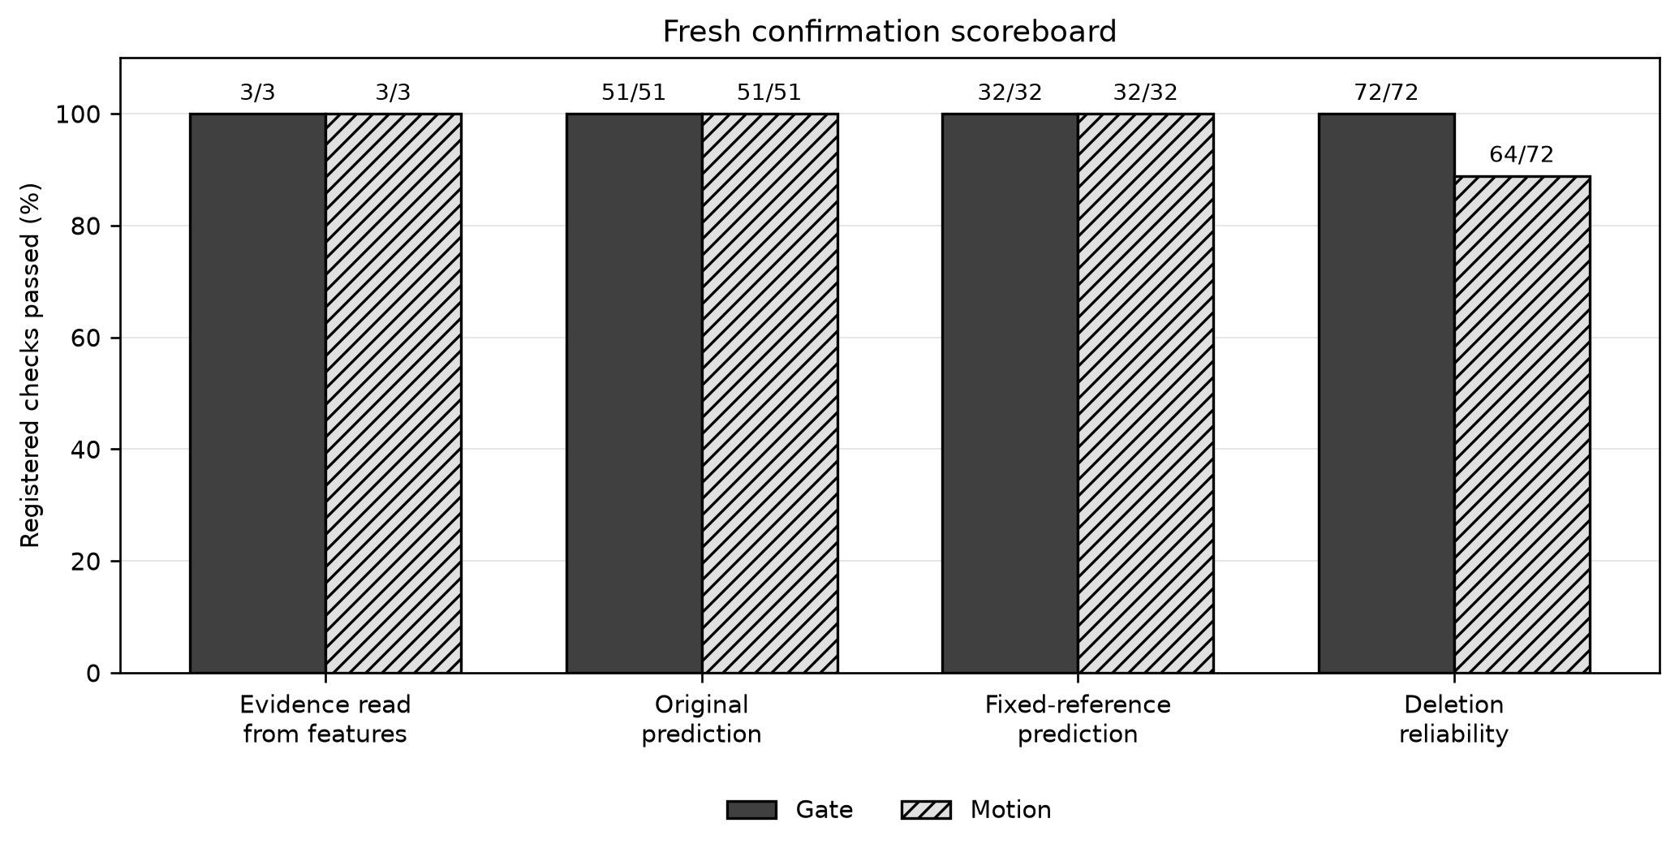
Figure 9. Passing counts are shown as x/y. Gate clears every group. Motion clears all prediction and fixed-reference checks and 64/72 deletion checks. Under the pre-registered conjunction, the visual majority does not replace the missing eight Motion checks.
Check group | Gate | Motion | Overall
Evidence readable (included in original) | 3/3 | 3/3 | 6/6
Original prediction | 51/51 | 51/51 | 102/102
Fixed-reference | 32/32 | 32/32 | 64/64
Deletion reliability | 72/72 | 64/72 | 136/144
Total registered checks | 155/155 | 147/155 | 302/310

What the numbers mean. The result is 302/310 checks passed, or 97.4%. This count is descriptive; the original decision rule requires all checks, so the strict Phase 1 decision is not met. The audit was not inconclusive, and the GPU ledger stayed within the approved budget: 53,544 of 69,299 seconds.

4.1 What was achieved
The study provides strong fresh evidence that history is encoded, decoded, and used by the predictor. Gate is fully supported. Motion's prediction and fixed-reference behavior are also fully supported. These are meaningful prerequisites for a future retention study, but they are not a substitute for the deletion reliability requirement.

4.2 Why Motion's deletion test failed
The failure is concentrated in long-gap Motion and in the comparison with the reject-newest baseline. The future-informed choice lowers feature MSE, yet it does not reliably lower decoded position error. A feature error and a downstream task error can rank deletions differently. The confirmation therefore shows a mismatch between the current deletion score and the position objective in this assay. This is evidence of limited task alignment, not a causal proof of a unique underlying failure mechanism.

4.3 Can the project enter the retention-policy stage?
No, not under the registered Phase 1 rule. The Motion deletion requirement is not met, and every acceptance criterion is conjunctive. Training a retention policy now would optimize against a score that has not passed the confirmation test. The appropriate next study is a separate, validation-only examination of motion-state alignment and baseline-relative deletion value. It must not reuse these fresh test outcomes to tune a threshold.

Evidence and reproducibility
Primary artifacts: final_outcome.json, primary_outcome.json, independent_final_audit.json, deletion/summary.json, and probes/metrics.json under /scratch/xl4358/phase1_independent_confirmation_execution_v9_cpu_incarnation/fresh. The independent audit report hash is de0638ab1f0141e15003a5bae004ccfc09df47046b5366c27754853c66ae4e09.
Method references: [1] Assran et al., Self-Supervised Learning from Images with a Joint-Embedding Predictive Architecture, CVPR 2023, arXiv:2301.08243. [2] Lee et al., Set Transformer, ICML 2019. [3] Hooker et al., A Benchmark for Interpretability Methods in Deep Neural Networks, NeurIPS 2019.

4.4 Conclusion
Phase 1 does not pass. Gate passes completely; Motion passes 147 of 155 checks and misses exactly eight long-gap deletion checks. The final report therefore records a scientific standard failure, not an execution failure. The memory mechanism is supported well enough to justify a new independently designed validation study, but not enough to begin retention-policy training.

