Memory Retention for Visual World Models
  - A controlled Phase 1 pilot on eight LoopNav scenes

Purpose
We tested whether relevance to the current state is a useful rule for retaining a small visual memory. The experiment adapts a pretrained FAR world model to irreversible online storage. It compares retention rules while keeping the predictor and memory reader fixed, so differences reflect the retained evidence and the resulting closed loop predictions.

Controlled design
We selected eight distinct LoopNav scenes before inspecting their scores, with four ABA and four ABCA routes. Three common seeds and four conditions produced 96 complete return records and 6996 prediction steps. FIFO, true Reservoir sampling and FAR current each retain 16 past entries plus a separate current entry. Archive reference keeps all arrived history and serves only as a diagnostic with greater storage.
FAR current ranks candidates using the newly arrived state and a zero motion and zero time query. Retention cannot inspect future routes, images or queries. Deleted payloads cannot return. Return observations are each policy's generated images. All conditions use DDIM 20, stride 4 and context 12. Temporal chunks are one frame, instead of the original ten, to accommodate the same 16 entry capacity.

Evaluation
The primary score is DreamSim error over the final quarter of each return, using the last ceil(n/4) actual predictions. Lower DreamSim and LPIPS are better; higher PSNR is better. We average seeds within each scene, then weight the eight scenes equally.
Retention rule | DreamSim  mean (seed SD) | LPIPS  mean | PSNR  dB
FIFO | 0.3327 (0.0115) | 0.7965 | 10.798
Reservoir | 0.1795 (0.0143) | 0.5589 | 13.616
FAR current | 0.3389 (0.0068) | 0.8029 | 10.512
Archive reference | 0.1954 (0.0286) | 0.5725 | 12.944

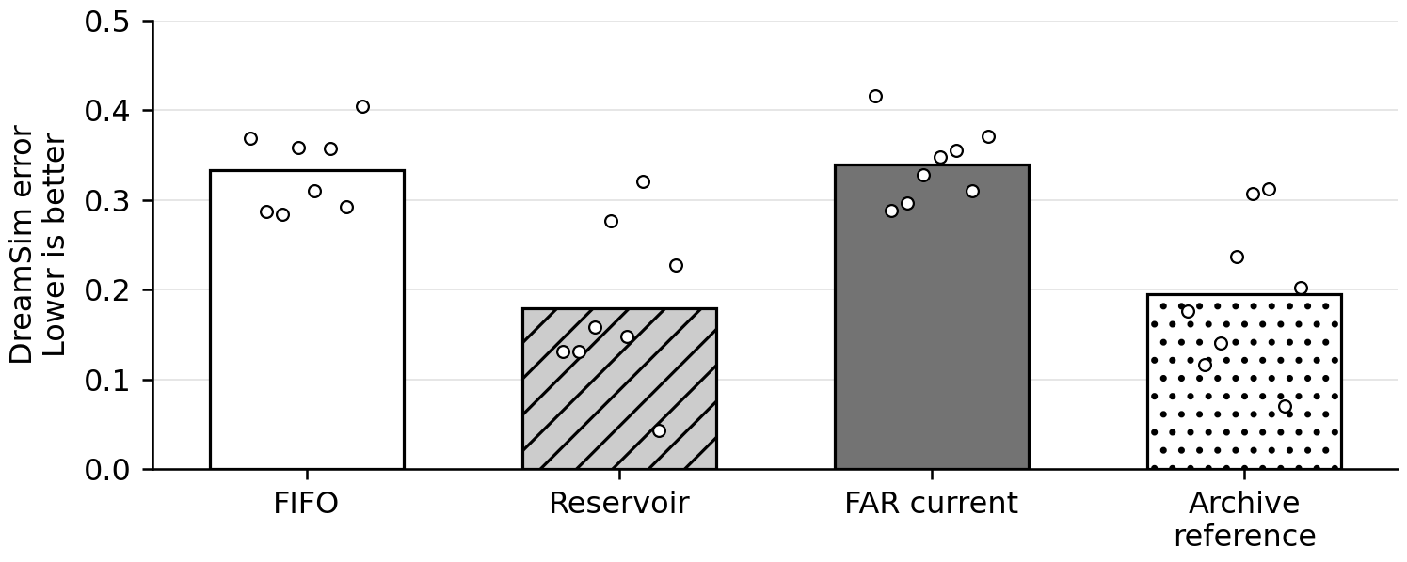
Figure 1 Primary prediction error. Bars show equal scene means; each dot is one scene averaged over three seeds. Archive reference has greater storage.

Paired comparisons
FAR current did not improve on FIFO. Its mean error was 0.3389 versus 0.3327 for FIFO, while Reservoir achieved 0.1795. Reservoir error was descriptively 46.1% lower than FIFO. The predefined comparison also found FAR current worse than Reservoir. Archive reference reached 0.1954, which shows that keeping every arrived entry was not the best configuration in this pilot.
Comparison | Mean  improvement | Paired 95%  interval | One sided  p
FAR versus FIFO | -0.0062 | [-0.0248, +0.0123] | 0.7305
FAR versus Reservoir | -0.1595 | [-0.2178, -0.0998] | 1.0000

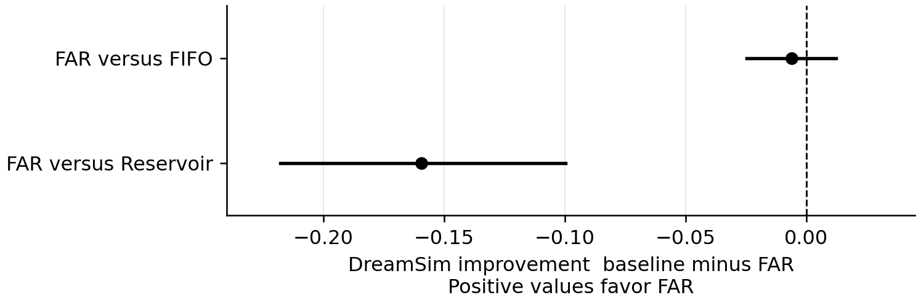
Figure 2 Positive values favor FAR current. Intervals use 10000 paired scene bootstrap draws. Exact one sided sign flip tests enumerate all 256 patterns over eight scenes.

What the memory traces show
An additional descriptive audit examined which retained entries came from the observed outward route. At the end of return, those entries occupied 89.3% of Reservoir memory, 4.7% of FAR current memory and 0% of FIFO memory, averaged across the 24 scene and seed cases. This is consistent with current state relevance losing older evidence needed on return. It does not establish a causal explanation: generated current images can diverge across policies. This audit was added after results and did not change the primary test.

Scope and verification
The GPU stage completed in 1 hour 46 minutes 50 seconds on one A100. A separate CPU audit and an independent replay verified all 96 paired frame axes, finite scores, source and asset hashes, storage transitions, and exact Algorithm R Reservoir choices. All reported summary statistics reproduced. This is an eight scene pilot using an existing FAR checkpoint. It is neither a full FAR reproduction nor an I JEPA evaluation, and it does not satisfy or replace the original Phase 1 GO criteria.

Conclusion
The tested current state scoring rule should not replace the simpler baselines. Reservoir is the strongest equal capacity method in this pilot and should remain the reference for future retention studies. The results support testing preservation of earlier evidence rather than assuming that current relevance predicts later usefulness. A broader causal claim or a new retention mechanism requires a separate prospective experiment.

