Historical Visual Memory in Phase1
  - A controlled FAR study on eight LoopNav scenes

Purpose
We tested historical evidence for return prediction in a fixed FAR world model. Eight LoopNav scenes, four ABA and four ABCA, and three common seeds produced 144 returns and 10494 predictions. The 96 pilot records were preserved and 48 controls were added.

Controlled design
Current only supplies one real current frame and no explicit past. Recent only stores 16 past entries and directly reads the latest 11 plus current. FIFO, Reservoir and FAR current each store 16 past entries; the same pretrained FAR reader selects 11 per query. Archive reference retains all arrived history and has greater storage.
All conditions use the released far_multicue predictor, DDIM 20, stride 4 and one frame chunks, adapted from the original ten. Initial current and external actions are shared. Each policy then uses its own generated current. Return ground truth never enters memory, and evicted payloads cannot reenter the policy buffer. Retention cannot inspect future routes or queries.

Six condition results
The primary score is DreamSim over the last ceil(n/4) actual predictions. We average three seeds within each scene, then weight eight scenes equally. Lower DreamSim and LPIPS and higher PSNR are better.
Condition | DreamSim tail  mean (seed SD) | DreamSim  full | LPIPS  tail | PSNR tail  dB
Current only | 0.4151 (0.0711) | 0.3352 | 0.8380 | 10.266
Recent only | 0.3238 (0.0124) | 0.2597 | 0.7956 | 10.601
FIFO with FAR | 0.3327 (0.0115) | 0.2616 | 0.7965 | 10.798
Reservoir | 0.1795 (0.0143) | 0.1622 | 0.5589 | 13.616
FAR current | 0.3389 (0.0068) | 0.2631 | 0.8029 | 10.512
Archive reference | 0.1954 (0.0286) | 0.1869 | 0.5725 | 12.944

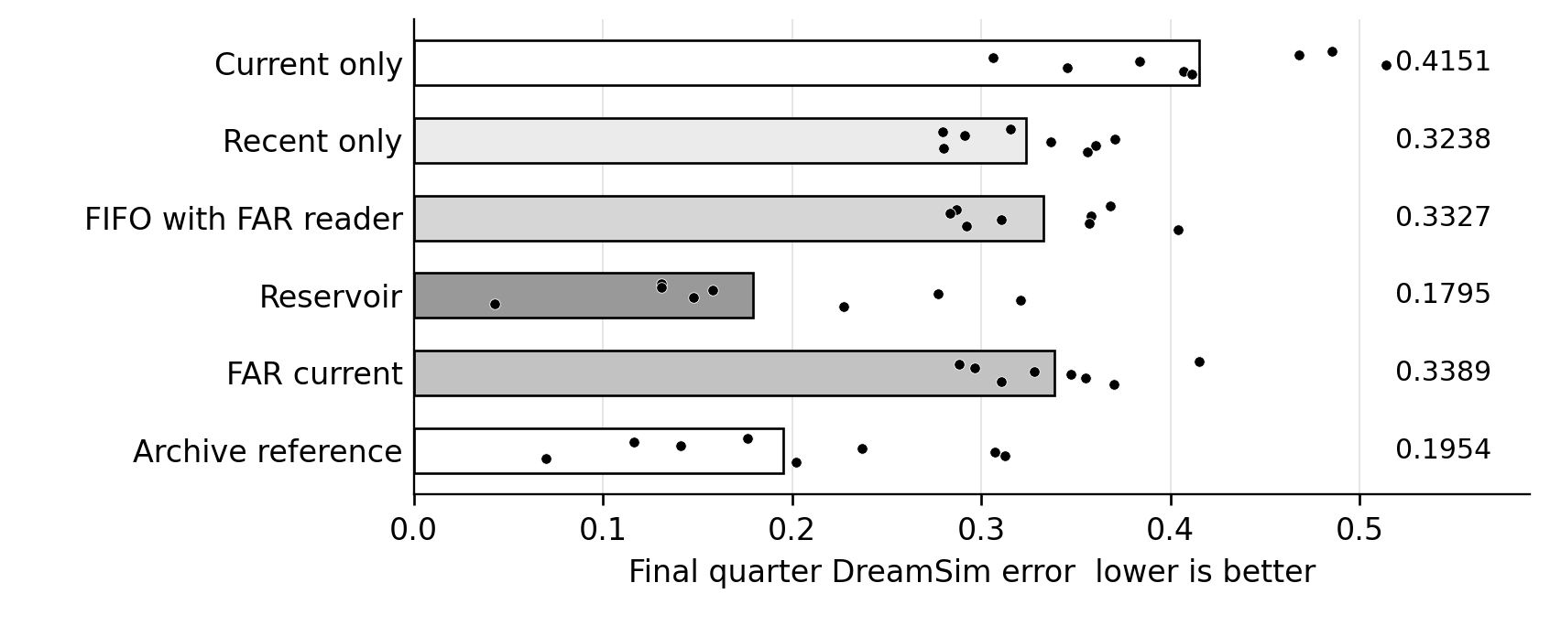
Figure 1 Final quarter error. Each dot is one scene averaged over three seeds; bars show the equal scene mean. Archive reference has greater storage.

Paired memory benefit
Reservoir reduced final quarter DreamSim error by 56.8% relative to current only and by 44.6% relative to recent only. Both comparisons favored Reservoir in all eight scene averages and in all three seed averages. It was also 46.1% lower than FIFO, which uses the same reader as Reservoir. The declared two control criterion was met.
Comparison | Mean  improvement | Paired 95%  interval | Exact  p | Holm  p
Reservoir over current | +0.2356 | [0.1446, 0.3227] | 0.00391 | 0.00781
Reservoir over recent | +0.1443 | [0.1035, 0.1826] | 0.00391 | 0.00781

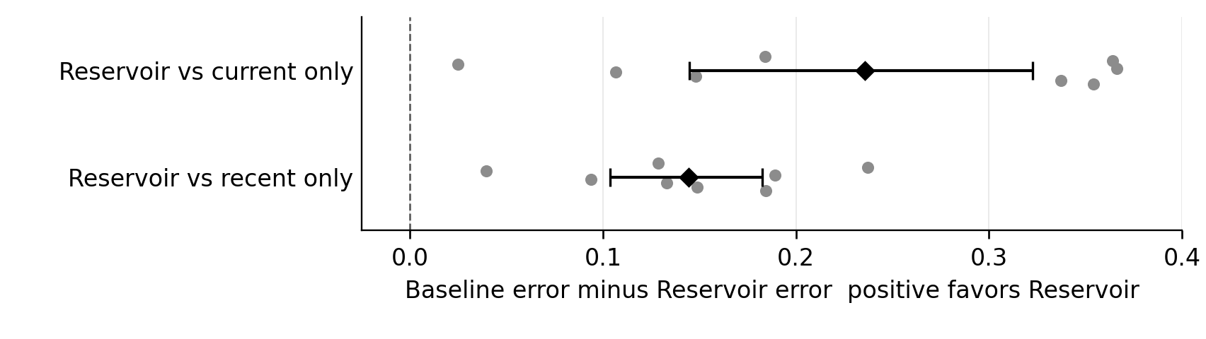
Figure 2 Positive values favor Reservoir. Gray dots are paired scene effects; black diamonds and intervals show the mean and 95% interval from 10000 paired bootstrap draws.
Exact one sided sign flip tests enumerate all 256 sign patterns across eight scenes. Holm correction covers the two primary comparisons. We required both positive lower 95% bounds and both adjusted p values below 0.05. These thresholds were fixed before the new controls ran.

Relevance did not improve retention
FAR current reached 0.3389 versus 0.3238 for recent only. Its improvement over recency was -0.0151, with a paired 95% interval of [-0.0437, 0.0092], which provides no supported advantage. FAR current was worse than Reservoir by 0.1595, with the entire improvement interval below zero. The original finding against adopting this retention rule remains unchanged.

Limits of the inference
The controls were fixed before their own inference but added after the pilot results were examined; Reservoir was selected from that pilot. All conditions reuse the same eight scenes. The results are exploratory evidence within this set, not independent confirmation. Current only removes explicit history but generated current can carry past information, and one frame inference differs from the usual twelve frame context. Recent only bypasses the reader, so that comparison changes both retention and reading. FIFO shares Reservoir's reader and provides a separate check. Closed loop current images can diverge; these effects describe complete policies. Capacity and deletion are enforced at the policy interface, with no claim of physical deletion from evaluator memory.

Scene and seed detail
The tables report final quarter DreamSim. Every scene row averages three seeds; village names are abbreviated and the test indices preserve exact scene identities. All 144 record summaries and all six full and tail metrics are retained in the accompanying compact results.
Scene | Current | Recent | FIFO | Reservoir | FAR | Archive
1708 Zombie 17 ABA | 0.4853 | 0.3155 | 0.3684 | 0.1310 | 0.4153 | 0.1766
3401 Taiga 20 ABCA | 0.4679 | 0.2795 | 0.2870 | 0.1307 | 0.2884 | 0.1166
1881 Zombie 8 ABA | 0.3062 | 0.2913 | 0.2837 | 0.1582 | 0.2965 | 0.1410
3742 Zombie 20 ABCA | 0.3837 | 0.3708 | 0.3582 | 0.2770 | 0.3279 | 0.2372
1266 Snowy 9 ABA | 0.5140 | 0.3367 | 0.3105 | 0.1477 | 0.3475 | 0.3072
1924 Desert 1 ABCA | 0.3457 | 0.3604 | 0.3572 | 0.3210 | 0.3551 | 0.3125
1409 Taiga 18 ABA | 0.4069 | 0.2801 | 0.2925 | 0.0428 | 0.3105 | 0.0700
2339 Plains 16 ABCA | 0.4115 | 0.3562 | 0.4040 | 0.2275 | 0.3704 | 0.2020

Aggregate | Current | Recent | FIFO | Reservoir | FAR | Archive
Seed 0 | 0.3854 | 0.3363 | 0.3212 | 0.1691 | 0.3455 | 0.2275
Seed 1 | 0.4963 | 0.3115 | 0.3326 | 0.1958 | 0.3320 | 0.1859
Seed 2 | 0.3637 | 0.3236 | 0.3443 | 0.1735 | 0.3393 | 0.1728
ABA four scenes | 0.4281 | 0.3059 | 0.3138 | 0.1199 | 0.3424 | 0.1737
ABCA four scenes | 0.4022 | 0.3417 | 0.3516 | 0.2390 | 0.3355 | 0.2171

Seed rows average eight scenes. Route rows average three seeds within each of four scenes. Seeds share scenes and are not independent population units.

Execution and verification
The added controls consumed 36 minutes 26 seconds on one A100; the independent CPU audit took 2 minutes 9 seconds. No model was trained. A second implementation verified all 144 finite metric records and paired frame axes, every storage trace and control read, all 24 Algorithm R replays, and all 42 paired statistics and the Holm calculation. Current hashes matched 187 source files and 54 selected data, model and metric cache files. The 487 loaded floating tensors were finite before prediction.

Conclusion
Within these eight LoopNav scenes, bounded memory that preserves earlier observations improves return prediction beyond both current only and recent only controls. Reservoir meets the declared memory benefit criterion and is the strongest equal capacity condition observed. FAR current provides no supported gain over recency and performs worse than Reservoir. This completes the explicit memory controls for the FAR based Phase1 test. It does not establish a superior learned retention rule, independent generalization, an I JEPA result or the original Phase1 GO decision.

