Equal capacity memory deletion assay
Proposal Phase 1 mechanism evaluation
We test whether deleting different memories produces a reproducible prediction-cost signal that could supervise a bounded retention policy. We reuse six complete frozen predictors and existing development features. No predictor is retrained and no new visual encoding or GPU allocation is used. The entry decision appears at the end.

Design and scope
Each parent contains three real historical observations. Three forks delete one entry each, leaving exactly two memories alongside identical recent frames and action continuations. Gate parents contain one cue and two post-cue frames; Motion parents contain two pre-occlusion observations and one shutter frame. Two fixed nuisance-time variants are included. These privileged pools diagnose a mechanism and are not online retention policies.
We evaluate all 128 independent trajectory pairs in each of three existing development splits, both horizons h3 and h6, and seeds 17, 29 and 43. Siblings and nuisance variants are averaged within each pair before 10000 paired bootstrap replicates. The model always reads the same complete 5120-dimensional target representation. Simulator states are used only for evaluation after prediction.
The prospective ID entry rule requires at least 10 percent relative error reduction and a positive confidence lower bound when retaining each critical observation, for both feature and task errors in every seed and horizon. A feature-loss deletion ranking chosen at one horizon must also improve both errors at the other horizon. Long-gap and distractor splits separately delimit scope. Previous predictor-adoption failures are preserved.

Audited results
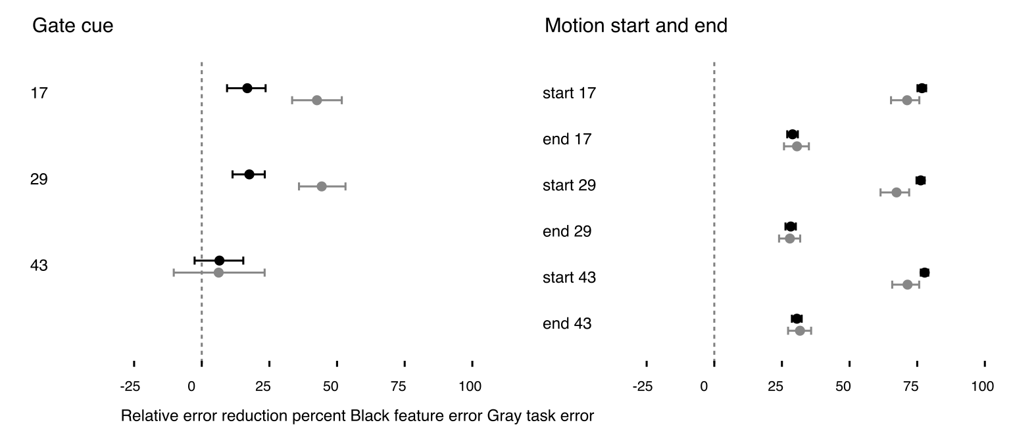
ID h6 effects by seed and evidence role. Points show mean relative reduction and bars show paired 95 percent bootstrap intervals. Positive values favor retaining the critical observation over nuisance content.

Task | Split | Critical contrasts | Cross horizon | Supported
gate | id | 4/6 | 6/6 | No
gate | long gap | 0/6 | 6/6 | No
gate | distractor shift | 2/6 | 6/6 | No
motion | id | 12/12 | 6/6 | Yes
motion | long gap | 12/12 | 6/6 | Yes
motion | distractor shift | 12/12 | 6/6 | Yes
Counts summarize prespecified checks, not the probability that Phase 1 is complete. A supported entry decision applies only to an ID-bounded policy pilot.
Gate remains unstable for seed43: its ID h3 lane-error benefit has a confidence interval containing zero, while ID h6 fails both feature-error and lane-error contrasts. Motion passes the deletion contrasts in all three examined development splits, including long occlusion, even though its earlier absolute prediction-adoption test failed. Ranking useful deletions and solving future prediction to the earlier quality threshold are different requirements.
Motion provides limited headroom over a simple rule in these privileged pools. At ID h6, mean feature MSE across three seeds is 0.116061 for reject-newest and 0.115305 for the future oracle, only 0.65% lower. This descriptive comparison does not establish a learned retention advantage; varied streaming memory states are still needed.

Limitations and decision boundary
The existing development data and earlier prediction results have been inspected. Deletion outcomes were new at specification time, but this is not untouched-data confirmation. Candidate pools are privileged, deletion is a single fork rather than a full streaming policy, and future-selected oracle rankings are unavailable online. Same-horizon oracle headroom alone is optimistically selected and cannot establish learnability or an advantage over strong retention baselines. FIFO, reject-newest and uniform-deletion costs are supplied in the accompanying audited data.
The audit independently recomputed 180 scalar comparisons from 55296 raw fork/horizon rows and checked equal capacity, pairing and current asset hashes. Native CPU inference took 163.7 seconds. Added GPU time is zero; cumulative settled GPU use remains 12723 of 28800 seconds.

Conclusion
Only motion supports an ID-bounded retention-policy pilot. The joint two-task policy stage is not ready. Keep the supported task as a scoped pilot and preserve the unsupported task as an explicit limitation; no additional predictor training was performed.

