Phase One Evidence for Bounded Visual Memory
  - I-JEPA prototype Controlled prediction and equal capacity deletion
Academic evidence report | 16 October 2026

1 Research objective
Our proposal asks which historical observations a model should retain when its memory is limited. The intended learning signal is the prediction cost of deleting an observation: a memory should matter when forgetting it makes useful future prediction worse. The research goal is a better retention decision, rather than a predictor that solves every possible future.
Phase One tests the prerequisites: whether stored visual features contain the missing evidence, and whether a predictor can use it. The later deletion assay adds a bridge toward policy learning, while keeping the predictor and memory capacity fixed. No retention policy has been trained.
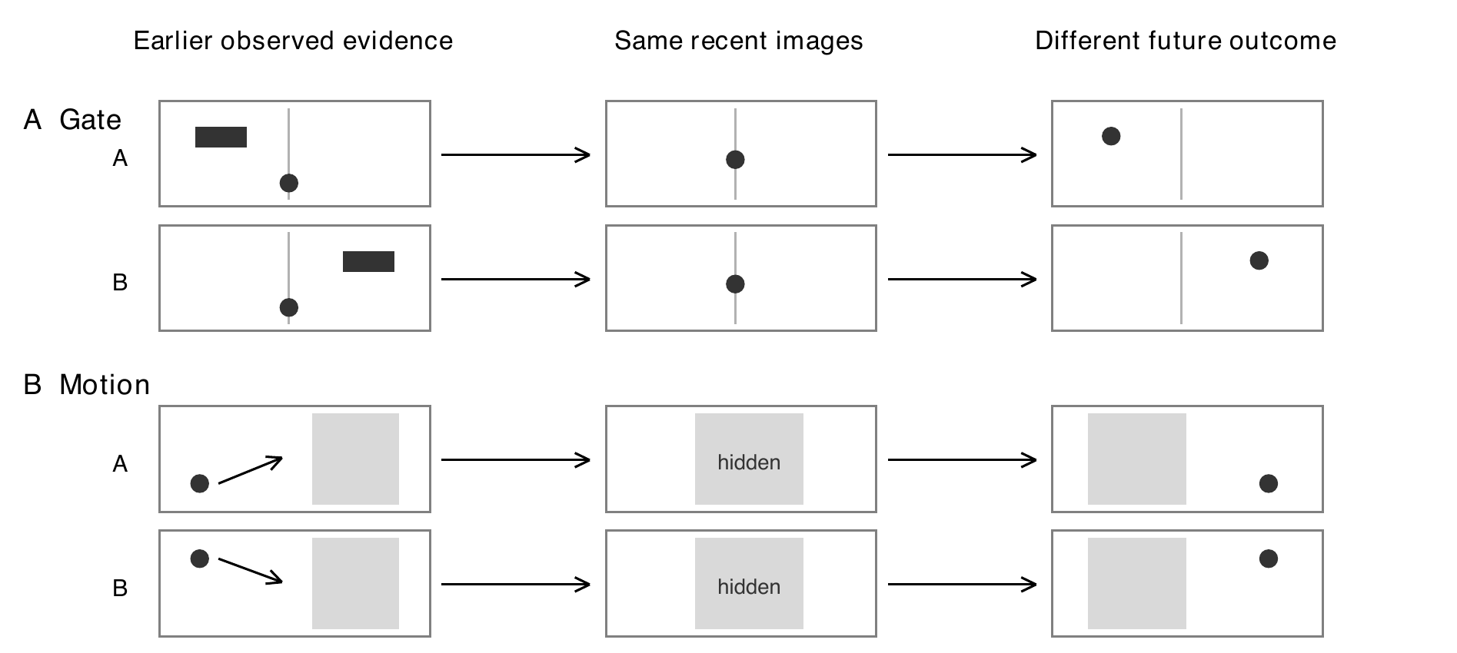
Figure 1. Read each row from left to right: earlier evidence, recent view, then future outcome. A and B look the same recently but have different futures. A useful memory must preserve what distinguishes them: the Gate cue or earlier Motion positions. Drawings illustrate the task; they are not test images or model predictions.

Three questions guide the experiments
Question | Evidence needed
Representation | Can the relevant cue or motion evidence be recovered from frozen image features?
Prediction | Does supplying historical evidence improve forecasts over recent observations alone?
Deletion signal | At the same memory capacity, does losing critical evidence cause more harm than losing a nuisance frame?

Scope. The proposal asks for evidence that history is useful before policy training. It does not require every diagnostic to succeed. We therefore report coverage, effect sizes and exceptions; the original strict all-checks verdict is retained separately. The deletion assay is a later-stage bridge, and no policy has been trained.

2 Experimental design
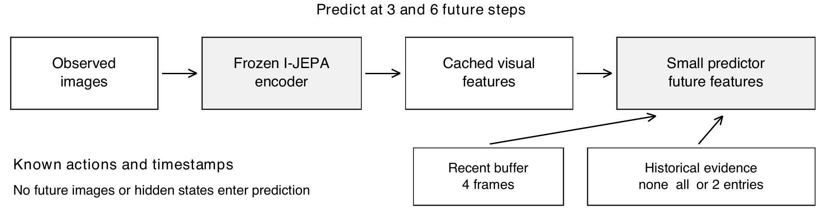
Figure 2. Images become numerical features, then a small model predicts future features. Compare the same recent context with and without history to measure memory value. The image encoder is frozen I-JEPA [1], not V-JEPA. No future image or hidden simulator state is supplied to the predictor.
Component | Specification
Controlled tasks | Gate cue and occluded Motion
Data per task | 512 training pairs; 96 validation pairs; 128 test pairs in each of 3 conditions
Test conditions | Ordinary; longer gaps or occlusion; changed visual distractors
Prediction context | 4 recent frames; historical budget B = 2; horizons h = 3 and h = 6
Complete candidate models | 2 tasks x seeds 17, 29, 43 = 6 models; 120 epochs and 7680 steps each
Visual representation | Frozen I-JEPA; train-only normalization and 128-dimensional basis; full 5120-dimensional scored output
Model selection | Earliest minimum of validation MSE, equally weighting 4 conditions and both horizons
Data separation | Pairs stay in one split; no simulator state, sibling identity or future image is a predictor input

What was compared
Condition | Information provided
Recent only | Recent buffer and actions; no historical evidence
Full history | All available legal history; a diagnostic upper information reference
Privileged small budget | Two important historical frames, chosen using task construction
Content intervention | Replace the relevant historical content to test whether prediction depends on it

The last complete candidate used centered visual differences, attention pooling over observed history and explicit elapsed-time transport. These components were motivated by Set Transformer [2] and NLinear [3]; the candidate is an adaptation, not a reproduction or a novelty claim. Its empty-history output equals the frozen recent-only reference.
Statistics. Feature error is mean squared error (MSE); task error measures lane or position. Reported prediction intervals use paired bootstrap resampling over 128 base trajectory pairs. Seed-averaged intervals are conditional on the three tested training seeds. Forks, siblings and seeds are not treated as extra independent episodes.

3 Prediction gains and coverage
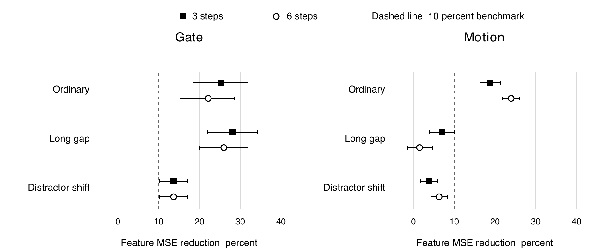
Figure 3. Further right means a larger error reduction from history. A point is the average gain; its horizontal line shows uncertainty. A line crossing zero leaves the direction uncertain. Squares predict 3 steps ahead and circles 6. Gate gains are broad; Motion gains shrink in harder conditions. Paired 95 percent intervals, conditional on the three seeds; D1.
Task and condition | Recent only  MSE | Full history  MSE | Budget 2  MSE | Gain and 95 percent CI
Gate Ordinary | 0.0997 | 0.0562 | 0.0776 | 22.2% [15.2, 28.5]
Gate Long gap | 0.0995 | 0.0960 | 0.0737 | 26.0% [20.0, 31.9]
Gate Distractor shift | 0.1385 | 0.1003 | 0.1196 | 13.7% [10.3, 17.1]
Motion Ordinary | 0.1526 | 0.0995 | 0.1161 | 23.9% [21.7, 26.1]
Motion Long gap | 0.1831 | 0.1879 | 0.1804 | 1.5% [-1.5, 4.6]
Motion Distractor shift | 0.2908 | 0.2713 | 0.2726 | 6.3% [4.3, 8.3]

Six-step normalized feature errors, averaged over three seeds. The last column compares privileged two-memory prediction with recent only. Full history uses more memory and is an information reference, not a capacity-matched competitor. Data: D1.
Evidence check | Gate coverage | Motion coverage
Evidence readable from features | 3 / 3 pass | 3 / 3 pass
Privileged history benefit under original task rules | 23 / 24 pass | 8 / 24 pass
Response to historical content intervention | 24 / 24 pass | 24 / 24 pass
Fixed recent-reference feature comparisons | 24 / 24 pass | 8 / 24 pass
Critical error improvement over prior predictor at the same budget | 8 / 8 pass | 0 / 8 pass

Table 1. x/y pass means x of y comparisons met the fixed criterion. Counts overlap in data and measure different claims, so they are not a probability of success or a project completion score. D1.
Interpretation. Gate has broad coverage: 50/51 original and 32/32 additional checks, with one inconclusive ordinary h6 result for seed 43. Motion has 35/51 and 8/32, with limitations concentrated in long occlusion and changed distractors. These are useful, uneven findings. The earlier strict all-checks rule was not met; that record is unchanged.

4 Does deletion cost identify important memory
We reused the six complete models and their existing feature caches. From the same parent set of three real observations, we removed each entry in turn and compared the resulting forecasts. Every fork retained exactly two historical entries, so a gain cannot be explained by a larger memory budget.
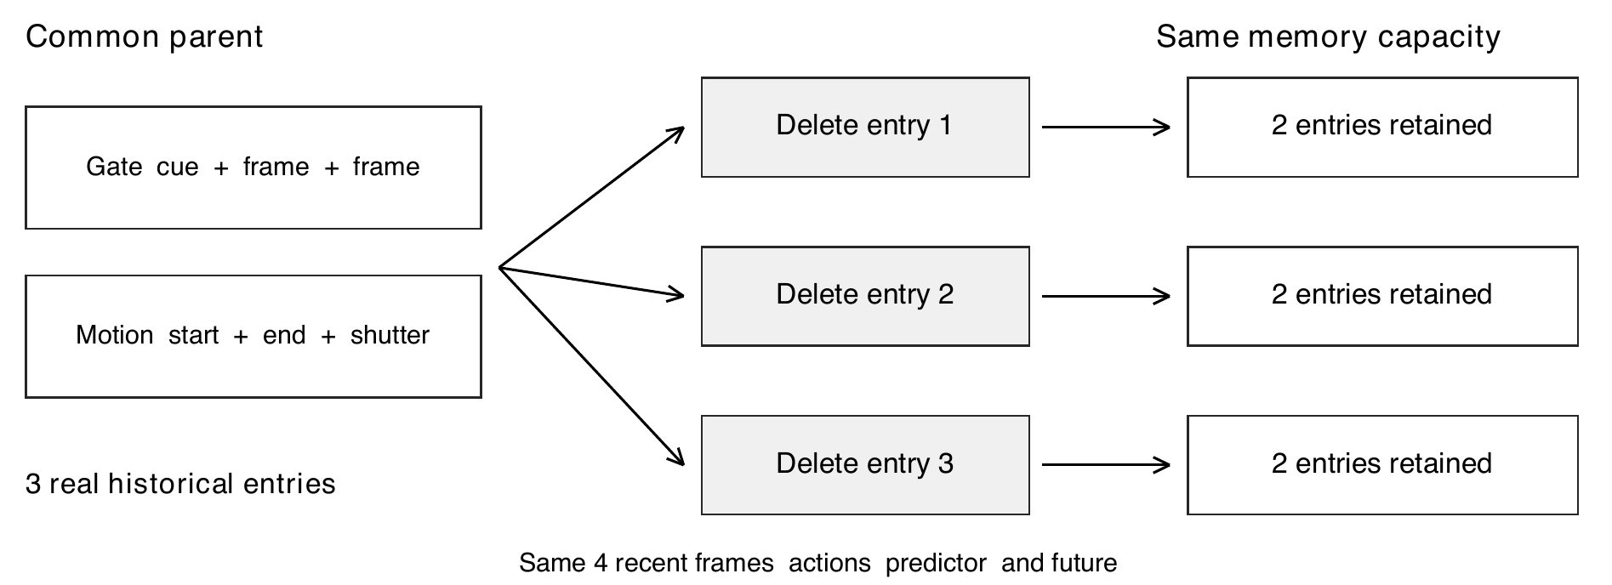
Figure 4. Start with the same three memories, remove a different one in each branch, and always leave two. If removing the important observation hurts more, deletion cost has identified useful evidence rather than extra capacity. Two fixed parent variants were used. These constructed pools are diagnostics, not a learned policy.
A check is counted when keeping critical evidence reduces both visual-feature error and lane or position error by at least 10 percent, with a positive paired 95 percent interval. Each check uses 128 base pairs. Gate has one critical role and Motion two, giving 6 and 12 checks per condition. The thresholds and original results remain unchanged.
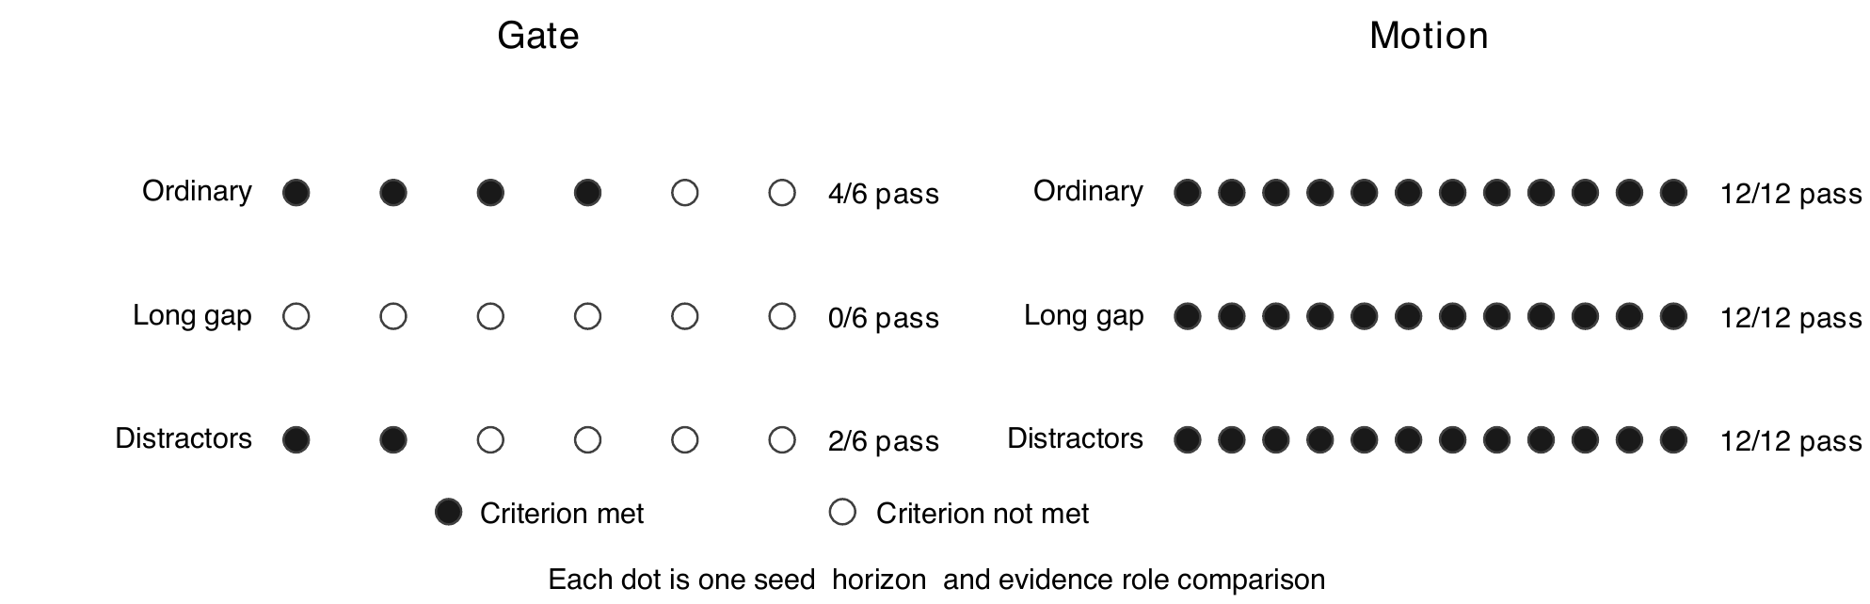
Figure 5. Filled dots count comparisons meeting the criterion; open dots count those that did not. Dot order has no meaning. Motion has 36/36 across conditions. Gate has 4/6 in ordinary conditions, 0/6 with long gaps and 2/6 with distractors: partial support with clear limits, not a single binary outcome. D2.
Task | Ordinary | Long gap | Distractor shift | Cross horizon checks
Gate | 4 / 6 pass | 0 / 6 pass | 2 / 6 pass | 18 / 18 pass
Motion | 12 / 12 pass | 12 / 12 pass | 12 / 12 pass | 18 / 18 pass

Table 2. Cross-horizon checks ask whether a deletion chosen at 3 steps is useful at 6, and vice versa, relative to uniform deletion. Both tasks show 18/18 coverage here, while Gate has weaker critical-versus-nuisance coverage. Selection uses future outcomes, so this is not yet an online policy result. D2.

5 Effect sizes and uncertainty
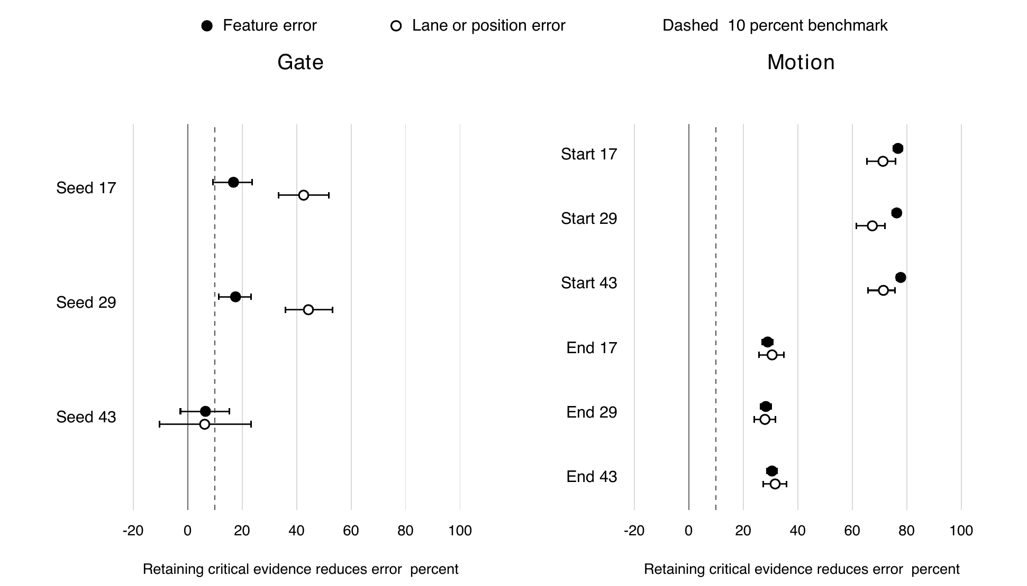
Figure 6. Further right means keeping that memory is more useful. Black dots measure feature error; white dots measure lane or position error. Lines show 95 percent uncertainty. Motion start and end memories help in all three runs. Gate seed 43 lies near zero, showing uncertainty rather than evidence of no value. Ordinary condition, 6 steps ahead; D2.
Selected contrast | Delete critical  feature MSE | Delete nuisance  feature MSE | Difference and 95 percent CI
Gate cue seed 43 | 0.0987 | 0.0923 | 0.0065  [-0.0026, 0.0152]
Motion start seed 17 | 0.5005 | 0.1163 | 0.3842  [0.3529, 0.4162]
Motion end seed 17 | 0.1636 | 0.1163 | 0.0473  [0.0430, 0.0519]

Table 3. Illustrative numeric contrasts at h6. Within each row, only the deletion differs. Losses across Gate and Motion are not calibrated to the same task difficulty. All seeds and both Motion roles are shown in Figure 6.
Motion. Coverage is 36/36 critical comparisons and 18/18 cross-horizon checks. At h6, retaining the start observation reduced feature error by 76.3 to 77.8 percent, and retaining the end observation by 28.3 to 30.5 percent. Position-error contrasts agreed. Both observations carry useful complementary evidence.
Gate. Ordinary coverage is 4/6. The two exceptions are seed 43: at h3 lane benefit is uncertain; at h6 feature benefit is 6.5 percent and lane benefit 6.3 percent, with both intervals crossing zero. This limits claims of seed stability without erasing the four supported comparisons.
Different questions. Deletion cost asks which forgetting choice is worse. Prediction quality asks how accurate the forecast is overall. Motion can provide a consistent ranking of memory value while still forecasting difficult long occlusions poorly. These results describe different capabilities.

6 A useful signal does not prove a better policy
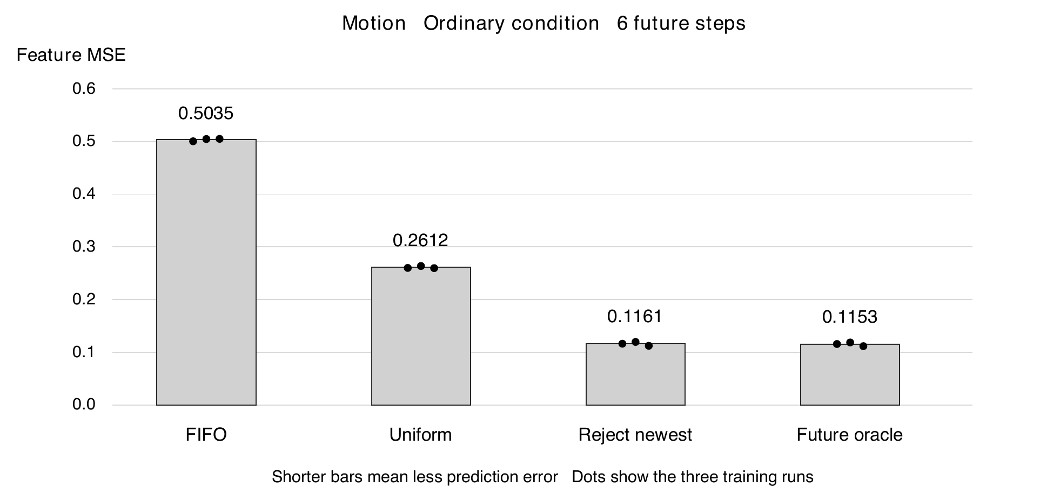
Figure 7. Shorter bars are better. FIFO removes the oldest entry; uniform deletion chooses randomly; reject-newest keeps the existing memories. The future oracle uses unavailable future outcomes to choose the best removal. Reject-newest nearly matches this ideal reference in these simple pools. Bars average three runs; dots show each run. D2.
Deletion rule | Feature MSE | Position MSE
FIFO | 0.503474 | 0.025186
Uniform | 0.261175 | 0.014506
Reject newest | 0.116061 | 0.007548
Future oracle | 0.115305 | 0.007338

The oracle feature MSE is only 0.65 percent lower than rejecting the newest frame: 0.115305 versus 0.116061. This small headroom matters. These constructed pools show which evidence is useful, but a simple rule already finds most of that value; they do not yet demonstrate a need for a learned selector.

What the experiments have achieved
We have a working visual-feature prediction pipeline, paired causal input comparisons, auditable model checkpoints, and a fast same-capacity deletion evaluation. Motion supplies a reproducible signal about relative memory value. Gate supplies a concrete counterexample to assuming that feature-level utility is always stable across training seeds.

Limits that should shape the next experiment
Adaptive development data. The same development trajectories informed predictor repairs. No untouched-data confirmation has been run.
Privileged pools. Candidate times were constructed using known task evidence. This does not show that a policy can discover them from past inputs alone.
Single deletion. Every fork resets to its parent. Continuous irreversible forgetting, accumulated errors and long-term redundancy remain untested.
Uncertain learning headroom. A learned policy must beat strong past-only rules in more varied memory states, not merely beat random deletion in an easy diagnostic pool.

7 Evidence coverage and next research scope
Evidence category | Gate | Motion
Evidence readable from features | 3/3 pass | 3/3 pass
Original prediction checks | 50/51 pass  Broad coverage | 35/51 pass  Limited on harder tests
Additional fixed-reference checks | 32/32 pass | 8/32 pass
Critical deletion contrasts across all conditions | 6/18 pass  Ordinary 4/6 | 36/36 pass  Ordinary 12/12
Cross-horizon deletion checks | 18/18 pass | 18/18 pass
Learned-policy advantage and fresh confirmation | Not yet tested | Not yet tested

Why majority coverage is useful but not sufficient by itself
Exploratory research does not require universal success. High coverage supports a broad but qualified claim; concentrated exceptions identify its boundary. However, correct pairing, past-only inputs and equal capacity are validity requirements, not votes. A large count of easier successes cannot establish long-occlusion reliability when that specific condition is weak. These checks also share data, so 50/51 is not a 98 percent probability that the proposal works.
The earlier all-checks acceptance rule was conservative and remains unmet. This descriptive coverage summary was written after observing the results; it does not replace that rule with a new majority threshold or claim a retrospective confirmation pass.

Evidence and reproducibility
D1 contains six complete models, 720 epoch records and 69120 evaluation rows; 64 fixed comparisons were independently checked. D2 contains 55296 fork-horizon rows and 180 independently recomputed comparisons. The statistical units are 128 base pairs per task and condition, not the raw rows. D2 used zero new GPU time. Settled GPU use was 3 h 32 min 03 s within the 8 h cap; no retention policy or fresh confirmation was run.

Sources
[1] Assran et al. Self-Supervised Learning from Images with a Joint-Embedding Predictive Architecture. CVPR, 2023. https://arxiv.org/abs/2301.08243
[2] Lee et al. Set Transformer A Framework for Attention-based Permutation-Invariant Neural Networks. ICML, 2019. https://proceedings.mlr.press/v97/lee19d.html
[3] Zeng et al. Are Transformers Effective for Time Series Forecasting. AAAI, 2023. https://arxiv.org/abs/2205.13504
D1 Predictor experiment 7574 and audited evaluation 7575/7576, archived in phase1_predictor_repair_v2. This report covers the last complete candidate, not incomplete later trials.
D2 Deletion assay 7590, archived in phase1_deletion_assay. Its protocol preceded deletion outcomes, but its models and data were already development-selected.

Conclusion
The proposal has meaningful, graded support. Gate shows broad prediction evidence at 50/51 plus 32/32 checks, with an unresolved seed and weaker deletion coverage. Motion shows consistent deletion value at 36/36 plus 18/18 checks, while its harder prediction conditions remain limited. This supports a scoped Motion learnability pilot and targeted Gate stability checks. It does not yet establish a learned retention advantage, V-JEPA transfer or untouched-data confirmation. The useful outcome is a clearer mechanism and research boundary, not a single pass or fail label.

