Proposal Phase1 Second Predictor Repair Validation
Completed development evaluation and independent verification
15 October 2026 America New York

Purpose and fixed experimental scope
Phase1 asks whether a JEPA predictor can use earlier observed evidence to improve future prediction when recent frames are insufficient. The current test evaluates the preregistered repair on delayed Gate cues and occluded Motion. It does not train a memory selector or test the full research proposal.
The second repair combines learned attention pooling inspired by Set Transformer [1] with current centered visual differences inspired by NLinear [2]. Learned attention keys use observed differences and legal past action rates; explicit linear elapsed transport enters the value path. The history correction excludes absolute visual level. This is an adapted composite, not a reproduction of either method. It retains the frozen recent reference and reads all retained history without TopK retrieval.
Boundary | Preserved setting
Data and seeds | Development data 6301; seeds 17 29 43; two tasks
Sample sizes per task | 512 training pairs; 96 validation pairs; 128 pairs in each of three test splits
Training | 6 models; each 120 epochs and 7680 steps; four conditions balanced
Context and targets | 4 recent frames; memory budget 2; horizons 3 and 6; full 5120 dimensional output
Selection | Earliest equal condition validation MSE minimum; no test based checkpoint selection
Acceptance | All original task rules and all 32 fixed reference checks per task required

Execution and verification
Training 7574, CPU evaluation 7575, and independent scalar audit 7576 each completed with exit 0:0. All six current best and latest checkpoints passed finite model and optimizer, RNG, scheduler, frozen reference, source signature, 120 epoch and earliest best checks. Native and local training logs agree across 720 rows. All six models start from their fixed seeds. The first complete Gate17 and Motion17 epochs count toward the 120 epochs and are restored within the same job after timing both tasks; no earlier candidate checkpoint is reused.
The audit checked all 69120 raw records for finite values and complete paired axes, then independently reproduced all 64 fixed reference intervals and pass flags. A separate final CPU verification repeated these checks. All transferred compact files have matching native before transfer, local, and native after transfer SHA256 values. These are execution and arithmetic checks, not evidence that scientific acceptance criteria were met.
Task | Original rules met | Fixed checks met | Raw records
Gate | 50 of 51 | 32 of 32 | 34560
Motion | 35 of 51 | 8 of 32 | 34560
Check counts summarize different requirements. They are not prediction accuracies, success probabilities, or substitutes for the all required rule.

Where the repaired predictor remains unreliable
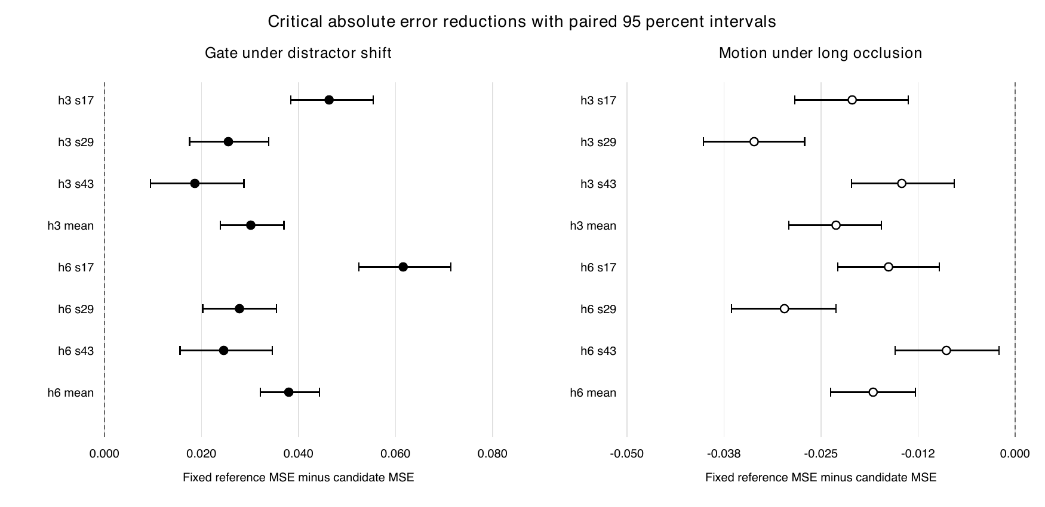
Figure 1. Positive values favor the repaired privileged memory predictor over the fixed reference privileged memory predictor. A critical absolute check requires a strictly positive mean and lower interval bound. Filled markers pass; open markers fail. Each interval uses 128 episode pairs, grouped at pair level with 2000 fixed bootstrap resamples. The mean label averages scalar errors across the three seeds within each paired episode; it does not add independent pairs.
Gate satisfies every fixed reference comparison, including all eight critical absolute checks under changed distractors. It still misses one original required rule at ID horizon6 seed43: the paired interval does not establish the required improvement threshold. Warnings also identify worse full-history behavior at long-gap horizon6 for seeds17 and29. Those warnings and the single failed hard check are distinct; all required checks must pass.
Motion remains the main failure. Every long-gap comparison against the fixed recent reference fails, as does every critical absolute comparison against the fixed privileged reference. Under distractor shift, all eight fixed recent-reference comparisons fail. Only the eight ID fixed-reference comparisons pass. Relative to the earlier repaired trial, the original and fixed check counts decrease; centering and separating transport did not solve Motion generalization.
Task | Seed17 fixed | Seed29 fixed | Seed43 fixed | Three seed mean fixed
Gate | 8/8 | 8/8 | 8/8 | 8/8
Motion | 2/8 | 2/8 | 2/8 | 2/8
The paired intervals describe this revealed development data. The repair was chosen after previous development failures were inspected, so these results cannot serve as independent confirmation. Differences across seeds and splits identify unresolved behavior; they do not isolate a unique causal mechanism.

How to read the full comparison tables
R compares candidate privileged memory with the fixed reference recent only predictor. Relative error reduction must be at least 10 percent and its interval lower bound must be above zero. A compares candidate privileged memory with fixed reference privileged memory in the preregistered critical split; absolute MSE reduction and its lower bound must both exceed zero. All reported R rows use the relative scale. ID means the original test distribution, Long means long occlusion, and Shift means changed distractors. The next two pages include every fixed comparison.

Gate fixed reference comparisons
Values are mean reduction and paired 95 percent interval. R values are percent; A values are normalized MSE units. Each row uses 128 pairs. All rows are required.
Split | h | Seed | Type | Mean | 95 percent interval | Rule
ID | 3 | 17 | R | 25.52 | [18.39, 32.06] | PASS
ID | 3 | 29 | R | 27.13 | [20.54, 33.40] | PASS
ID | 3 | 43 | R | 23.48 | [16.26, 30.16] | PASS
ID | 3 | Mean | R | 25.38 | [18.43, 31.88] | PASS
ID | 6 | 17 | R | 22.78 | [15.38, 29.54] | PASS
ID | 6 | 29 | R | 24.01 | [17.55, 29.85] | PASS
ID | 6 | 43 | R | 19.62 | [12.25, 26.36] | PASS
ID | 6 | Mean | R | 22.15 | [15.23, 28.52] | PASS
Long | 3 | 17 | R | 27.72 | [20.63, 34.48] | PASS
Long | 3 | 29 | R | 28.80 | [23.09, 34.61] | PASS
Long | 3 | 43 | R | 27.84 | [21.84, 33.92] | PASS
Long | 3 | Mean | R | 28.12 | [21.91, 34.23] | PASS
Long | 6 | 17 | R | 26.30 | [19.81, 32.58] | PASS
Long | 6 | 29 | R | 26.01 | [20.45, 31.68] | PASS
Long | 6 | 43 | R | 25.57 | [19.62, 31.53] | PASS
Long | 6 | Mean | R | 25.96 | [19.97, 31.89] | PASS
Shift | 3 | 17 | R | 14.64 | [11.36, 18.03] | PASS
Shift | 3 | 17 | A | 0.04629 | [0.03844, 0.05542] | PASS
Shift | 3 | 29 | R | 13.39 | [9.74, 16.84] | PASS
Shift | 3 | 29 | A | 0.02553 | [0.01753, 0.03387] | PASS
Shift | 3 | 43 | R | 12.76 | [8.98, 16.65] | PASS
Shift | 3 | 43 | A | 0.01862 | [0.00948, 0.02873] | PASS
Shift | 3 | Mean | R | 13.63 | [10.13, 17.13] | PASS
Shift | 3 | Mean | A | 0.03015 | [0.02389, 0.03700] | PASS
Shift | 6 | 17 | R | 15.73 | [12.47, 19.00] | PASS
Shift | 6 | 17 | A | 0.06156 | [0.05242, 0.07142] | PASS
Shift | 6 | 29 | R | 13.51 | [9.73, 17.05] | PASS
Shift | 6 | 29 | A | 0.02782 | [0.02025, 0.03549] | PASS
Shift | 6 | 43 | R | 11.61 | [7.90, 15.35] | PASS
Shift | 6 | 43 | A | 0.02457 | [0.01556, 0.03459] | PASS
Shift | 6 | Mean | R | 13.65 | [10.26, 17.10] | PASS
Shift | 6 | Mean | A | 0.03798 | [0.03209, 0.04427] | PASS

Motion fixed reference comparisons
Values are mean reduction and paired 95 percent interval. R values are percent; A values are normalized MSE units. Each row uses 128 pairs. All rows are required.
Split | h | Seed | Type | Mean | 95 percent interval | Rule
ID | 3 | 17 | R | 18.58 | [15.95, 21.09] | PASS
ID | 3 | 29 | R | 16.64 | [13.62, 19.61] | PASS
ID | 3 | 43 | R | 21.27 | [18.58, 23.78] | PASS
ID | 3 | Mean | R | 18.83 | [16.31, 21.29] | PASS
ID | 6 | 17 | R | 23.77 | [21.57, 25.95] | PASS
ID | 6 | 29 | R | 21.77 | [19.16, 24.37] | PASS
ID | 6 | 43 | R | 26.29 | [23.92, 28.59] | PASS
ID | 6 | Mean | R | 23.94 | [21.70, 26.10] | PASS
Long | 3 | 17 | R | 7.85 | [4.27, 11.37] | FAIL
Long | 3 | 17 | A | -0.02099 | [-0.02838, -0.01374] | FAIL
Long | 3 | 29 | R | 5.06 | [1.95, 8.08] | FAIL
Long | 3 | 29 | A | -0.03362 | [-0.04015, -0.02711] | FAIL
Long | 3 | 43 | R | 7.95 | [4.94, 11.04] | FAIL
Long | 3 | 43 | A | -0.01460 | [-0.02106, -0.00783] | FAIL
Long | 3 | Mean | R | 6.94 | [3.90, 9.98] | FAIL
Long | 3 | Mean | A | -0.02307 | [-0.02915, -0.01724] | FAIL
Long | 6 | 17 | R | 2.41 | [-1.21, 5.81] | FAIL
Long | 6 | 17 | A | -0.01630 | [-0.02284, -0.00975] | FAIL
Long | 6 | 29 | R | -0.26 | [-3.34, 3.00] | FAIL
Long | 6 | 29 | A | -0.02972 | [-0.03654, -0.02309] | FAIL
Long | 6 | 43 | R | 2.36 | [-0.68, 5.46] | FAIL
Long | 6 | 43 | A | -0.00885 | [-0.01543, -0.00207] | FAIL
Long | 6 | Mean | R | 1.49 | [-1.55, 4.62] | FAIL
Long | 6 | Mean | A | -0.01829 | [-0.02375, -0.01285] | FAIL
Shift | 3 | 17 | R | 1.09 | [-1.34, 3.61] | FAIL
Shift | 3 | 29 | R | 6.47 | [4.39, 8.61] | FAIL
Shift | 3 | 43 | R | 4.00 | [1.91, 6.15] | FAIL
Shift | 3 | Mean | R | 3.74 | [1.64, 5.97] | FAIL
Shift | 6 | 17 | R | 3.66 | [1.27, 6.02] | FAIL
Shift | 6 | 29 | R | 9.24 | [7.21, 11.25] | FAIL
Shift | 6 | 43 | R | 6.28 | [4.26, 8.40] | FAIL
Shift | 6 | Mean | R | 6.28 | [4.27, 8.31] | FAIL

Budget and retained evidence
GPU job | Actual seconds | Purpose
7477 | 100 | Earlier partial execution
7480 | 126 | Earlier partial execution
7485 | 6021 | Previous complete development trial
7524 | 164 | Earlier repair budget stop
7535 | 3386 | Previous repaired development
7574 | 2807 | Second repair all six development models
Cumulative GPU allocation time is 12604 seconds, or 3 hours 30 minutes 4 seconds, against the authorized 28800 seconds. The unused balance is 16196 seconds, or 4 hours 29 minutes 56 seconds. CPU evaluation, independent audit, and final evidence collection add no GPU time. No additional GPU training or fresh data generation was launched after the negative development result.
The fixed 57 scientific files and 3 independent audit files match their locked SHA256 values at final native verification. Raw records, weights, feature arrays, and checkpoints remain on HPC. Local compact evidence includes both task outcomes, metrics, training histories, checkpoint certificates, the independent audit, the GPU ledger, and the complete transfer manifest. The full 102 original rule flags and 64 comparison values are also supplied as editable CSV files.

What the evidence supports
The completed run tests the third practical premise: whether this predictor reliably uses available earlier evidence across required conditions. It improves many slices but still fails the full criterion. Earlier controlled task and representation diagnostics motivated the trial; the new run does not independently reconfirm those premises. This result rejects the current candidate under the stated development rules, not every possible predictor or the broader research idea.

Recommended next decision
Do not describe Phase1 as passed or proceed to selector training. Preserve fresh9137 as unseen. Preserve both negative trials and separate the improved Gate cue use from the unresolved Motion behavior. Another repair would require a new bounded hypothesis and a frozen experiment under the original rules; unused GPU budget alone is not evidence for another unplanned attempt. No further training trial is started by this report. A fresh 12 model confirmation is eligible only after both development tasks satisfy all rules and pass independent audit.

Method references
[1] Lee et al. Set Transformer A Framework for Attention based Permutation Invariant Neural Networks. ICML 2019. https://proceedings.mlr.press/v97/lee19d.html
[2] Zeng et al. Are Transformers Effective for Time Series Forecasting. AAAI 2023. NLinear reference implementation https://github.com/cure-lab/LTSF-Linear/blob/main/models/NLinear.py

Conclusion
Proposal Phase1 has not passed. The repaired development trial completed correctly, but both tasks fail required original criteria. Independent confirmation was not opened because its prerequisite was not met. This is a scientific acceptance failure for the tested candidate, rather than an incomplete training run, a connection failure, or exhaustion of the authorized GPU budget.

