Proposal Phase1 third repair and budget evidence
  - 16 October 2026 | Gate and occluded Motion
This report records the focused diagnosis of Motion long occlusion, the remaining Gate check, and the measured resource boundary of one new predictor. It preserves the original acceptance rules and separates completed scientific evidence from an incomplete new trial.

Completed evidence before the third repair
Task | Original checks | Fixed reference checks | Decision
Gate | 50 of 51 | 32 of 32 | Rejected
Motion | 35 of 51 | 8 of 32 | Rejected
These are the second repair results from all six completed models, each with 120 epochs and 7680 steps. Their 69120 raw records and 64 fixed comparisons were independently checked. All checks are required; a near pass is not a pass.

What the focused diagnosis found
Motion: no geometric reflections occurred in the diagnosed subset. Directly extending visual features produced much larger errors at long gaps. The second repair also increased the common part of long gap prediction error, despite improving the difference between paired futures. Removing its transport component reduced h6 MSE from 0.1871 to 0.1727. These observations motivate a different dynamics representation; they do not identify one unique cause.
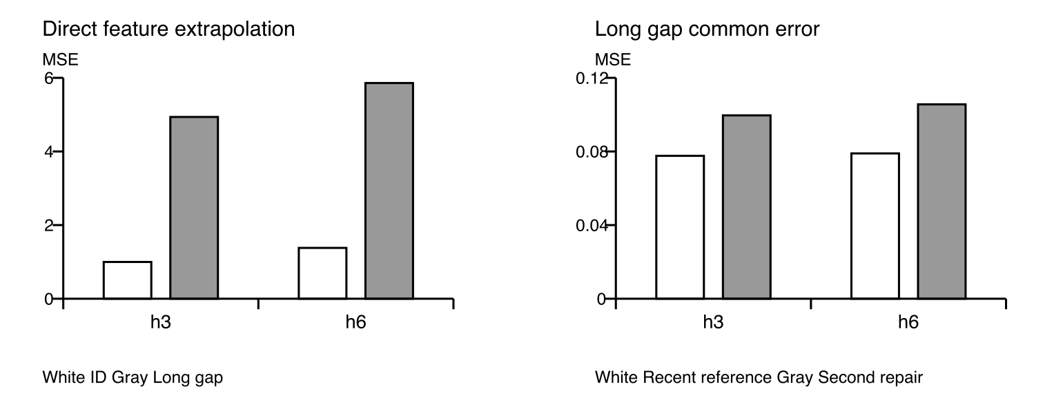
Figure 1 Read only diagnostics on the first 64 pairs per split, averaged across three seeds. These subset summaries do not replace any acceptance test.
Gate: the remaining hard failure was seed43 on ID at h6. Privileged memory improved normalized latent MSE, but relative state classification error reduction was 10.94% with a confidence interval of -4.69% to 26.56%. The interval crossing zero prevented acceptance. The proposed change therefore targets how the remembered cue combines with the future action.

One fixed literature informed correction
LatentFlowPredictor learns a small nonlinear coordinate map from observed visual features, extrapolates differences over elapsed time in that coordinate space, and decodes nonlinearly into the frozen output basis. Post pooling FiLM conditions the correction on legal future actions. This borrows coordinate learning principles from E2C and nonlinear dynamical embeddings, and featurewise conditioning from FiLM. It is not a reproduction of those full methods or evidence that a physical state was learned.
The frozen recent predictor remains exact when history is empty. All retained observations are read. No hidden simulator state, labels, sibling identity, or future image enters the predictor. Tasks, seeds17/29/43, samples, 120 epochs, losses, optimizer, selection rule, and all acceptance thresholds remain unchanged. The revealed development data make this an exploratory repair; independent confirmation is still required.

Checks completed and work retained
Evidence | Verified scope
Software boundaries | 10 predictor fixtures and 4 staged data fixtures
Native input preflight | 9728 exact input target info RNG samples and 24 validation batches
Frozen current sources | 58 science files and 3 independent audit files
Retained scientific work | Gate17 and Motion17 each 1 of 120 epochs and 64 of 7680 steps
Partial checkpoint audit | Four best latest files finite with AdamW RNG and frozen reference verified
Complete new models and tests | 0 of 6 models complete no new held out result no fresh9137 opened

Measured complete sequence budget
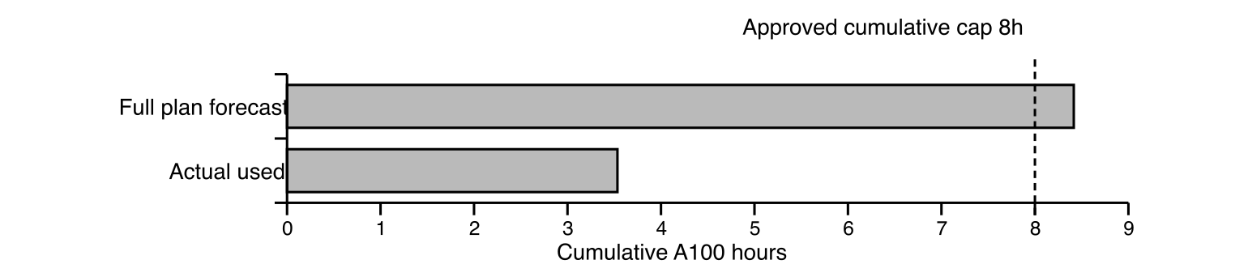
Figure 2 Actual consumption and a conservative cost forecast are different quantities. The forecast includes all remaining development, 12 new confirmation models, encoding, safety margin, and overhead.
GPU accounting | Seconds | Time
Prior settled use | 12604 | 3h 30m 04s
This partial GPU allocation | 119 | 0h 01m 59s
Total actual used | 12723 | 3h 32m 03s
Unused within approved cap | 16077 | 4h 27m 57s
Projected complete cumulative plan | 30296.42 | 8h 24m 56s

Why the budget guard stopped
The first full Gate and Motion epochs took 6.603 and 4.051 seconds. The complete plan forecast was 8h 24m 56s, exceeding the approved eight hour cumulative cap by 0h 24m 56s. This is an estimate, not a promise that a small budget increase would suffice.
The forecast reserves six complete development candidates, six new confirmation references and six new confirmation candidates, all 120 epochs; 198656 encoded confirmation frames; a 15% safety factor; and fixed proof and loading overhead. Leaving GPU time unused avoids completing development at the expense of the required independent confirmation. No sample, seed, epoch, or threshold was shortened to fit.

Evidence integrity and limits
The native partial verifier checked the terminal GPU ledger, all current source files, and four real partial checkpoints without a model forward or optimizer update. All 20 explicitly selected compact files, including the verifier output, have matching native before transfer, local, and native after transfer SHA256 values. Large checkpoints and raw feature arrays remain on HPC.
The new trial has no complete evaluated model and no new scientific score. Its epoch validation values are not acceptance results. The diagnostic subset was selected by fixed manifest order and is descriptive. Learning dynamics coordinates and action conditioning may help, but their effect has not been established. Fresh confirmation would require new train only transforms and all 12 newly trained models locked before opening the tests; none of that confirmation was run.
Evidence directory: runs/phase1_predictor_repair_v3/native_final7586. Diagnostic records: native_diagnosis7580 and diagnostic_review.json. Frozen implementation: execution/control/source_lock.json. Full 120 slice summaries accompany this report as a CSV. The earlier complete second repair remains unchanged in phase1_predictor_repair_v2.

Primary method references
Watter et al 2015. Embed to Control. https://arxiv.org/abs/1506.07365
Lusch Kutz and Brunton 2018. Deep learning for universal linear embeddings of nonlinear dynamics. https://arxiv.org/abs/1712.09707
Perez et al 2018. FiLM Visual Reasoning with a General Conditioning Layer. https://arxiv.org/abs/1709.07871

Conclusion
Proposal Phase1 has not passed. The last complete development experiment failed the unchanged criteria. The third repair was stopped by the authorized resource guard before a complete model or independent confirmation existed. Its method therefore remains untested by the full acceptance procedure. This is insufficient evidence to certify Phase1 under the approved eight hour budget, rather than a demonstrated scientific failure of the new predictor.

