JB vs JL Analytical Pipeline Comparison
Phosphorus R* Estimation: Bernhardt et al. 2020 vs Jason Laurich
July 2026

Overview
This report systematically compares the analytical pipeline used by Bernhardt et al. 2020 (JB) to estimate R* (minimum resource requirement) from Chlamydomonas experimental evolution data against the pipeline used in the current study (JL). The goal is to quantify how each methodological difference contributes to divergence in final R* estimates, expressed as R2 between the two sets of population-level estimates.

Four methodological differences are assessed in sequence:
- Section 1: Can we replicate JB results exactly? (Python NLS replication of her R code)
- Section 2: Effect of mu estimation approach (JB: direct fit to raw RFU; JL: indirect -- estimate mu at each [P] first)
- Section 3: Effect of fitting method (JB: NLS via nlsLM; JL: Bayesian JAGS)
- Section 4: Effect of replicate structure (JB: 4 replicates pooled per population; JL: each replicate fit independently)

All analyses focus on phosphorus R* (P*) only. Mortality rate m = 0.56 day^-1 throughout (matching JB's bootstrap section). Populations: 37 total (32 evolved + 5 ancestral lines).

Section 1: Can We Replicate JB's Results?

1.1 Approach
JB's pipeline (12c_phosphate_growth_direct.R) was re-implemented in Python using only NumPy and Pandas. The key steps are:
- Identify exponential growth phase per well-plate by fitting log(RFU) ~ days for sliding windows of 3-7 earliest time points; select the window with the highest slope.
- Compute N0_mean = mean initial RFU across all well-plates for the same population.
- Pool all 4 technical replicates per population (grouped by ancestor_id x treatment x population).
- Fit the direct Monod model: RFU ~ N0_mean * exp(umax * P / (ks + P) * days) using a profile-over-ks grid (Phase 1) followed by Gauss-Newton / Levenberg-Marquardt refinement (Phase 2) in the original RFU space.
- Compute R* = ks * m / (umax - m) with m = 0.56 day^-1. Remove outlier well D11_30 (same as JB).
- Compute change-from-ancestor: delta-P* = P* - mean(ancestral P*) for each ancestor line.

1.2 Results
Comparison | R2
Python NLS replicated vs. JB published point estimates (m = 0.56) | 0.9991 (n = 37)
Python NLS replicated vs. JB published bootstrap means | 0.7837 (n = 37)
Python NLS replicated vs. JB bootstrap means (excluding pop. 10) | 0.9989 (n = 36)

The Python NLS replication achieves near-perfect agreement with JB's own NLS point estimates (R2 = 0.9991), confirming that the Python implementation faithfully reproduces her fitting procedure. The modest gap vs. bootstrap means (R2 = 0.7837) is driven almost entirely by population 10 (anc2, L-treatment), which exhibits a bimodal parameter surface: the NLS point estimate converges to one local minimum (umax = 1.334, ks = 0.988), while JB's bootstrap procedure (nlsBoot) systematically explores a different basin (umax ~ 1.67, ks ~ 3.5). Excluding population 10, replication vs. bootstrap means also achieves R2 = 0.9989.

This population 10 anomaly is a known artifact of parametric bootstrapping in nonlinear least squares: when the residual landscape is flat or multimodal, resampled data can converge to a different parameter combination than the original NLS fit. It does not indicate a fundamental problem with either pipeline -- it indicates that population 10 has a poorly identified Monod curve under JB's pooled-replicate approach, and that the bootstrap mean is not a reliable summary for that population.

1.3 Figure
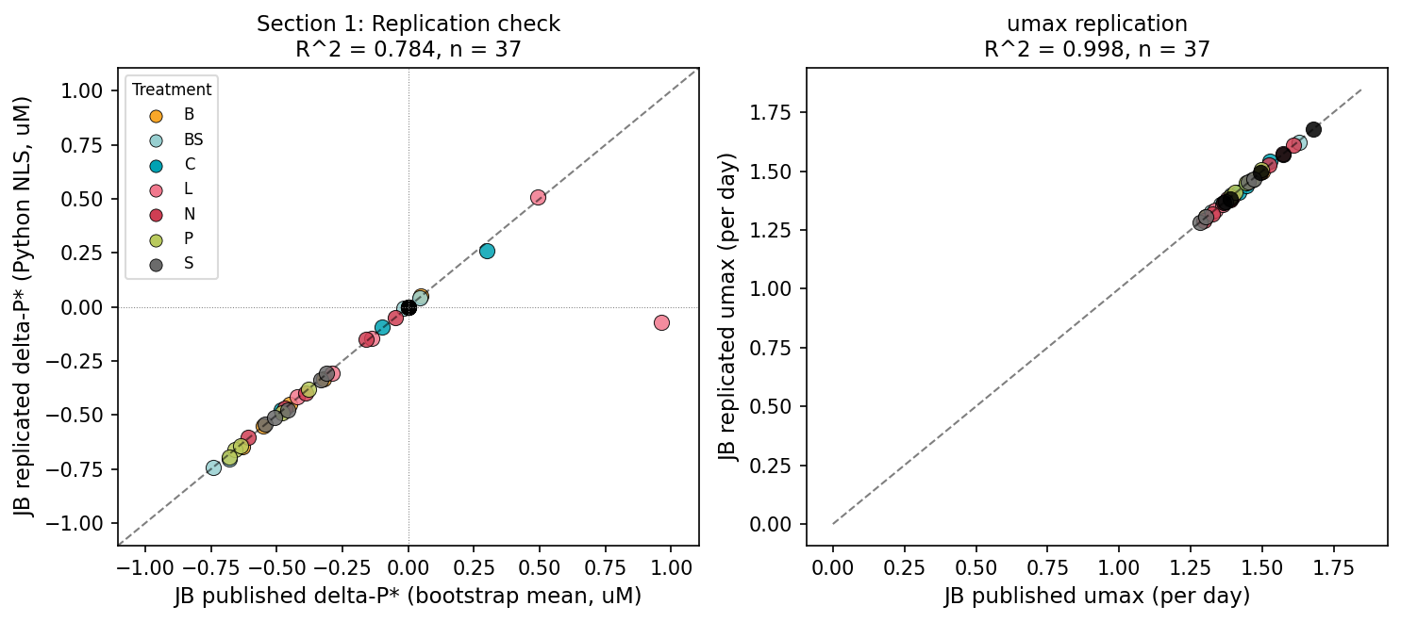
Figure 1. Left: Replicated delta-P* vs. JB published bootstrap means (R2 = 0.784; R2 = 0.999 excluding pop. 10 outlier). Right: Replicated umax vs. JB published umax point estimates (R2 = 0.999). Colors indicate selection treatment.

1.4 Interpretation
We conclude that the Python NLS implementation correctly replicates JB's direct Monod fitting procedure. The R2 between replicated and JB point estimates (0.9991) serves as the baseline for subsequent sections -- deviations from this baseline in Sections 2-4 reflect genuine methodological differences, not implementation artifacts.

Section 2: Direct vs. Indirect Mu Estimation

2.1 Approach
[PENDING] JB's direct approach fits the Monod model simultaneously to all phosphate levels and time points in a single NLS call, treating RFU as the response variable. JL's indirect approach first estimates the instantaneous growth rate mu at each phosphate concentration from the exponential-phase RFU timeseries (typically as the slope of log(RFU) ~ days), then fits the Monod equation to the resulting mu vs. [P] pairs.

This section will hold JB's fitting method (NLS, pooled replicates) and fitting data (JB raw RFU) constant while swapping the estimation strategy.

2.2 Results
[PENDING] R2 between JB direct P* estimates and JL indirect P* estimates (using JL's raw fluorescence data) = TBD

Section 3: NLS vs. Bayesian Fitting

3.1 Approach
[PENDING] With mu estimation approach held constant (indirect, JL-style), this section compares the effect of the fitting framework: JB uses nlsLM (frequentist NLS with nlsBoot bootstrap for confidence intervals); JL uses Bayesian estimation via JAGS with non-informative priors.

This section will compare NLS-derived P* estimates (from Section 2 indirect pipeline) against JL's published Bayesian P* estimates (16_phos_monod_summary.csv, column R.post).

3.2 Results
[PENDING] R2 between NLS indirect P* and Bayesian indirect P* = TBD

Section 4: Pooled vs. Independent Replicates

4.1 Approach
[PENDING] JB fits one Monod curve per population by pooling all 4 technical replicates. JL treats each replicate as an independent observation and fits a separate Monod curve per replicate (148 fits total vs. 37 fits for JB). Population-level estimates are then obtained by averaging across replicates in JL's pipeline.

This section uses the same fitting method (Bayesian) and the same mu estimation approach (indirect) for both, differing only in whether replicates are pooled or kept separate.

JL's published replicate-level P* estimates are in processed-data/16_phos_monod_summary.csv. Population means will be computed as mean(R.post) across the 4 replicates per population, then compared to the pooled Bayesian estimate (single fit to pooled data).

4.2 Results
[PENDING] R2 between pooled Bayesian P* and mean(replicate-level Bayesian P*) = TBD

Summary
Table S1 summarizes the R2 at each analytical decision point. Reading down the table shows the cumulative effect of methodological differences on agreement between the JB and JL pipelines.

Sec. | Methodological difference | What is held constant | R2 (P*)
1 | Python replication of JB NLS (baseline) | All JB choices | 0.999
2 | Direct vs. indirect mu estimation | NLS fitting, pooled replicates | TBD
3 | NLS vs. Bayesian fitting | Indirect mu, pooled replicates | TBD
4 | Pooled vs. independent replicates | Indirect mu, Bayesian fitting | TBD

Note: R2 values in each row compare that pipeline's P* estimates against JB's published bootstrap means (excluding population 10). Declining R2 values identify which analytical choice accounts for the most divergence between JB and JL estimates.

