JB vs. JL pipeline comparison – phosphorus R*

All analysis below is in JB-v-JL/01_section1_replicate_JB.py. The goal here is to work out how much our analytical choices (vs. JB’s) are driving differences in estimated P* values, starting from the simplest possible question: can we reproduce her results? We’re working just with P for the moment because there were obvious differences AND we want to keep things simple for now.

At the top of each section, I will include an indication of how much similarity is being lost through the section-specific modification of JB’s approach. I will summarize R² values comparing my results to JB’s.

Section 1: Replicating JB’s P* results?

R² > 0.99999

JB approach (direct method): fit the Monod model directly to the raw RFU timeseries, pooling all 4 technical replicates per population. The model is RFU ~ N₀ × exp(umax × P/(ks+P) × days). JB identifies the exponential growth window per well-plate by fitting log(RFU) ~ days for sliding windows of 3–7 earliest time points and taking the window with the highest slope. Then fits all wells for a population simultaneously with nlsLM. R* = ks × 0.56 / (umax − 0.56). Change-from-ancestor = R* minus the mean ancestral R* for that lineage.

Can we get the same model parameters as Joey?

Yes. Absolutely!

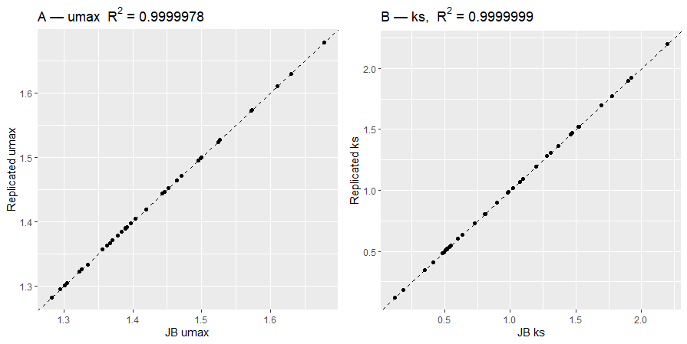

Figure 1. Model predictions for µ_{max} and k_{s}. R² values are approximately 1.

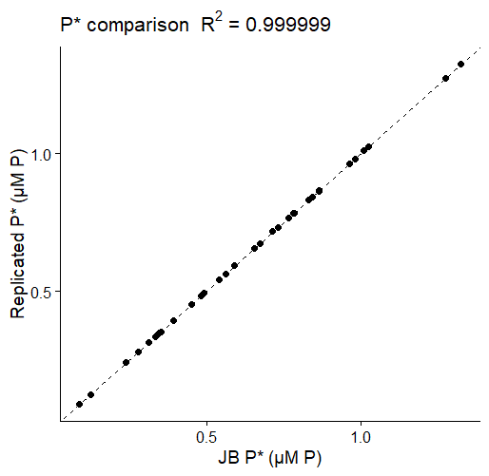
Figure 2. Model predictions for P*. R² value is approximately 1.

Finally, let’s contrast my change in ancestral values plot against your figure 2a:
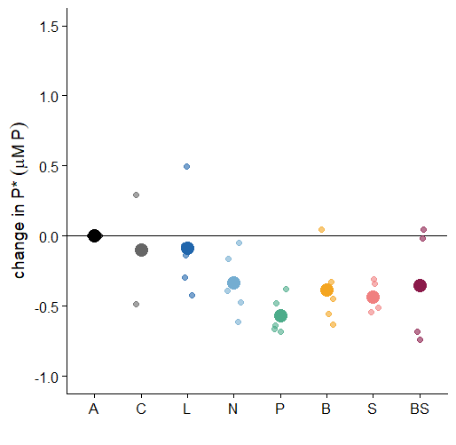
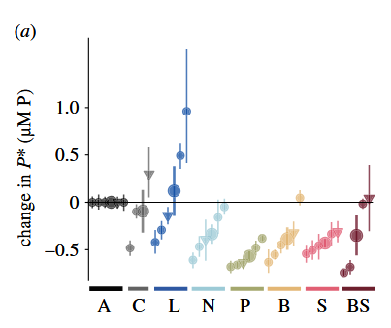

Figure 3. I think that looks pretty good. Small differences in light are likely down to the fact that you are using bootstrapped means here, while I am just using raw model outputs to save time?

Section 2: how much is using the indirect approach affecting things?

R2 < 0.4…

OK so here we are still fitting models to all the replicates at once, in NLS. The difference has to do with how I estimated µ (using the indirect approach where I estimated it first then ported in those data)…

… And this is where our results begin to diverge. Turns out how you choose to estimate µ matters a lot.

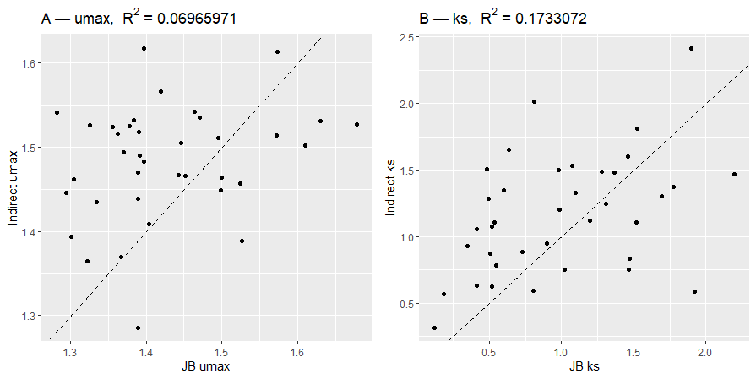
Figure 4. Model predictions for µ_{max} and k_{s}., comparing the indirect approach I used (y) and your direct approach (x). R² values are very small.

This also shows up when we compare our P* estimates:
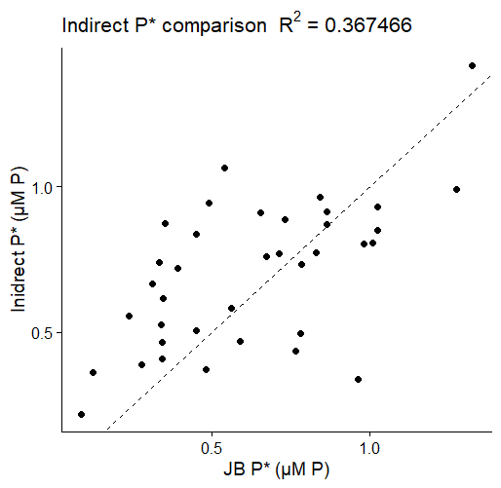
Figure 5. Model predictions for P*, comparing the indirect and direct approaches. R² ~ 0.367


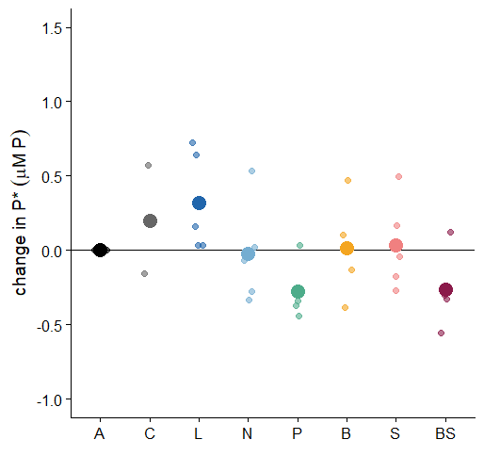
…. And it turns out that this is the difference that seems to explain our divergent results. As you can see below, now I am recovering the pattern we discussed last week (few to no changes in P*), after changing ONLY how I estimate µ.

Figure 6. Familiar differences emerge when I plot parameters predicted by my modelling approach (indirect approach in nls) on the left against yours (direct approach, NLS) on the right. Only P and BS are now showing a reduction in P*.

