COMPS350F  
Software Engineering

Test Plan

|  |
| --- |
| Group 40 Members: |
| Chow Chun Ting |
| Wong Lok Tin |
| Leung Yu Sun |
| Kwan Ho Yeung |

Contents

Login System: 3

Validation test 3

Defect test 6

Attendance: 7

Validation test 7

Defect test 9

Take Attendance: 10

Validation test 10

Defect test 15

Course Schedule System: 17

Validation test 17

Defect test 22

# Login System:

### Validation test

User needs to input their email into the username entry and type their password into the password entry. If the users are not related to the school, they cannot log in to the system.

Student:

If the user is a student, the email format should be like this, studentID + @ +’stu’ + ‘abcu.edu.hk’.

If the login is successful, it will change to the student side. The color is black. so, the user is a student.

Teacher:

If the user is a teacher, the email format should be like this, teacherName + @ + ‘abcu.edu.hk’.

If the login is successful, it will change to the teacher side. The color is light blue. so, the user is a teacher.

### Defect test

If the user enters the wrong password or username, it will get the same error message box telling the user there is something wrong.

# Attendance:

### Validation test

Teacher:

The teacher can select which day attendance he/she wants to check. For example, 2023-11-22.

The attendance records for that day will now be displayed.

Student:

Students could see their attendance records if they had attended on that day.

### Defect test

Teacher

If there are no attendance records on that day, it will not display any records.

# Take Attendance:

### Validation test

This function just allows students to use it.

Student:

For example, if there is a lesson today, Students can take attendance on the attend page. You can see that the button is not available for students to click because it is not class time.



Students can click the left arrow or right arrow to change the date.

If it is class time now, there will be a label prompt and a button that will allow students to click.

When a student clicks this button, a record is created in the database. This record will tell the system that the student has attended classes for that day. Also, it will display a tick icon to let students know he/she had taken attendance.

Now the student can go to check the attendance by that course.

You can see that the record has been created in the database.

### Defect test

Student:

Try clicking the button when there is no class time. As a result, the button becomes unclickable.



When the student has an attendance record in that lesson, he/she clicks the button again. It will not create one more record.

# Course Schedule System:

### Validation test

This function just allows Teachers to use it.

Teacher:

This is the course schedule page. Teachers can create lessons here and delete lessons.

The teacher clicks the plus button to show a new TK window to input the details about the lesson. Such as Venue, Date, Start Time, End Time, and Group.

The lesson with the lesson date of December 6, 2023 is created in the database.

If the teacher wants to delete the lesson, she/he can click the delete button on that line. The lesson will be deleted after the delete button is clicked.

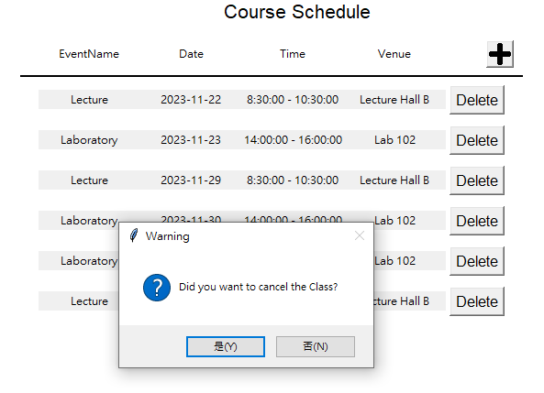

When the delete button is clicked, it will have a message box to ask the teacher did you want to cancel the class. If the teacher selects Yes, the lesson will be deleted. If the teacher selects No, it will close the message box and don’t execute the delete function.

In this example, I will choose Yes.

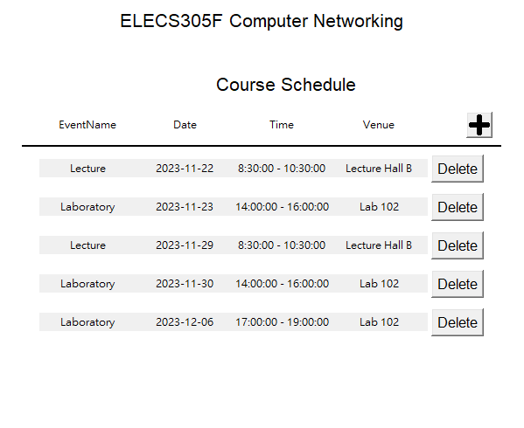

You can see that the lesson had been deleted.

### Defect test

Teacher:

If the Create Course form is incomplete and the teacher clicks the OK button, they will receive an error message telling the teacher to "Please fill out the form" and the form will close.

End