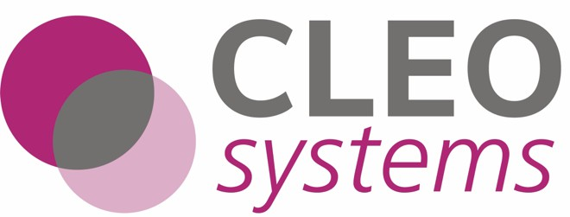

[[TITLE]] v[[VERSION]]

Document Filename [[FILENAME]]
Directorate / Programme |  | [[PRODUCT]]
Document Reference |  | [[DOC_VERSION]]
Product Director | [[DIRECTOR]] | Environment | [[ENV]]
Owner | [[OWNER]] | Release Version | [[VERSION]]
Authors | [[AUTHORS]] | Version Build Date | [[DATE]]

Release Highlights
[[HIGHLIGHTS]]
Release Summary
[[SUMMARY]]

[[#SECTIONS]]
[[title]]
[[#items]][[key]]
[[text]]
[[/items]]
[[/SECTIONS]]

Sign-off

To proceed with the release, the following must be approved.
- Test scripts covered all functionality, and the degree of testing has covered the functionality of the system to a satisfactory level
- The defect level is at an acceptable level to release.
- The outstanding defects above the exit criteria threshold will go into OAT with other outstanding defects as known defects.

Name | Position | Signature | Date
[[DIRECTOR]] | Product Director | [[DIRECTOR]] | [[DATE]]
[[OWNER]] | Product Owner | [[OWNER]] | [[DATE]]

