**University of Pretoria**

Monica D. G. Oleastro - u16030193

Olivia R. de Kok - u16011598

Kyle B. Oosthuizen - u16077343

Matthew J. Louw - u16054017

IMY 320 - Assignment 2

Group Design and Development

**September 04, 2018**

https://jasonlouw.github.io/2018_IMY320_stranded.github.io/Website/

# Overview

The game, on which our website is bases, is called Stranded. It is an island survival / tower defense game. The art-style is cute, cartoony and 2D. Because of this, we intend to make our website reflect the style.

**Navigation Bar:**

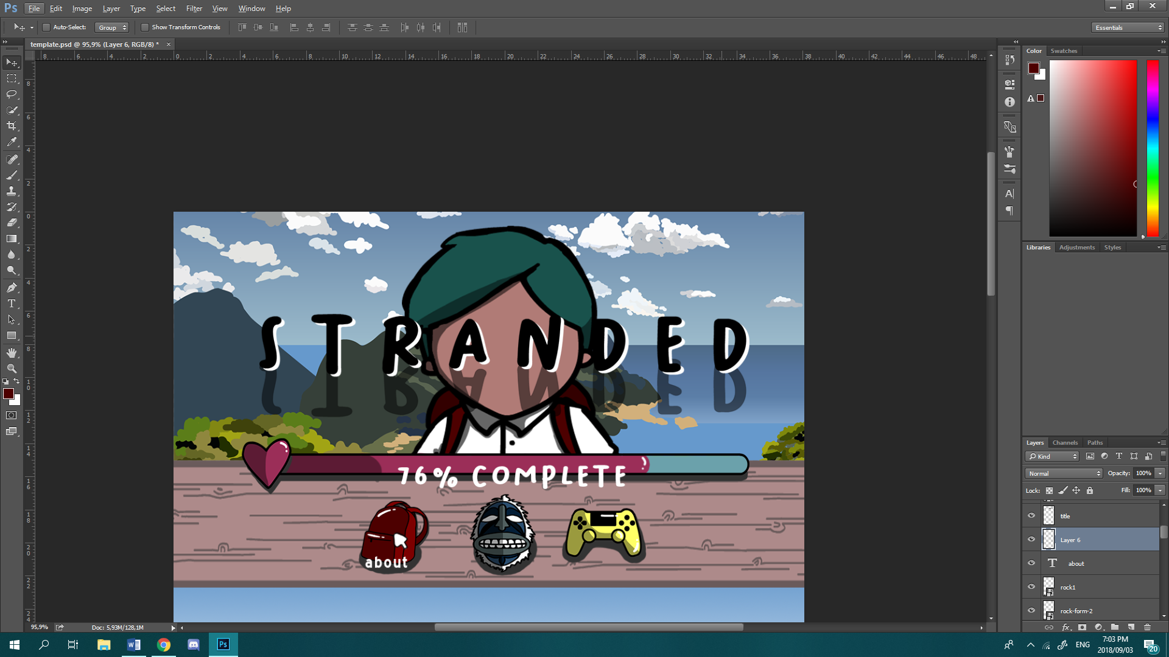The navigation bar makes use of icons that appear in the game. The three icons making up the navigation menu consist of the three primary colours which fits with the cute and childlike aesthetic of the game. The navigation menu mimics gameplay whereby it is placed on a wooden panel background that is the same as the wooden panel that holds the HUD in the game. The navigation icons do not display the word that represents what they do (e.g. “about”, “meet the developers”, “preorder”), until the user hovers over them. This is because it is implemented the same way as in the game. We added a bar to show how far the game was from its finished state. The bar is the actual health bar used in game. Symbolically it represents the “health” of the game and how far it is from release with a playful reference at how games load to completeness before they are playable. We have tried to keep as much continuity and consistency, in our website, with regards to the game “Stranded”. The sections of the website, that the navigation bar jumps the user to, will have visuals of the same colour as the corresponding icon, to keep consistency and make plainly evident that the user is in this section (e.g. the red backpack section).

A lot of inspiration was drawn from the Hollow Knight game website: <http://hollowknight.com/> as well as the Fran Bo website: <http://www.franbow.com/> for things such as border design.

**Backpack - About**

In the game, the backpack icon represents the player’s inventory and also the pause menu. In our website, we have chosen to use it as a link to the “About” section. This is because we think that a backpack representing more information or more “stuff” is a very easy mental link for a user to make. The backpack will “unpack” things that the user should know about the game and some basic mechanics the user can look forward to. The idea surrounding about is visually represented under Broken Grid layout explained later in the pdf.

**Mask - Meet the Team**

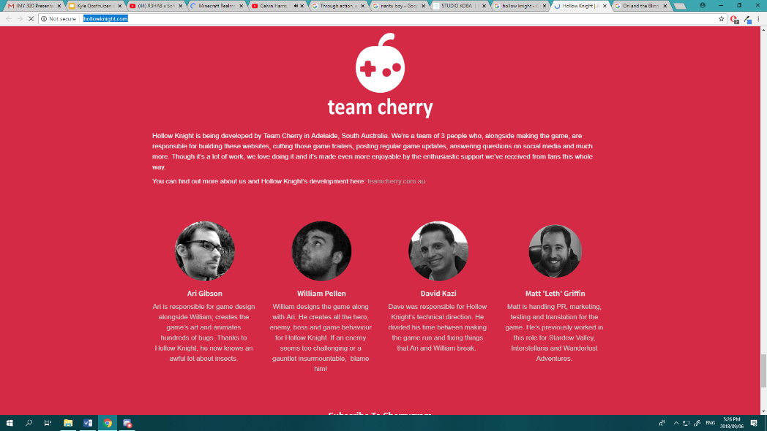The enemy mask represents the section of the website where users can learn more about the developers of the game. Once again we believe this is a relatively easy link for the user to make. The mask represents people and “people” in this case meaning the creators/developers. The idea for this page is drawn from the Hollow Knight website as show above. Each developer’s picture is accompanied with a short paragraph describing them. Our website will instead use hand drawn pictures of each developers in order to maintain flow with the other art on the website. The website will make use of the general template as used in the Hollow Knight website where each developer is on a line to keep the website clean and neat.

**Controller - Pre-Order**

The yellow controller completes the set of primary coloured icons. The controller represents pre-order for the game. Since the game will only be complete sometime in October, we found it more appropriate to include a pre-order rather than the ability to purchase the game. The loading bar at the top of the game is directly linked with pre-ordering and can be used as a visual but abstract reference for how long the user will need to wait before the game is playable.

**Background:**

The background consists of a main dynamic gradient sections for the base content of the website. The gradient progresses from blue to white and then to green. We have chosen to do this as a subtle reference to the sky and the grass which is a main visual aspect within the game.

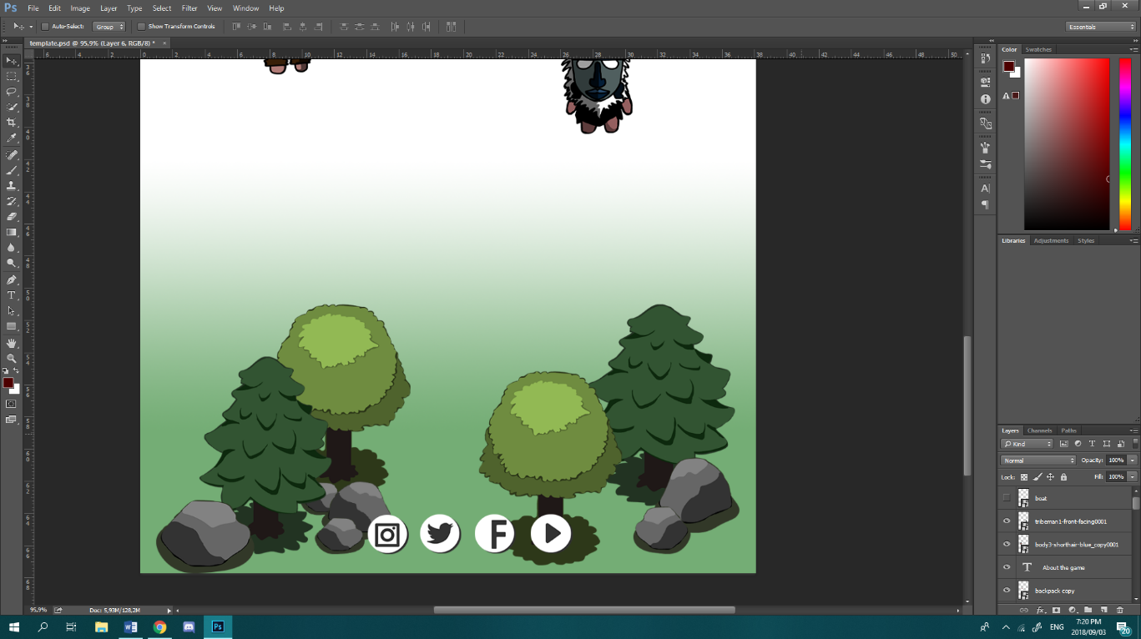

The bottom of the website will contain the part of the website that is green, and since it is plainly representing grass, we have used it as a way to close off the website. We have included a small forest scene at the end of the page to act as the footer or the closing of the website.

The top of our website, the title and navigation menu, has a different background. This part contains a slightly more realistic island scene. We have chosen to do this because that is how the main menu appears in the game. Equating the main menu (starting menu) of the game and the front/beginning of the website, is done as an intentional mental link between the actual gameplay and the website.

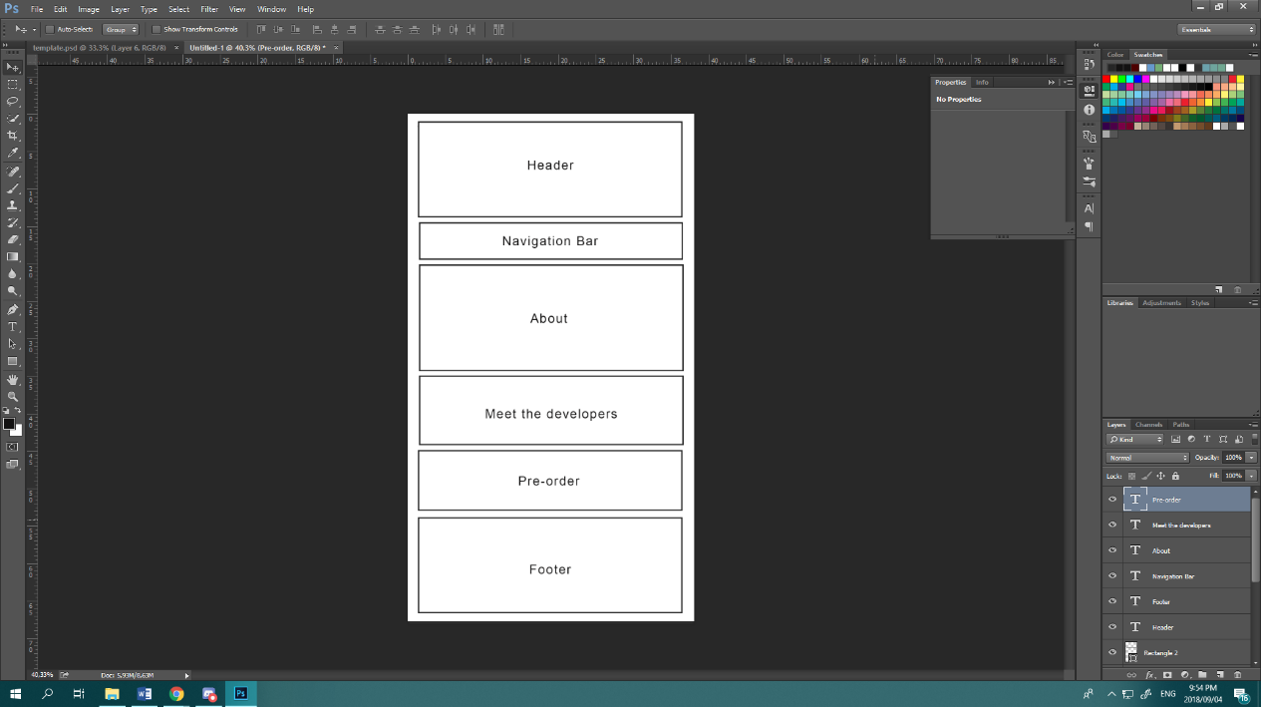**Trends:**

**Single Page Application/One Pagers**

Our entire website will appear on a single page. The navigation bar will jump to sections lower down on one continuous page, rather than jumping to another webpage. The general layout for the website is shown on the right.

**Broken Grid Layout**

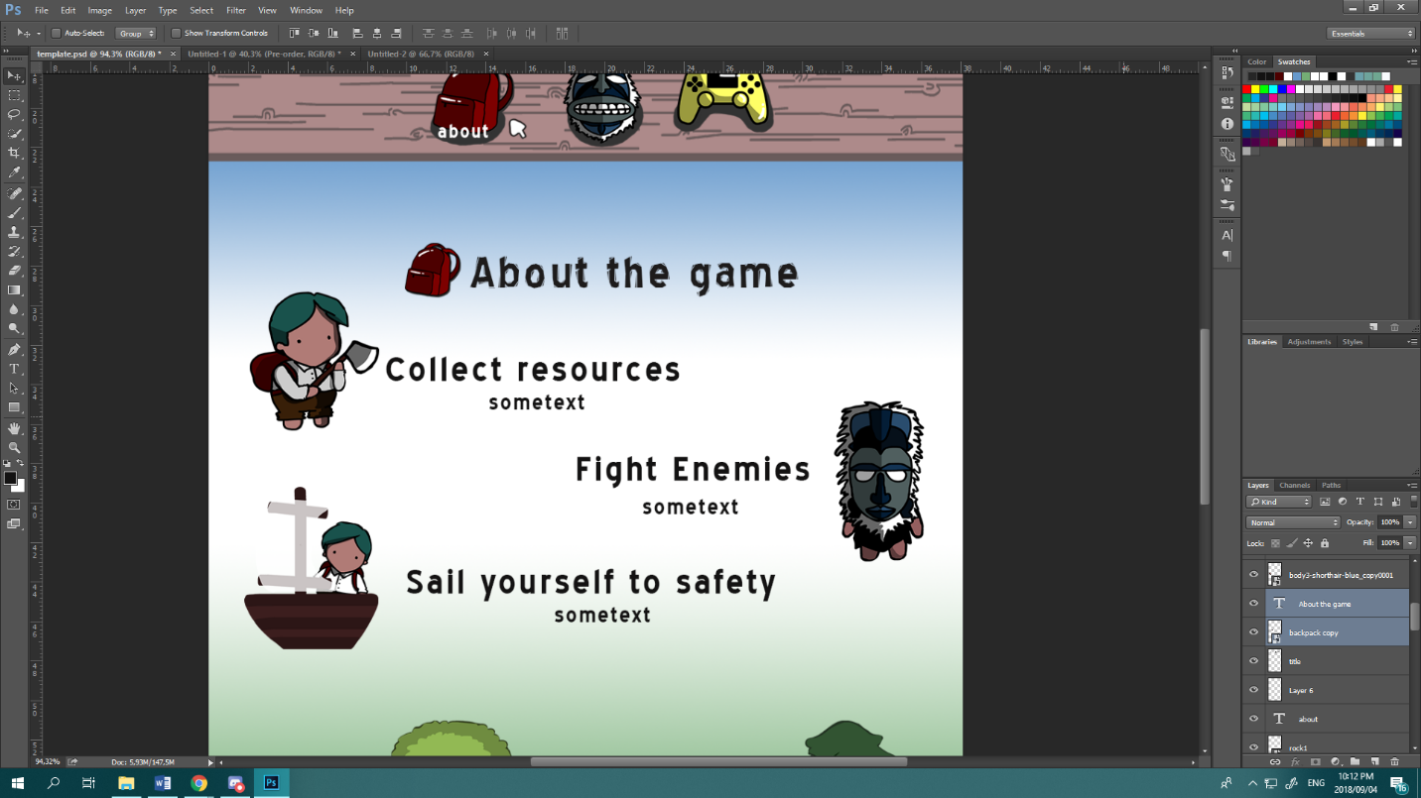There is no obviously followed grid system within our website. The composition and layout varies between sections depending on what kind of layout looks best for each heading or area within the page. As shown on the left the website follows a soft curve, it has no clear grid system but each member (animated gif) shows association to its partner (explanatory text) via how close they are put together.

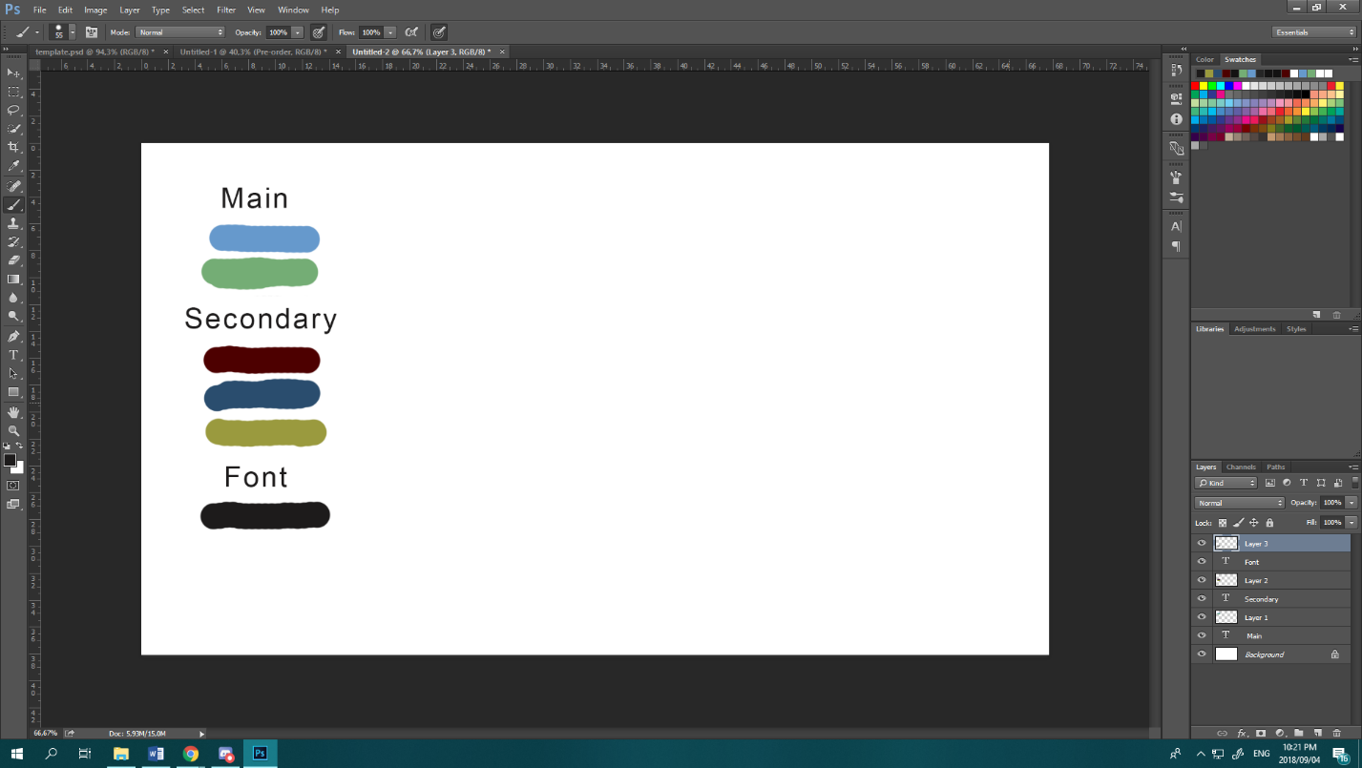

**Colour Definition**

The website makes use of a variety of vibrant and saturated colours. The colour scheme of the website directly mimics the colour scheme of the game. It has bright, primary and fun childlike colours that emphasise the cute and cartoony aesthetics of the game. The colour scheme is show on the left.

**Dynamic Gradients**

The plan of the website is to implement colours that transform dynamically. As the user traverses the website the colours will change from blue to green. This main gradient is formed by the two main colours as indicated above. A white will be added to the gradient where there is lots of text as to have enough contrast.

**Integrated Animations**

We intend to use GIFs from the actual game, such as the characters walking and chopping, in order to engage the user when learning about gameplay and storyline.

**Background Videos**

We will make use of a background video/gif of the health bar on a loop reaching 76% health and then slowly coming down again. Since this video will not be communicating any extra information to the user it is classified as a background video. It will be used primarily to communicate a visual/abstract representation on when the game will be out. If the user would like more in depth information they would need to click on the health bar or the pre-order button on the navigation bar.