**SYSC-3200: Industrial Engineering - Project Proposal**

Instructor: K.R. Goheen

Group 31:

Reginald Pradel - 100963239

Prottoy Biswas - 101066778

Sergei Shirobokov - 100712263

Jason Nyentap - 101032473

Madalo Malonda - 101013452

February 1st, 2021

**Overview**

The presentation will be on solving network scheduling problems with a software application. The team will create a reliable scheduler based on PERT and CPM techniques by analyzing the requirements for solving these types of problems, the generalizations that can be made, and how those generalizations can be applied to software .

The team will create a program that performs the calculations necessary for PERT and CPM, and demonstrate its effectiveness as part of the final report.

**Problem Statement**

Performing PERT and CPM calculations manually can be a tedious and error-prone activity, especially in situations where many milestones and activities are involved. In order to perform PERT and CPM calculations faster and with fewer errors it would be beneficial to have a computer program automate the process.

The accuracy of the final solution would no longer depend on a human performing many repetitive calculations without arithmetic errors. The software would ideally be very simple and LINDO-like from the users’ perspective, except it would solve PERT and CPM problems instead of optimization problems.

**Potential software solutions**

Free software matching the description outlined in the problem statement was not readily available. Therefore, the goal will be to create a program that will perform PERT and CPM calculations software with a presentation demonstrating how it works, and how to use it. The implementation of the software will closely follow the five steps used for manual PERT and CPM calculations.

Since this is a user application, we will be using a high-level coding language for the program. In particular, Python and Matlab stand out for their ease of use/readability and specialization in solving mathematical problems respectively. Python is currently the most ideal approach since it allows developers to take an object-oriented approach and offers a plethora of extensive libraries for data manipulation and visualization.

At the highest level, ProjectTask is defined with fields:

* priorityLVL
* description
* membersAssigned

From there, child PertTask is defined with fields:

* optimisticETC,
* mostLikelyETC,
* pessimisticETC,

Also, child CrmTask is defined with fields:

* updatedETC
* List_of_tasks

**Timeline**

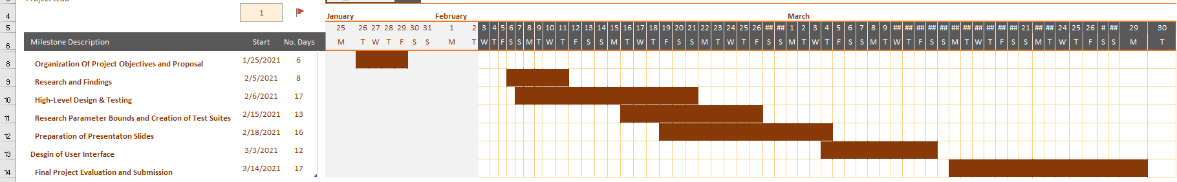  
 Figure 1: Shows the timeline and description of our project in a Gantt Chart.

**Roles and Responsibilities**

Reginald Pradel - Software Engineering Design: UML Class Diagram, Python program implementation

Prottoy Biswas - Software Tester: drafting & writing test cases, compare handwritten PERT and CPM techniques.

Sergei Shirobokov - Lead writer

Jason Nyentap - Lead software developer

Madalo Malonda - Team leader, software support