HỆ THỐNG ĐÀO TẠO CNTT QUỐC TẾ

**APTECH ĐÀ NẴNG**

**-----🙠🕮🙢-----**



**PROJECT REPORT**

**Topic:**

**Green Nursery Website Design and Development SRS**



Instructors: **Mr Nguyen Ngoc Nhan**

**Group:**

|  |  |
| --- | --- |
|  |  |
| 1 | Le Van Hung (Leader) |
| 2 | Nguyen Quoc Bao An |
| 3 | Nguyễn Ngoc Ky Phong |
| 4  5  6 | To Anh Tu  Nguyen Van Quoc  Nguyen Trung Nghia |

**Da Nang, 12 August 2023ACKNOWLEDGEMENT**

I would like to express my sincere gratitude to everyone who helped make this project possible. First and foremost, I would like to thank my science teacher Nguyen Ngoc Nhan for guiding me throughout the entire process and providing valuable feedback and support.

I would also like to thank my partners who helped with data collection and analysis, as well as my parents for providing the necessary materials and encouragement. Additionally, I would like to acknowledge the scientists and researchers whose work served as inspiration and provided the foundation for my project.

Finally, I would like to thank Aptech for taking the time to evaluate my project. Without the support of these individuals and organizations, this project would not have been possible. Thank you all for your contributions and support.

Thank you sincerely!

**TABLE OF CONTENTS**

**PART 1: INTRODUCTION** 4

**1.** **Reason for choosing the topic** 4

**2.** **Goals** 4

**3. Proposed Solution** 5

**4. Objects and scope of research** 6

4.1. Object 6

4.2. Research scope 6

**5. Research Methods** 6

5.1. Collection method 6

5.2. Information processing methods 6

**6. The layout of the topic** 6

**PART 2: CONTENT** 7

**CHAPTER 1:** **SURVEY, DETERMINATION OF REQUIREMENTS** 7

1.1 System requirements survey 7

**CHAPTER 2: SYSTEM DESIGN ANALYSIS** 10

2.1 Analysis of topic requirements 10

2.2. System design analysis chart 11

2.3 Interface Design 15

2.4 Project task list 25

**CHAPTER 3: SOFTWARE TESTING AND EVALUATION** 26

3.1 Software Testing 26

3.2 Evaluation of software 26

**PART 3: CONCLUSIONS AND DEVELOPMENT** 27

**1. Conclusions** 27

**2. Development** 27

**PART 4: REFERENCES** 28

# **PART 1: INTRODUCTION**

## **Reason for choosing the topic**

The need for a plant nursery website stems from several factors. To the growing interest in gardening, increasing demand for plants and the convenience of online shopping. Pages An e-commerce website about a plant nursery serves as an information platform for customers. Provide detailed information about each plant species, including provenance, care requirements and watering cycles, helping customers understand the plants they are interested in.

## **Goals**

* Increased Interest in Gardening:

“'There has been a significant rise in the popularity of gardening and plant

Ownership, driven by various factors such as the desire for a green

environment, stress relief, and aesthetic appeal. As more people engage in

gardening as a hobby or lifestyle, the necessity for easily accessible and

diverse plant options become crucial.

* Wide Variety of Plants

Plant nurseries offer a wide variety of plant species, each with unique

characteristics, care requirements, and purposes. A dedicated Website

allows the nursery to showcase its extensive collection and provide

detailed information to potential customers, enabling them to make

informed decisions based on their specific requirements and preferences.

'* Convenience and Accessibility-

-An e-commerce 4s well as informational Website provides convenience.

allowing customers to browse and purchase plants from the comfort of

their homes. Users can access the Website at any time, eliminating the

constraints of physical store hours and geographical limitations. This

accessibility increases the reach of the nursery, attracting customers from

different locations.

* Plant Information:

A plant nursery e-commerce Website serves as an informational platform

for customers. Providing detailed information about each plant species,

including origin, care requirements, and watering cycle, helps customers

understand the plants they are interested in.

This information promotes responsible gardening practices and ensures

thạt customers select plants suitable for their environment and abilities.

* Search, Sorting, and Filtering Capabilities:

With a wide range of plant options, users may have specific preferences

such as indoor plants, succulents, or flowering shrubs. The Website

search, sorting, and filtering features allow users to find plants that match

their criteria efficiently. This saves time and enhances the overall user

experience by narrowing down options based on their preferences.

* Customer Engagement and Loyalty:

A well-designed Website can foster customer engagement and loyalty by

offering features such as wishlists, personalized recommendations, and

informative blog content related to gardening and plant care. This

engagement strengthens the relationship between the nursery and its

customers, increasing the likelihood of repeat purchases and referrals.

## **3. Proposed Solution**

The proposed solution is a Website called 'GreenNursery' for a plant nursery. The Website should serve as an e-commerce as well as an informational platform where users can browse and purchase various plants. It should. Provide categories for different types Of plants, allow users to search for specific plants, and offer sorting and filtering options. Additionally, detailed information about each plant species should be displayed, including the origin country and watering cycle.

## **4. Objects and scope of research**

### 4.1. Object

• Small and large stores or farms that want to sell their plant nursery.

• People who need to buy food online.

### 4.2. Research scope

• This Web portal will be a responsive and visually appealing Website to be

used by individuals.

## **5. Research Methods**

### 5.1. Collection method

Apply theoretical research methods (method of collecting information through books, documents, and websites) to find the theoretical bases related to the research problem.

### 5.2. Information processing methods

* Methods of analysis and evaluation: based on the found theoretical basis and see the problem into reality to choose the solution to complete the topic.
* Synthetic method: Apply the best selection from the analysis step combined with technology, thereby completing the project step by step.

## **6. The layout of the topic**

- Part 1: Introduction

- Part 2: Content:

1. The survey, determines the requirements

2. System design analysis

3. Program development and testing

- Part 3: Conclusion and Development

- Part 4: References

# **PART 2: CONTENT**

## **CHAPTER 1:** **SURVEY, DETERMINATION OF REQUIREMENTS**

### System requirements survey

1.1.1. Purpose

- This phase focuses on gathering information and documents related to the system's structure and operations to identify some problems before starting to build and develop a project.

- The content to be surveyed corresponds to the problems that need to be solved to suit the requirements of the users and the scale of the information system.

1.1.2. Scope of project

- Catering to small shops that need to sell trees online and for manufacturers who want to introduce and promote their products to consumers.

- Catering to consumers shopping online through the Internet.

1.1.3. Location

Survey sales sites:

* cmtgarden.com
* greenpop.org

- caycanhxanh.vn

1.2. Survey content

1.2.1. Current sales website infrastructure

There have been many chain stores that have successfully applied technology in remote management and achieved results above expectations. However, besides that, there are still many other chain stores that have not yet applied these technologies and still do manual work or cannot operate effectively.

1.2.2. Business process

Online sales:

- The manager will post the products with specifications, promotional information, condition, quantity and price.

- Customers who need to purchase after selecting and providing the specifications of the item to be purchased will have to log in to proceed with adding items to their cart. Then the customer will choose other payment methods. each other can be paid via bank transfer or online account…

- Customers enter the delivery address, and phone number in the order.

⮚ Customer care:

- Direct.

- By phone or email.

- Messages on the Web.

1.2.3. Define business requirements

**Catalog Display:**

The Website should display a catalogue of plants available for purchase. Plants should be organized into categories, such as indoor, outdoor, succulents, flowering shrubs, and so on. Users should be able to browse through the catalogue and view individual plant listings.

**Search and Navigation:**

Users should be able to search for a specific plant by name or keywords. The Website should provide navigation options to access different plant categories and sections.

**Sorting and filtering:**

Users should be able to sort the plant catalogue based on various criteria, such as price, popularity, or alphabetical order.

Users should be able to filter plants based on specific attributes, such as indoor/outdoor, light requirements, water requirements, and so on.

**Plant information:**

Each plant listing should display detailed information about the plant species. Information should include the plant's common and scientific name, origin country, watering cycle, light requirements, and other relevant details.

**Shopping Cart and Checkout:**

Users should be able to add plants to their shopping cart for purchase. The Website should display the contents of the users' shopping cart and. allow them to modify quantities or remove items.

**Feedback:**

The feedback menu option should enable users to provide their feedback about this Website through a feedback form.

**Contact us:**

The Contact Us menu option should enable users to contact the creators of the Website. An email id can be displayed here for contact information.

**Site map:**

Sitemap: To help users understand the flow of the Website, you will create 1 Sitemap and add it to the home page of your Website.

**⮚ Non-functional requirements:**

**Safe to use;** The Website should not result in any malicious downloads or unnecessary file downloads

**Accessible:** The Website should have clear and legible fonts, user-interface elements, and navigation elements.

**User-friendly**: The Website should be easy to navigate with clear items and other elements and easy to understand

**Operability**: The Website should operate in a reliably efficient manner.

**Performance:** The Website should demonstrate a high value of performance through speed and throughput. In simple terms, the Website should be fast to load and page redirection should be smooth

**Capacity**: The Website should support a large number of users

**Availability**: The Website should be available 24/7 with minimum downtime.

**Compatibility**: The Website should be compatible with the latest browsers.

1.3. Define technical requirements

1.3.1. Applied technique

**⮚ HTML**

**⮚ CSS**

**⮚ Javascript**

**⮚ Jquery**

## **CHAPTER 2: SYSTEM DESIGN ANALYSIS**

### Analysis of topic requirements

2.1.1 Summary of system operation

- Website specializing in selling crops

- As a static Website, the information is updated periodically.

- Users accessing the Website can view, search, buy products, or order products.

- Users can view details of each product (with product illustrations).

- When you have selected a satisfactory item, the user clicks on the button to add to the cart or select the cart icon to have the product updated in the cart.

- Users can still return to the product page to view and select further, the selected products will be saved in the shopping cart.

- Customers can also remove unsatisfactory products already in the shopping cart.

- If the user has decided to buy the products in the cart, the user clicks on the payment item to complete the purchase or can cancel the purchase.

- The user will choose the shipping and payment methods determined by the system.

2.1.2 Target users

There are two basic users: users and administrators:

* Users: Through the Website, customers can view information and choose their favourite products anywhere, even in their office.

* Administrator: The administrator has full rights to use and update products, and invoices, manage customers, and ensure the safety of the Website.

2.1.3 Project purpose

- Meeting the growing needs of society, and building an effective working environment.

- Inventory management becomes easy.

- Products are arranged systematically so users can easily find products

### 2.2. System design analysis chart

2.2.1. Activity chart

|  |  |
| --- | --- |
| Title | Shopping cart |
| Description | * For Guest : * On the homepage of the website the agent searches for the product on the application and makes a purchase. * The agent can perform the function of removing products from the cart or increasing the number of products already in the cart |
| Evaluation Criteria | * For Guests, the shopping cart only exists in the browser's Local Storage. |

2.2.2 Use a case diagram

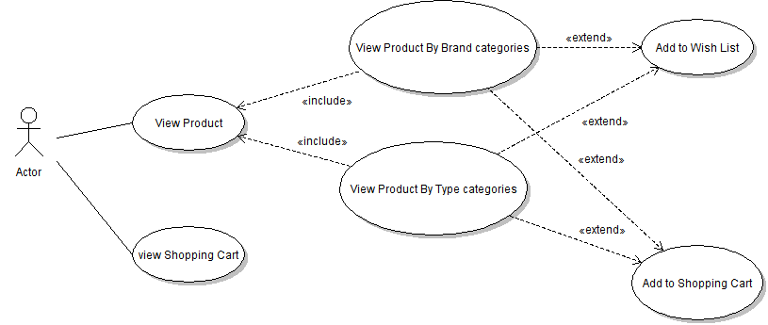

2.2.3 Use case specification

|  |  |  |  |
| --- | --- | --- | --- |
| **USE CASE SPECIFICATION** | | | |
| **Use-case No.** | UC02 | **Use-case Version** | 1.0 |
| **Use-case Name** | *The shopping cart* | | |
| **Purpose:**  Summary of the number of products, and the price of the product selected by the user on the products page.  **Input:**  The product selected by the user on the products page  **Output:**  Display product information, total. | | | |

2.2.4 Flowchart

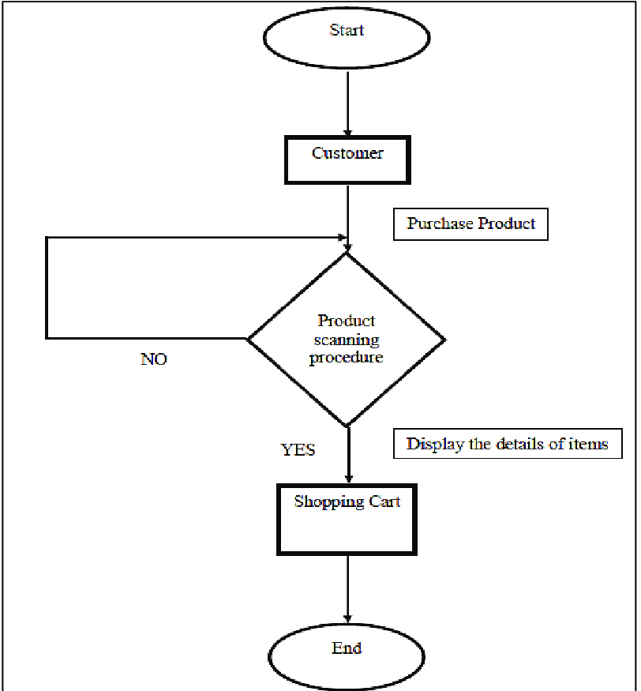

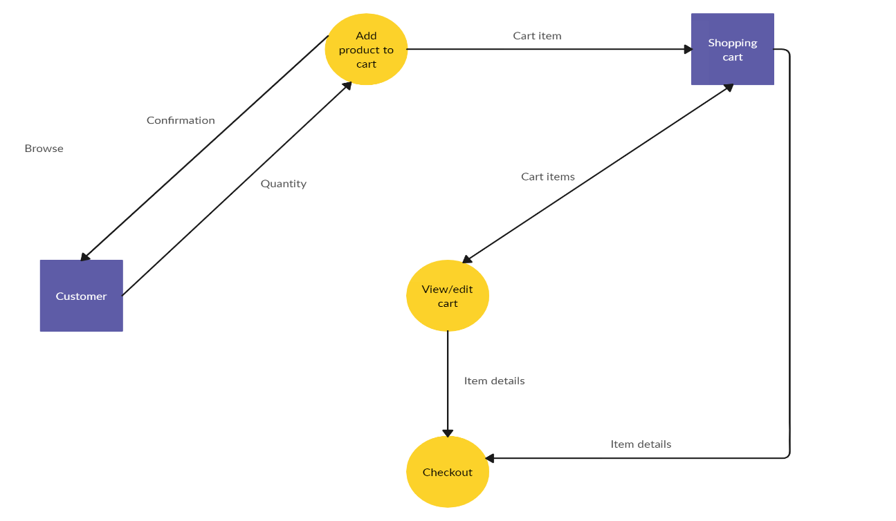

### 2.3 Interface Design

2.3.1 Preliminary interface design (Wireframe):

**Home**

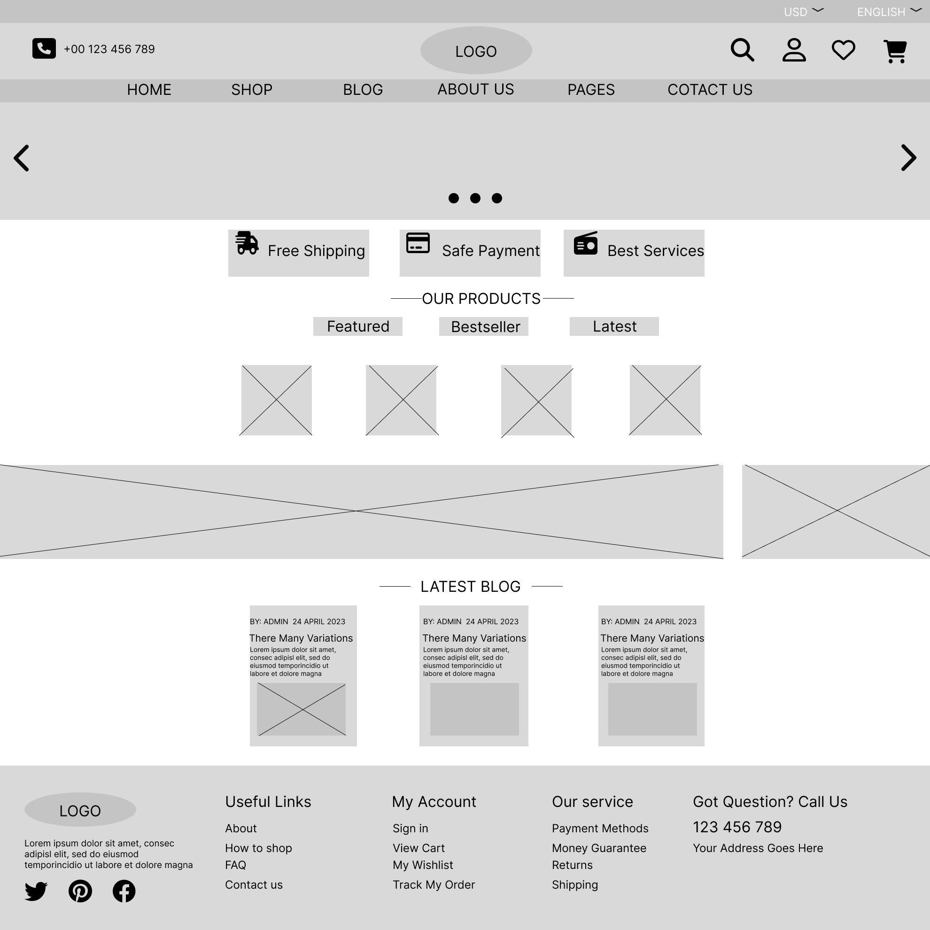

**Categories**

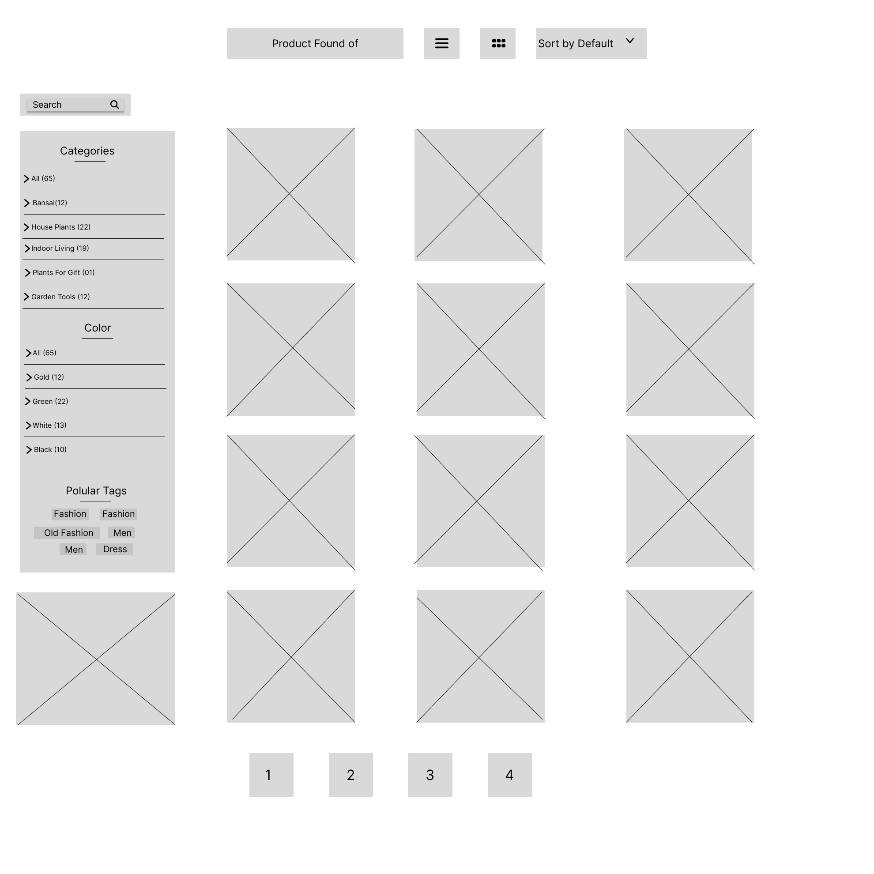

**ShoppingCart**

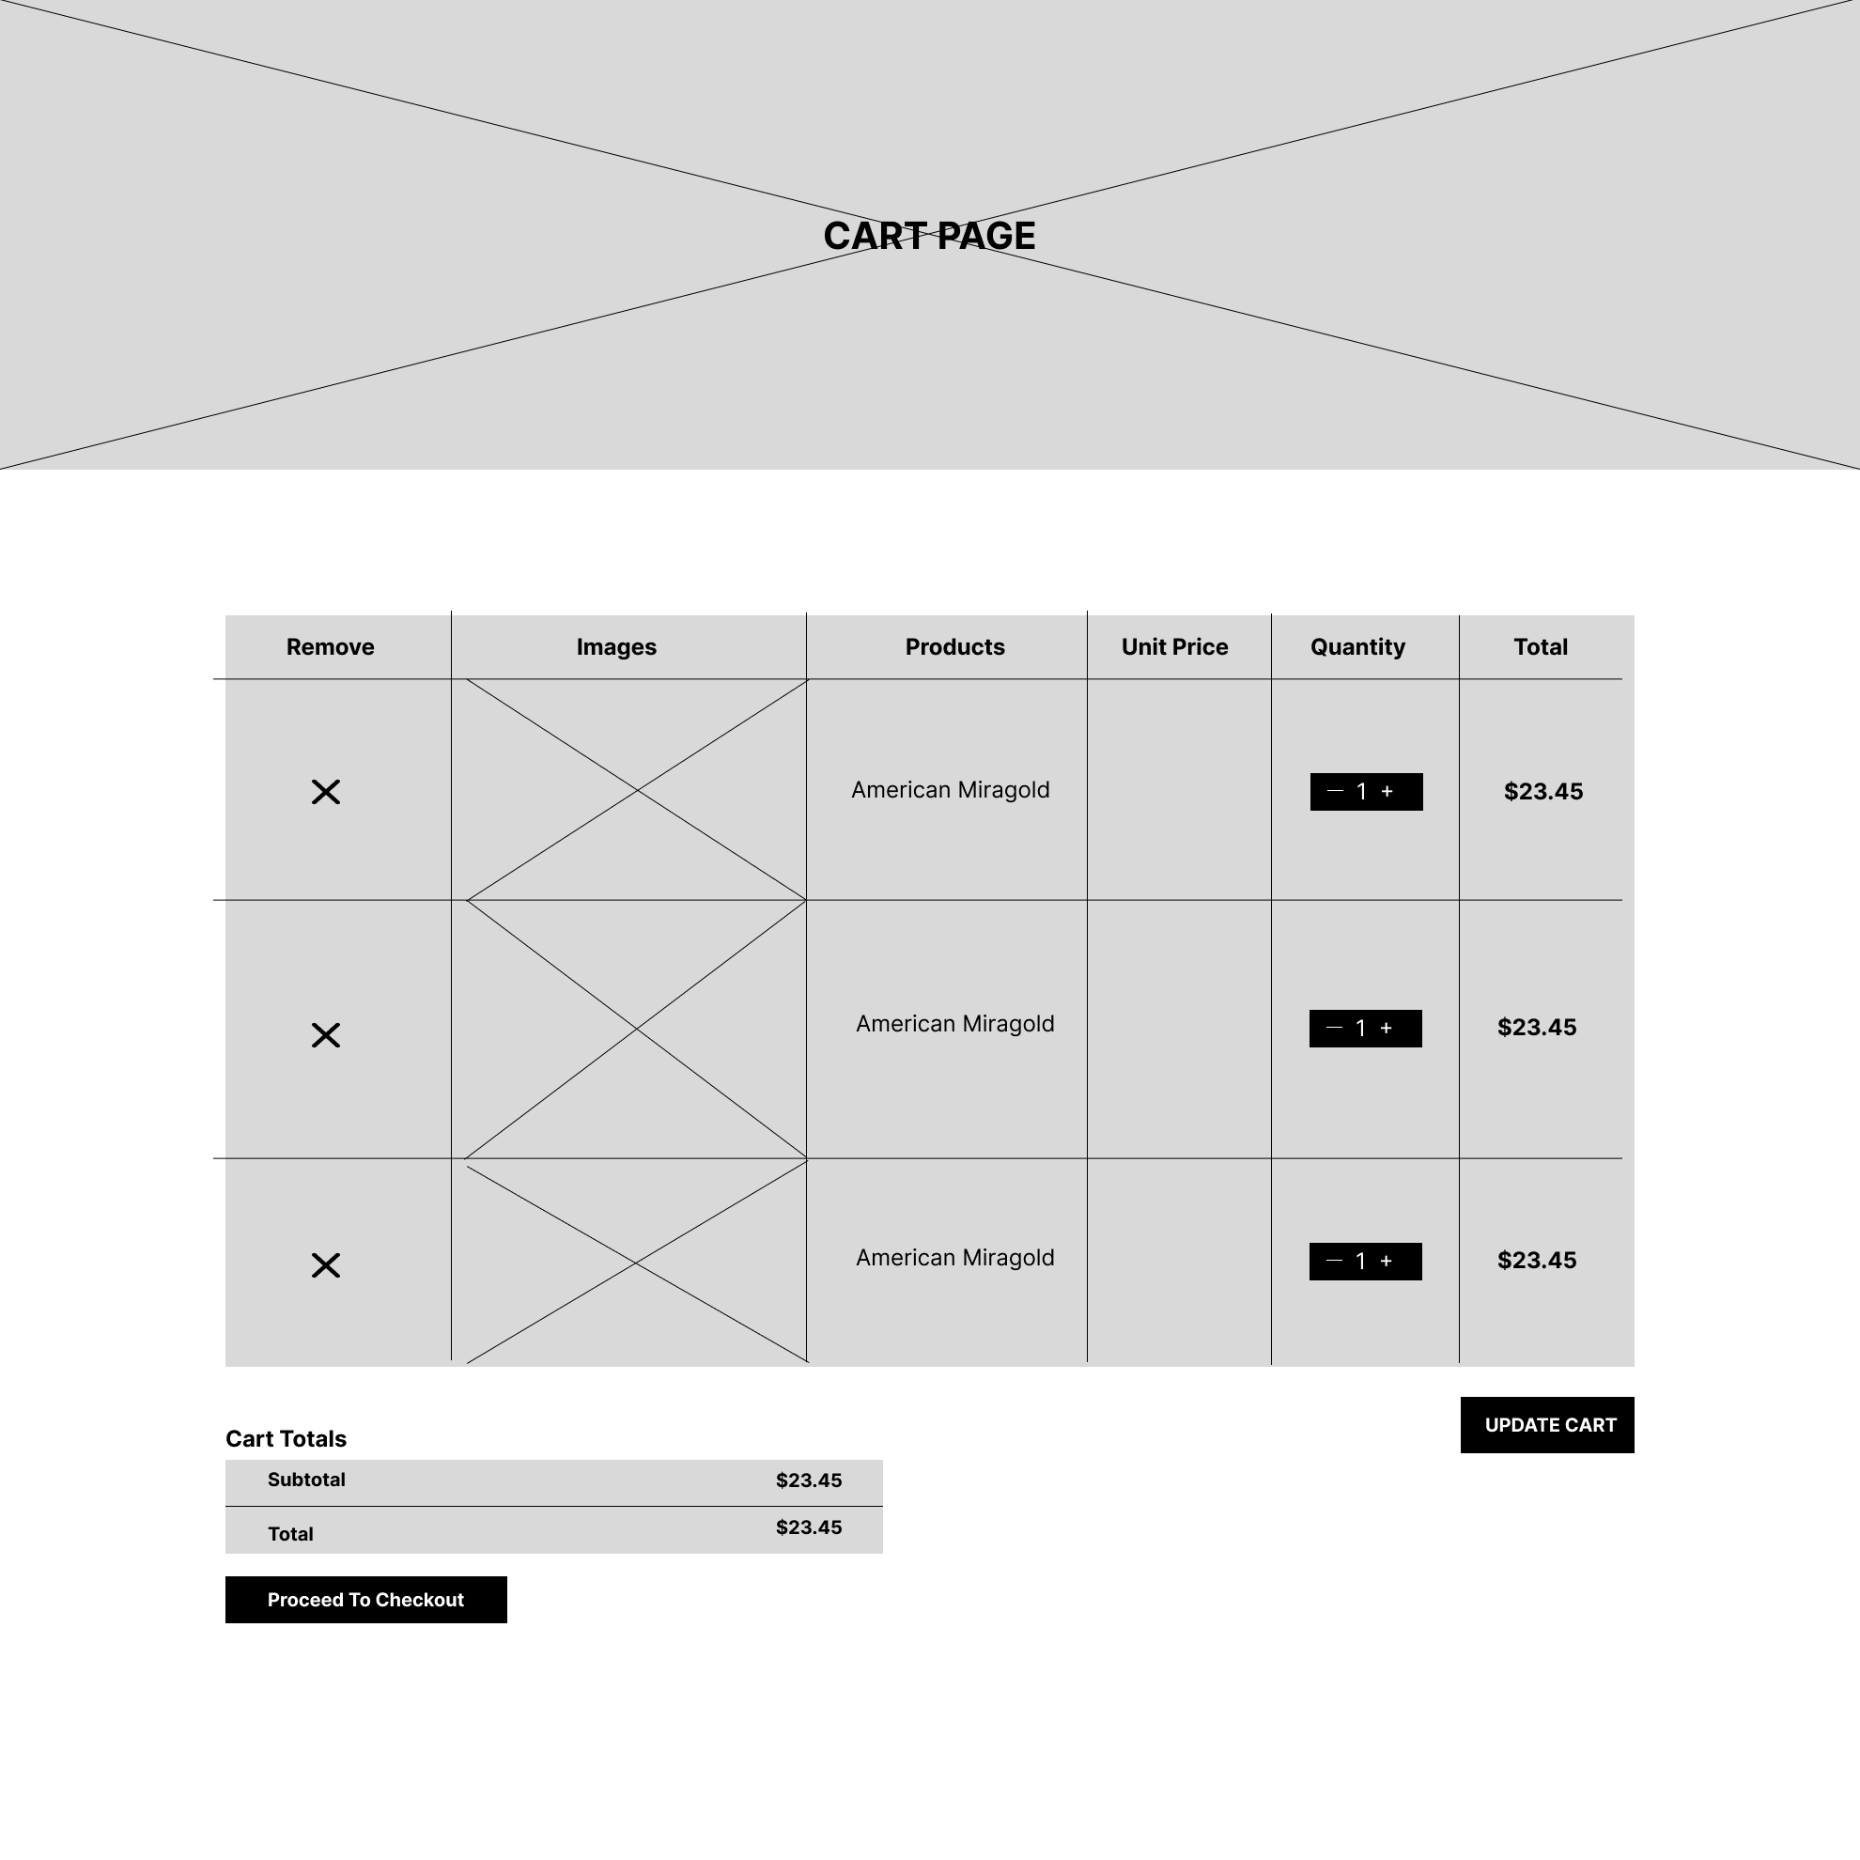

**Checkout**

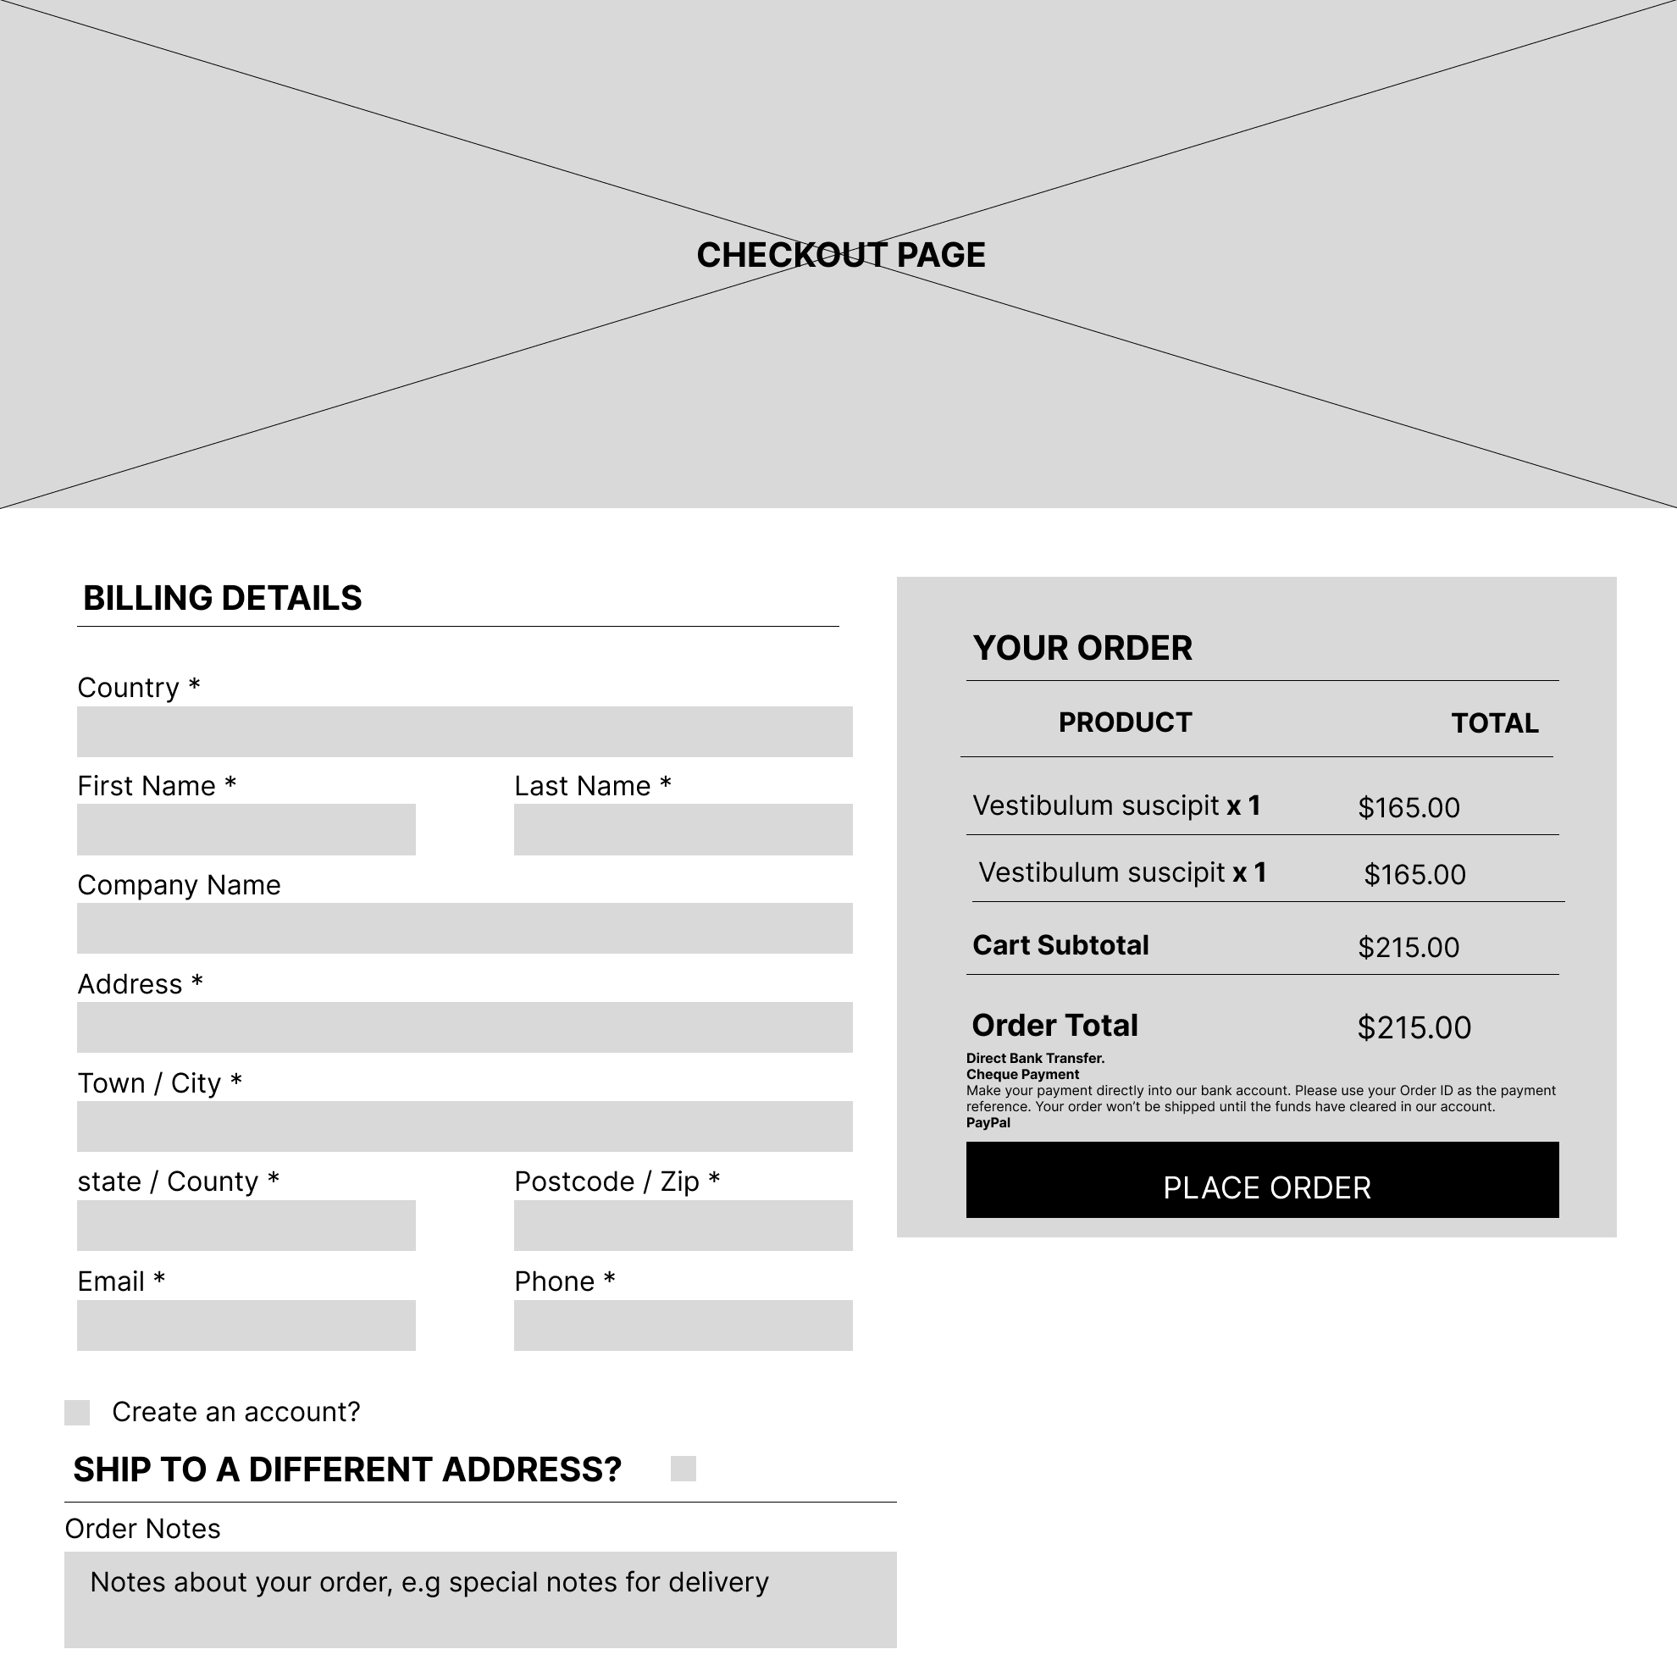

**Contact us**

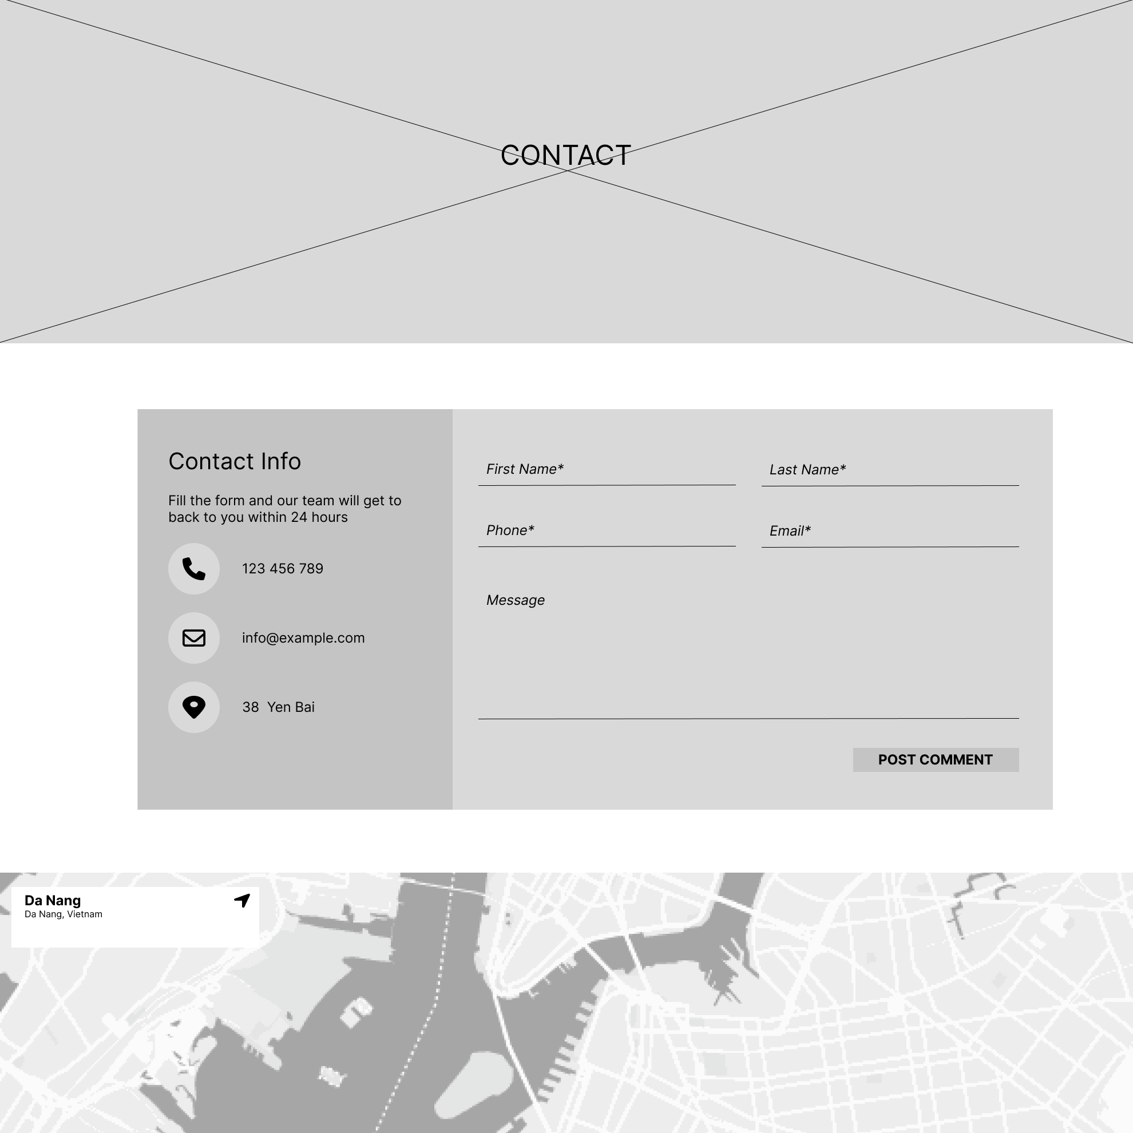

2.3.2 User Interface Design (UI Design):

**Home**

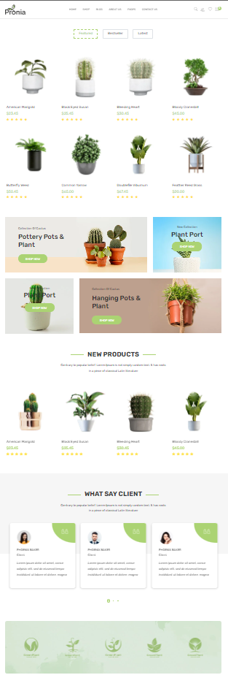

**Categories**

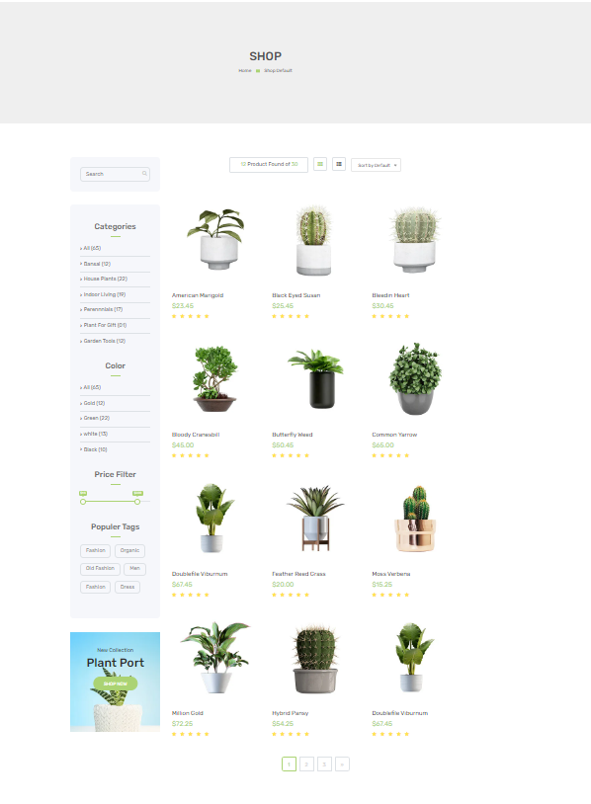

**ShoppingCart**

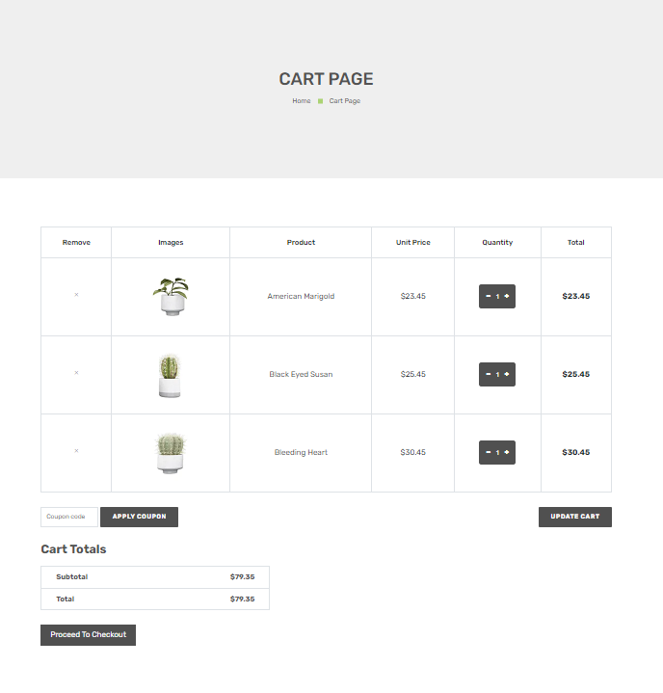

**Checkout**

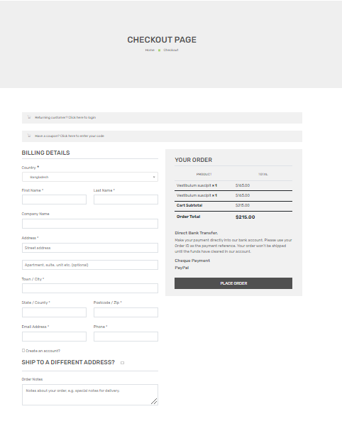

**Contact us**

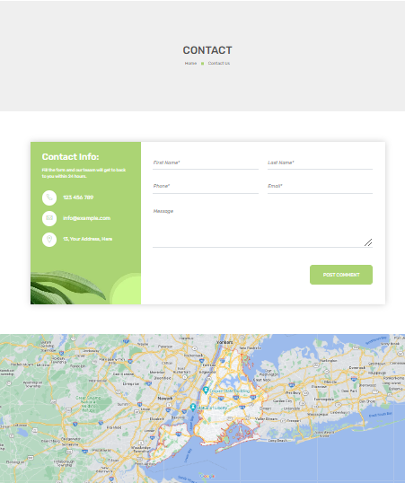

### 2.4 Project task list

|  |  |  |  |  |
| --- | --- | --- | --- | --- |
| **No** | **Tasks** | **Name** | **StartDate** | **End Date** |
| **1** | Home | To Anh Tu | 9/08/2023 | 12/08/2023 |
| **2** | Categories | Nguyen Quoc Bao An | 9/08/2023 | 12/08/2023 |
| **3** | Shopping  cart | Le Van Hung | 9/08/2023 | 12/08/2023 |
| **4** | Checkout | Nguyen Ngoc Ky Phong | 9/08/2023 | 12/08/2023 |
| **5** | Contact us | To Anh Tu | 9/08/2023 | 12/08/2023 |
| **6** | Report | Nguyen Trung Nghia | 9/08/2023 | 12/08/2023 |
| **7** | Report | Nguyen Van Quoc | 9/08/2023 | 12/08/2023 |

## **CHAPTER 3: SOFTWARE TESTING AND EVALUATION**

### 3.1 Software Testing

The online plant nursery website is done and tested at the programming level. The next testing process is the installation and testing process at the company.

### 3.2 Evaluation of software

The Website has met some basic management functions for e-commerce such as: Giving information about products, helping users to buy goods at the website quickly and easily. , performing a product search, an update, adding new products, give the user order details. However, the website has not been fully completed in terms of interface, user experience and performance. Later on, the product will be further improved and new technologies will be applied to improve performance.

# **PART 3: CONCLUSIONS AND DEVELOPMENT**

## **1. Conclusions**

The topic "Plant Nursery Website" also comes from today's reality to create an initial foundation to be able to further support those who want to design a website for a company or a personal website.

Although there have been many efforts, learning the knowledge learned, combined with looking up specialized documents, due to limited time, ability and experience, certain shortcomings should inevitably be addressed. Talent completed at the following level:

- Learn website programming and design and development SRS

- Applying to build an experimental application for a website selling plant nurseries.

## **2. Development**

- Learn more about SRS to be able to meet more needs of users, develop and optimize the system,

- Learn some more languages, and application software to enhance the beautiful, user-friendly graphical interface...

- Build a larger-scale Web site with many applications, functions...

# **PART 4: REFERENCES**

We consulted information on the websites:

[1] <https://jquery.com/>

[2] <http://www.w3schools.com/>

[3] <https://fontawesome.com/>

[4] https://icons.getbootstrap.com/