Jason Passalacqua

CART - 253

Final project concept notes

FPS / Target practice game

SYNOPSIS

3D Shooter

I want to create a game where players could sharpen their accuracy for shooter games and have fun doing so. Aesthetically the game will be minimal in order not to strain the eye too much and to have the player really focus on the importance of self-improvement. The game will be in a 3D environment and you will be able to walk / jump like any other shooter. Targets will be represented in an abstract way and will give different amount of points depending on the size. The game will incorporate a practice range where players can get a feel of the game and just mess about. The actual game will be point based with a 5-min timer. The objective is to get the most amount of points possible.

2D Shooter

If making a 3D environment is out of my skill level that I will go forth with a similar concept in a 2D environment. This direction would incorporate the same themes of quick reflects, aim, hand eye coordination, and good peripheral vision. This will also be an “endless” style of gameplay where the player just tries to get as many points as possible in order to accumulate the most amount of point in a span of 5 min or without dying.

GENERAL IDEAS

(for both 3D and 2D shooters)

* Dynamic background maps
* Engaging music
* Point system
* Different modes?
* Practice range to improve aiming skill
* Actual game where you accumulate the most amount of points possible in 5min
* Improve hand / eye coordination
* Shooting targets that move / some stationary
* Move with WASD
* ADS option?
* Minimalist aesthetic style

STRUCTURE IDEAS

3D shooter

* Use of QueasyCam (in library)
* In P3D
* Use of arrays for targets
* Look at AI life exercise for random movement
* Photoshop to create / edit images
* Use of timer
* Scoreboard
* A saved leaderboard to compare scores with friends
* Have adjustments for mouse sensitivity

2D shooter

* Looking at pong midterm for structure
* AI life exercise for random movement
* Photoshop to create / edit images
* Making different backgrounds as time goes on
* Use of timer
* Scoreboard
* Saved leaderboards
* Use arrays
* Have adjustments for mouse sensitivity

INFLUENCIAL IMAGES

3D Shooter

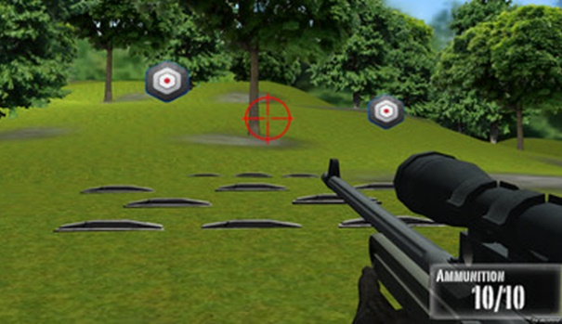

Figure 1 Use of target / crosshair

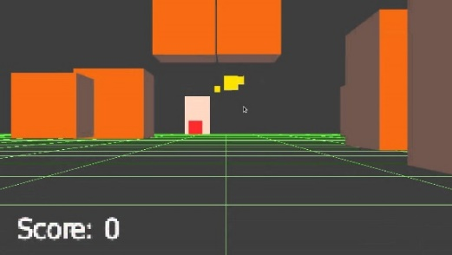

Figure 2 Minimal geometric aesthetics

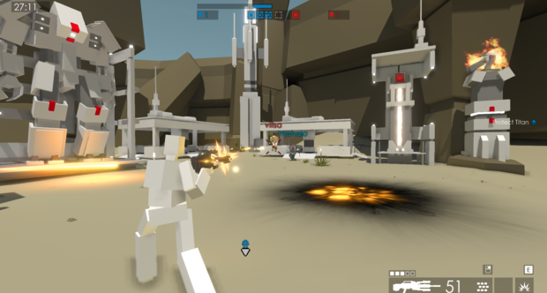

Figure 3 More geometric style

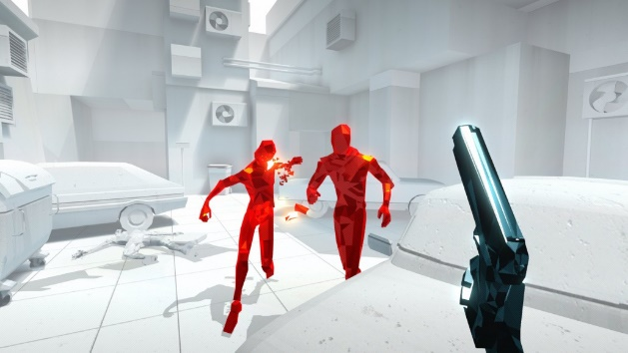

Figure 4 Careful use of colors

2D Shooter

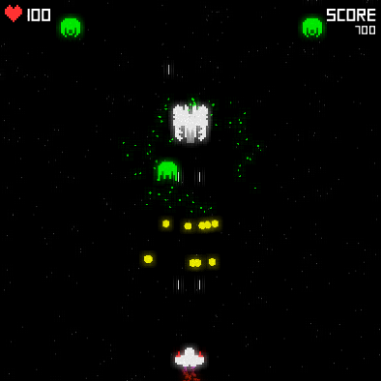

Figure 5 Clean interface with only necessities

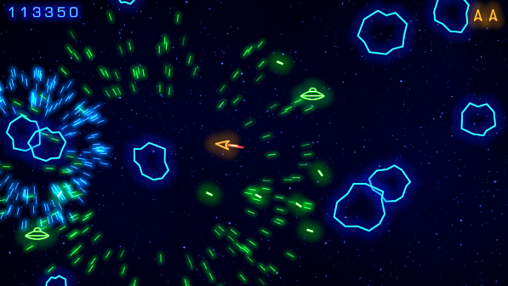

Figure 6 Shooting targets to accumulate points (however in my game targets don't shoot back)