國 立 清 華 大 學
工業工程與工程管理學系

工工專題報告
IEEM Capstone Project Report

衛星任務排程—基於混和整數線性規劃與限制式規劃
Satellite task Scheduling — Based on Mixed Integer Linear Programming and Constraint Programming

學號及姓名：
111034043 蔡坤憲
111034010 羅彥凱
111034017 黃冠捷

指導教授： 林東盈 博士
中 華 民 國 一 一 四 年 十 二 月

摘要
本研究旨在探討單一衛星的任務排程問題。由於衛星記憶體、檔名容量與電力等資源有限，如何在多重限制下有效安排拍攝、下載、刪除、追蹤與姿態調整等任務，成為一項重要挑戰。
研究建立混合整數線性規劃（Mixed Integer Linear Programming, MILP）模型，描述任務相依性、地面站通訊視窗與日蝕運作限制，並最大化可執行任務數量，同時優先排定下載與刪除任務提升排程效率與合理性。另以限制規劃（Constraint Programming, CP）模型結合全域限制與啟發式搜尋，提升大規模問題求解的可擴展性與效率。
結果顯示，MILP 於小規模問題能有效取得最優解，CP 則在大規模問題中能在合理時間內取得高品質解。本研究提出兼顧準確與實務的混合排程架構，為未來衛星任務規劃提供參考。

Abstract
This study addresses the task scheduling problem for a single satellite in orbit. Due to the limited onboard resources such as memory, filename capacity, and power, efficiently scheduling multiple tasks—including Shoot, Download, Remove, Track, and Maneuver—under various operational constraints becomes a critical challenge. A Mixed Integer Linear Programming (MILP) model is formulated to rigorously capture task precedence, ground station contact windows, and eclipse duty cycle limitations, with the objective of maximizing the number of executed tasks while prioritizing early scheduling of Download and Remove tasks. In addition, a Constraint Programming (CP) model is developed, leveraging global constraints such as no_overlap and cumulative, along with search heuristics to enhance scalability and solution quality. Computational results show that MILP performs effectively on small-scale problems to achieve optimality, while CP demonstrates greater flexibility in large-scale scenarios, providing high-quality solutions within reasonable time. This research contributes to a hybrid scheduling framework that balances accuracy and practicality, offering valuable insights for future satellite task planning.

Table of Contents
摘要 i
Abstract ii
Table of Contents iii
Chapter 1 Introduction and Motivation 1
Chapter 2 Problem Definition, Assumptions and Operation Constraints 2
2.1 Problem Description 2
2.2 Task Description 2
2.3 Assumptions 2
2.4 Operation Constraints 2
2.5 Format of The Input Data 2
Chapter 3 Mixed Integer Linear Programming (MILP) 3
3.1 Sets and Notations 3
3.2 Parameters 3
3.3 Decision Variables 3
3.4 Objective Function 3
3.5 Constraints 3
Chapter 4 Constraint Programming (CP) 4
4.1 Constraint Propagation 4
4.2 Global Constraint Filtering 4
4.3 Search and Branching Strategies 4
4.4 DOcplex CP Formulation 4
Chapter 5 Experimental Design and Results 5
5.1 Experimental Setup 5
5.2 Comparison of MILP and CP Performance 5
5.3 Discussion 5
Chapter 6 Conclusions 6
References 7

Introduction and Motivation
Remote sensing satellites play a critical role in Earth observation by capturing images and performing various tasks such as tracking, shooting, downloading, and removing data. These tasks are interdependent and compete for limited onboard resources such as memory and filename capacity. In addition, operational constraints such as ground station contact windows and duty cycle limitations further complicate the scheduling problem.
The scheduling problem for satellites is therefore highly challenging: it requires maximizing the number of executed tasks while respecting resource limits and ensuring the correct execution sequence among dependent tasks. In particular, Download and Remove tasks are especially important since they directly determine whether new Shoot tasks can be executed, due to memory and file storage constraints.
Traditional approaches using Mixed Integer Linear Programming (MILP) provide strong mathematical formulations but may encounter scalability issues for large instances. On the other hand, Constraint Programming (CP) leverages global constraints and advanced propagation techniques, which are often more efficient for scheduling-type problems.
This study is motivated by the need to evaluate and compare MILP and CP approaches for the satellite task scheduling problem, analyzing their effectiveness in terms of feasibility, solution quality, and computational performance. The insights aim to provide guidance for developing more efficient scheduling methods for satellite operations under realistic constraints.

Problem Definition, Assumptions and Operation Constraints

Problem Description
The remote sensing satellite is used to capture Earth images and carries multiple types of tasks. Each task requires different resources and many tasks are highly interdependent. The scheduling problem is to maximize the total number of tasks that can be executed under limited resources, while considering task priorities and ensuring that all operational constraints are satisfied .

Task Description
Table 2.1 Satellite task type and task function
Task Type | Task Function
Track | Monitor satellite status.
Shoot | Capture images.  The number of images captured per Shoot varies; there will be several Download tasks based on how many images were taken.
Download | Download images.
Remove | Remove images.  One Shoot corresponds to one Remove.
T maneuver | Rotate the satellite to the desired shooting angle.
P maneuver | Rotate the satellite to the desired download angle.
H maneuver | Rotate the satellite to point towards the sun.  Some with specified Contact ID.

Assumptions
In this problem, only a single satellite is considered for scheduling.
- Except for Download and Remove tasks, all other tasks have fixed execution times. Scheduling only determines whether these tasks can be executed. Their times will not change during scheduling.
- For Download and Remove tasks, both start and end times must be decided.
- The satellite’s contact times with ground stations are predetermined and remain fixed during scheduling. Ground stations are divided into two types: R-type and J-type, specified according to the task requirements.
- The satellite has a memory capacity of 1,280,000 Mb.
- Captured images must be assigned filenames, with a maximum of 116 filenames available.
- To prevent power shortage during operation, Shoot and Download tasks have duration limits per orbit cycle. An orbit is defined as the interval between entering one penumbra (partial eclipse) and entering the next.
- Maximum Shoot time per orbit: 8 minutes (480 seconds).
- Maximum Download time per orbit: 10 minutes (600 seconds) .

Operation Constraints
This section details the various operational constraints governing the scheduling of different satellite tasks. It outlines rules such as non-overlapping execution periods, dependencies between tasks (e.g., Shoot and Remove), specific requirements for ground station contact, and the sequential execution of maneuvers relative to Download tasks. The section is organized by task type, clearly listing the restrictions applicable to each.

Operation constraints for Track tasks:
- The execution period of the Track must completely fall within the J-type ground station contact time (rise to fade).
- The execution periods of Tracks must not overlap with each other.

Operation constraints for Shoot tasks:
- Shoot execution periods cannot overlap with each other.
- Shoot execution periods cannot overlap with T maneuver.
- Shoot execution periods cannot overlap with H maneuver.
- Shoot execution periods cannot overlap with P maneuver.
- Shoot execution periods cannot overlap with Download.
- Shoot execution periods cannot overlap with Remove.
- The total execution time of all Shoots in each track cannot exceed 8 minutes.
- Whether a Shoot can be executed is limited by memory capacity and the number of filenames.

Operation constraints for Download tasks:
- Download operations cannot overlap with each other.
- Download cannot overlap with T maneuver execution.
- Download cannot overlap with H maneuver execution.
- Download cannot overlap with P maneuver execution.
- Download cannot overlap with Shoot execution.
- Download cannot overlap with Remove execution.
- The total execution time of all Download operations on each track cannot exceed 10 minutes.
- The execution period of Download must be entirely within the R-type ground station contact time (R-type rise to R-type fade).
- Download can only be executed if the Shoot in the same group as the Download is executed.
- The P maneuver and H maneuver corresponding to the ground station selected for Download must be executed. And the execution period of Download must be after the end time of the P maneuver and before the start time of the H maneuver.

Operation constraints for Remove tasks:
- Remove must be executed only after the Shoot and executed Download operations within the same group are completed.
- Remove must be executed at least 6 seconds after the latest contact end time (fade) of the ground station selected by each executed Download operation within the same group.
- Remove cannot overlap with the execution period of Shoot.
- Remove cannot overlap with the execution period of Download.
- Remove operations within the same group cannot overlap with each other.
- If a Shoot operation in the same group as Remove is executed, then Remove must also be executed.
- Operation constraints for T maneuver tasks:
- T maneuvers cannot overlap with each other in execution time.
- T maneuvers cannot overlap with H maneuvers in execution time.
- T maneuvers cannot overlap with P maneuvers in execution time.
- T maneuvers cannot overlap with Shoot in execution time.
- T maneuvers cannot overlap with Download in execution time.
- Operation constraints for P maneuver tasks:
- P maneuver execution periods cannot overlap with each other.
- P maneuver execution periods cannot overlap with T maneuver execution periods.
- P maneuver execution periods cannot overlap with H maneuver execution periods.
- P maneuver execution periods cannot overlap with Shoot execution periods.
- P maneuver execution periods cannot overlap with Download execution periods.
- If a H maneuver corresponding to the same Contact ID is executed, an P maneuver must also be executed.
- Operation constraints for H maneuver tasks:
- H maneuver execution periods cannot overlap with each other.
- H maneuver execution periods cannot overlap with T maneuver execution periods.
- H maneuver execution periods cannot overlap with P maneuver execution periods.
- H maneuver execution periods cannot overlap with Shoot execution periods.
- H maneuver execution periods cannot overlap with Download execution periods.
- If a P maneuver corresponding to the same Contact ID is executed, an H maneuver must also be executed.

Format of The Input Data
The input data for the satellite task scheduling problem is organized into four distinct table types: activity, contact, eclipse, and image. This section describes the format and attributes of each of these tables.

The activity table contains the following attributes for each task:
- duration: The execution time of the task.
- starttime: For Download or Remove tasks, this is the earliest time the task can start. For all other task types, it is the exact start time.
- endtime: For Download or Remove tasks, this is the latest time the task can start. For all other task types, it is the exact end time.
- scheduled: Indicates whether the task can be executed after scheduling. Initially set to 0. If it can be executed after scheduling, it changes to 1; otherwise, it remains 0.
- group: Represents the task group. Only camera-related tasks (Shoot, Download, and Remove) are grouped. Tasks with the same number belong to the same group.
- type: Represents the task type.
- info: Only P maneuver and H maneuver with specified Contact ID have a value, representing their corresponding Contact ID.
- priority: Represents the priority of the task. A smaller value indicates lower priority.
- memory: Represents the amount of satellite memory required by the task. Only Shoot tasks have a value; all others are 0.

The contact table contains the following attributes for each ground station:
- id: Contact number.
- rise: The start time of satellite-ground station contact.
- fade: The end time of satellite-ground station contact.
- R-type rise: For R-type ground stations, this value represents the time the satellite enters the downloadable area of that ground station. For J-type, it's just garbled code and can be ignored.
- R-type fade: For R-type ground stations, this value represents the time the satellite leaves the downloadable area of that ground station. For J-type, it's just garbled code and can be ignored.
- type: Ground station type.

The eclipse table contains the following attributes for each eclipse:
- id: The identification number of the eclipse.
- type: Sun represents a solar eclipse; Moon represents a lunar eclipse. This study only uses Sun.
- penumbraentrancetime: The time the satellite enters the penumbral eclipse.
- penumbraexittime: The time the satellite exits the penumbral eclipse.

The image table contains only two attributes:
- file: The total number of file names available for this satellite.
- memory: The Amount of usable memory (in MB) for this satellite.

Mixed Integer Linear Programming (MILP)
In this section, we develop a mathematical model based on Mixed Integer Linear Programming (MILP) for task scheduling for a single satellite on an orbit. For the convenience of modeling, we assume that the impacts of these real-world factors are ignored. The task scheduling model aims to maximize the number of executed tasks and try to schedule Download and Remove tasks as early as possible, while satisfying the constraints related to satellite operations, including avoiding temporal overlap between two consecutive tasks, file capacity, and memory capacity.

Sets and Notations
The notations for the sets are summarized in Table 3.1. Let $A=\left\{1,2,…,n\right\}$ denote the set of all tasks, where nis the total number of tasks. Tasks are classified into subsets by category; for example, N represents the set of Track tasks. Two types of ground stations are considered: J-type and R-type. Some tasks must be scheduled within specific time windows, including resource time windows defined by the start of a Shoot task and duty cycle time windows defined by the start of an eclipse.
Table 3.1 Notations for Sets in the Scheduling Model
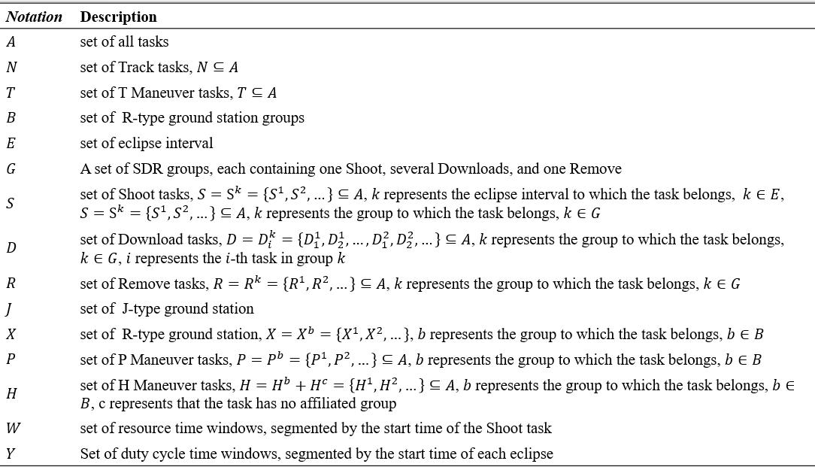

Parameters
The used notations for parameters are summarized in Table 3.2. These include each task's start time $t_{i}$, end time $e_{i}$, and duration $d_{i}$. The model also defines the satellite's contact time with ground stations [$r_{i}$ , $f_{i}$​], as well as resource and orbit-related time windows [$ƞ_{i}$, $ξ_{i}$​] and [$π_{i}$, $τ_{i}$​]. To manage the satellite's limited resources, the model incorporates parameters for memory capacity and filename capacity . The memory and filename requirements for each task are represented by $ω_{i}$ and $θ_{i}$​, respectively, while $δ_{i}$​ and $λ_{i}$ represent the amounts of each resource released. with a memory capacity $μ$ and a filename capacity $ε$.
The maximum value M is used to linearize our logical constraints. In our model, we define the value of M as the latest possible start time for any task plus 24 hours. This choice guarantees that M is larger than the maximum time difference between any two tasks' start and end times, thus preventing the constraints from being over-satisfied due to an arbitrarily large number.
Table 3.2 Notations for Parameters in the Scheduling Model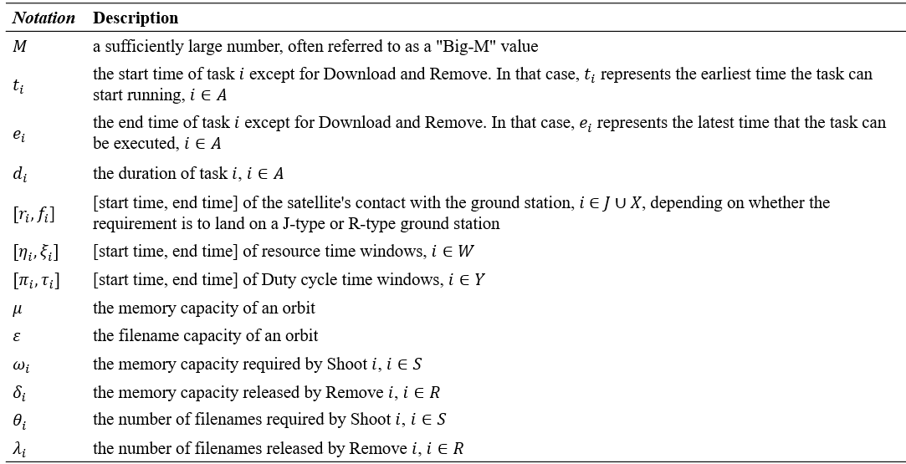

Decision Variables
To accomplish the model, we introduce several decision variables. First, the binary variable $x_{i}$, for $i ∈ A$, is defined to indicate whether a task is scheduled, where it is 1 if the task is scheduled and 0 otherwise. For tasks such as Download and Remove, we define the continuous variable $σ_{i}$($σ_{i}≥0$) to represent the actual start time, as these are not predetermined. To avoid temporal overlaps between two tasks, we define $a_{ij}$, for $i ∈ A^{'}, j ∈ A^{″}$, and $i ≠ j$, as a binary variable, where it is 1 if the start time of task i is later than the start time of task j, and 0 otherwise. Other binary variables are used to manage specific aspects of the model and can be found in Table 3.3.
Table 3.3 Notations for Decision variables in the Scheduling Model
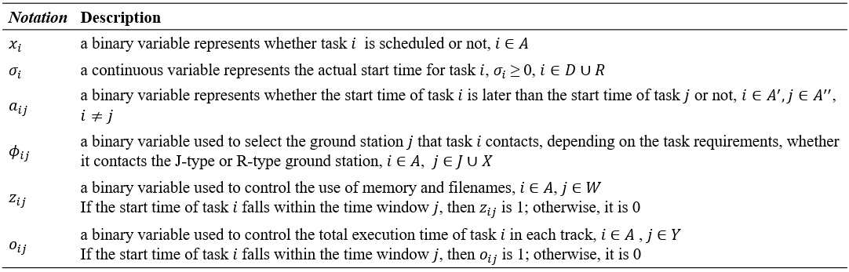

Objective Function
As we mentioned earlier, the objective function of this model is to maximize the total number of scheduled tasks while also scheduling Download and Remove tasks as early as possible. Thus, the Objective Function of this integer programming model is constructed as:
$$maximize\left( W_{task}·\sum_{i∈A}{x_{i}}-α_{late}·\sum_{j∈D∪R}{{\frac{σ_{i}}{M}x}_{i}} \right)$$
The primary goal is encapsulated by the first term , where a high weighting factor $W_{task}$ applied to the sum of all task binary variables, ensuring the model prioritizes the successful execution of the largest possible number of tasks. This is counterbalanced by a penalty term, where late​imposes a cost for delays caused by scheduled Download and Remove tasks, penalizing their Normalized Start Time (the task's start time divided by the total task horizon M).

Constraints
To clearly articulate the satellite's operational requirements, this section organizes the task constraints into the following four categories: Non-overlapping task execution time, Interdependencies with R-type Ground Stations and tasks, Duty Cycle Constraints for Shoot and Download tasks, and Memory and Filename Constraints.

Non-overlapping task execution time
This set of constraints is a fundamental component of the model that ensures the satellite can only perform one task at a time. It is a logical condition that must hold for any two tasks, i and j, that are scheduled. The constraint is expressed by using maximum value M to linearize the logical relationship. The core idea is to force a temporal order between two tasks that are scheduled. For any two tasks i and j, one must end before the other begins.
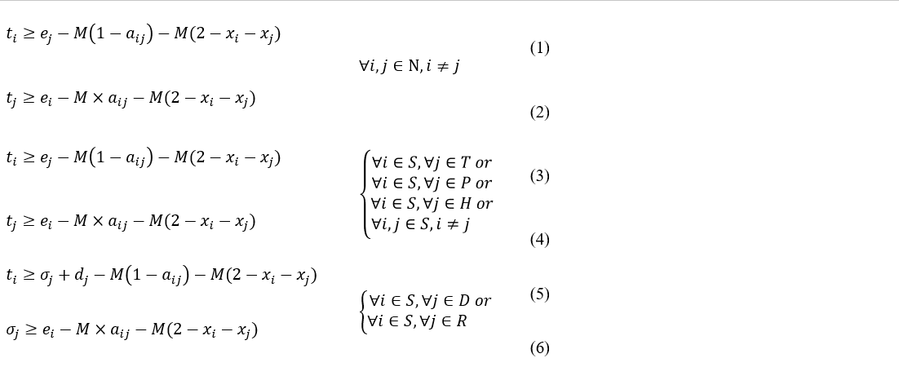
Take constraints(1)-(2) for explanation, Here’s how it works:
- I f both tasks are scheduled ($x_{i}=1$ and $x_{j}=1$):
The term $M\left({2-x}_{i}{-x}_{j}\right)$ is 0, and the inequalities are simplified to: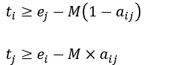
The binary variable aᵢⱼ ​then dictates the order:
  - If $a_{ij}=1$, it means task i starts after task j. The second inequality becomes $t_{j}≥e_{i}-M$​, which is non-binding (always true since M is a large number), and the first inequality becomes $t_{j}≥e_{i}$ ​, which enforces that task i can only start after task j has finished.
  - If $a_{ij}=0$, it means task j starts after task i. The first inequality becomes $t_{i}≥e_{j}-M$, which is non-binding, and the second becomes $t_{j}≥e_{i}$, which enforces that task j can only start after task i has finished.
Since either $a_{ij}$ or $a_{ji}$ must be 1 (as they represent the order), one of the two pairs of constraints will be active, successfully preventing any overlap between the scheduled tasks
- If one or both tasks are not scheduled ($x_{i}=0$ or $x_{j}=0$):
The term $M\left({2-x}_{i}{-x}_{j}\right)$ will be a positive value, making the right-hand side of both inequality a large negative number. This effectively makes the constraints non-binding, meaning they will not restrict the scheduling of other tasks. This ensures the constraints only apply to tasks that are actually selected for execution.
While the General Non-Overlap Constraints handles tasks with fixed timings, the non-overlap constraints must be slightly modified to model these two other scenarios.
- Scenario 1: One Task with a Flexible Start Time and One with a Fixed Start Time
If task j is of the Download or Remove type, its start time is a flexible variable $σ_{j}$ and its end time​ becomes $σ_{i}+d_{j}$. Task i, however, has a fixed start time $t_{i}$ and end time $e_{i}$. The non-overlap constraints would be written as:
These two constraints operate in the same way as the general ones, using the binary variable $a_{ij}$ to determine the execution order of the two tasks. If task i starts after task j ($a_{ij}=1$), the first inequality ensures that task i begins only after task j has finished. If task j starts after task i ($a_{ij}=0$), the second inequality ensures that task j begins only after task i has finished.
- Scenario 2: Both tasks Have Flexible Start Times
If both tasks i and j have flexible start times (e.g., both are Download or Remove tasks), their start times will be represented by the continuous variables i​ and j​. The non-overlap constraints would be: 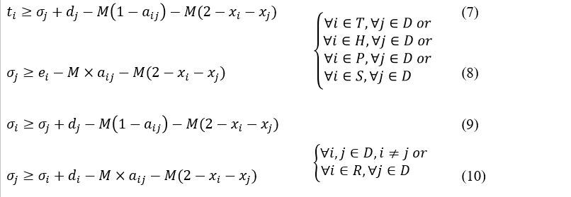
Again, the value of $a_{ij}$ dictates which task is executed first. If $a_{ij}=1$, the first inequality will be active, forcing task i to start after task j has ended. If $a_{ij}=0$, the second inequality will be active, forcing task j to start after task i has ended. This ensures that even when the start times of both tasks are variables, their execution will not overlap.
The following are all non-overlapping constraints in the model, sorted by task type:
- Track
Constraints(1)-(2) represent Track tasks which cannot overlap with each other.
- Shoot
Constraints(3)-(5) represent the following pairs of tasks that must not overlap: [Shoot, T maneuver], [Shoot, P maneuver], [Shoot, H maneuver], [Shoot, Shoot].
Constraints(5)-(6) represent the following pairs of tasks that must not overlap: [Shoot, Download], [Shoot, Remove].
- Download
Constraints(7)-(8) represent the following pairs of tasks that must not overlap: [Download, T maneuver], [Download, P maneuver], [Download, H maneuver], [Download, Shoot].
Constraints(9)-(10) represent the following pairs of tasks that must not overlap: [Download, Download], [Download, Remove].
- Remove
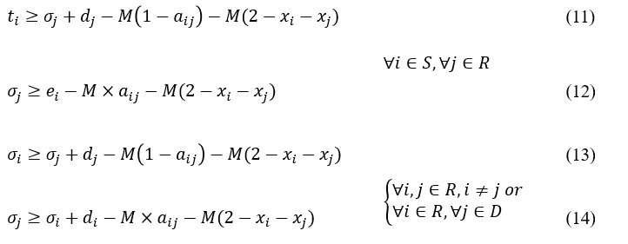
Constraints(11)-(12) represent the following pairs of tasks that must not overlap: [ Shoot, Remove].
Constraints(13)-(14) represent the following pairs of tasks that must not overlap: [Remove, Remove], [Download, Remove].
- T maneuver
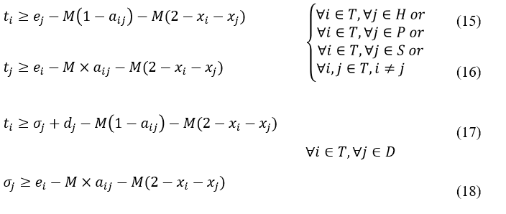
Constraints(15)-(16) represent the following pairs of tasks that must not overlap: [T maneuver, H maneuver], [T maneuver, P maneuver], [T maneuver, Shoot], [T maneuver, T maneuver].
Constraints(17)-(18) represent the following pairs of tasks that must not overlap: [T maneuver, Download].
- P maneuver
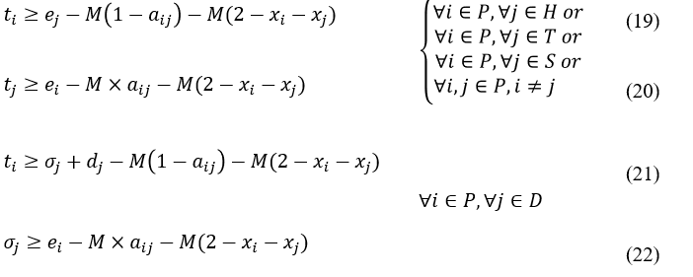
Constraints(19)-(20) represent the following pairs of tasks that must not overlap: [P maneuver, H maneuver], [P maneuver, T maneuver], [P maneuver, Shoot], [P maneuver, P maneuver].
Constraints(21)-(22) represent the following pairs of tasks that must not overlap: [P maneuver, Download].
- H maneuver
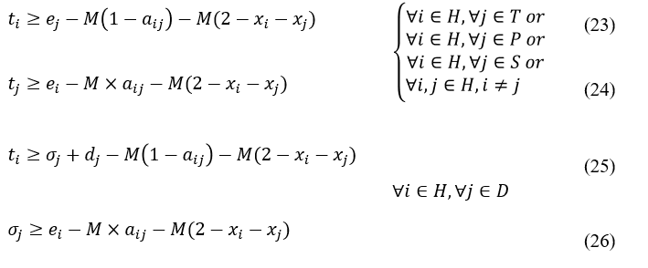
Constraints(23)-(24) represent the following pairs of tasks that must not overlap: [H maneuver, T maneuver], [H maneuver, P maneuver], [H maneuver, Shoot], [H maneuver, H maneuver].
Constraints(25)-(26) represent the following pairs of tasks that must not overlap: [H maneuver, Download].

Interdependencies with R-type Ground Stations and tasks
This set of constraints handles the complex dependencies between Shoot, Download, Remove tasks, R-type ground station contacts, and P/H maneuver tasks.
The following are all Interdependencies constraints sorted by task type:
- Shoot
Constraint(27) guarantees that if a Shoot task is executed, the corresponding Remove task in its Group must also be executed.
- Download
  - R-type ground station contact window
Each Download task must be executed entirely within the contact window of an R-type ground station.
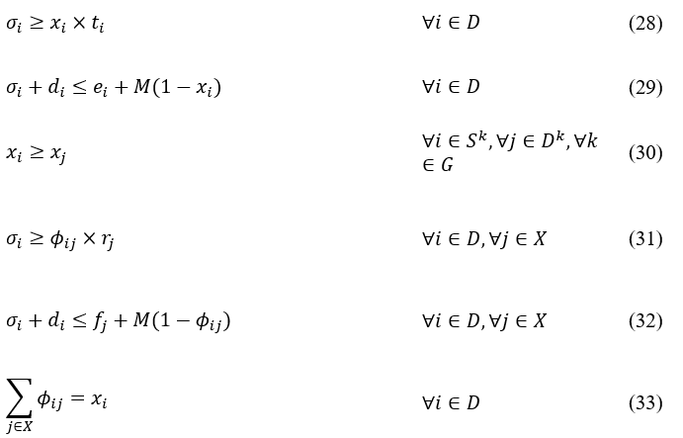
Constraint(28) guarantees the actual start time $σ_{j}$ for a scheduled Download task ($x_{i}=1$​) must be no earlier than its earliest possible start time $t_{j}$. If the task is not scheduled ($x_{i}=0$​), the constraint becomes $σ_{j}≥0$​, which is trivially satisfied.
Constraint(29) guarantees a scheduled Download task's end time $σ_{i}+d_{i}$ must be no later than its latest possible execution time $e_{i}$. If the task is not scheduled ($x_{i}=0$)​, the M makes the constraint non-binding, allowing flexibility for unscheduled tasks.
Constraint(30) guarantees a Download task i can only be executed if its corresponding Shoot task j in the same SDR group k is also executed. Since $x_{i}$​ and $x_{j}$​ are binary, if $x_{j}=1$, then $x_{i}$ must also be 1.
  - Operation is completed within one contact window
The following constraints ensure the entire download operation is completed within one contact window:
Constraint(31) guarantees the start time $σ_{i}$ for a Download task​ must be no earlier than the rise time $r_{j}$ of the R-type ground station contact j it utilizes. If the contact is selected ($Φ_{ij}=1$), $σ_{i}$​ must respect the ground station's rise time; otherwise, it is non-binding.
Constraint(32) guarantees the end time $σ_{i}+d_{i}$​ for a Download task must be earlier than or equal to the fade time $f_{i}$ of the R-type ground station contact j it utilizes. If the contact is selected ($Φ_{ij}=1$), $σ_{i}+d_{i}$​ must respect the ground station's fade time; otherwise, it is non-binding.
Constraint(33) guarantees a scheduled Download task ($x_{i}=1$) must be assigned to exactly one R-type ground station ($\sum_{i∈X}{Φ_{ij}=1} )$. If the task is not scheduled ($x_{i}=1$), it must not be assigned to any contact ($\sum_{i∈X}{Φ_{ij}=0} )$.
  - Operation is completed within correspond P/H maneuver
If a Download task is scheduled, its corresponding P maneuver and H maneuver must also be scheduled. The start time of the Download task must be later than the end time of the P maneuver, and its end time must be earlier than the start time of the H maneuver; otherwise, it is non-binding.
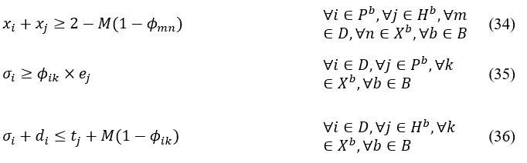
Constraint(34) guarantees if a Download task m is assigned to use a specific R-type contact n, then the corresponding P Maneuver i and H Maneuver j tasks must also be scheduled (i.e., $x_{i}=1$ ​and $x_{j}=1$). If the contact is selected ($Φ_{mn}=1$​), the constraint is simplified to $x_{i}+x_{j}≥2$, forcing both maneuvers to be executed.
Constraint(35) guarantees a Download task i can only begin after its preceding P Maneuver task j has finished. If the Download task is assigned to a contact k, $Φ_{ik}=1$, which strictly enforces that the download start time i must be greater than or equal to the P Maneuver end time $e_{j}$; otherwise, it is non-binding.
Constraint(36) guarantees a Download task i must be completed before its succeeding H Maneuver task j begins. If the Download task is assigned to a contact k, $Φ_{ik}=1$, which strictly enforces that the download end time $σ_{i}+d_{i}$ must be less than or equal to the H Maneuver start time $t_{j}$; otherwise, it is non-binding.
- Remove
  - Executed after all executions of its corresponding tasks
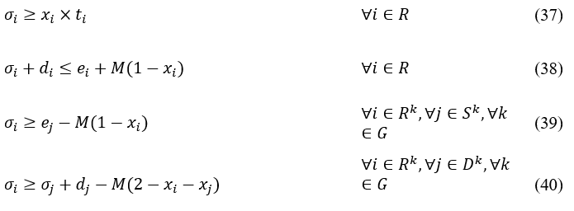
Constraint(37) guarantees the actual start time $σ_{i}$ for a scheduled Remove task ($x_{i}=1$) must be no earlier than its earliest possible start time ti​. If the task is not scheduled ($x_{i}=0$​), the constraint becomes $σ_{i}≥0$​, which is trivially satisfied.
Constraint(38) guarantees a scheduled Remove task's end time $σ_{i}+d_{i}$ must be no later than its latest possible execution time $e_{i}$. If the task is not scheduled ($x_{i}=0$)​, the M makes the constraint non-binding, allowing flexibility for unscheduled tasks.
Constraint(39) guarantees a Remove task i can only start after its corresponding Shoot task j has finished. If the Remove task is scheduled ($x_{i}=1$), the constraint simplifies to $σ_{i}≥e_{j}$​, forcing the actual start time $σ_{i}$ to be greater than or equal to the Shoot task's end time $e_{i}$; otherwise, it is non-binding. This Constraint combined with Constraint(27) ensures that both Shoot and Remove in the same group must be executed together or not, and Remove must wait for Shoot to finish running before starting.
Constraint(40) guarantees a Remove task i can only start after any scheduled Download task j in the same group k is finished. If the Remove task is scheduled ($x_{i}=1$), the constraint simplifies to $σ_{i}≥e_{j}$​, forcing the actual start time $σ_{i}$ to be greater than or equal to the Shoot task's end time $e_{j}$. If both the Download task and the Remove task are scheduled (i.e., $x_{i}=1$​ and $x_{j}=1$), the M term becomes 0. This simplifies the constraint to $σ_{i}≥{σ_{j}+d}_{j}$ , forcing the Remove task to start after that particular Download task has ended; otherwise, it is non-binding.
  - Executed after 6 second after latest contact end time
A Remove must be performed at least 6 seconds after the latest contact end time (fade) of each ground station selected by the download in the same group.
Constraint(41) guarantees a Remove task i must start at least 6 seconds after the fade time $f_{k}$ of the R-type ground station contact k selected by any Download task j in the same group g. If a specific Download task j is assigned to ground station contact m ($Φ_{jk}=1$​), the constraint simplifies to $σ_{i}≥f_{k}+6$. This mandates a minimum 6-second buffer between the contact's fade time and the start of the Remove task. Since this constraint must hold for all selected contacts within the group, the Remove task is effectively forced to wait for the latest contact to fade, plus the 6-second buffer.
- P maneuver and H maneuver
Constraint(42) guarantees if a P maneuver task with a certain contact ID is executed, its corresponding H maneuver task must also be executed, and vice-versa.

Duty Cycle Constraints for Shoot and Download tasks
This set of constraints limit the total execution time for Shoot and Download tasks within each Duty cycle to prevent power depletion. An "Duty cycle" is defined as the time from entering one penumbra (partial eclipse) to entering the next.
- Shoot
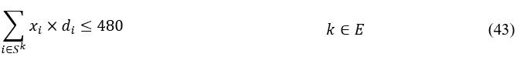
Constraint(43) limits the total execution time of Shoot tasks within each Duty cycle to no more than 8 minutes (480 seconds).
- Download
  - Entire download within one Duty cycle
The following constraints ensure the entire download operation is completed within one Duty cycle:
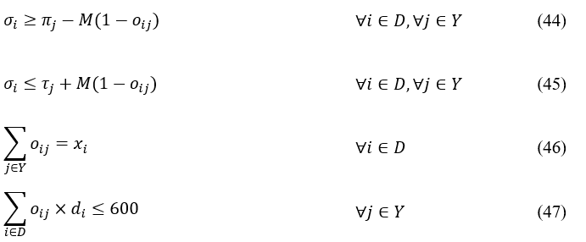
Constraint(44) guarantees the start time $σ_{i}$​ for a Download task​ must be no earlier than the start time j of the Duty cycle j it is within. If the Duty cycle is selected ($o_{ij}=1$), $σ_{i}$​ must respect the Duty cycle's start time; otherwise, it is non-binding.
Constraint(45) guarantees the end time $σ_{i}+d_{i}$​ for a Download task must be earlier than or equal to the end time $τ_{i}$ of the Duty cycle j it is within. If the Duty cycle is selected ($o_{ij}=1$), $σ_{i}+d_{i}$​ must respect the ground station's end time; otherwise, it is non-binding.
Constraint(46) guarantees a scheduled Download task ($x_{i}=1$) must be in exactly one Duty cycle ($\sum_{j∈Y}{o_{ij}=1} )$. If the task is not scheduled ($x_{i}=0$), it must not be assigned to any contact ($\sum_{j∈Y}{o_{ij}=0} )$.
  - Limitation of the total Download execution time
Constraint(47) limits the total execution time of Download tasks within each Duty cycle to no more than 10 minutes (600 seconds).

Memory and Filename Constraints
This set of constraints manages the satellite's limited memory and filename resources. Because resource time windows are segmented by the start time of the Shoot tasks, there is no need to determine which resource time window a Shoot task is within. However, there is still a need to determine which resource time window a Remove task is within.
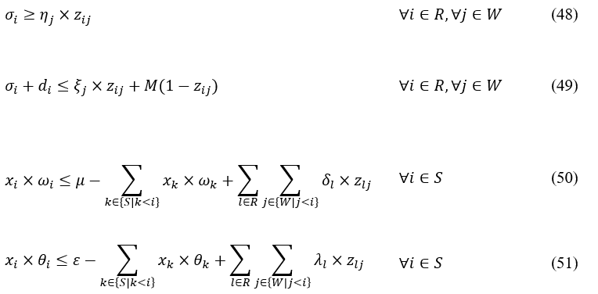
Constraint(48) guarantees the start time $σ_{i}$ for a Download task​ must be no earlier than the start time j of the resource time window j it is within. If the resource time window is selected ($z_{ij}=1$), i​ must respect the resource time window's start time; otherwise, it is non-binding.
Constraint(49) guarantees the end time $σ_{i}+d_{i}$ for a Download task must be earlier than or equal to the end time $ξ_{j}$ of the resource time window j it is within. If the resource time window is selected ($z_{ij}=1$), $σ_{i}+d_{i}$​ must respect the resource time window's end time; otherwise, it is non-binding.
Constraint(50) guarantees the remaining memory must be sufficient for a Shoot task i that needs $ω_{i}$ memories to be scheduled. The remaining memory is computed by using the memory capacity of an orbit $μ$ to minus the memory consumed by all previously scheduled Shoot tasks ($k<i$), and then plus the memory released by any Remove tasks l that completed in prior time windows ($j<i$).
Constraint(51) guarantees the remaining filename must be sufficient for a Shoot task i that needs $θ_{i}$ filenames to be scheduled. The remaining filename is computed by using the filename capacity of an orbit $ε$ to minus the filename consumed by all previously scheduled Shoot tasks ($k<i$), and then plus the filename released by any Remove tasks l that completed in prior time windows ($j<i$).

Constraint Programming (CP)

Constraint Propagation
The cornerstone of CP solvers is constraint propagation: each constraint eliminates inconsistent values from variable domains by enforcing local consistency. For example, arc consistency ensures that for every value of a variable there exists a compatible value in all related variables. Advanced forms such as domain consistency and bounds consistency allow even stronger filtering. (Rossi, van Beek & Walsh (2006). Handbook of Constraint Programming. Elsevier.)

Global Constraint Filtering
CP makes extensive use of global constraints — high-level constraints with specialized propagation algorithms. For example:
- “alldifferent” : Uses matching algorithms to ensure all variables take distinct values.
- “cumulative” : Model resource usage and enforce that total demand never exceeds capacity.
- “no_overlap”: Manage scheduling tasks without temporal overlap.
These global propagators are central to CP Optimizer’s strength in scheduling, since they efficiently prune large parts of the search space. (Régin (1994). A filtering algorithm for constraints of difference in CSPs. AAAI.)

Search and Branching Strategies
CP Optimizer incorporates multiple strategies to guide and improve the search process (IBM ILOG CPLEX Optimization Studio CP Optimizer User’s Manual, Version 12 Release 6.0, IBM Corp., 2013):
- Heuristics for Branching:
  - Domain reduction (fail-first principle): choose the variable with the smallest domain.
  - Activity-based search (ABS): prioritize variables frequently involved in propagation conflicts.
  - Impact-based search: evaluate the reduction of the search space after branching.
- Automatic Search Mode:
CP Optimizer provides a robust automatic search. Users no longer need to define branching scripts, as the solver dynamically adapts its strategy to the problem structure.
- Large Neighborhood Search (LNS):
Beyond systematic branching, CP Optimizer integrates LNS. Once a feasible solution is found, part of the solution is relaxed and re-optimized, often improving solution quality.

DOcplex CP Formulation

Sets
  - $T$: set of all tasks, partitioned into:
    - $S$: Shoots
    - $D$: Downloads
    - $R$: Removes
    - $K$: Tracks
    - $M$: Maneuvers (T, P, H)
  - $C^{R}$: set of R-type contacts (used for Downloads)
  - $C^{-R}$: set of non-R contacts (used for Tracks)
  - $G$: groups linking Shoot–Download(s)–Remove
  - $ε$: eclipse intervals

Parameters
  - $p_{i}$: duration of task i
  - [$L_{i}$, $U_{i}$]: time window for Download/Remove i
  - $s_{i}$: fixed start time for Shoot/Track/Maneuver i
  - $H$: time horizon (latest end time across all tasks)
  - For each contact c ∈ $C^{R}$: rise $r_{c}$ , fade $f_{c}$​
  - Eclipse capacity:
    - Downloads per interval ≤ 600 seconds
    - Shoots per interval ≤ 480 seconds
  - Memory capacity = Memory_value
  - File capacity = File_value
  - Objective weights: $W_{task}$ , $α_{late}$

Decision Variables
  - $I_{i}$: optional interval for task i with start $s_{i}$ , end $e_{i}$ , duration $p_{i}$ .
  - $y_{i}∈ \left\{0,1\right\}$ presence of task i .
  - For Download d and contact c : $I_{d,c}$ with presence $z_{d,c}∈ \left\{0,1\right\}$ .
  - For Track k and contact c : $I_{k,c}$ with presence $z_{k,c}$ .
  - For each group g: span interval $V_{g}=\left[s_{S\left(g\right)},e_{R\left(g\right)}\right]$ from Shoot start to Remove end. Used in pulse profiles for memory and file usage.
  - For eclipse interval assignment : $u_{d,e}∈ \left\{0,1\right\}$ , equals 1 if Download d is scheduled in interval e.

Constraints
  - Domain of intervals
    - Shoots/ Maneuvers/ Tracks: $y_{i}=1⇒ s_{i}=ŝ_{i}, e_{i}=s_{i}+p_{i}$
    - Downloads/ Removes: $y_{i}=1⇒ s_{i}∈\left[L_{i}, U_{i}\right], e_{i}=s_{i}+p_{i}$
  - Non-overlapping
    - No overlap among $M∪S∪D$
    - No overlap among all Tracks K
    - No overlap among $D∪R∪S$
  - Download-Contact assignment
    - Alternative:
$$y_{d}=\sum_{c∈C^{R}\left(d\right)}{z_{d,c} , z_{d,c}∈ \left\{0,1\right\}}$$
    - Feasible window:
$$z_{d,c}=1$$
$$⇒ s_{d}=s_{d,c},{ e}_{d}=e_{d,c}, s_{d,c}∈\left[{max⁡(L}_{d}, r_{c}\right), {min⁡(U}_{d},f_{c})-p_{d}]$$
    - Shoot prerequisite:
$$y_{d}≤y_{S\left(g\right)}$$
    - P/ H consistency:
$$z_{d,c}=1$$
$$⇒ y_{P_{c}}=y_{H_{c}}=1,{ e}_{P_{c}}≤s_{d,c}, { e}_{d,c}≤s_{H_{c}}$$
  - Remove
    - Presence coupling with Shoot: $y_{R\left(g\right)}=y_{S\left(g\right)}$
    - Precedence: $s_{R\left(g\right)}=e_{S\left(g\right)}$
    - Buffer after last Download contact fade:
$$z_{d,c}=1⇒ s_{R\left(g\right)}≥f_{c}+6$$
  - Track–Contact assignment
    - If feasible contact exist:
$$y_{k}=1⇒ ∃c∈C^{-R}\left(k\right):s_{k}=ŝ_{k}, \left[s_{k},s_{k}+p_{k}\right]⊆\left[r_{c},f_{c}\right]$$
    - Otherwise: $y_{k}=0$
  - Eclipse
    - Download assignment: $\sum_{e∈ε}{u_{d,e}}=y_{d}$
    - Timing: $u_{d,e}=1⇒s_{d}=start\left(e\right), e_{d}≤end\left(e\right)$
    - Capacity: $\sum_{d}{u_{d,e}×p_{d}}≤600, ∀e∈ε$
    - Shoot bound: $\sum_{s∈S∩e}{y_{s}×p_{s}}≤480, ∀e∈ε$
  - Memory/ File profiles
    - Define span $V_{g}=\left[s_{S\left(g\right)},e_{R\left(g\right)}\right]$
    - Memory: $\sum_{g}{pulse\left(V_{g}, memory\left(g\right)\right)}≤Memory_{value}$
    - File: $\sum_{g}{pulse\left(V_{g}, photos\left(g\right)\right)}≤File_{value}$

Objective
$$maximize\left( W_{task}·\sum_{i∈T}{y_{i}}-α_{late}·\sum_{i∈D∪R}{{\frac{s_{i}}{H}y}_{i}} \right)$$

Experimental Design and Results

Experimental Setup

Parameters setup
For this experiment, both models were set with a $W_{task}$ value of 600.0 and a late value of 100.0 for comparison. These two parameters are used in the objective function.
In both model, the logic of the Objective function is equivalent. We use the one in MILP model to demonstrate, which is :
$maximize\left( W_{task}·\sum_{i∈A}{x_{i}}-α_{late}·\sum_{j∈D∪R}{{\frac{σ_{i}}{M}x}_{i}} \right)$.
The primary goal is encapsulated by the first term , where a high weighting factor $W_{task}$ applied to the sum of all task binary variables, ensuring the model prioritizes the successful execution of the largest possible number of tasks. This is counterbalanced by a penalty term, where late​imposes a cost for delays caused by scheduled Download and Remove tasks, penalizing their Normalized Start Time (the task's start time divided by the total task horizon M). On the other hand, to prevent the solver from becoming stuck in endless computations when dealing with extremely difficult problems, time limits were established for the both models. When the time limit is reached, the CPLEX solver will stop calculations and return the best solution found up to that point.

Experimental Design
In this study, we designed two complementary experiments using six benchmark instances, consisting of two small-scale, two medium-scale, and two large-scale test datasets, with their complexities as Table 5.1:
Table 5.1 Test datasets Complexity
Test datasets | small_1 | small_2 | medium_1 | medium_2 | large_1 | large_2
Complexity  (task number) | 61 | 69 | 104 | 112 | 193 | 266
The first experiment aims to evaluate how efficiently the proposed model can obtain a high-quality and stable solution. For this purpose, each test dataset is solved with a maximum time limit of 600 seconds. We record the time required for the model to reach a stable solution—the formal definition of stable state is provided later—and identify the corresponding stability category achieved. This experiment focuses on the convergence speed and the model’s ability to rapidly produce reliable solutions.
The second experiment focuses on assessing the quality of solutions generated during the optimization process. Instead of allowing the solver to run until a single time limit, multiple predefined time limits are introduced. For each test dataset, the model is terminated at these stopping points, and the resulting solutions are evaluated. Solution quality is measured using two performance indicators: the Scheduled Task Ratio and the Average Normalized Start Time Ratio, both of which are formally defined in subsequent sections. This experiment provides insights into the trade-off between computation time and solution quality, as well as the solver’s intermediate performance behavior.

Comparison of MILP and CP Performance

Model Performance Comparison: Time to Reach Stable State
The comparison between MILP and CP models highlights significant differences in efficiency and solution quality. The experiments were conducted with a maximum runtime of 600 seconds to observe the time required for each model to reach a stable state. The stable condition is defined as follow:
- Stability Condition Definition:
  - Optimal: The global best solution determined by the system.
  - Best Feasible: The best solution found within the 600-second limit.
  - Stable Feasible: A stable solution where no better solution was found in the subsequent 60 seconds.
Based on the solver log files collected from each run, we identify the earliest time at which the solution satisfies any of the predefined stability conditions. This solution is regarded as the stable solution for the corresponding dataset. The results are presented in Table 5.2:
Table 5.2 Result of time to reach stable state experiment
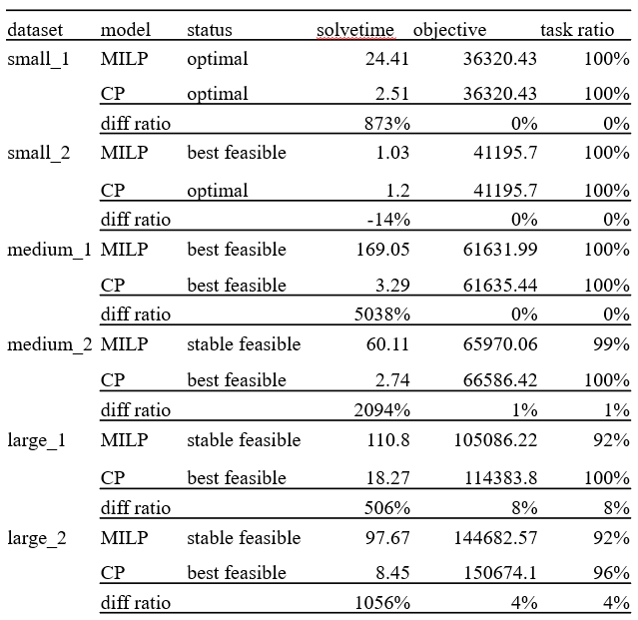
The CP model demonstrates superior computational speed compared to MILP, particularly in the Medium and Large datasets. For instance, in the Medium_1 dataset, the CP model reached a best feasible solution in 3.29 seconds, whereas the MILP model required 169.05 seconds—a time difference ratio of approximately 5038%. Furthermore, regarding solution quality in larger datasets (Large_1 and Large_2), the CP model maintained a higher task completion ratio (100% and 96%) compared to the MILP model, which dropped to 92%. This result indicates that, under increasing problem complexity, the MILP formulation exhibits difficulties in preserving schedule completeness, whereas the CP approach remains robust and computationally efficient.

Impact of Time Limits on Scheduled Task Ratio
The performances of both models were evaluated by assessing the Average Normalized Start Time Ratio, referred to as ANSTR in the following section, for Download and Remove tasks and the overall scheduled task ratio. The "Scheduled Task Ratio" indicates the proportion of tasks that were successfully scheduled within the specified constraints. To evaluate the efficiency of the schedule's temporal placement, particularly how effectively the objective function forces Download and Remove tasks to start as early as possible, we utilize the ANSTR.
$$Average Normalized Start Time Ratio=\frac{\sum_{i∈D∪R}{{(σ}_{i}-t_{i})/}{(e}_{i}-t_{i})}{\sum_{j∈D∪R}{x_{j}}}$$
Where $σ_{i}$​ is the actual start time, $t_{i}$ is the earliest feasible start time, and $e_{i}$ is the latest feasible start time. The ratio ranges from 0 (ideal: task starts immediately at $t_{i}$) to 1 (worst: task starts at $e_{i}$​, consuming all available slack). A low ANSTR indicates that the scheduling model prioritizes starting time, successfully placing the Download and Remove tasks right next to the point at which they were initially feasible to start. In contrast, a high ANSTR indicates that tasks are unnecessarily delayed and the schedule is not "tight" enough.
To evaluate the robustness and efficiency of the models under strict time constraints, experiments were conducted with varying maximum time limits set to 30, 60, 120, 180, 300, and 600 seconds. The primary metric for this comparison is the Scheduled Task Ratio (Tasks/K), where K represents the total number of input tasks.
  - Average Normalized Start Time Ratio:
Table 5.3 Average Normalized Start Time Ratio of both models on the large datasets
Time Limit (s) | dataset | MILP  Ratio | CP  Ratio | CP − MILP | dataset | MILP  Ratio | CP  Ratio | CP − MILP
30 | large_1 | 0.176 | 0.180 | 0.004 | large_2 | 0.422 | 0.036 | -0.386
60 | large_1 | 0.307 | 0.159 | -0.148 | large_2 | 0.424 | 0.033 | -0.391
120 | large_1 | 0.303 | 0.157 | -0.146 | large_2 | 0.079 | 0.033 | -0.046
180 | large_1 | 0.303 | 0.157 | -0.146 | large_2 | 0.077 | 0.033 | -0.044
300 | large_1 | 0.303 | 0.156 | -0.147 | large_2 | 0.077 | 0.033 | -0.044
  - Scheduled Task Ratio:
Table 5.4 summarizes the performance of both models on the large_1 and large_2 datasets across the defined time intervals.
Table 5.4 Schedule task ratio of both models on the large datasets
dataset | Time limit (s) | MILP ratio | CP ratio | Δ ratio (%) (CP-MILP)
large_1 | 30 | 0.751 | 1.000 | +24.870
large_1 | 60 | 0.886 | 1.000 | +11.399
large_1 | 120 | 0.917 | 1.000 | +8.290
large_1 | 180 | 0.927 | 1.000 | +7.254
large_1 | 300 | 0.927 | 1.000 | +7.254
large_1 | 600 | 0.933 | 1.000 | +6.736
large_2 | 30 | 0.361 | 0.959 | +59.774
large_2 | 60 | 0.361 | 0.959 | +59.774
large_2 | 120 | 0.921 | 0.959 | +3.759
large_2 | 180 | 0.951 | 0.959 | +0.752
large_2 | 300 | 0.951 | 0.959 | +0.752
large_2 | 600 | 0.959 | 0.959 | +0.000

The CP model exhibits superior robustness in finding feasible schedules. As indicated by the Scheduled Task Ratio, the CP model achieves a 100% task completion rate for the Large_1 dataset and approximately 96% for Large_2 within just 30 seconds. In contrast, the MILP model struggles with short time limits, scheduling only 75.1% and 36.1% of tasks for Large_1 and Large_2, respectively, at the 30-second mark. Even with an extended runtime of 600 seconds, the MILP model fails to match the CP model's coverage, plateauing at 93.3% for Large_1. This highlights the CP model's ability to quickly identify valid solutions for complex, high-load scenarios.
Regarding the ANSTR, the CP model consistently generates "tighter" schedules by placing Download and Remove tasks closer to their earliest feasible start times.

Discussion
This section gives a comparative analysis of the MILP model and the CP model performance for addressing scalability, solution quality, and computational efficiency.
- Scalability and Robustness:
The CP model consistently outperforms MILP in terms of scalability and robustness. It reliably finds schedules for all tasks, even for large datasets and reduced time limits, demonstrating its efficiency in navigating complex constraint satisfaction problems.
- Solution Quality:
For Download and Remove tasks, CP generally maintains a better Average Normalized Start Time Ratio, indicating it adheres more closely to the objective of early scheduling. MILP, especially with large problem sizes and limited time, tends to compromise on this aspect, scheduling tasks later or failing to schedule them altogether.
- Computational Efficiency:
CP's significantly lower execution times across all scenarios, even for small datasets, positions it as the superior choice for real-time or near-real-time satellite scheduling applications where rapid decision-making is crucial. MILP's performance degrades sharply, often hitting time limits before finding satisfactory solutions for larger problems.
In conclusion, while MILP provides a powerful framework for precise optimization, its practical application to large-scale, time-sensitive satellite task scheduling is limited by its computational intensity. Constraint Programming Optimizer, with its specialized algorithms and inherent strengths in handling scheduling problems, offers a more efficient, scalable, and robust alternative, consistently delivering higher-quality solutions within practical timeframes.

Conclusions
This study examined the single-satellite task scheduling problem under realistic operational constraints and compared Mixed Integer Linear Programming (MILP) and Constraint Programming (CP) approaches. Both models were formulated to capture task precedence, resource limitations, ground station contact windows, and duty cycle constraints, enabling a consistent performance comparison.
The results indicate that MILP performs well on small-scale datasets when sufficient computation time is available, but its effectiveness decreases as problem size and time constraints increase. In contrast, the CP approach consistently produces high-quality feasible solutions within short time limits and maintains stable performance on larger datasets. This suggests that CP is better suited for practical satellite scheduling scenarios that require timely and robust solutions.
The scope of this study is limited to a single-satellite setting with deterministic task and contact information. Future research may extend the proposed framework to dynamic or multi-satellite scheduling problems and investigate hybrid methods that combine the strengths of MILP and CP.

References
[1] IBM ILOG CPLEX Optimization Studio CP Optimizer User’s Manual, Version 12 Release 6.0, IBM Corp., 2013.
[2] IBM Decision Optimization CPLEX Modeling for Python: DOcplex.MP Reference Manual (Version 2.30), IBM Corp., 2022.
[3] Rossi, van Beek & Walsh (2006). Handbook of Constraint Programming. Elsevier.
[4] Régin (1994). A filtering algorithm for constraints of difference in CSPs. AAAI.
[5] M. Vasquez and J. K. Hao, "A 'logic-constrained' knapsack formulation and a tabu algorithm for the daily photograph scheduling of an earth observation satellite," Comput. Optim. Appl., vol. 20, no. 2, pp. 137–157, 2001.
[6] B. Ferrari, J.-F. Cordeau, M. Delorme, M. Iori, and R. Orosei, "Satellite scheduling problems: A survey of applications in Earth and outer space observation," Comput. Oper. Res., vol. 173, Art. no. 106875, 2025.
.

