Instructions of source code:

MATLAB package for *Autonomous Vehicles* is available at

https:// github.com/ JasonSHTsai/ AutonomousVehicles

It is necessary to install MATLAB R2018a to verify the research data. Selecting all toolboxes to install is advised. After opening MATLAB R2018a, choose folder ‘Car_simulator’ or ‘Car_real’ according to the program for Part 1 or Part 2. The location of the Part 1 main program is ‘Car_simulator\main\MPC_main.m’, and that of Part 2 main program is ‘Car_real\MPC_contol\main\MPC_control_main_3.m’. Open ‘IncreasingSteer.prj’ and change the location to the current folder of ‘ID_model’ for ‘Car_simulator’ or ‘Car_real’ in main program line 3.

Follow the instructions for each figure below before running the main program. Sometimes MATLAB fails to recognize the number of elements of a vector during solving HQP, so an error occurs at that time. The main program needs to be run again.

Paper Part 1: Open the Part 1 main program. Some of the figures are generated by opening the Part 2 main program.

Fig. 4: Uncomment (Ctrl+T) lines 6-9. Comment (Ctrl+R) lines 12-29 which are related to other routes. Uncomment lines 305-320.

Fig. 5: Uncomment lines 11-14. Comment other lines which are related to other routes. Uncomment lines 322-337.

Fig. 6: Open the Part 2 main program. Uncomment lines 6-9. Comment other lines which are related to other routes. Uncomment lines 666-686. Then run the Part 2 main program.

Fig. 7: Open the Part 2 main program. Uncomment lines 26-29. Comment other lines which are related to other routes. Uncomment lines 666-686. Then run the Part 2 main program.

Example 1: Uncomment lines 6-9. Comment other lines which are related to other routes.

Fig. 8: Uncomment lines 423-431.

Fig. 9: Uncomment lines 433-439.

Fig. 10: Uncomment lines 339-350.

Fig. 11: Uncomment lines 450-471.

Figs. 12, 13: Uncomment lines 492-519.

Fig. 14: Uncomment lines 533-553. Change the file name in line 533 to 'data_veh_ex1_20220210.mat'.

Fig. 15(a): Open the Part 2 main program. Uncomment lines 6-9. Comment other lines which are related to other routes. Uncomment lines 426-435. Then run the Part 2 main program.

Fig. 15(b): Uncomment lines 352-364.

Fig. 16: Uncomment lines 521-531.

Example 2: Uncomment lines 11-14. Comment other lines which are related to other routes.

Fig. 17: Uncomment lines 423-431.

Fig. 18: Uncomment lines 433-439.

Fig. 19: Uncomment lines 339-350.

Fig. 20: Uncomment lines 450-471.

Figs. 21, 22: Uncomment lines 492-519.

Fig. 23: Uncomment lines 533-553. Change the file name in line 533 to 'data_veh_ex2_20220210.mat'.

Fig. 24(a): Open the Part 2 main program. Uncomment lines 11-14. Comment other lines which are related to other routes. Uncomment lines 426-435. Then run the Part 2 main program.

Fig. 24(b): Uncomment lines 352-364.

Example 3: Uncomment lines 16-19. Comment other lines which are related to other routes.

Fig. 26: Uncomment lines 473-483.

Fig. 27: Uncomment lines 423-431.

Fig. 28: Uncomment lines 433-439.

Figs. 29, 30: Uncomment lines 366-374. Use command ‘xlim’ to adjust the scale of the x-axis to an appropriate one.

Figs. 31, 32: Uncomment lines 492-519.

Paper Part 2: Open the Part 2 main program except for fig. 14.

Figs. 6, 7: Uncomment lines 11-14. Comment other lines which are related to other routes. Uncomment lines 698-752.

Example 1: Uncomment lines 6-9. Comment other lines which are related to other routes.

Fig. 8: Uncomment lines 327-353.

Fig. 9: Uncomment lines 497-509.

Fig. 10: Uncomment lines 526-538.

Fig. 11: Uncomment lines 415-424.

Fig. 12: Uncomment lines 555-560.

Fig. 13: Uncomment lines 625-649.

Fig. 14: Open ‘IncreasingSteer.prj’ in the folder ‘Car_real\reference_generation\main’ first, then run the main program ‘reference_generation_main.m’.

Fig. 15 Open ’Car_real\MPC_contol\main\System\MPC_control.slx’. Comment lines 22-27 in ’MPC_control/Mpc_of_plant/HQP_solver’. Comment lines 23-28 in ’MPC_control/observer_of_plant/Subsystem_*j*/simulator_*j*/MPC_of_simulator_*j*/HQP’, for *j*=1, 4, 7. Uncomment lines 625-649 in the main program. Recover the codes after the plotting is finished.

Example 2: Uncomment lines 11-14. Comment other lines which are related to other routes.

Fig. 16: Uncomment lines 355-362.

Fig. 17: Uncomment lines 364-388.

Fig. 18: Uncomment lines 497-509.

Fig. 19: Uncomment lines 526-538.

Fig. 20: Uncomment lines 415-424.

Fig. 21: Uncomment lines 651-663.

Fig. 22: Uncomment lines 555-560.

Fig. 23: Uncomment lines 625-649.

Fig. 24: The changing procedure of ’MPC_control.slx’ is the same as fig. 15, for *j*=3, 7, 8. Uncomment lines 625-649. Recover the codes after the plotting is finished.

Comparison between the proposed pose updating method and the pure pursuit method

Fig. 27: Uncomment lines 6-9. Comment other lines which are related to other routes. Open ’ Car_real\MPC_contol\main\System\MPC_control.slx’. Change the wiring of ’MPC_control/YV_update’ and ’MPC_control/observer_of_plant/Subsystem_*j*/simulator_*j*/YV_update’ as the picture below, for *j*=1, 4, 7.

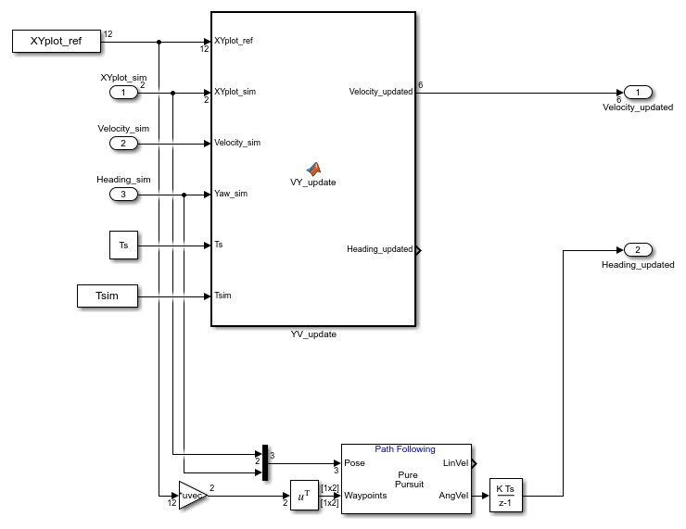

Comment lines 22-27 and uncomment line 28 in ’MPC_control/Mpc_of_plant/HQP_solver’. Comment lines 23-28 and uncomment line 29 in ’MPC_control/observer_of_plant/Subsystem_*j*/simulator_*j*/MPC_of_simulator_*j*/HQP’, for *j*=1, 4, 7. Uncomment lines 571-582 and 600-609. Recover the codes after the plotting is finished.

Fig. 28: Same as fig. 27. Uncomment lines 625-649.

Fig. 29: Same as fig. 15. Uncomment lines 571-582 and 600-609.

Fig. 30: Same as fig. 15.

Fig. 31: Same as fig. 24.

Fig. 32: Uncomment lines 11-14. Comment other lines which are related to other routes. The changing procedure of ’MPC_control.slx’ is the same as fig. 27, for *j*=3, 7, 8. Uncomment lines 625-649. Recover the codes after the plotting is finished.

Example 3: Uncomment lines 16-19. Comment other lines which are related to other routes.

Fig. 33(b)-(d): Uncomment lines 390-400.

Fig. 34(a)-(b): Uncomment lines 497-509.

Fig. 34(c)-(d): Uncomment lines 611-623.

Fig. 35: Uncomment lines 526-538.

Figs. 36, 37: Uncomment lines 437-444. Use command ‘xlim’ to adjust the scale of the x-axis to an appropriate one.

Fig. 38: Uncomment lines 651-663.

Fig. 39: Uncomment lines 555-560.

Fig. 40: Uncomment lines 625-649.

Fig. 41: The changing procedure of ’MPC_control.slx’ is the same as fig. 15, for *j*=3, 5, 7. Uncomment lines 625-649. Recover the codes after the plotting is finished.