

Infinitegrids

http://8grids.com

Gym&Fitness Theme – the best WordPress theme

By 8Grids

First, the 8Grids we would like to thank you for purchasing our theme and hope you make a good use of it.

This is an instruction manual and guide, the zenith theme information to help you as much as possible with your new theme.

This document covers installation, configuration, and answers frequently asked questions to clarify all your questions with respect to its new theme - we encourage you to read this document entirely if you are facing any difficulty if you have any questions beyond that was not remedied by this document please contact with our support http://8grids.com/support.

**1. Getting Started**

1.1 Installation

1.2 Setting up the Homepage 1

1.2.1 Adding Portfolio Items 2

1.2.2 Adding Images 2

1.2.3 Adding Video 3

1.2.4 Adding Audio 4

1.3 Setting up the Blog

1.4 Tools

1.4.1 Import

1.4.2 Export

1.5 Pages

1.5.1 Create Pages

1.5.2 Edit Pages

1.5.3 Delete Pages

1.5.4 Fullwidth page

1.6 Posts

1.6.1 Adding Images to Post

1.6.2 Adding Videos to Post

1.6.3 Customize Sidebar

1.6.4 Adding Comments to the Post

1.6.5 Hide Featured Image in Post

1.6.6 Create Portfolio with Post

1.6.7 Adding Audio to Post

1.6.8 Adding Links to Post

1.6.9 Formatting the Post

1.7 Comments

1.8 Setting up menus and Footer menus

2. Theme Features

2.1 Custom Menus

2.2 Theme Options

2.2.1 General Settings

2.2.2 Blog Settings

2.2.3 Support

2.2.4 Import / Export

2.2.5 Theme Information

2.2.6 Dev Mode Info

2.2.7 Footer

2.3 Custom Widgets

2.3.1 Custom Flickr Photos Widget

2.3.2 Custom Latest Tweets Widget

2.3.3 Custom Video Widget

2.3.4 About us Widget

2.3.5 Footer Widget

2.4 Custom Page Templates

2.4.1 Blog Template

2.5 Custom Login Logo

2.6 Featured Images

2.7 Create Page Gallery

3 Theme Files

3.1 Plugins

3.1.1 Contact Form 7

3.1.2 Slider Revolution

3.1.3 Timetable

3.2 Cascading Style Sheets

3.3 JavaScript Files

4 Shortcodes

4.1 Shortcode List

4.2 Dropcap

4.3 Shortcode Pricing

4.4 Shortcode Toggle Element

4.5 Tweets Shotcode

4.6 Title and Subtitle Shortcode

4.7 Border Divider Shortcode

4.8 Divider shortcode

4.9 Creating Graphs

5 More Shortcodes

5.1 Adding Buttons

5.2 Adding Icons

5.3 Adding Icons Boxes

5.4 Team Member

5.5 Gallery

5.6 Highlighted

1. Getting Started

To install this theme you must have a working version of WordPress already installed. For information in regard to installing the WordPress platform, please see the WordPress Codex -http://codex.wordpress.org/Installing_WordPress

1.1 Installation

When you are ready to install a theme, you must first upload the theme files and then activate the theme itself. The theme files can be uploaded in two ways:

• FTP Upload: Using your FTP program, upload the non-zipped theme folder into the /wpcontent/themes/ folder on your server.

• WordPress Upload: Navigate to Appearance > Add New Themes > Upload. Go to browse, and select the zipped theme folder. Hit “Install Now” and the theme will be uploaded and installed.

Once the theme is uploaded, you need to activate it. Go to Appearance > Themes and activate your chosen theme.

1.2 Setting up the Homepage

To set up the homepage you must create a new page, you can do so by navigating to Pages > Add New. You can give this page a title (which will be your homepage’s headline) yet you do not have to include any content unless you wish to do so.

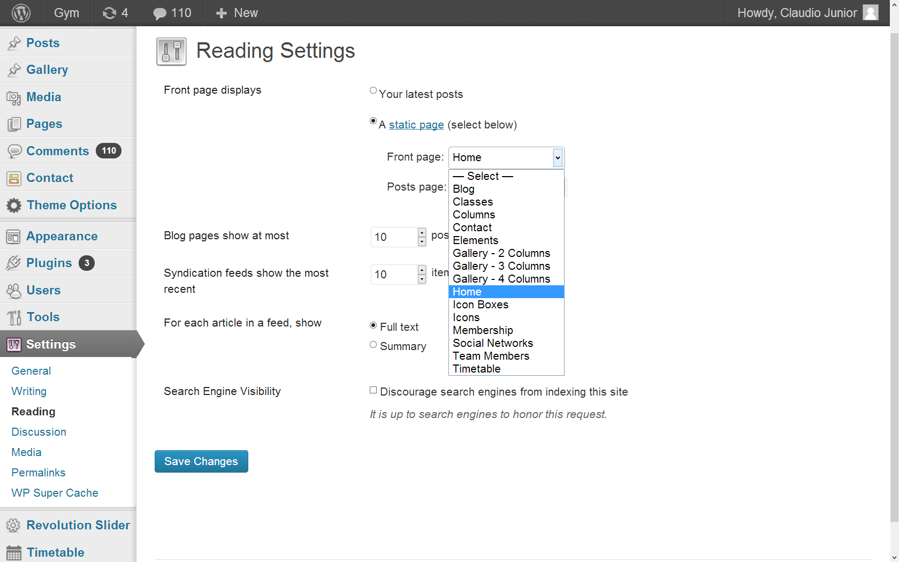

Go to settings and then reading and there you choose the area 'home page' the page you want to be the home of your website.

Once you have created your new page, navigate to Settings > Reading and configure the “Front Page Displays” setting. Select the static page option and choose the page you just created as your front page.

Your homepage is now created and can be configured through the theme options

(Gym>Theme Options)

1.2.1 Adding Gallery Items

To add a new gallery item, navigate to gallery > Add New. Here you can add a brief description of the project and upload media.

1.2.2 Adding Images

To add images to each portfolio item, you simply need to upload your images using the inbuilt

WordPress media uploader. All images uploaded while creating or editing your portfolio item become attached automatically and will be shown on the project’s detail page. You can upload an unlimited number of images.

Click the “upload images” button, select your images, upload. That’s it.

1.2.3 Adding Video

Each portfolio item can display either a self hosted video or video embedded from YouTube or Vimeo. To add a video from either Vimeo or YouTube, simply copy and paste the provided embed code in the appropriate section.

To display self hosted video, ensure to include the correct paths to the .m4v and .ogv file formats and declare the video height. You must also provide a poster image. Note: You must provide both formats for consistent display across all browsers.

1.2.4 Adding Audio

Each portfolio item can play a self hosted audio file. To play self hosted audio, ensure you include the correct paths to the .mp3 and .ogg file formats hosted on your server. You must also provide a poster image. Note: You must provide both formats for consistent display across all browsers.

1.3 Setting up the Blog

To set up the blog, you must create a new page, you can do so by navigating to Pages > Add New. You can give this page a title of “blog” yet you do not have to include any content. Click

“Publish”.

Once you have created your new page, navigate to Settings > Reading and configure the “Front Page Displays” setting. Select the static page option and choose the page you just created as your posts page. Your blog index is now created and can be viewed by visiting the page you just published.

Then navigate to 'reading' in the settings of your WordPress post page look for the tab and select the name of the page you just created. Ready and you already have a blog and everything you post will automatically go there.

1.4 Tools

The tools WordPress serveth to facilitate its use with some features such as 'Press This' you click on it and drag to the bookmarks bar of your browser so when you see a link or video or even a text you just selected click on it and then publish it and the content will be published on your website or blog.

1.4.1 Import

Using this tool you can import a content from another site hosted on another server easily and quickly.

1.4.2 Export

Using this tool you can export content from your website to your computer in a file in order to have the content saved in a secure manner that it can serve as a restore point in the future.

1.5 Pages

1.5.1 Create Pages

It's simple to create a new page, you must do the following way, first you are on the homepage of your WordPress administration> pages> add new and to end just click on 'Publish'

1.5.2 Edit Pages

To edit pages go to the menu of your WordPress called ‘Pages’ find the page you want to edit and click on 'edit' and to finish click on 'Update'.

1.5.3 Delete Pages

To delete a page you need to go to the area of pages of your WordPress, then stop the mouse over the page you want to delete and click in 'trash' so your page will go to a tab at the top of your screen even in area of pages called 'trash' click on this tab and look for the page and delete permanently.

1.5.4 Fullwidth Page

Is a container used to increase the level of customization of the page, there you can put a background image on your page or color the way you want. It only works if you enable Fullwidth page that is located just below your editor, enabling the page Fullwidth you leave your page from one ledge to another full screen. And you can also use several Full Width container section shortcode on a page just to have a piece of content with a blue background and the other with black background for example. For you to add a Full Width container section shortcode you need to click in 'shotcode' in your editor and procutar 'Full Width container section' thus opening a window for you colocaar their fullwidth.

1.6 Posts

The theme has options to facilitate your work when you post new content such as: Custom Fields, Extra image, comments, choices that will help you make your posts more beautiful, complete and enjoyable for readers.

1.6.1 Adding images to post

Click on add media> upload files and selecting the file.

1.6.2 Adding videos to post

You can add videos by copying the video URL from YouTube, Vimeo, SWF, MOV and pasting the video space of Custom Fields.

1.6.3 Customize sidebar

You can upload images in Extra image and select them from the sidebar for your categories and tags.

1.6.4 Adding comments to the post

You can add comments to your posts opening the comments area below the area of custom fields.

1.6.5 Hide featured image in post

You can choose to activate it to appear joins a picture previews of your post or disables it so that it does not happen.

1.6.6 Create post with portfolio

Our theme lets you create a portfolio of images very simply, you click on Media> create a portfolio and upload images to the portfolio.

1.6.7 Adding audio to post

In this issue you can add an audio file simply by your post. Click on Media> upload files and select your audio file.

1.6.8 Adding links to post

To add a link to your post you need to change the tab text editor for visual Text and click on link

1.6.9 Formatting the Post

You can format your post using the editor and make your post the way you want.

1.7 Comments

In this area of your WordPress menu you can manage comments from your site quickly and easily.

1.8 Setting up menus and Footer menus

Is necessary to create a menu to organize your pages created, to do this you navigate to 'appearance' on the left side of your WordPress, then 'menus'

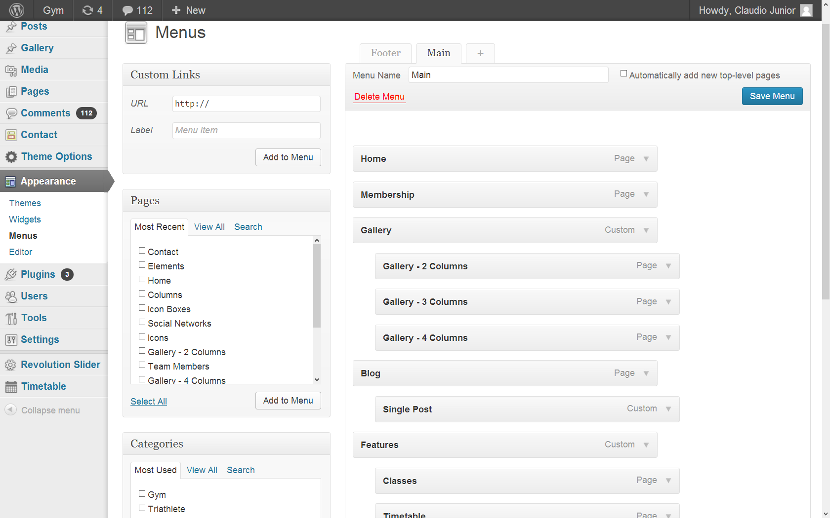

Create a menu named 'main' then click on '+' and create another named footer, in the upper area of the screen.

Then 'Theme Location' in 'Primary Menu' select the 'main' and 'Footer Menu' select the 'footer'

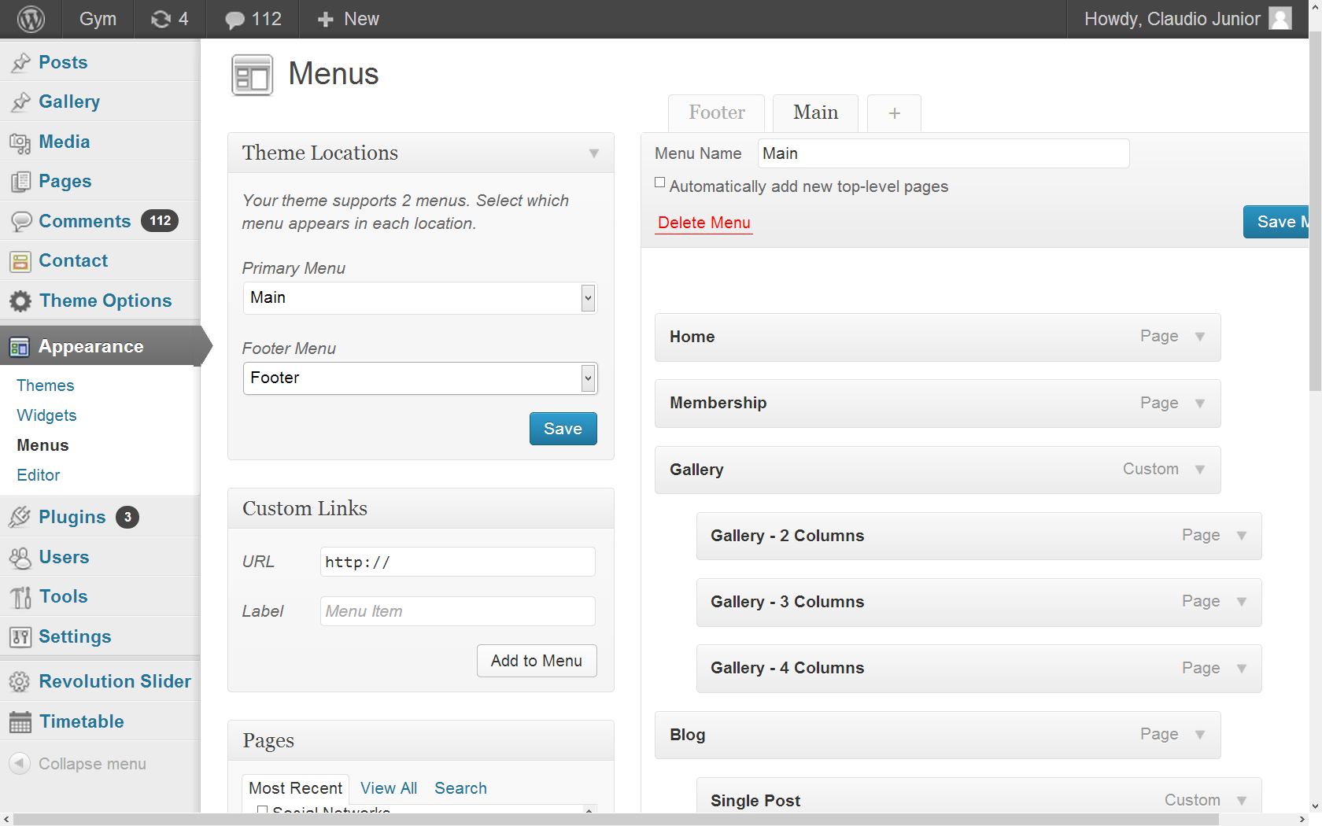

After you select the page you created and placed in this menu area 'Pages' and adds the menu 'main' or 'footer' and arranges them as you wish.

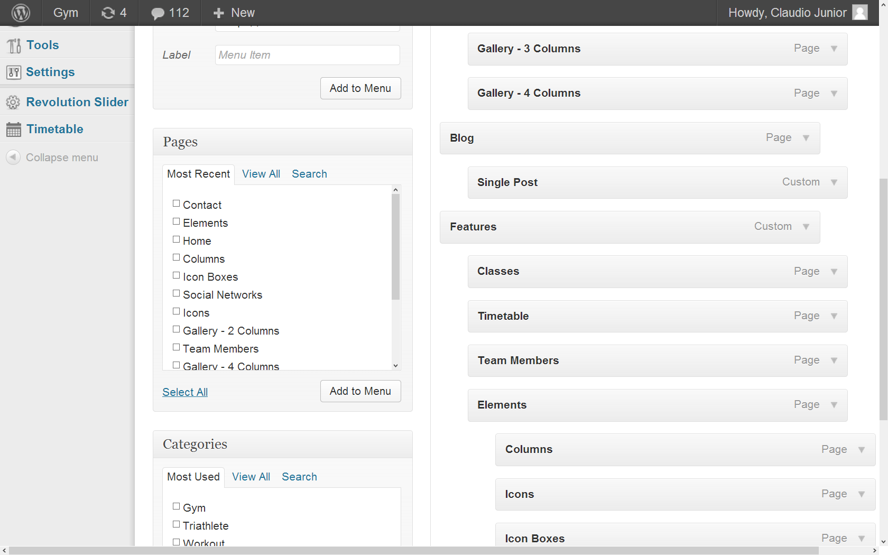

2 Theme Features

The theme comes packed with features that control the layout and extend the functionality of WordPress. This section will document those features and how to use them successfully.

2.1 Custom Menus

The theme has a single custom menu location located in the header. You can assign this location a custom menu and in addition, custom menus to be used within widgets. To setup your custom menus, navigate to Appearance > Menus. Give your menu a name and build it up using the available widgets. You can add a variety of items including pages, categories, custom links. To extend the available widgets, click the screen options tab at the very top of the screen and configure your options. Once you have built your menu, save it and assign it to a location.

2.2 Theme Options

The theme comes with a simple to use administration panel. You can access it by navigating to Hoarder > Theme Options. The theme options are conveniently spread over a number of tabs and each tab contains the options that pertain to a particular area of the theme.

2.2.1 General Settings

Choose Global Color: In this area you can choose the color of your global theme simply clicking on the marked area.

Select Title Position: Here you can change the position of their main title theme.

Upload your Logo: In this area you can upload a logo image of your site.

Logo for Fixed Menu (activated on scroll): You can upload your logo here. A plain text logo of the blog name will be placed here if you have not uploaded any image for the logo.

Upload your Favicon: You can upload your Favicon here.

Show Pinned menu on scroll: Enable this option to lock the menu at the top when there rollover.

Background Image/Pattern Upload: You can upload your image/pattern here. If you have uploaded your pattern here, then the selected pattern from the above Background Pattern will be overriden.

Tile image: If no is selected, image will be stretched.

Boxed or Stretched style: Choose the format that works best for you.

Google Font Family: In this area you can click on the link and choose a different font for the theme through http://www.google.com/webfonts.

URL for Google Font: In this area you paste the URL to change your font

Custom JavaScript: You can add your own custom JavaScript in that space.

Custom CSS: You can add your own custom CSS in that space.

Google Analytics tracking code: In this area you can use google analytics to make him mount graphics on your site.

Number of Extra images for slides: This is the number of images that will show on the slider.

2.2.2 Blog Settings

In this area you can edit and make your blog the way you want.

2.2.3 Support:

In this area you can get in touch with support and clarify all your doubts.

2.2.4 Import / Export

This is the place where you can upload information to your website using the 'Import' or leave your information saved on your computer using the 'Export'.

2.2.5 Theme Information

Where you can view the information of the theme.

2.2.6 Dev Mode Info

This is where you can view the codes used to form the theme options.

Note: Always remember to click 'Save Changes' as the top right of your screen to save your changes.

2.2.7 Footer

Footer is the opposite of the header, is the final part of your site, you

can put there the your phone and email, to get there you need to go to theme options and then footer then 'Footer Text' and to complete you click on 'save changes'.

2.3 Custom Widgets

The theme comes with 4 custom widgets that can be used to configure how your site displays

content - they can be found under Appearance > Widgets.

2.3.1 Custom Flickr Photos Widget

This widget allows you to configure and display Flickr photos from a user’s photostream.

2.3.2 Custom Latest Tweets Widget

This widget allows you to configure and display your latest Twitter tweets.

First of all to put their latest tweets on your website you need to create an access key, twitter requires that each has its own key. Login first twitter usually (on twitter what you want appears on your site. Then click this link <https://dev.twitter.com/>

Now you are in the area for developers twitter. Look at the top right of your screen, hover the picture and a menu will aprir, clik on 'My applications'

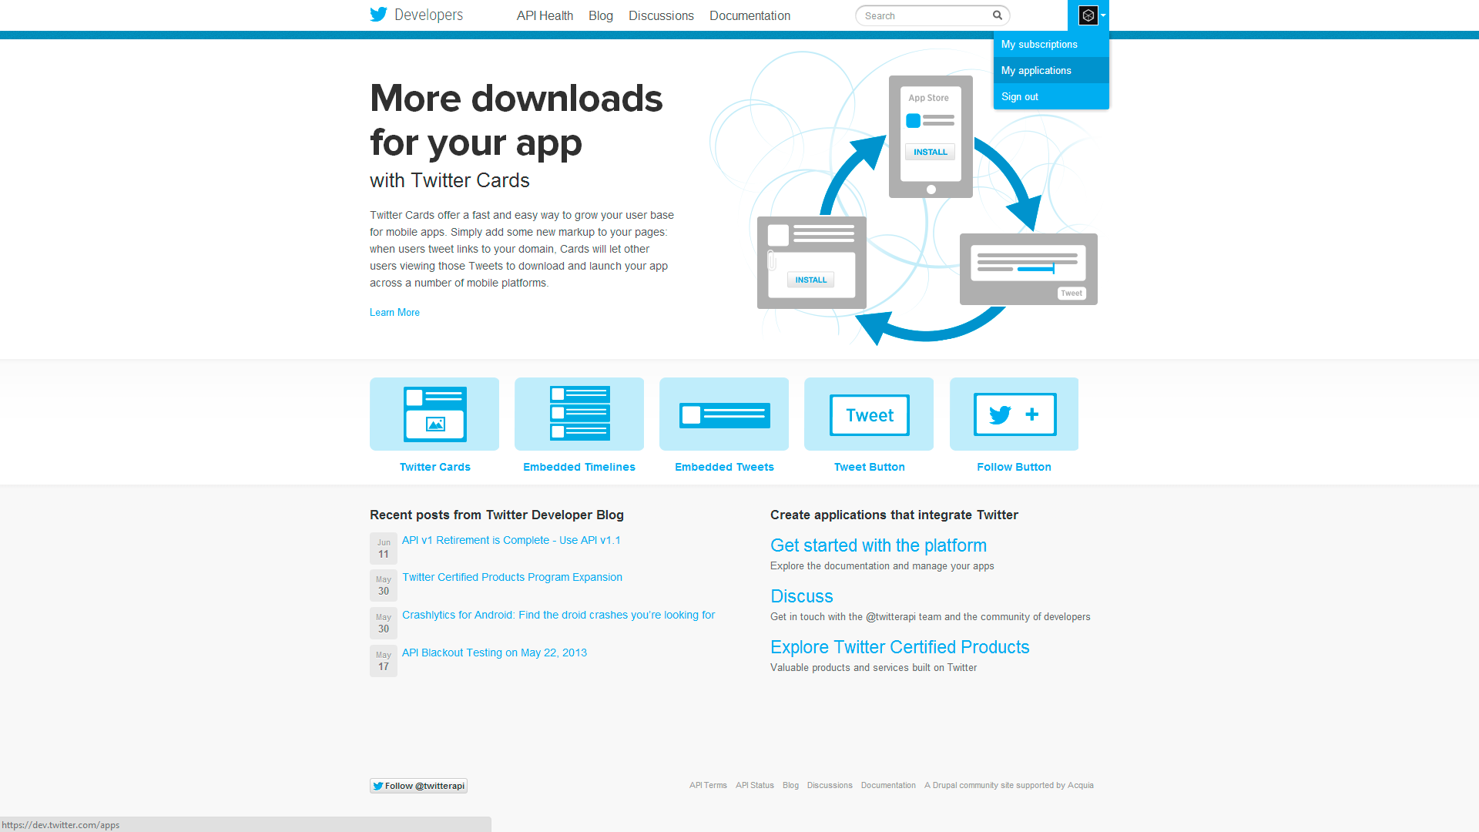

Then click on 'Create a new application' now register your application by following the steps indicated by twitter. Now after you have created your application you back in 'my application' click on your application and down the screen to where it is written 'create my access token after that you go on the third tab. 'OAuth tool' and there you will find the necessary links for you to add fields in the widget to get your twitter on your website.

2.3.3 Custom Video Widget

This widget allows you to configure and display a single video.

2.3.4 About us Widget

In this widget you can place your logo and write about your brand.

2.3.5 Footer Widget

You can add widget in the footer of your site, such as a widget, for example ‘TIMETABLE today's classes’ To do this go to his appearance in WordPress then Widget and then later in Footer_01 or Footer_02 Footer_03 or click on one and drag the widget you want and then click on the widget and edit it as you want.

2.4 Custom Page Templates

Our themes come with templates for each specific functionality.

2.4.1 Blog template

Using this template when you create a page that makes accessing that page it lists all content posted like a blog.

2.5 Custom Login Logo

The theme comes with an inbuilt function to replace the default WordPress login logo. To replace the default login logo, replace admin-login-logo.png with your chosen image in the themes /images/ folder. Upload the new image to your server via FTP and the new logo will become visible on the WordPress login screen.

2.6 Featured Images

The theme supports the use of featured images. The theme supports auto-resizing of the featured images and so there is only the requirement to specify a single image. Auto-resizing will only occur however when the image is uploaded for the first time, images that have previously been uploaded will not be resized.

To upload a post thumbnail, go to Posts > Add New or open an existing post in editing mode.

Locate the Featured Image module and click the Set featured image link.

Clicking the link will open up the usual WordPress image uploader where you will upload your image. Simply make sure that it is either the same size or larger than what the final thumbnail will be. Once you’re done uploading the image, simply click the link that says “Set Featured Image”, which is next to the button to insert it into the post.

For more on how to use the WP+ Post Thumbnail feature you can view ssthis article - http://en.support.wordpress.com/featured-images/

2.7 Create page Gallery

A 'page gallery' is a specific area of your website that you put your photo albums.

Before anything to create a great gallery you need to navigate to the area of your gallery wordpresse create categories your gallery, however create a category called 'categories' and then other subcategories with names however you want all within category 'categories' and so create new galleries with pictures and text within them select your category.

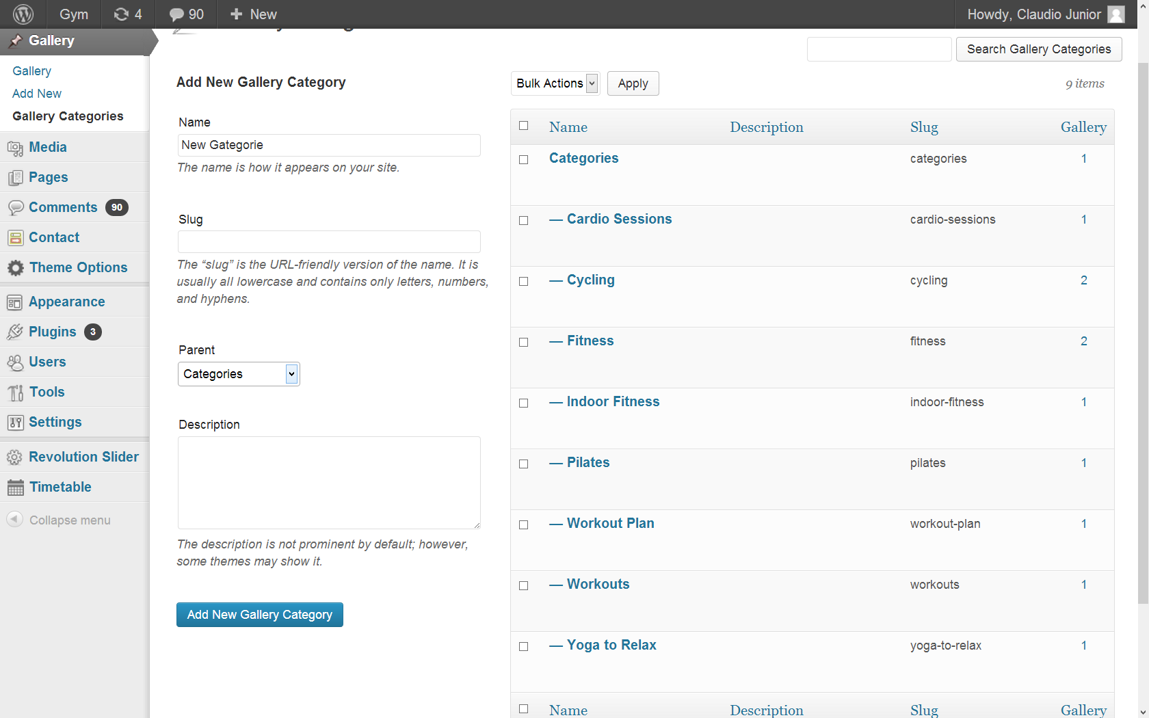

You need to click on the menu 'Gallery' of your WordPress> Add New> sidebar and look for the 'Featured Image' upload your images, or use an existing one in your WordPress select it and click on 'Set featured image' you've chosen cover that your portfolio, now click on 'extra image 1> set extra image 1> open the image and click on set as an extra image 1 and do the same with the extra image 2, 3.4 ..... until complete your portfolio.

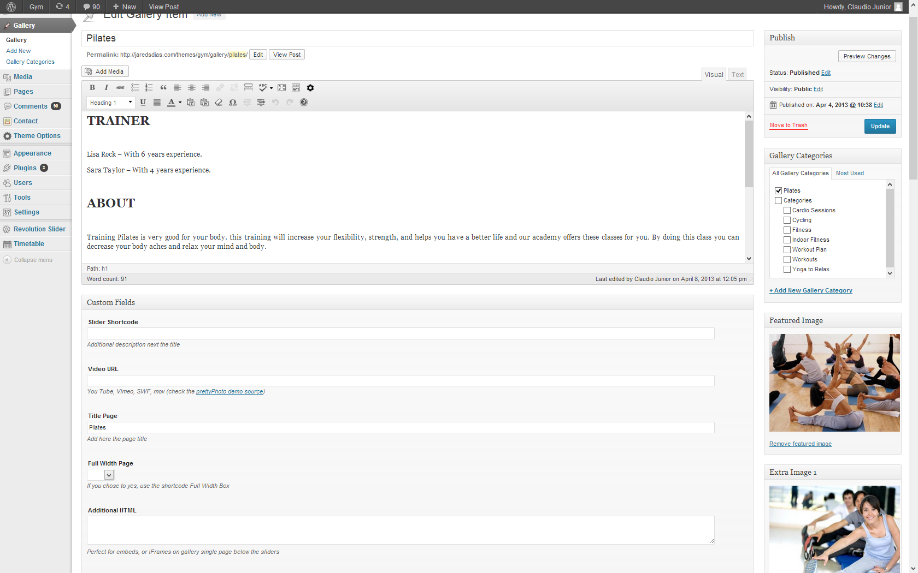

and before publishing creates a new category and put the album in that category now click on 'Publish' after that go to the menu 'portfolio categories' just let your mouse cursor above that category just below near the start menu you will see a computer link with the 'ID' gallery created, usually a number, remember it.

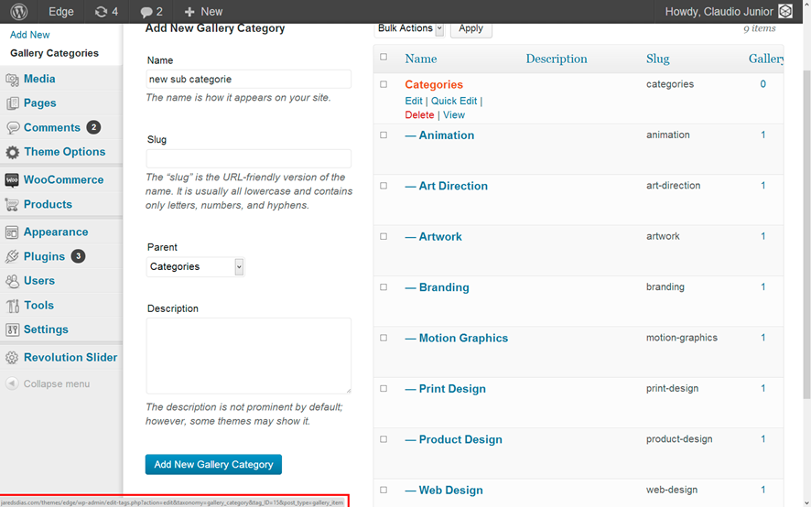

To finish creating a new page, with the name 'Gallery' in the text editor and look for the options 'shortcodes' and click on it will open a menu and that menu search for the word 'portfolio' click it and then click Insert portfolio section 'code will appear on your screen and where this an' id ='' type the number you viewed previously in ID, click on 'Publish' and this finished.

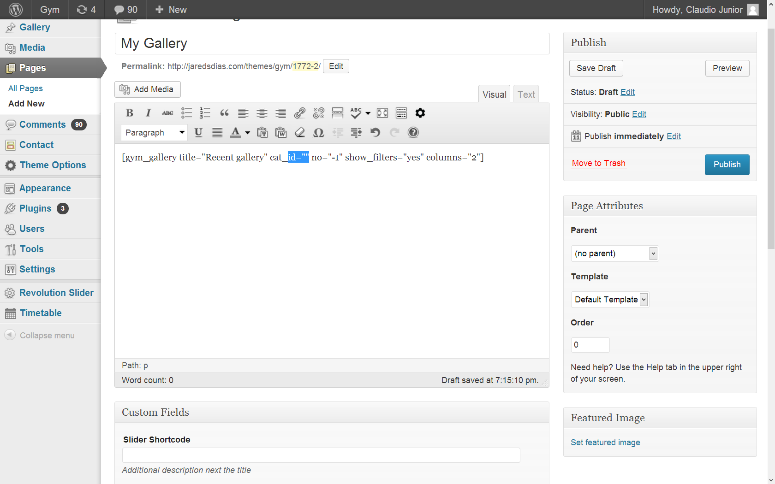

3 Theme files

3.1 Plugins

Our theme comes with plugins and great compatibility with plugins that will help you and facilitate everything for you.

3.1.1 Contact Form 7

Contact Form 7 can manage multiple contact forms, plus you can customize the form and the mail contents flexibly with simple markup. The form supports Ajax-powered submitting, CAPTCHA, Akismet spam filtering and so on.

Installation: Upload the entire contact-form-7 folder to the /wp-content/plugins/ directory.

Activate the plugin through the 'Plugins' menu in WordPress.

You will find 'Contact' menu in your WordPress admin panel.

For basic usage, you can also have a look at the plugin homepage.

3.1.2 Slider Revolution

Create a responsive(mobile friendly) or fullwidth slider with must-see-effects and meanwhile keep or build your SEO optimization (all content always readable for search engines). See the heaps of custom transitions/animations for each object on the page! Customize this slider with our convenient drag&drop backend to your very needs.

This plugin features tons of unique transition effects, an image preloader, video embedding, autoplay that stops on user interaction and lots of easy to set options to create your own effects.

Our theme comes with a shortcode for you more easily add a slide to your page, just add just below where this Slider Shortcode written in the Custom Fields 'Slider Alias' and ready.

Features:

• Image and Thumbs fully resizable

• Using CSS Animation with FallBack to jQuery

• Unlimited Caption Layers

• Captions like Video, Image and html tags can be easily Created

• Unlimited Slides

• iPhone & Android Swipe Touch enabled

• jQuery Conflict free plugin

• Customizable 100% via Plugin Backend

• Easy installation in your Website

• Special Easing

• Vimeo & Youtube Supported

• Full Screen Video with Autoplay function

• Stop AutoPlay during Video Playback

• Duplicate, Slider, slide, captions Function

• Drag and Drop Captions in the Editor

• Fullwidth, Responsive (8 Level) and Normal Modes

• Optional Shadows included

• Hide Captions Separetely or Together depending on Slider Width

• Hide whole Slider Depending on Screen Width

• Countless Art of Transitions

• 10 Different Caption Animation Types

• 20 Differen Slide Transition, and Unlkmited Variations due Rotation and Amount of Slots

• Two Level Animations of Captions. Start Time, End time, Different Animation Type and Easing at Start and End

• Public Api, like stop & start, next, prev, jump to slide. Events at video play, start and stop, events at slide change.

Our theme includes Slider Revolution Responsive WordPress Plugin – $15 Value for you.

3.1.3 Timetable

**MAIN FEATURES**

* Easily manage and update schedule entries (classes).
* Manage and update the classes and instructors database.
* Easy customization of schedule appearance and colors.
* Option to change the first day of the week, number of days to display on the schedule, and schedule time increments.
* Fully supports both 12-hour and 24-hour clocks.
* True timezones support.
* Use a simple templating system to customize the class details display.
* Supports multiple classrooms/schedules.
* Instructor collision prevention – Prevents the scheduling of an instructor for 2 classes at the same time.
* Switchable “classroom collision detection” to allow for the scheduling of multiple classes at the same classroom at the same time.
* Display class and instructor details directly on the schedule.

Our theme has a timetable for the classes you can show your FITNESS, in what time they start, end and who gives the best possible way.

To create a timetable you need to click the menu 'Timetable' at the end of your WordPress menus then 'Classes' to add the name of the class to be shown then' Instructors' to add your FITNESS teachers then in 'Classrooms 'add to the rooms. You can also change this timetable at their 'Options' menu. Done that you create a page in menu 'Pages' of your WordPress named 'Timetable' and make the text editor as an example of this in the options or for example:

Timetable or so [timetable classroom = "The Classroom"; "Classroom D ";" Classroom B "," C Classroom ";" Classroom E "," F Classroom ";" Classroom G "," H Classroom ";" Classroom I "," J Classroom "] to the page recognize the or separate its timetable for 'classes' or 'Instructors' you done it again timetable and start adding your classes.

To conclude we have to add this new page to your site menus, to do this you need to go in the menu of your WordPress called 'Appearance' and clcik on 'Menus' in' Pages' select 'Timetable' and then click 'Add to menu and then drag to where you want to leave it on your menu and finally click on 'Save Menu' and over.

Note: The contact form 7 and revolution slider plugins are third party and not the 8grids support for these plugins and case of doubt contact the support of the developers of these plugins

http://contactform7.com/support/ for contact form 7

http://codecanyon.net/item/slider-revolution-responsive-wordpress-plugin/2751380/faqs to Slider Revolution

3.2 Cascading Style Sheets

The theme includes a main CSS files (style.css) which is used to style the layout and content.

3.3 JavaScript Files

The theme imports various Javascript files depending on the page being viewed, widget configuration and settings in the theme options.

jQuery Library - jQuery is a fast and concise JavaScript Library that simplifies HTML document traversing, event handling, animating, and Ajax interactions for rapid web development. More information can be found at http://jquery.com.

Custom.js - This file controls various sections of JS throughout the theme dependant on settings in the theme options.

3.3 Photoshop Files

PSD logo included with the theme contain the necessary styling for all elements including layouts, icons and all custom widgets.

4 Shortcodes

The shortcodes have been developed to ease your work and make your site better and more beautiful.

To access dozens of shortcodes theme use the editor that opens once you click on new post or new page. as well as show the picture below

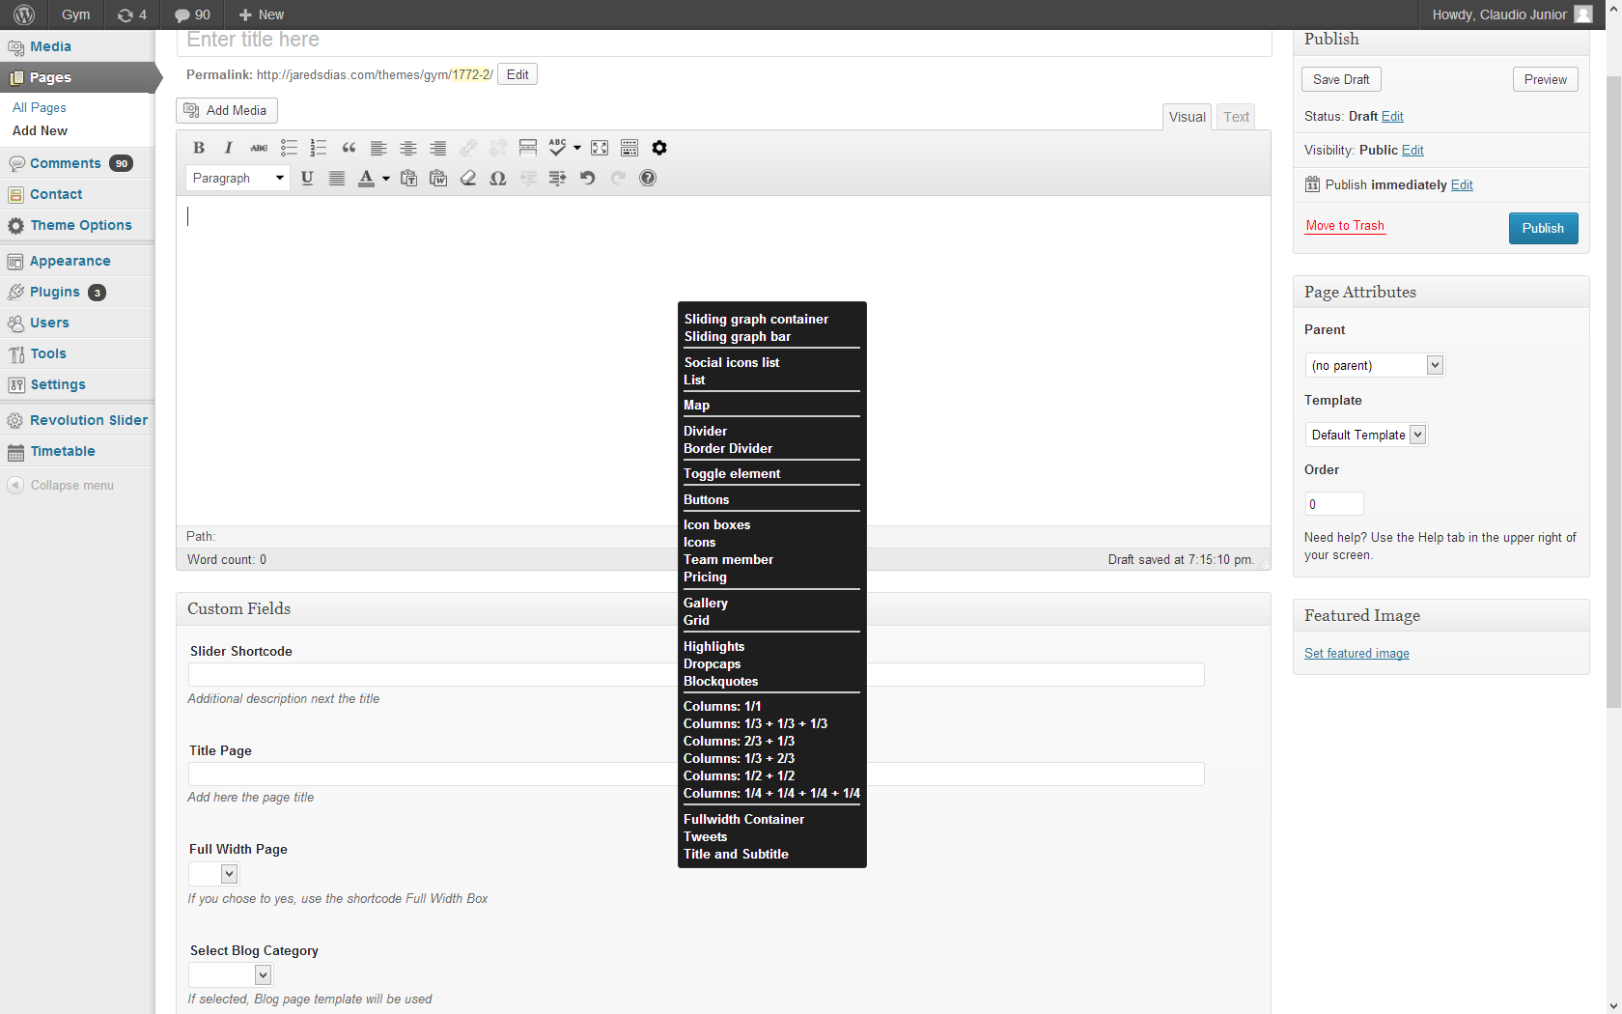

4.1 Shortcode List

This shortode was developed exclusively for the zenith theme and serves to increase the level of customization of lists and not just stay with 'balls' before the words, with it you can put other images. To add this shortcode to your page or post is simple, you just go on your area of shortcodes editor click in 'List' choose the one that best suits you and make your list of tags aberturae closing shortcode.

4.2 Dropcap

You can use this shortcode to put the first word of your text bigger, to use this shortcode navigate to the area of shortcodes> 'dropcap' will open a window where you can choose the letter and style.

4.3 Pricing

This shortcode allows you to make a price for any plan to buy a very easy way to use it there you need to navigate to shortcodes> 'pricing' thus opening a window where you can put everything you need.

4.4 Shortcode Toggle Element

This shortcode allows you to make a tab, when you do click on that tab text will appear, and when you do click on this tab again will return the text to disappear, to use this shortcode you need to navigate to the area of shortcodes> 'toggle element' thus opening a window where you put the title and the text that will appear.

4.5 Tweets Shotcode

The Tweets Shortcode is used to show the tweets from your account. You can add it by click on shotcodes the editorial page and then click on 'Tweets' so will open a window where you put your User name and twitter account.

4.6 Title and Subtitle Shortcode

This shortcode is designed to make your job easier to put titles and subtitulos in your post. you can add it to your post or page clicking on the menu shotcodes in your editor and then click on 'Title and Subtitle' thus opening a window wave you put the title and subtitle of your text and you can choose the alignment him.

4.7 Border Divider Shortcode

You can use this shortcode to create a line between a text and or other type of graphic and or text on the page, it does show a dashed line between them. To add a just click in shortcode in your editor and then click in 'Border divider' thus opening a window where you put as much space as her.

4.8 Divider shortcode

Use this shortcode to create a space, ideal for sharing contents to add just one click in 'Divider' in your editor shortcodes.

4.9 Creating Graphs

To create a graph it is necessary to go in your editor of shortcodes and first click in 'Sliding container graphs' delete the text between the tags and insert the' Sliding bar graphs and then click in 'Sliding bar graphs' thus opening a window where you place the name and percent [gym_graph_container] delete this text and insert graph bars [/ gym_graph_container]

Delete the text and go to the shortcodes and add a bar graph so you do click on it will open a jnela where you can put the name and percentage. the code that will appear to finel is this:

[gym_graph_container] [gym_graph Title = "8grids themes" Percent = "100"] [/gym_graph_container]age of graph.

5 More Shortcodes

5.1 Adding Buttons

To add a button to your post or page you just go to the shortcodes your editor and click in 'buttons' thus opening a window where you edit the button the way you want by giving name, address, size.

You can also add color to the button, if it does not happen the button is the color theme and can change the button size.

5.2 Adding Icons

To add an icon to your text or your page is simple, just do click on shortcodes in your editor and click in 'Icons' choose one of the 420 to its layout and add it.

5.3 Adding Icons Boxes

Boxes Icons are larger icons where you can put a title and text below them.

To add icons boxes is simple you just click in your editor of shortcodes and there click in ' Icons Boxes "choose the icon, the text and adds it.

Make sure that the 4 fields of the window that opens when you click on icon boves are complete.

5.4 Team Member

With this shortcode you can show everyone your team officials, their staff. For use this you need to navigate until the part of its editor shortcodes posts or pages and click on 'team member' thus opening a window that allows you to provide all the information your team of staff.

5.5 Gallery

This allows you to put shortcode in posts or pages the gallery you learned to do in part 2.7 of this document, to use it there you need to navigate to shortcodes> 'gallery' thus opening a window where you can choose the thymus gallery, columns , and everything else.

5.6 Highlighted

With this shortcode you can underline text and leaves you highlighted in your page or post, to do this you go to the area of your shortcodes editor page and click on 'highlighted' thus opening one window with all you can making.

Again, thank you for purchasing this theme!

If you have any questions that are beyond the scope of this document, feel free to pose them in the dedicated support (http://8grids.com/support)