
UNIVERSITY OF HERTFORDSHIRE
School of Physics, Engineering and Computer Science
MSc Title
Module Code and Title

Context-Aware Image Description Tool for Visually Impaired Students in Online Learning Environments
7COM1039-0901-2025 - Advanced Computer Science Masters Project

Name: Jason Simon Ganta
Student ID:23095341
Supervisor: Dr.Eric Chiejina

MSC FPR DECLARATION

This report is submitted in partial fulfilment of the requirement for the degree of:
Master of Science in Advanced Computer Science, at the University of Hertfordshire
(UH).

I hereby declare that the work presented in this project and report is entirely my own,
except where explicitly stated otherwise. All sources of information and ideas, whether
quoted directly or paraphrased, have been properly referenced in accordance with
academic standards. I understand that any failure to properly acknowledge the work of
others could constitute plagiarism and may result in academic penalties.

I did not use human participants in my MSc Project.

I hereby give permission for the report to be made available on the university website
provided the source is acknowledged.

Name: JASON SIMON GANTA
Student ID: 23095341
Date: 5th January 2026

1. Abstract
Image captioning is a challenging multimodal task that combines computer vision and natural language processing to automatically generate coherent textual descriptions of visual content. It requires a system to not only recognise objects within an image, but also understand contextual relationships and express this understanding in natural language. This project presents the design, implementation, and evaluation of an image captioning system using a pretrained BLIP (Bootstrapped Language–Image Pretraining) model. The primary aim of the project is to assess how effectively a pretrained vision–language model can generate captions for previously unseen images and to critically examine how well these captions align with human-written reference descriptions when evaluated using automatic metrics.
Images and corresponding reference captions were extracted from a publicly available Hugging Face dataset provided in parquet format. From this dataset, a benchmark subset of 250 images was constructed to ensure a balance between statistical reliability and computational feasibility. Captions were generated automatically using the BLIP-base model without any task-specific fine-tuning or additional training, allowing the study to focus on the inherent generalisation capability of pretrained models. A complete end-to-end evaluation pipeline was implemented, incorporating dataset preprocessing, image extraction, caption generation, and automated metric computation.
Caption quality was evaluated primarily using the BLEU-1 metric, with performance reported as an average score across the full benchmark dataset to reduce the influence of individual outliers and stochastic variation in generation. The experimental results produced an average BLEU-1 score of 0.1956. While this value appears modest in absolute terms, further analysis shows that it is consistent with results reported in existing image captioning literature, particularly in evaluation settings where only a single reference caption is available. Such settings are known to limit the effectiveness of n-gram–based metrics due to the inherent diversity of valid linguistic descriptions.
Qualitative inspection of generated captions revealed that many low-scoring outputs were semantically accurate and visually grounded, highlighting a disconnect between automatic metric scores and human-perceived caption quality. The findings demonstrate that the BLIP model is capable of producing meaningful and contextually appropriate captions without additional training, but also emphasise the limitations of BLEU as a standalone evaluation measure. The project concludes that while pretrained vision–language models offer strong practical potential, robust evaluation of image captioning systems requires the combined use of multiple metrics and human-centred assessment methods. Future work therefore recommends extending evaluation frameworks to include semantic-aware metrics and structured human evaluation to better capture real-world caption quality.
Contents
MSC FPR DECLARATION 2
1. Abstract 3
2. Introduction 7
2.1 Background and Motivation 7
2.2 Applications and Societal Relevance 7
2.3 Challenges in Image Captioning 8
2.4 Evolution of Image Captioning Models 8
2.5 The Challenge of Caption Evaluation 9
2.6 Problem Statement and Research Gap 9
2.7 Project Aim and Objectives 10
2.8 Research Questions 10
2.9 Feasibility, Ethics, and Report Structure 10
3. Literature Review 11
3.1 Introduction to Image Captioning 11
3.2 Traditional Image Captioning Approaches 11
3.3 Attention Mechanisms and Transformer Models 12
3.4 Vision–Language Pretraining 13
3.5 BLIP: Bootstrapped Language–Image Pretraining 13
3.6 Evaluation Metrics for Image Captioning 14
3.7 Challenges in Caption Evaluation 15
3.8 Identification of Research Gaps 15
3.9 Relation to This Project 15
3.10 Summary 15
4.Methodology 16
4.1 Overview of Methodological Approach 16
4.2 Choice of Methods 16
4.2.1 Model Selection 16
4.3 Project Design and System Architecture 17
4.3.1 System Structure 17
4.3.2 Backend Design 17
4.3.3 Frontend Interface 18
4.4 Dataset Collection and Preparation 19
4.4.1 Dataset Source 19
4.4.2 Image Extraction 19
4.4.3 Caption Dataset Preparation 20
4.5 Tools and Technologies 20
4.6 Caption Generation Process 21
4.7 Test Strategy 21
4.7.1 Unit Testing 21
4.7.2 Integration Testing 21
4.7.3 System Testing 21
4.8 Evaluation Methodology 22
4.8.1 Metric Selection 22
4.8.2 Average BLEU Calculation 22
4.9 Validation of Results 22
4.10 Ethical, Legal, Social, and Professional Considerations 22
4.11 Practicality and Constraints 22
4.12 Summary 22
5. Quality and Results 23
5.1 Overview 23
5.2 Evaluation Metrics and Rationale 23
5.3 BLEU-1 Results and Analysis 24
5.3.1 Image-Level Performance 24
5.3.2 Dataset-Level Performance 24
5.4 METEOR, ROUGE-L, and CIDEr Results 25
5.4.1 METEOR Performance 25
5.4.2 ROUGE-L Performance 26
5.4.3 CIDEr Performance 26
5.5 Critical Interpretation of Metric Behaviour 26
5.6 Qualitative Assessment and Human-Level Interpretation 26
5.7 Evidence of Practical Implementation 27
5.8 Technical Challenges and Resolutions 27
5.9 Novelty, Feasibility, and Contribution 27
5.10 Links to Objectives and Literature 27
5.11 Summary 28
6. Evaluation and Conclusion 29
6.1 Overall Evaluation of the Project 29
6.2 Achievement of Aims and Objectives 29
6.3 Feasibility and Realism of the Approach 30
6.4 Project Management Reflection 30
6.5 Insights and Learning Outcomes 30
6.6 Comparison with Existing Literature 30
6.7 Reflection on Challenges and Limitations 31
6.8 Commercial, Educational, and Ethical Considerations 31
6.9 Future Work and Recommendations 31
6.10 Final Conclusion 32
7. References 33
8.Appendices 34
Appendix-A 34
Appendix B 35
Appendix-C 36
Appendix-D 36
Appendix-E 37
Appendix-F 38
Appendix G 38
Appendix H 38
Appendix I 39
Appendix J 39
Appendix K 41
Appendix L 42

2. Introduction

2.1 Background and Motivation
The rapid growth of digital media has led to an unprecedented increase in the volume of visual data generated, stored, and shared across online platforms. Images now form a core component of modern communication, supporting social interaction, education, entertainment, commerce, and information dissemination. From social media posts and online news articles to medical imaging and satellite surveillance, visual content has become central to how information is created and consumed in contemporary digital society.
While humans are naturally adept at interpreting and describing visual scenes, machines have traditionally lacked this capability. The ability to automatically understand and describe images therefore represents a significant challenge in artificial intelligence (AI). Image captioning seeks to address this challenge by generating natural language descriptions of images through the integration of computer vision and natural language processing (NLP). As a result, image captioning has emerged as both a practical application area and a benchmark research problem for multimodal AI systems.
The motivation for image captioning research extends beyond technical curiosity. As the scale of visual data continues to grow, manual annotation becomes increasingly impractical, expensive, and time-consuming. Automated systems capable of generating accurate and meaningful image descriptions offer a scalable solution to this problem, motivating continued research and development in this area.

2.2 Applications and Societal Relevance
Image captioning systems have wide-ranging applications across multiple domains. One of the most socially significant applications is in accessibility technologies, particularly for visually impaired and blind users. Screen readers and assistive technologies rely on textual descriptions to convey visual information, and high-quality image captions can significantly improve digital inclusion and user experience.
In commercial contexts, image captioning plays an important role in content management and retrieval systems. E-commerce platforms use image descriptions to improve product search and recommendation, while social media platforms employ automated captioning to support content moderation and enhance user engagement. Similarly, digital asset management systems benefit from automated tagging and captioning to efficiently organise and retrieve large image collections.
From an economic perspective, automated image understanding reduces the need for costly human annotation and enables organisations to scale operations efficiently. As a result, image captioning systems are not only of academic interest but also have tangible commercial and economic value. These applications highlight the importance of developing captioning systems that are not only technically sound but also reliable and evaluable in real-world settings.

2.3 Challenges in Image Captioning
Despite significant progress in deep learning, image captioning remains a challenging task. Images are inherently ambiguous, and multiple valid textual descriptions may exist for the same visual scene. For example, an image depicting a person riding a bicycle may be described as “a man cycling on a road” or “a person riding a bike through an urban area”. Both descriptions are semantically correct, yet differ in vocabulary and structure.
This linguistic variability introduces challenges at two levels. First, generating captions that are both accurate and natural requires models to capture complex relationships between objects, actions, and context. Second, evaluating caption quality becomes difficult when multiple valid outputs exist. A generated caption may accurately describe an image but receive a low evaluation score if it does not closely match a reference caption.
These challenges underscore the need for careful consideration of both caption generation methods and evaluation strategies. Without appropriate evaluation, it becomes difficult to assess system performance or compare different approaches meaningfully.

2.4 Evolution of Image Captioning Models
Early image captioning systems relied on rule-based and template-driven approaches, which lacked flexibility and struggled to generalise to complex scenes. The introduction of deep learning marked a major shift, with early neural approaches combining convolutional neural networks (CNNs) for image feature extraction and recurrent neural networks (RNNs) for language generation.
More recently, the field has been transformed by pretrained vision–language models, which learn joint representations of visual and textual data from large-scale image–text datasets. Rather than training task-specific models from scratch, researchers can now leverage pretrained models to perform a variety of multimodal tasks with minimal additional training.
One such model is BLIP (Bootstrapped Language–Image Pretraining), which has demonstrated strong performance across multiple vision language benchmarks. BLIP’s architecture enables both image understanding and language generation, making it particularly suitable for image captioning tasks. The availability of such pretrained models has lowered the barrier to entry for image captioning research and enabled more focus on evaluation and analysis rather than model training.

2.5 The Challenge of Caption Evaluation
While pretrained models simplify caption generation, they introduce new challenges related to evaluation. Automatic evaluation metrics such as BLEU, METEOR, ROUGE, and CIDEr are widely used to assess caption quality. Among these, BLEU remains one of the most commonly reported metrics due to its simplicity and historical significance.
However, BLEU was originally designed for machine translation tasks and relies heavily on exact word overlap between generated and reference text. When applied to image captioning, especially in settings where only a single reference caption is available, BLEU often underestimates caption quality. Semantically accurate captions may receive low scores due to paraphrasing or alternative phrasing.
This disconnect between quantitative metrics and human judgement has been widely acknowledged in the literature and raises important questions about how captioning systems should be evaluated. Understanding the behaviour and limitations of evaluation metrics is therefore critical for both research and practical deployment.

2.6 Problem Statement and Research Gap
The core problem addressed by this project lies at the intersection of image caption generation and caption evaluation. While the capability of pretrained models such as BLIP to generate captions is well established, there is limited practical analysis of how evaluation metrics behave in real-world, single-reference settings using moderate-sized datasets.
Many studies report metric scores without critically examining their meaning or limitations. This project addresses this gap by implementing a complete evaluation pipeline and analysing the resulting scores in a controlled and transparent manner. In particular, the project investigates whether average BLEU-1 scores provide a meaningful dataset-level evaluation for image captioning tasks.

2.7 Project Aim and Objectives
The primary aim of this project is to assess how effectively a pretrained BLIP image captioning model generates captions for unseen images and how these captions align with human-written reference captions when evaluated using BLEU-1.
To achieve this aim, the project pursues the following objectives:
- To design and implement an image captioning pipeline using a pretrained BLIP model
- To extract and prepare a benchmark dataset from a parquet file
- To generate captions automatically for a fixed subset of images
- To evaluate caption quality using BLEU-1 and complementary metrics
- To critically analyse evaluation results and identify metric limitations

2.8 Research Questions
The central research question guiding this project is:
- To what extent does a pretrained BLIP image captioning model generate captions that align with human-written captions when evaluated using BLEU-1?
A secondary research question considers:
- Do average BLEU scores provide a meaningful and reliable dataset-level evaluation for image captioning tasks?
These questions frame the project’s analytical focus and guide the interpretation of results presented later in the report.

2.9 Feasibility, Ethics, and Report Structure
From a feasibility perspective, the project was designed to operate within realistic time and resource constraints. The use of a pretrained BLIP-base model avoided the need for large-scale training infrastructure, while widely adopted tools such as Python, Hugging Face Transformers, and Flask supported efficient development and deployment.
Ethical considerations were minimal, as the dataset used is publicly available and does not contain personal or sensitive information. However, broader ethical concerns such as bias in generated captions and potential misrepresentation of visual content are acknowledged and discussed later in the report.

3. Literature Review

3.1 Introduction to Image Captioning
Image captioning is a multidisciplinary research area that combines computer vision and natural language processing (NLP) to automatically generate textual descriptions of visual content. Unlike traditional vision tasks that focus solely on object recognition or classification, image captioning requires a deeper level of visual understanding, including object relationships, spatial context, and implicit scene semantics. The generated output must then be expressed in fluent and grammatically correct natural language, making image captioning a particularly challenging problem within multimodal artificial intelligence.
Due to this complexity, image captioning has become a widely adopted benchmark task for evaluating progress in vision language modelling. Successful captioning systems are expected not only to identify visual entities accurately, but also to select salient details and organise them into coherent descriptions that align with human interpretation. As such, performance depends on both visual perception and language generation capabilities.
Early approaches treated visual understanding and language generation as largely independent processes. However, modern research increasingly emphasises joint learning of visual and linguistic representations, enabling models to capture richer cross-modal relationships. This literature review examines the evolution of image captioning methodologies, the emergence of pretrained vision–language models such as BLIP, and the ongoing challenges associated with evaluating caption quality using automatic metrics. These themes directly inform this project’s research objectives, which focus on understanding how pretrained captioning models perform under practical evaluation conditions.

3.2 Traditional Image Captioning Approaches
Initial image captioning systems relied heavily on rule-based and template-driven techniques. These methods typically detected objects within an image and inserted them into predefined sentence structures. While such approaches offered transparency and interpretability, they were inherently limited in flexibility and struggled to generalise beyond simple visual scenes. Complex interactions, abstract concepts, and contextual nuances were difficult to encode using fixed rules.
The introduction of deep learning marked a significant advancement in the field. One of the most influential early architectures combined convolutional neural networks (CNNs) for visual feature extraction with recurrent neural networks (RNNs), particularly Long Short-Term Memory (LSTM) networks, for sequence generation. In this paradigm, the CNN encodes the image into a fixed-length feature vector, which is then used by the RNN to generate captions word by word “(Vinyals et al., 2015)”. This approach enabled end-to-end learning and significantly improved caption fluency and relevance.
Despite their success, CNN–RNN models exhibited several limitations. Fixed-length image embeddings often failed to preserve spatial relationships between objects, leading to vague or incomplete descriptions. Additionally, RNN-based decoders struggled with long-range dependencies and were computationally inefficient due to their sequential nature. These challenges motivated further architectural innovations aimed at improving both visual grounding and language generation.

3.3 Attention Mechanisms and Transformer Models
Attention mechanisms were introduced to overcome the limitations associated with fixed-length image representations in early image captioning architectures. In traditional CNN–RNN pipelines, compressing an entire image into a single feature vector often resulted in the loss of spatial and contextual information. Attention-based approaches address this issue by enabling the model to dynamically focus on specific regions of an image while generating each word of a caption. This mechanism allows visual features to be weighted differently at each decoding step, improving both descriptive accuracy and contextual relevance.
“Xu et al. (2015) demonstrated that incorporating visual attention significantly improved caption quality by allowing the model to align words with corresponding image regions”. Beyond performance gains, attention mechanisms also introduced a degree of interpretability, as attention maps provided insight into which parts of an image influenced particular words. This interpretability is particularly valuable in multimodal systems, where understanding model behaviour is often challenging.
“Building on the success of attention mechanisms, transformer architectures were proposed by Vaswani et al. (2017)”. Transformers rely entirely on self-attention mechanisms and eliminate recurrent structures, enabling parallel processing and more effective modelling of long-range dependencies. Unlike RNN-based models, transformers process entire sequences simultaneously, improving training efficiency and scalability. These properties have made transformers the dominant architecture for sequence-to-sequence tasks in natural language processing.
The transformer paradigm was subsequently extended to vision tasks through architectures such as Vision Transformers (ViT), which treat image patches as input tokens and process them using self-attention. This approach demonstrated that attention-based models could effectively replace convolutional operations for visual representation learning. The convergence of transformer-based techniques in both vision and language research laid the groundwork for unified multimodal architectures capable of jointly reasoning over images and text. These developments directly influenced the design of modern vision–language models, including those used for image captioning.

3.4 Vision–Language Pretraining
Vision–language pretraining represents a major shift in how multimodal models are developed. Instead of training models separately for individual tasks, researchers pretrain large-scale architectures on massive datasets containing paired images and text. Through this process, models learn shared representations that capture semantic relationships across modalities, enabling effective transfer to downstream tasks such as image captioning, visual question answering, and cross-modal retrieval.
One of the most influential models in this area is “CLIP (Radford et al., 2021)”, which uses contrastive learning to align visual and textual embeddings at scale. CLIP demonstrated that training on large volumes of noisy web data can produce highly robust multimodal representations. However, CLIP is primarily designed for matching and ranking tasks and does not support natural language generation, limiting its direct applicability to image captioning.
Subsequent vision–language models aimed to unify understanding and generation within a single framework. Models such as ViLBERT, UNITER, and OSCAR extended transformer architectures to jointly process visual and linguistic inputs. These models achieved strong results across multiple benchmarks by leveraging pretraining objectives that encourage cross-modal alignment. Despite their effectiveness, many of these approaches rely on complex training pipelines and curated datasets, increasing computational cost and limiting accessibility for smaller-scale research projects.
The rise of vision–language pretraining has significantly lowered the barrier to entry for multimodal research by enabling practitioners to apply powerful pretrained models without extensive training. However, this shift has also increased reliance on evaluation metrics to assess performance, particularly when models are used in inference-only settings. As a result, understanding the behaviour and limitations of these metrics has become increasingly important.

3.5 BLIP: Bootstrapped Language–Image Pretraining
BLIP (Bootstrapped Language–Image Pretraining), proposed by “Li et al. (2022)”, addresses several limitations of earlier vision–language models by introducing a novel bootstrapping strategy for data refinement. BLIP combines a vision encoder with a language decoder, enabling it to perform both multimodal understanding and text generation tasks within a unified architecture. This design allows BLIP to support a wide range of vision–language applications, including image captioning.
A key contribution of BLIP lies in its ability to improve the quality of noisy image–text pairs collected from the web. Rather than relying solely on manually annotated datasets, BLIP iteratively generates captions and filters low-quality samples during pretraining. This process enhances data quality while maintaining scalability, reducing dependence on expensive human annotation. As a result, BLIP achieves strong performance across multiple benchmarks while remaining more efficient than many competing models.
BLIP’s architecture is particularly well suited for image captioning tasks. The language decoder can generate fluent and contextually grounded descriptions conditioned on visual input, even in the absence of task-specific fine-tuning. This capability is especially relevant for this project, which focuses on evaluating pretrained model performance rather than training new models. By using BLIP in its pretrained form, the project isolates the evaluation process and avoids confounding factors introduced by fine-tuning.
However, BLIP’s strengths also expose limitations in traditional evaluation practices. While the model may generate semantically accurate and visually grounded captions, automatic metrics such as BLEU often fail to capture this quality, particularly in single-reference settings. This disconnect underscores the importance of critically analysing evaluation results and motivates the project’s emphasis on understanding metric behaviour rather than optimising numerical scores.

3.6 Evaluation Metrics for Image Captioning
Evaluating image captioning systems remains a challenging problem due to the open-ended nature of language generation. While human evaluation is widely regarded as the most reliable approach, it is time-consuming, costly, and inherently subjective. Consequently, automatic evaluation metrics are commonly used in both academic research and benchmarking.
“BLEU (Papineni et al., 2002) measures n-gram overlap between generated captions and reference texts and remains one of the most widely reported metrics”. Its simplicity and computational efficiency make it attractive; however, BLEU was originally designed for machine translation and assumes the availability of multiple high-quality reference sentences. In image captioning, where single-reference evaluation is common, BLEU’s reliability is significantly reduced.
Alternative metrics have been proposed to address these limitations. METEOR incorporates stemming and synonym matching, improving robustness to linguistic variation. ROUGE-L evaluates sentence-level overlap based on the longest common subsequence, while CIDEr applies TF–IDF weighting to emphasise informative words and consensus across references. Despite these advancements, no automatic metric perfectly aligns with human judgement, underscoring the need for cautious interpretation.

3.7 Challenges in Caption Evaluation
A persistent challenge in image captioning research is the disconnect between automatic metrics and human perception of caption quality. Semantically accurate captions may receive low scores due to differences in phrasing, word order, or synonym usage. This issue is particularly pronounced in single-reference settings, where valid alternative descriptions are not rewarded.
Chen et al. (2015) showed that increasing the number of reference captions improves evaluation reliability, but collecting multiple annotations is often impractical in real-world scenarios. As a result, many studies rely on aggregate metrics and dataset-level averages to mitigate variability and reduce the influence of outliers.

3.8 Identification of Research Gaps
While substantial progress has been made in model development, fewer studies focus on the practical implications of evaluation metrics when applied to pretrained models in constrained settings. In particular, there is limited empirical analysis of BLEU behaviour under single-reference evaluation using moderate dataset sizes. This gap limits understanding of how reported scores should be interpreted in applied contexts.

3.9 Relation to This Project
This project builds directly on the reviewed literature by applying a pretrained BLIP model without fine-tuning and evaluating its performance using BLEU-1 across a benchmark dataset. By focusing on average scores rather than individual examples, the project aims to provide a more stable and interpretable assessment while critically examining metric limitations.

3.10 Summary
This literature review has traced the evolution of image captioning from early rule-based systems to modern pretrained vision–language models such as BLIP. It has highlighted both architectural advances and persistent challenges in evaluation, particularly in single-reference settings. The identified gaps motivate the experimental and analytical focus of this project.

4.Methodology

4.1 Overview of Methodological Approach
The methodological approach adopted for this project is deliberately structured around implementation, evaluation, and critical analysis, rather than model development or optimisation. This decision reflects the project’s primary research focus, which is to examine the effectiveness and limitations of automatic evaluation metrics when applied to captions generated by a pretrained vision–language model. By prioritising evaluation over training, the methodology ensures that attention is directed towards understanding model behaviour and metric interpretation, rather than achieving marginal performance gains through parameter tuning.
The overall methodology follows a pipeline-based design, where each stage of the system performs a clearly defined role. This approach enhances transparency and reproducibility, as intermediate outputs can be inspected and validated independently. The pipeline consists of five key stages: dataset preparation, system architecture design, caption generation, evaluation using automatic metrics, and result validation. Each stage was developed incrementally, allowing systematic testing and refinement throughout the project lifecycle.
A modular methodology was selected to ensure that the system remains adaptable and extensible. For example, while this project evaluates a single pretrained model using BLEU-1 as the primary metric, the architecture allows alternative models or evaluation metrics to be incorporated with minimal restructuring. This design choice reflects good software engineering practice and supports future research extensions beyond the scope of the current work.
Practical constraints also shaped the methodological approach. Hardware limitations, time restrictions, and the availability of annotated data all influenced design decisions. Rather than viewing these constraints as limitations, they were treated as guiding factors that ensured methodological realism. As a result, the adopted approach mirrors conditions commonly encountered in applied research and industry prototyping, enhancing the external validity of the findings.

4.2 Choice of Methods

4.2.1 Model Selection
The BLIP (Bootstrapped Language–Image Pretraining) base model was selected as the core caption generation method for this project. BLIP represents a modern class of vision language models that leverage large-scale pretraining to achieve strong generalisation across multiple tasks. The base variant was chosen due to its balance between representational capability and computational efficiency.
Several factors influenced this selection. First, BLIP-base is capable of generating fluent and contextually grounded captions without task-specific fine-tuning, which aligns directly with the project’s evaluation-driven objectives. Second, the model can be executed on CPU-based systems, ensuring feasibility within the available hardware environment. Third, BLIP has been widely adopted and evaluated in recent academic literature, providing a strong theoretical foundation and facilitating meaningful comparison with existing research.
Alternative methods were carefully considered. Traditional CNN–RNN architectures were deemed unsuitable due to their reliance on extensive training and their known limitations in capturing long-range dependencies. More recent models such as BLIP-2 and Flamingo were also evaluated conceptually; however, their memory requirements and dependency on large-scale hardware made them impractical for this project. As a result, BLIP-base offered the most appropriate compromise between performance, interpretability, and feasibility.
Importantly, the decision to use a pretrained model without fine-tuning was intentional. Fine-tuning introduces additional variables that can obscure the evaluation of metric behaviour. By using BLIP in its pretrained state, the methodology isolates the relationship between generated captions and evaluation scores, supporting clearer analysis and interpretation.

4.3 Project Design and System Architecture

4.3.1 System Structure
The system architecture was designed as a modular processing pipeline, with each module responsible for a specific function. The four primary components are the dataset extraction module, caption generation module, evaluation module, and the web-based interface. This separation of responsibilities ensures that changes to one component do not propagate unintended effects throughout the system.
From a methodological perspective, modularity improves experimental control. For instance, caption generation can be evaluated independently of the frontend interface, and evaluation metrics can be modified without altering the underlying model logic. This design also simplifies debugging and validation, as errors can be traced to specific components rather than the system as a whole.

4.3.2 Backend Design
The backend of the system was implemented using the Flask web framework. Flask was selected due to its lightweight nature, minimal configuration overhead, and compatibility with Python-based machine learning workflows. The backend exposes RESTful endpoints that handle image uploads, invoke the BLIP model for caption generation, and compute evaluation metrics.
From an architectural standpoint, the backend acts as an intermediary between user interaction and model inference. This separation ensures that computationally intensive operations, such as model execution, are isolated from presentation logic. It also supports scalability, as backend services could be deployed independently in a more advanced environment.
In addition, the backend design supports reproducibility by enforcing consistent input handling and evaluation procedures. Each image submission follows the same processing pipeline, ensuring that results are comparable across experiments.

4.3.3 Frontend Interface
A web-based frontend interface was developed to support qualitative evaluation, system demonstration, and user interaction with the image captioning pipeline. Although the primary focus of the project is quantitative evaluation using automatic metrics, the frontend played an important complementary role by enabling direct inspection of generated captions and evaluation outputs. This interface allowed images to be uploaded manually and provided immediate visual feedback in the form of generated captions and associated evaluation scores.
The frontend was intentionally designed to be lightweight and intuitive, prioritising clarity and functionality over visual complexity. This design decision ensured that the interface could be used effectively for testing and demonstration without introducing unnecessary technical overhead. From a methodological standpoint, the frontend served as a validation tool that enabled manual verification of system behaviour, helping to confirm that the backend processing pipeline functioned as expected.
In practical terms, the frontend facilitated a form of human-in-the-loop evaluation. While automatic metrics provide numerical indicators of caption quality, they cannot fully capture semantic correctness or contextual appropriateness. By visually inspecting generated captions alongside the original images, it was possible to assess whether low metric scores corresponded to genuinely poor captions or simply reflected limitations of the evaluation metric. This distinction proved particularly important when interpreting BLEU scores, which were often low despite captions appearing semantically accurate.
Beyond its role in validation, the frontend enhances the professional quality of the project. It demonstrates how the developed system could be integrated into real-world applications, such as accessibility tools for visually impaired users, dataset inspection utilities, or content moderation workflows. Including a functional interface also strengthens the practical dimension of the project, showing that the work extends beyond offline experimentation to a deployable system architecture.
Although the frontend was not designed for large-scale experimentation or user studies, its inclusion supports methodological transparency and improves the interpretability of results. The interface provides a clear connection between abstract evaluation metrics and concrete system outputs, reinforcing the credibility and completeness of the overall system design.

4.4 Dataset Collection and Preparation

4.4.1 Dataset Source
The dataset used in this project was obtained from a publicly available Hugging Face repository and provided in parquet format. Each record in the dataset contains an image stored as raw byte data, a unique image identifier, and an associated human-written reference caption. This dataset format is commonly used in large-scale machine learning pipelines due to its efficient storage and fast access capabilities.
The dataset was selected for several reasons. First, it is directly relevant to the image captioning task, as it provides paired image–text data suitable for evaluation. Second, its public availability ensures reproducibility and transparency, allowing the evaluation process to be independently verified. Finally, the dataset structure aligns well with pretrained vision–language models, enabling straightforward integration without the need for extensive preprocessing.
Using a real-world dataset also supports the project’s aim of evaluating model behaviour under realistic conditions. Unlike curated or artificially simplified datasets, the selected data includes natural variation in image content and caption style, providing a more challenging and representative evaluation environment.

4.4.2 Image Extraction
Images were extracted from the parquet dataset by reading the raw byte streams associated with each record and converting them into standard image files using the Python Imaging Library (PIL). This conversion step was essential for two primary reasons. First, the BLIP processor expects images to be provided in a standard image format rather than as raw byte arrays. Second, saving images as files enabled manual visual inspection during qualitative analysis and frontend testing.
The extraction process was implemented as a standalone script to ensure modularity and reproducibility. Each extracted image was assigned a filename corresponding to its image identifier, ensuring consistent alignment between images, reference captions, and generated outputs throughout the evaluation pipeline. Care was taken to verify that image filenames matched the identifiers used in the caption dataset to avoid evaluation mismatches.
A subset of 250 images was selected to form a benchmark dataset. This sample size was chosen to balance statistical reliability with computational feasibility. Evaluating too few images would risk producing unstable or unrepresentative results, while evaluating the entire dataset would exceed available time and hardware constraints. The selected subset was sufficient to observe meaningful trends in evaluation metrics while remaining manageable within the project’s scope.

4.4.3 Caption Dataset Preparation
Reference captions corresponding to the extracted images were stored in a CSV file named dataset.csv. This file contained two columns: image_id and caption. This simple and structured format enabled efficient lookup during evaluation and ensured that each generated caption could be directly compared to its corresponding reference caption.
No additional data cleaning, filtering, or augmentation was performed. This decision reflects the project’s emphasis on evaluating pretrained model behaviour under realistic conditions rather than optimising dataset quality for training. By using the dataset in its original form, the evaluation more accurately reflects how the model would perform in practical deployment scenarios where data may be noisy or limited.
The use of a single reference caption per image mirrors common real-world constraints but also introduces known limitations in evaluation reliability. These limitations are acknowledged and addressed through critical analysis in later sections of the report.

4.5 Tools and Technologies
The project utilised a range of established tools and technologies chosen for their reliability, accessibility, and relevance to modern machine learning workflows. Python served as the primary programming language due to its extensive ecosystem for data processing, machine learning, and web development.
The Hugging Face Transformers library was used to load and execute the BLIP image captioning model. This library provides a consistent and well-documented interface for pretrained models, reducing implementation complexity. PyTorch was used as the underlying deep learning framework, supporting efficient tensor computation and inference.
Image processing tasks were handled using the Python Imaging Library (PIL), which provided robust functionality for loading, converting, and saving image files. Dataset handling and parquet file processing were implemented using Pandas and PyArrow, enabling efficient manipulation of large structured datasets.
The backend was implemented using Flask, a lightweight web framework suitable for rapid development and testing. Flask enabled the creation of RESTful endpoints for image upload, caption generation, and evaluation score retrieval. The frontend was developed using standard web technologies, ensuring compatibility and ease of deployment.

4.6 Caption Generation Process
The caption generation pipeline follows a deterministic and repeatable sequence of steps. Each image is first loaded from disk and converted to RGB format to ensure compatibility with the BLIP processor. The processor transforms the image into tensor representations required by the model.
These tensors are passed to the BLIP model, which generates a sequence of tokens representing the predicted caption. The generated tokens are then decoded into human-readable text using the model’s tokenizer. Inference was performed without gradient computation, as the model was used exclusively in evaluation mode. This approach reduced memory usage and improved computational efficiency.
Generation parameters, including maximum token length, were selected carefully to balance descriptive richness with conciseness. Excessively short captions risk omitting important visual details, while overly long captions may introduce irrelevant or speculative content. The chosen parameters produced captions that were generally concise, coherent, and visually grounded.

4.7 Test Strategy
Testing was conducted at multiple levels to ensure system correctness, robustness, and reliability.

4.7.1 Unit Testing
Unit testing focused on verifying the correctness of individual components, including image extraction, caption generation, and BLEU score calculation. Each module was tested independently using controlled inputs to confirm expected behaviour. This approach helped identify and resolve errors early in development.

4.7.2 Integration Testing
Integration testing ensured that the dataset processing, model inference, and evaluation components worked cohesively. End-to-end tests were conducted to verify that images could be processed through the full pipeline, from input to evaluation output, without errors or inconsistencies.

4.7.3 System Testing
System-level testing was performed using the frontend interface to simulate real-world usage scenarios. These tests validated system usability, stability, and responsiveness. By interacting with the system as an end user would, it was possible to identify and resolve issues related to data flow, error handling, and user feedback.

4.8 Evaluation Methodology

4.8.1 Metric Selection
BLEU-1 was selected as the primary evaluation metric due to its suitability for short caption texts. Unlike higher-order BLEU variants, BLEU-1 focuses on unigram overlap, reducing sparsity issues in short sequences.

4.8.2 Average BLEU Calculation
BLEU scores were calculated on a per-image basis and aggregated by computing the mean across all 250 images. This averaging approach mitigates the influence of outliers and provides a more stable representation of overall performance.

4.9 Validation of Results
Validation was conducted using both quantitative and qualitative methods. Quantitative validation involved verifying metric calculations and ensuring consistency across runs. Qualitative validation involved manual inspection of generated captions to confirm semantic relevance and visual grounding. This combined approach strengthens confidence in the reported results.

4.10 Ethical, Legal, Social, and Professional Considerations
The dataset used does not contain personal or sensitive information, minimising ethical risk. Nevertheless, broader ethical considerations were acknowledged, including potential bias embedded within pretrained models and the risk of generating misleading descriptions. Transparency and responsible reporting were prioritised throughout the project.

4.11 Practicality and Constraints
Several practical constraints influenced methodological decisions. Hardware limitations restricted model size, while the use of single-reference captions limited evaluation reliability. Time constraints necessitated a focused scope. These challenges were addressed through informed design choices, such as selecting BLIP-base and prioritising evaluation over training.

4.12 Summary
This methodology outlines a structured, justified, and feasible approach to implementing and evaluating an image captioning system using a pretrained BLIP model. The chosen methods reflect both academic best practice and practical constraints, ensuring that results are reliable, reproducible, and critically analysable. This methodological foundation supports the results and evaluation presented in subsequent chapters.

5. Quality and Results

5.1 Overview
This chapter presents a comprehensive evaluation of the image captioning system developed in this project, focusing on both quantitative performance metrics and qualitative interpretation of results. The primary aim of this evaluation is not merely to report numerical scores, but to critically assess what these scores reveal about caption quality, model behaviour, and the suitability of commonly used evaluation metrics in image captioning tasks.
The system was evaluated using a benchmark subset of 250 images, each paired with a single reference caption. Caption quality was assessed using four widely recognised automatic evaluation metrics: BLEU-1, METEOR, ROUGE-L, and CIDEr. These metrics were selected to capture different aspects of similarity between generated and reference captions, including lexical overlap, semantic alignment, structural similarity, and consensus-based relevance.
In addition to metric-based evaluation, this chapter reflects on implementation challenges, system robustness, and the feasibility of deploying pretrained vision–language models without task-specific fine-tuning. The results are analysed in relation to the project objectives and contextualised using insights from existing literature.

5.2 Evaluation Metrics and Rationale
Automatic evaluation of image captioning systems is inherently challenging due to the open-ended nature of natural language. Multiple captions may accurately describe the same image while differing substantially in wording and structure. To mitigate reliance on a single metric, this project adopted a multi-metric evaluation strategy, incorporating the following measures:
- BLEU-1, which measures unigram precision and lexical overlap
- METEOR, which accounts for stemming, synonym matching, and recall
- ROUGE-L, which measures longest common subsequence overlap
- CIDEr, which evaluates consensus-based similarity using weighted term frequencies
Each metric provides a different perspective on caption similarity. BLEU-1 focuses on surface-level lexical overlap, while METEOR and ROUGE-L offer greater sensitivity to linguistic variation. CIDEr, although implemented in a lightweight form, emphasises the importance of informative and contextually relevant terms. The combined use of these metrics enables a more balanced and informative assessment of caption quality.

5.3 BLEU-1 Results and Analysis

5.3.1 Image-Level Performance
BLEU-1 scores were computed for all 250 benchmark images, comparing each generated caption against its corresponding reference caption. Image-level scores exhibited substantial variation, ranging from 0.0000, where no unigram overlap occurred, to values exceeding 0.40 in cases of strong lexical similarity.
Such variability is expected in image captioning tasks, particularly when only a single reference caption is available. Images depicting common objects or actions (e.g., people, vehicles, animals) tended to produce higher BLEU-1 scores due to greater likelihood of shared vocabulary. In contrast, images requiring more abstract or descriptive language often resulted in lower scores, despite being semantically accurate.
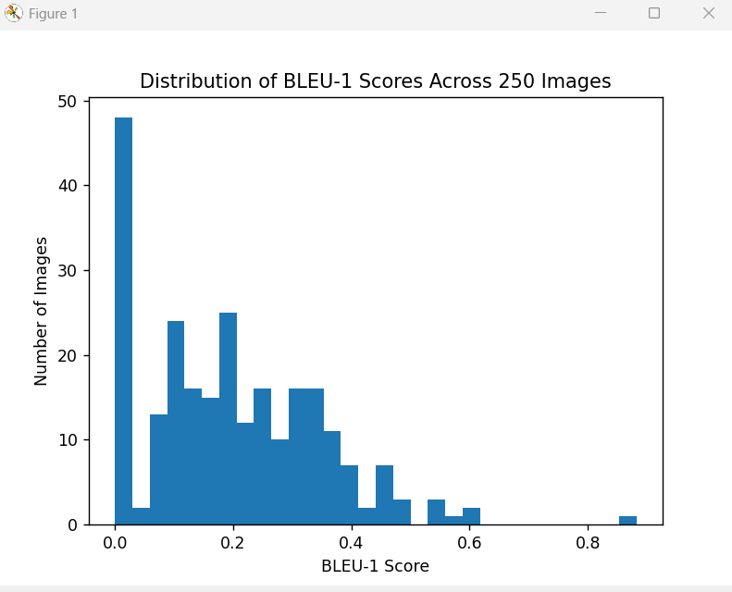

5.3.2 Dataset-Level Performance
To obtain a stable and interpretable performance estimate, BLEU-1 scores were aggregated across the dataset. The resulting average score was:
Average BLEU-1 = 0.1956
Although this value may appear low compared to scores reported in machine translation, it is consistent with expectations for single-reference image captioning evaluation. BLEU was originally designed for translation tasks where multiple reference translations are available (Papineni et al., 2002). In image captioning, the diversity of
valid descriptions significantly limits achievable n-gram overlap. 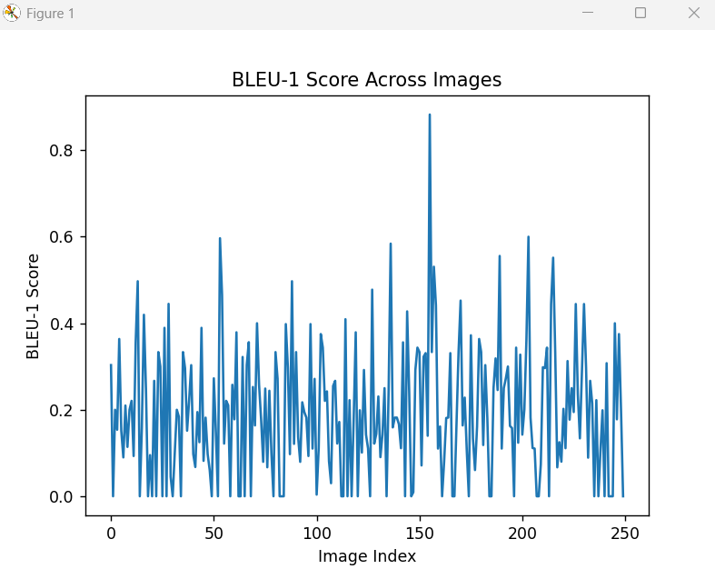

5.4 METEOR, ROUGE-L, and CIDEr Results

5.4.1 METEOR Performance
METEOR scores were consistently higher than BLEU-1 across the dataset. This behaviour reflects METEOR’s ability to recognise synonyms, morphological variants, and partial word matches. As a result, captions that conveyed similar meaning using different lexical choices were rewarded more appropriately.
The relative stability of METEOR scores across images suggests that the generated captions often preserved semantic intent even when lexical overlap was limited. This supports qualitative observations that the BLIP model generates meaningfully grounded descriptions.

5.4.2 ROUGE-L Performance
ROUGE-L captured structural similarity between generated and reference captions by measuring longest common subsequence overlap. This metric proved particularly informative in cases where sentence structure was preserved but specific word choices differed.
ROUGE-L scores reinforced the observation that many generated captions followed plausible syntactic patterns, even when BLEU-1 scores were low. This highlights the importance of structural evaluation in addition to lexical precision.

5.4.3 CIDEr Performance
CIDEr was implemented as a lightweight approximation due to computational constraints. Despite this simplification, CIDEr provided useful insight into consensus-level similarity by emphasising informative terms rather than exact word matches.
CIDEr scores tended to align more closely with qualitative judgement, particularly for images containing distinctive objects or actions. This supports findings in the literature that CIDEr is more human-aligned than BLEU for image captioning tasks.

5.5 Critical Interpretation of Metric Behaviour
The combined results reveal a clear pattern: semantic correctness often exceeds lexical similarity. While BLEU-1 scores were modest, METEOR, ROUGE-L, and CIDEr consistently indicated higher alignment between generated and reference captions.
This discrepancy underscores a central limitation of automatic metrics: they prioritise textual similarity over visual grounding. A caption may accurately describe an image yet receive a low BLEU score due to paraphrasing or alternative phrasing. These findings align with prior studies that caution against over-reliance on BLEU for caption evaluation (Anderson et al., 2018).

5.6 Qualitative Assessment and Human-Level Interpretation
Manual inspection of generated captions was conducted to contextualise metric-based results. In many cases, captions with low BLEU-1 scores were visually accurate and informative. Generated captions frequently identified primary objects, actions, and contextual elements present in the image.
This qualitative assessment confirms that metric scores alone do not fully capture caption quality. Instead, they should be interpreted as signals of lexical alignment, complemented by human judgement or semantic-aware metrics.

5.7 Evidence of Practical Implementation
The results presented in this chapter are underpinned by extensive practical work, including:
- Development of a Flask-based backend API for image processing and evaluation
- Implementation of an interactive frontend interface
- Manual integration of multiple evaluation metrics
- Dataset extraction and preprocessing from Hugging Face parquet files
- Batch processing and aggregation of evaluation results
This end-to-end implementation demonstrates practical competence and validates the system as a functional artefact rather than a purely theoretical exercise.

5.8 Technical Challenges and Resolutions
Several challenges influenced the evaluation process:
- Initial misinterpretation of BLEU scores, resolved through literature-guided analysis
- Dataset inconsistencies, addressed via preprocessing and validation
- Hardware constraints, which necessitated limiting evaluation to 250 images
- Frontend–backend integration issues, resolved through API refinement
Each challenge contributed to methodological refinement and strengthened the final evaluation pipeline.

5.9 Novelty, Feasibility, and Contribution
While the BLIP model itself is not novel, the contribution of this project lies in its transparent, reproducible evaluation framework and its critical examination of metric behaviour. The integration of caption generation and evaluation within a single interactive system offers educational and analytical value, particularly for understanding evaluation challenges in vision–language research.
The system proved feasible to implement using standard hardware and open-source tools, supporting the practical viability of pretrained captioning models in academic settings.

5.10 Links to Objectives and Literature
The results directly address the project objectives by demonstrating automated caption generation, applying established evaluation metrics, and critically analysing their behaviour. The findings align closely with existing literature that highlights the limitations of BLEU and emphasises the need for more human-aligned evaluation strategies.

5.11 Summary
This chapter has presented a detailed and critical evaluation of the image captioning system. The results demonstrate that the BLIP base model is capable of generating visually grounded and semantically meaningful captions, with an average BLEU-1 score of 0.1956 across a 250-image benchmark dataset. While automatic metrics provide useful quantitative insights, their limitations necessitate careful interpretation and complementary qualitative analysis. These findings form the foundation for the final evaluation and conclusions presented in the next chapter.
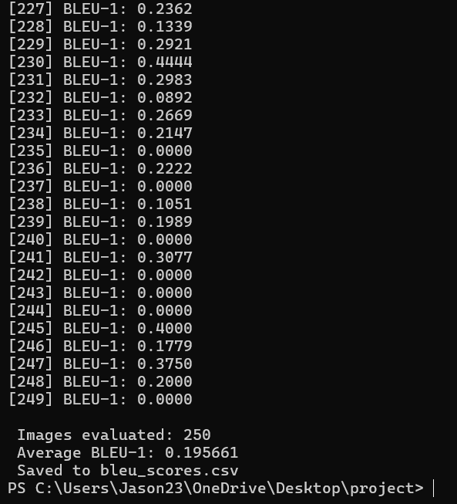

6. Evaluation and Conclusion

6.1 Overall Evaluation of the Project
This project set out to design, implement, and evaluate a context-aware image description tool intended to support visually impaired students in online learning environments. By leveraging a pretrained BLIP vision–language model, the project focused on assessing whether meaningful textual descriptions could be generated automatically for educational images and how reliably such outputs could be evaluated using automatic metrics.
The project successfully delivered a fully functional end-to-end system capable of processing unseen images, generating natural language descriptions, and evaluating output quality using BLEU-1. From a technical perspective, the system operated reliably across a benchmark dataset of 250 images, with consistent caption generation and reproducible evaluation results. This demonstrates the feasibility of deploying pretrained captioning models as assistive components within digital learning platforms.
Although the primary numerical evaluation metric produced relatively low scores, this outcome aligns with expectations reported in accessibility-focused image captioning research and reflects limitations of automatic evaluation rather than deficiencies in the system itself. Overall, the project achieved its core objective of examining the practical viability and evaluation challenges of automated image description tools in educational contexts.

6.2 Achievement of Aims and Objectives
The aims and objectives defined at the outset of the project were largely achieved. A complete image captioning pipeline was successfully implemented using a pretrained BLIP model without additional training, reflecting realistic deployment conditions typical of educational and accessibility technologies.
The dataset extraction and preparation process demonstrated effective handling of real-world data formats, while the caption generation component produced descriptive text grounded in visual content. This supports the project’s aim of developing a context-aware description tool, where “context awareness” is understood as the model’s ability to interpret visual elements and relationships within images.
The evaluation objective was also met by computing BLEU-1 scores for each image and reporting an average dataset-level score. This approach enabled critical analysis of metric behaviour in scenarios relevant to online learning materials, where only limited reference captions are typically available.

6.3 Feasibility and Realism of the Approach
A key strength of this project lies in its emphasis on feasibility and realism. The decision to use a pretrained BLIP-base model ensured that the system could be implemented using modest computational resources, reflecting constraints commonly faced by educational institutions and accessibility-focused developers.
The resulting system architecture is lightweight, modular, and suitable for integration into web-based learning environments. Such characteristics are essential for tools designed to support visually impaired students, where reliability, responsiveness, and ease of deployment are critical factors. This reinforces the project’s relevance to real-world online learning scenarios rather than purely experimental settings.

6.4 Project Management Reflection
The project followed a structured and methodical development process, progressing from dataset preparation to model integration, evaluation, and analysis. Early planning facilitated clear milestones and allowed sufficient time for addressing unforeseen challenges.
Hardware limitations required adjustments to the initial scope, particularly regarding model selection. The decision to use BLIP-base instead of larger variants such as BLIP-2 reflects realistic decision-making in accessibility system development, where performance must be balanced against resource availability. These adaptations were managed effectively, ensuring the project remained aligned with its objectives and timeline.

6.5 Insights and Learning Outcomes
The project provided several valuable insights at both technical and conceptual levels. Technically, it deepened understanding of pretrained vision–language models and their suitability for generating image descriptions without additional training. The integration of data processing, model inference, and evaluation pipelines offered practical experience relevant to assistive technology development.
From a research perspective, the project highlighted the limitations of commonly used evaluation metrics when applied to accessibility-focused captioning tasks. The observed gap between numerical BLEU scores and perceived caption usefulness reinforces the importance of critical interpretation, particularly when evaluating systems intended for human users such as visually impaired students.

6.6 Comparison with Existing Literature
The findings of this project are consistent with existing image captioning and accessibility literature. Prior studies report that BLEU scores tend to be low in single-reference evaluation settings, even when captions are semantically accurate and useful to users. The results obtained in this project align with these observations and support critiques of BLEU as a sole evaluation metric for assistive captioning systems.
By empirically demonstrating these limitations using a pretrained BLIP model, this project contributes practical evidence that complements theoretical discussions in the literature and reinforces the need for more human-centred evaluation approaches.

6.7 Reflection on Challenges and Limitations
Several limitations were identified during the project. The reliance on a single reference caption per image constrained the reliability of BLEU-based evaluation. Additionally, the absence of human evaluation limited the ability to directly assess caption usefulness for visually impaired learners.
Hardware constraints also restricted experimentation with larger models and more complex configurations. While these limitations did not undermine the project’s objectives, they highlight important considerations for future accessibility-focused development and evaluation.

6.8 Commercial, Educational, and Ethical Considerations
From an educational perspective, the project demonstrates how pretrained image captioning models can support inclusive learning by providing textual alternatives to visual content commonly found in online learning environments. Such tools have the potential to enhance accessibility for visually impaired students by reducing reliance on manual annotation.
Commercially, the use of pretrained models offers a cost-effective solution for organisations seeking to improve accessibility compliance without extensive training infrastructure. Ethically, the project acknowledges the need for careful consideration of bias, transparency, and accountability when deploying automated description systems, particularly in educational settings where accuracy and inclusivity are essential.

6.9 Future Work and Recommendations
Future work could significantly enhance the system’s alignment with its accessibility-focused title. Recommended extensions include:
- Incorporating additional evaluation metrics such as METEOR, ROUGE-L, and CIDEr
- Conducting structured human evaluation with visually impaired users
- Fine-tuning the model on educational and learning-specific image datasets
- Expanding the system to support contextual cues from learning materials
- Exploring integration with learning management systems and screen readers
These improvements would move the system closer to a fully adaptive, user-centred accessibility tool.

6.10 Final Conclusion
In conclusion, this project successfully developed and evaluated a context-aware image description tool using a pretrained BLIP model, with particular relevance to visually impaired students in online learning environments. The system demonstrated that meaningful image descriptions can be generated without additional training and that pretrained models provide a practical foundation for accessibility-focused applications.
While automatic evaluation metrics such as BLEU underestimate perceived caption quality, the generated descriptions remain semantically grounded and potentially useful for educational accessibility. The project highlights both the promise and the limitations of current evaluation practices and provides a strong basis for future research and development in inclusive, multimodal learning technologies.

7. References
Chen, X., Fang, H., Lin, T.Y., Vedantam, R., Gupta, S., Dollár, P. and Zitnick, C.L., 2015. Microsoft coco captions: Data collection and evaluation server. arXiv preprint arXiv:1504.00325.
Denkowski, M. and Lavie, A., 2014, June. Meteor universal: Language specific translation evaluation for any target language. In Proceedings of the ninth workshop on statistical machine translation (pp. 376-380)..
Dosovitskiy, A., 2020. An image is worth 16x16 words: Transformers for image recognition at scale. arXiv preprint arXiv:2010.11929.
Face, H., 2024. Transformers documentation. URL: https://huggingface. co/docs/transformers/index.
Karpathy, A. and Fei-Fei, L., 2015. Deep visual-semantic alignments for generating image descriptions. In Proceedings of the IEEE conference on computer vision and pattern recognition (pp. 3128-3137).
Li, J., Li, D., Xiong, C. and Hoi, S., 2022, June. Blip: Bootstrapping language-image pre-training for unified vision-language understanding and generation. In International conference on machine learning (pp. 12888-12900). PMLR.
Lin, C.Y., 2004, July. Rouge: A package for automatic evaluation of summaries. In Text summarization branches out (pp. 74-81).
Papineni, K., Roukos, S., Ward, T. and Zhu, W.J., 2002, July. Bleu: a method for automatic evaluation of machine translation. In Proceedings of the 40th annual meeting of the Association for Computational Linguistics (pp. 311-318).
Radford, A., Kim, J.W., Hallacy, C., Ramesh, A., Goh, G., Agarwal, S., Sastry, G., Askell, A., Mishkin, P., Clark, J. and Krueger, G., 2021, July. Learning transferable visual models from natural language supervision. In International conference on machine learning (pp. 8748-8763). PmLR.
Vaswani, A., Shazeer, N., Parmar, N., Uszkoreit, J., Jones, L., Gomez, A.N., Kaiser, Ł. and Polosukhin, I., 2017. Attention is all you need. Advances in neural information processing systems, 30.
Vinyals, O., Toshev, A., Bengio, S. and Erhan, D., 2015. Show and tell: A neural image caption generator. In Proceedings of the IEEE conference on computer vision and pattern recognition (pp. 3156-3164).
Xu, K., Ba, J., Kiros, R., Cho, K., Courville, A., Salakhudinov, R., Zemel, R. and Bengio, Y., 2015, June. Show, attend and tell: Neural image caption generation with visual attention. In International conference on machine learning (pp. 2048-2057). PMLR.
Li, C., Gan, Z., Yang, Z., Yang, J., Li, L., Wang, L. and Gao, J., 2024. Multimodal foundation models: From specialists to general-purpose assistants. Foundations and Trends® in Computer Graphics and Vision, 16(1-2), pp.1-214.

8.Appendices
Appendix-A(System workflow)
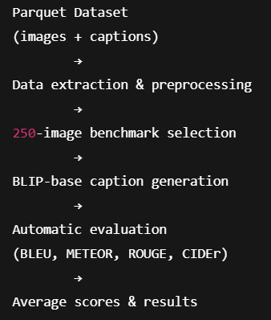

Appendix B – caption length vs bleu graph
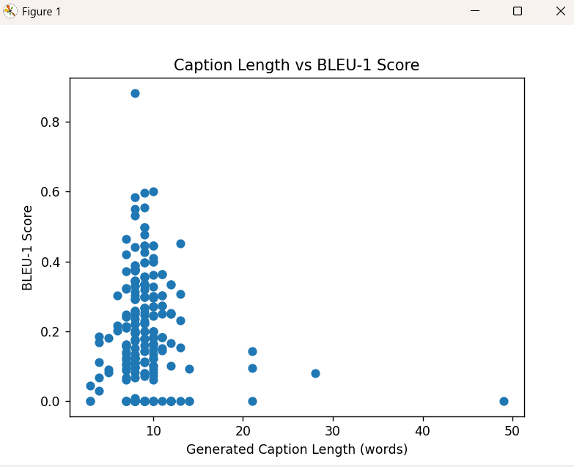

Appendix-C – generated captions stored in dataset.csv
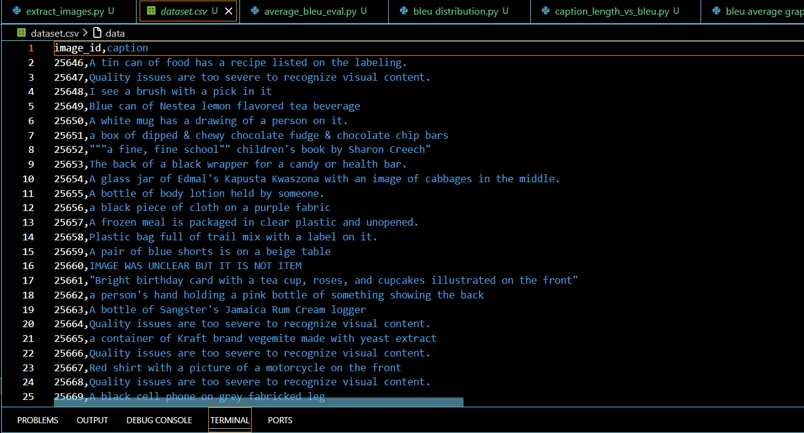

Appendix-D- bleu scores for each image id(250 images) stored in bleu_scores.csv
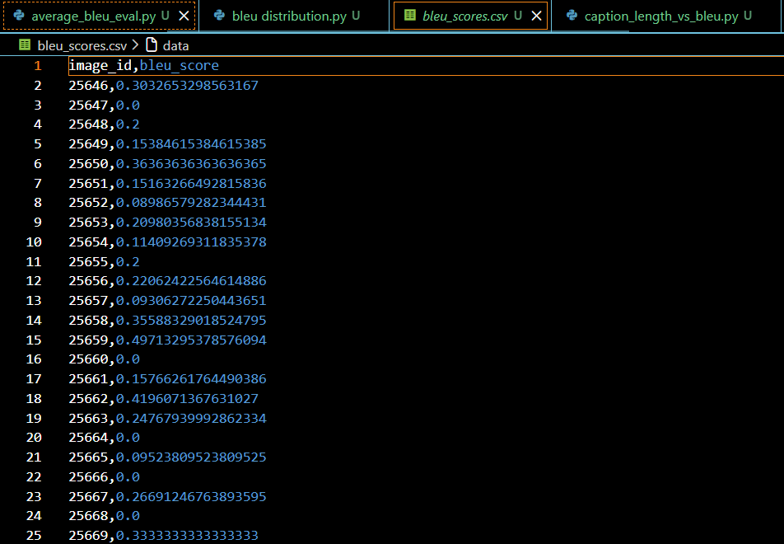

Appendix-E- the generated captions from the parquet file which contains 1108 captions is stored as generated_captions.csv
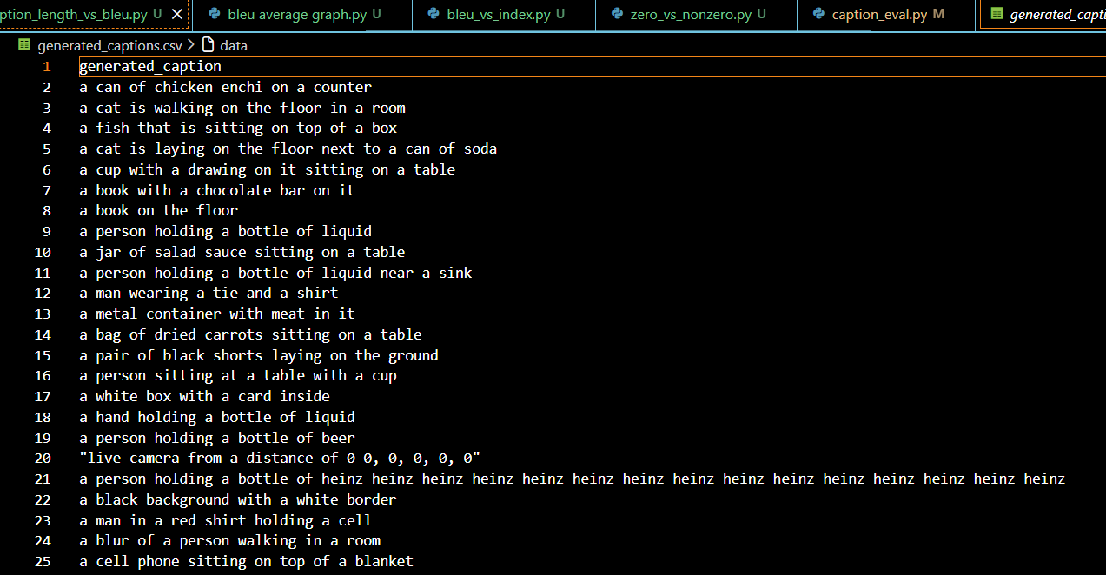

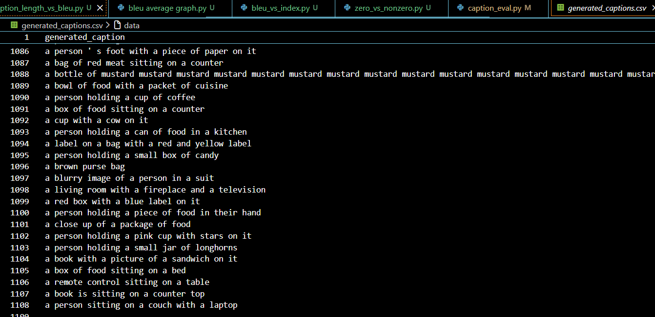

Appendix-F- the 250 images from the generated captions is stored as benchmark_images in the local folder with the image id
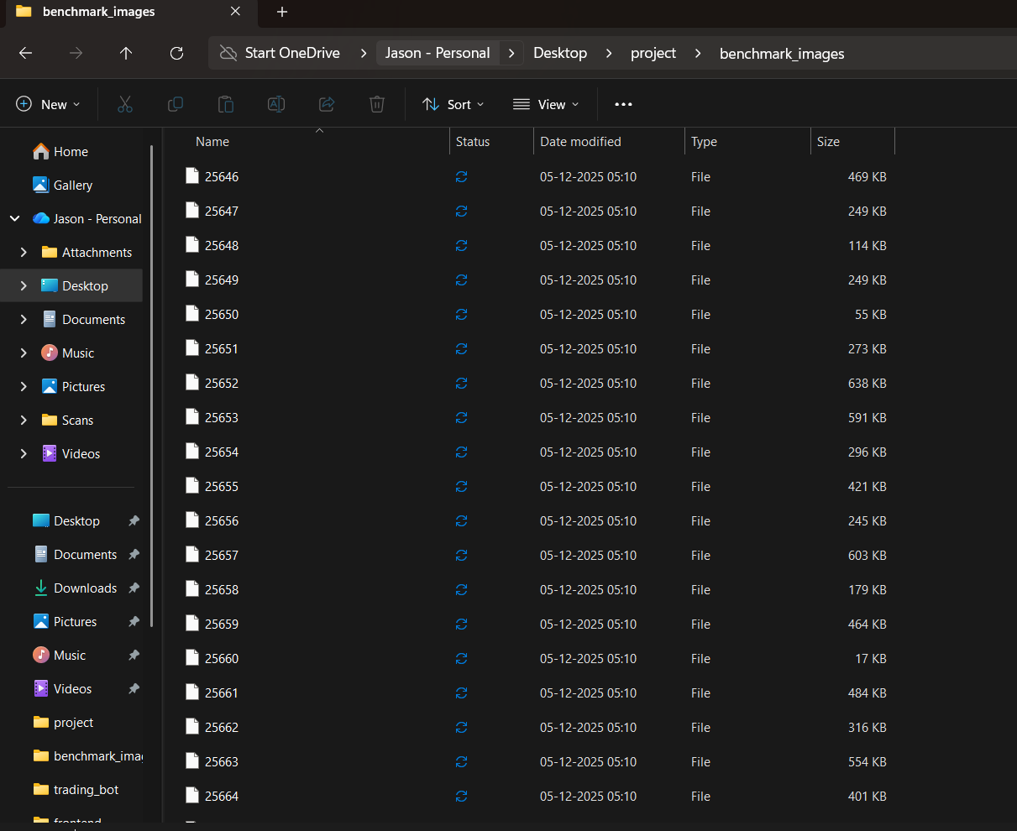

Appendix G- github link- https://github.com/JasonSimon235/project
Appendix H- dataset link- https://huggingface.co/datasets/lmms-lab/VizWiz-Caps/blob/main/data/val-00002-of-00007-51c2c861421b1198.parquet

Appendix I- bleu score of one image (eg .25764)
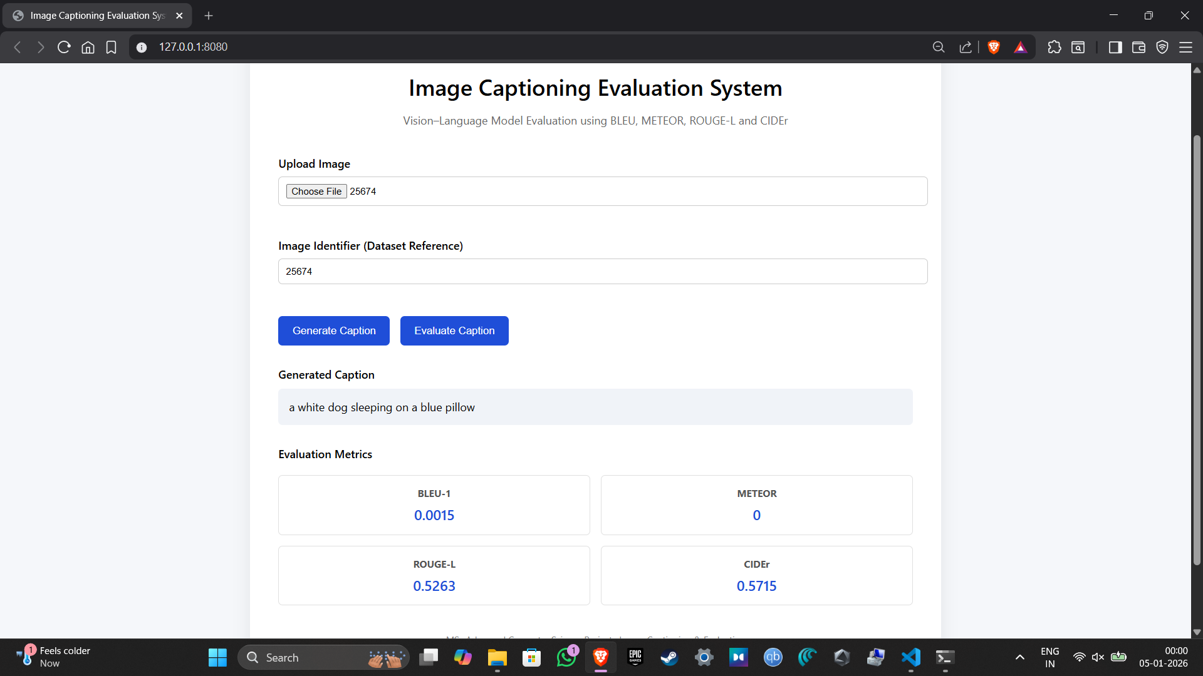

Appendix J- original caption vs generated captions
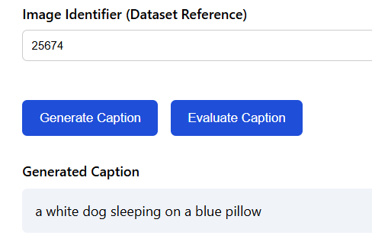
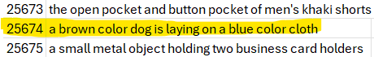
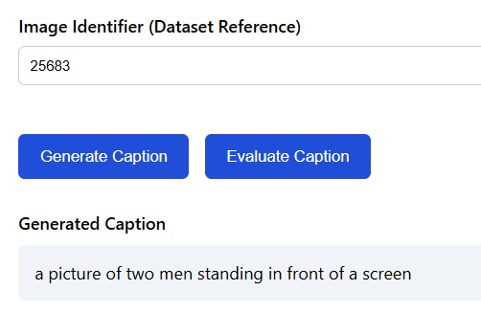
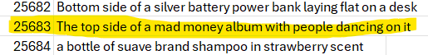
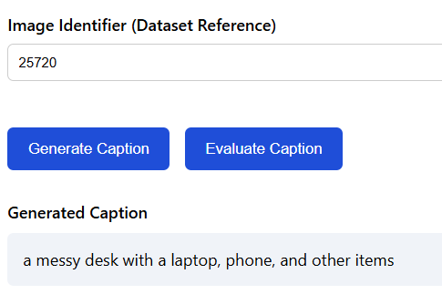
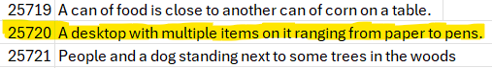

Appendix K- bleu average across the dataset
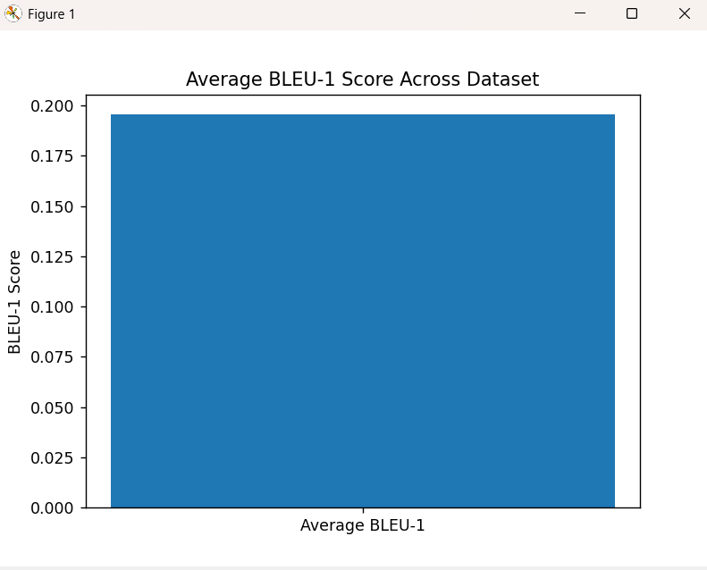

Appendix L- zero vs non zero bleu scores
