Accessible Design Studio Application Guide
Windows use and validation
By Jason Stys Version 1.1.0 11 November 2026
Create bounded component blueprints with live interactions and export editable React and CSS using the original tested component library. Inspect design choices, keyboard behavior and contrast while retaining explicit accessibility review limits.
The independently downloaded installed application passed its original full native acceptance and retained-file checks. Current main source workflows and processed security analyses passed before publication; shortcut targets were verified separately.

Capabilities and previous improvements
The original system retains semantic components, design tokens, responsive browser checks and a framework-independent example. The new authoring workspace adds seven supported block types, schema-checked project editing, real interactive preview, literal generated source export and current/previous saved revisions.
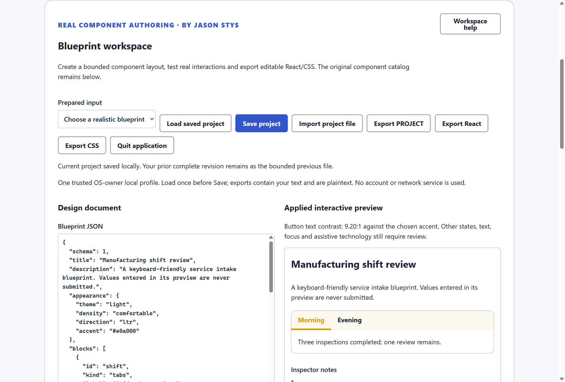
Figure 1 The actual installed blueprint workspace shows an edited shift review, its JSON input and working tab preview.

A worked application journey
A designer adapts a manufacturing shift-review blueprint, changes its theme and tabs, tries its actual controls and exports source for independent integration. Invalid project input must not erase the last valid design.
1. Choose an editable blueprint or import supported project JSON. Set its appearance and supported blocks through the ordinary authoring workspace.
2. Apply the design and try real preview buttons, fields, choices, tabs and dialog behavior. Inspect the measured contrast and documented limitations.
3. Save the complete project and export its literal JSON, React TSX and CSS to fresh destinations; generated code has a separate real consumer check.
4. Reopen the same project with its previous complete revision retained. Quit waits for an accepted export before closing the native app.
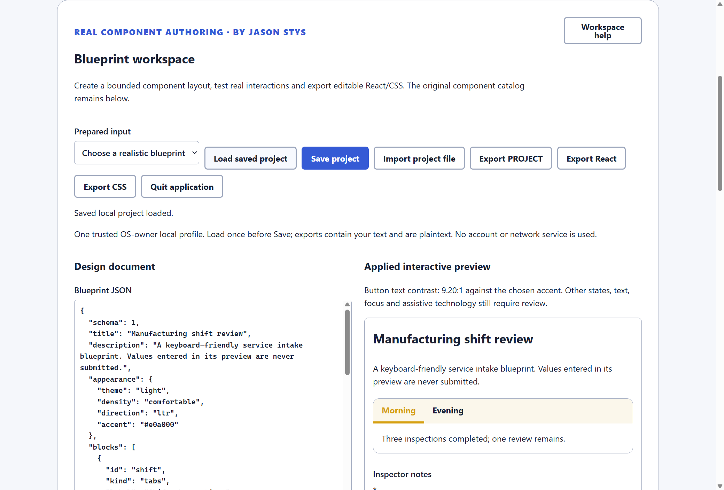
Figure 2 The actual installed workspace preserves its authored project and export controls. Generated React and CSS were checked by an independent consumer.

Important implementation details

Generate source only from validated supported blocks
Source export first validates the complete project, then imports only components needed by its seven supported block types. It emits editable source rather than executing arbitrary project text.
src/authoring/project.ts lines 422 to 435
422 export function reactSource(project: DesignProject): string {
423 const validated = parseProject(JSON.stringify(project));
424 const kinds = new Set(validated.blocks.map((item) => item.kind));
425 const messageState = kinds.has("button") || kinds.has("choice");
426 const dialogState = kinds.has("dialog");
427 const imports = new Set<string>();
428 for (const kind of kinds) {
429 if (kind === "button" || kind === "dialog") imports.add("Button");
430 if (kind === "field") imports.add("TextField");
431 if (kind === "choice") imports.add("Combobox");
432 if (kind === "table") imports.add("DataTable");
433 if (kind === "tabs") imports.add("Tabs");
434 if (kind === "dialog") imports.add("Dialog");
435 }
Source file SHA256 98484604ecf726cfd82e0c8507f9f2d36c3d06d3ed64d3b4d8f309774f536646

Validation results and operating limits
Runtime source 13dac81ab3819cd2208d96e4061e5e5484fc9dde
Check | Observed evidence | Result
Independent distribution | Downloaded provider assets, sidecar and installed file identities matched. The complete installed app was used; installation resources remained byte-identical. | Passed
Actual app use and restart | The original installed consumer passed actual component interactions, schema/invalid-input checks, exact React/CSS/project exports, independent generated-code consumption, retained revisions and two normal exits. | Passed
Source and security | All current main workflows passed before publication. All configured exact-source processed CodeQL categories had zero raw findings and zero open alerts. | Passed
Individual shortcut | Desktop and Start-menu targets were read back against the installed version. Normal default-profile shortcut activation is separate from full installed executable acceptance. | Verified

Installation and private data
Download the matching version and checksum from Releases. This is an unsigned per-user portable Windows x64 app; keep its complete accompanying files together. No system Python installation or Docker change is needed.
Use the individual Desktop icon and in-app help. Inputs, saved evidence and exports stay outside the installation. Preserve older versions and your own profiles; tests used only separate synthetic inputs.

Limits and help
A contrast result or automated browser check is not a complete accessibility certification. Review focus, states, content and assistive-technology behavior for each actual downstream use.
The preview does not submit forms or connect to a server. This is a trusted OS-owner-local design workspace; saved projects and exports are plaintext and have no multiuser account service.
Release and checksums | Exact runtime source | Usage and limits

